Contents

1. Securing Networks 11

1.0) Introduction 11

1.0.1. First Time in this Course 11

1.0.2. Ethical Hacking Statement 11

1.0.3. Inclusive Language 11

1.1) Current State of Affairs 12

1.1.1. Networks Are Targets 12

1.1.2. Reasons for Network Security 12

1.1.3. Vectors of Network Attacks 13

1.1.4. Data Loss 13

1.2) Network Topology Overview 14

1.2.1. Campus Area Networks 14

1.2.2. Small Office and Home Office Networks 16

1.2.3. Wide Area Networks 16

1.2.4. Data Center Networks 17

1.2.5. Cloud Networks and Virtualization 19

1.2.6. The Evolving Network Border 20

1.3) What Did I Learn in this Module? 20

2. Network Threats 21

2.0) Introduction 21

2.0.1. Why Should I Take this Module? 21

2.0.2. What Will I Learn in this Module? 21

2.1) Who is Attacking out Network? 22

2.1.1. Threat, Vulnerability, and Risk 22

2.1.2. Hacker vs. Threat Actor 24

2.1.3. Evolution of Threat Actors 25

2.1.4. Cybercriminals 25

2.1.5. Cybersecurity Tasks 25

2.1.6. Cyber Threat Indicators 26

2.1.7. Threat Sharing and Building Cybersecurity Awareness 27

2.2) Threat Actor Tools 27

2.2.1. Introduction of Attack Tools 27

2.2.2. Evolution of Security Tools 28

2.2.3. Categories of Attacks 29

2.3) Types of Malware 30

2.3.1. Viruses 30

2.3.2. Trojan Horses 31

2.3.3. Worms 32

2.3.4. Ransomware 34

2.3.5. Other Malware 34

2.3.6. Common Malware Behaviors 35

2.4) Network Attacks 35

2.4.1. Reconnaissance Attacks 36

2.4.2. Access Attacks 36

2.4.3. Social Engineering Attacks 37

2.4.4. DoS and DDoS Attacks 39

2.4.5. Evasion Methods 41

2.5) What Did I Learn in this Module? 42

3. Mitigating Threats 44

3.0) Introduction 44

3.0.1. Why Should I Take this Module? 44

3.0.2. What Will I Learn in this Module? 44

3.1) Defending the Network 44

3.1.1. Network Security Professionals 44

3.1.2. Network Intelligence Communities 45

3.1.3. Network Security Certifications 46

3.1.4. Communications Security: CIA 47

3.2) Network Security Policies 47

3.2.1. Network Security Domains 47

3.2.2. Business Policies 49

3.2.3. Security Policy 49

3.2.4. BYOD Policies 50

3.3) Security Tools, Platforms and Services 51

3.3.1. The Security Onion and The Security Artichoke 51

3.3.2. Security Testing Tools 53

3.3.3. Data Security Platforms 54

3.3.5. Security Services 55

3.4) Mitigating Common Network Attacks 55

3.4.1. Defending the Network 55

3.4.2. Mitigating Malware 56

3.4.3. Mitigating Worms 56

3.4.4. Mitigating Reconnaissance Attacks 57

3.4.5. Mitigating Access Attacks 58

3.4.6. Mitigating DoS Attacks 59

3.5) Cisco Network Foundation Protection Framework 59

3.5.1. NFP Framework 59

3.5.2. Securing the Control Plane 60

3.5.3. Securing the Management Plane 61

3.5.3. Securing the Data Plane 62

3.6) What Did I Learn in this Module? 63

4. Secure Device Access 65

4.0) Introduction 65

4.0.1. Why Should I Take this Module? 65

4.0.2. What Will I Learn in this Module? 65

4.1) Secure the Edge Router 65

4.1.1. Secure the Network Infrastructure 65

4.1.2. Edge Router Security Approaches 66

4.1.3. Three Areas of Router Security 67

4.1.4. Secure Administrative Access 68

4.1.5. Secure Local and Remote Access 68

4.2) Configure Secure Administrative Access 69

4.2.1. Passwords 69

4.2.2. Configure Passwords 70

4.2.3. Encrypt Passwords 71

4.2.4. Additional Password Security 72

4.2.5. Secret Password Algorithms 73

4.3) Configure Enhanced Security for Virtual Logins 75

4.3.1. Enhance the Login Process 75

4.3.2. Configure Login Enhancement Features 76

4.3.3. Enable Login Enhancements 76

4.3.4. Log Failed Attempts 77

4.4) Configure SSH 79

4.4.1. Enable SSH 79

4.4.2. Enhance SSH Login Security 81

4.4.3. Connect a Router to an SSH-Enabled Router 81

4.5) What Did I Learn in this Module? 82

5. Assigning Administrative Roles 83

5.0) Introduction 83

5.0.1. Why Should I Take this Module? 83

5.0.2. What Will I Learn in this Module? 83

5.1) Configure Privilege Levels 84

5.1.1. Limiting Command Availability 84

5.1.2. Configuring and Assigning Privilege Levels 85

5.1.3. Limitations of Privilege Levels 87

5.2) Configure Role-Based CLI 87

5.2.1. Role-Based CLI Access 87

5.2.2. Role-Based Views 87

5.2.3. Configure Role-Based Views 88

5.2.4. Configure Role-Based CLI Superviews 90

5.2.5. Verify Role-Based CLI Views 92

5.3) What Did I Learn in this Module? 93

6. Device Monitoring and Management 94

6.0) Introduction 94

6.0.1. Why Should I Take this Module? 94

6.0.2. What Will I Learn in this Module? 94

6.1) Secure Cisco IOS Image and Configuration Files 95

6.1.1. Cisco IOS Resilient Configuration Feature 95

6.1.2. Enable the IOS Image Resilience Feature 95

6.1.3. The Primary Bootset Image 96

6.1.4. Configure Secure Copy 97

6.1.5. Recover a Router Password 99

6.1.6. Password Recovery 99

6.2) Lock Down a Router Using AutoSecure 101

6.2.1. Discovery Protocols CDP and LLDP 101

6.2.2. Settings for Protocols and Services 102

6.2.3. Cisco AutoSecure 104

6.2.4. Cisco AutoSecure Command Syntax 105

6.2.5. Cisco AutoSecure Configuration Example 106

6.3) Routing Protocol Authentication 109

6.3.1. Dynamic Routing Protocols 109

6.3.2. Routing Protocol Spoofing 109

6.3.3. OSPF MD5 Routing Protocol Authentication 110

6.3.4. OSPF SHA Routing Protocol Authentication 112

6.4) Secure Management and Reporting 113

6.4.1. Types of Management Access 113

6.4.2. Out-of-Band and In-Band Access 115

6.5) Network Security Using Syslog 115

6.5.1. Introduction to Syslog 115

6.5.2. Syslog Operation 116

6.5.3. Syslog Message Format 117

6.5.4. Syslog Facilities 117

6.5.5. Configure Syslog Timestamps 118

6.5.6. Syslog Systems 118

6.5.7. Syslog Configuration 119

6.6) NTP Configuration 121

6.6.1. Time and Calendar Services 121

6.6.2. NTP Operation 122

6.6.3. Configure and Verify NTP 123

6.7) SNMP Configuration 125

6.7.1. Introduction to SNMP 125

6.7.2. SNMP Operation 126

6.7.3. Management Information Base (MIB) 126

6.7.4. SNMP Versions 127

6.7.5. SNMP Vulnerabilities 129

6.7.6. SNMPv3 129

6.8) What Did I Learn in this Module? 132

7. Authentication, Authorization, and Accounting (AAA) 135

7.0) Introduction 135

7.0.1. Why Should I Take this Module? 135

7.0.2. What Will I Learn in this Module? 135

7.1) AAA Characteristics 136

7.1.1. Authentication without AAA 136

7.1.2. AAA Components 137

7.1.3. Authentication Modes 138

7.1.4. Authorization 139

7.1.5. Accounting 140

7.2) Configure Local AAA Authentication 141

7.2.1. Authenticate Administrative Access 141

7.2.2. Authentication Methods 141

7.2.3. Default and Named Methods 143

7.2.4. Fine-Tuning the Authentication Configuration 143

7.3) Server-Based AAA Characteristics and Protocols 144

7.3.1. Compare Local AAA and Server-Based AAA Implementations 144

7.3.2. Cisco Identity Services Engine (ISE) 145

7.3.3. The TACACS+ and RADIUS Protocols 146

7.4) Configure Server-Based Authentication 148

7.4.1. Steps to Configure Server-Based AAA Authentication 148

7.4.2. Authenticate to the AAA Server Configuration Commands 150

7.5) Configure Server-Based Authorization and Accounting 151

7.5.1. Introduction to Server-Based AAA Authorization 151

7.5.2. Introduction to Server-Based AAA Accounting 152

7.6) What Did I Learn in this Module? 154

8. Access Control Lists (ACLs) 156

8.0) Introduction 156

8.0.1. Why Should I Take this Module? 156

8.0.2. What Will I Learn in this Module? 156

8.1) Introduction to ACL 156

8.1.1. What is an ACL? 156

8.1.2. Packet Filtering 157

8.1.3. Numbered and Named ACLs 158

8.1.4. ACL Operation 159

8.2) Wildcard Masking 159

8.2.1. Wildcard Mask Overview 159

8.2.2. Wildcard Mask Types 160

8.2.3. Wildcard Mask Keywords 161

8.3) Configure ACLs 162

8.3.1. Create an ACL 162

8.3.2. Protocols and Port Numbers 167

8.3.3. TCP Established Extended ACL 168

8.4) Modify ACLs 170

8.4.1. Text Editor Method 170

8.4.2. Sequence Number Method 170

8.5) Implement ACLs 171

8.5.1. ACL Configuration Guidelines 171

8.5.2. Apply an ACL 171

8.5.3. Where to Place ACLs 173

8.6) Mitigate Attacks with ACLs 176

8.6.1. Mitigate Spoofing Attacks 176

8.6.2. Permit Necessary Traffic through a Firewall 177

8.6.3. Mitigate ICMP Attacks 178

8.6.4. Mitigate SNMP Attacks 179

8.7) IPv6 ACLs 180

8.7.1. IPv6 ACL Overview 180

8.7.2. IPv6 ACL Syntax 180

8.7.3. Configure IPv6 ACLs 182

8.8) What Did I Learn in this Module? 182

9. Firewall Technologies 185

9.0) Introduction 185

9.0.1. Why Should I Take this Module? 185

9.0.2. What Will I Learn in this Module? 185

9.1) Secure Networks with Firewalls 185

9.1.1. Firewalls 185

9.1.2. Types of Firewalls 186

9.1.3. Packet Filtering Firewall Benefits and Limitations 188

9.1.4. Stateful Firewall Benefits and Limitations 188

9.2) Firewalls in Network Design 189

9.2.1. Common Security Architectures 189

9.2.2. Layered Defense 191

9.3) What Did I Learn in this Module? 192

10. Zone-Based Policy Firewalls 192

10.0) Introduction 192

10.0.1. Why Should I Take this Module? 192

10.0.2. What Will I Learn in this Module? 192

10.1) ZPF Overview 193

10.1.1. Benefits of a ZPF 193

10.1.2. ZPF Design 194

10.2) ZPF Operation 194

10.2.1. ZPF Actions 194

10.2.2. Rules for Transit Traffic 195

10.2.3. Rules for Traffic to the Self Zone 196

10.3) Configure a ZPF 197

10.3.1. Configuration 197

10.3.2. Step 1: Create the Zones 197

10.3.3. Step 2: Identify Traffic 198

10.3.4. Step 3: Define an Action 199

10.3.5. Step 4: Identify a Zone-Pair and Match to a Policy 199

10.3.6. Step 5: Assign Zones to Interfaces 200

10.3.7. Verify a ZPF Configuration 201

10.3.8. ZPF Configuration Considerations 202

10.4) What Did I Learn in this Module? 203

11. IPS Technologies 204

11.0) Introduction 204

11.0.1. Why Should I Take this Module? 204

11.0.2. What Will I Learn in this Module? 204

11.1) IDS and IPS Characteristics 204

11.1.1. Zero-Day Attacks 204

11.1.2. Monitor for Attacks 205

11.1.3. Intrusion Prevention and Detection Devices 205

11.1.4. Advantages and Disadvantages of IDS and IPS 206

11.2) IPS Implementations 208

11.2.1. Types of IPS 208

11.2.2. Network-Based IPS 209

11.2.3. Modes of Deployment 210

11.3) IPS on Cisco ISRs 210

11.3.1. IPS Components 210

11.3.2. Cisco IOS IPS 211

11.3.3. Snort IPS 211

11.4) Cisco Switched Port Analyzer 213

11.4.1. Network Monitoring Methods 213

11.4.2. Network Taps 214

11.4.3. Traffic Mirroring and SPAN 214

11.4.4. Configure Cisco SPAN 215

11.4) What Did I learn in this Module? 216

12. IPS Operation and Implementation 218

12.0) Introduction 218

12.0.1. Why Should I Take this Module? 218

12.0.2. What Will I Learn in this Module? 218

12.1) IPS Signatures 218

12.1.1. IPS Signature Attributes 218

12.1.2. Types of Signatures 219

12.1.3. IPS Signature Alarms 219

12.1.4. IPS Signature Actions 220

12.1.5. Evaluating Alerts 221

12.2) Cisco Snort IPS 222

12.2.1. IPS Service Options 222

12.2.2. NGIPS 222

12.2.3. Snort IPS 222

12.2.4. Snort Components and Rules 223

12.2.5. ISR Container Applications 224

12.2.6. Snort IPS Rule Alarms 224

12.2.7. Snort IPS Rule Actions 225

12.2.8. Snort IPS Header Rule Options 225

12.2.9. Snort IPS Operations 226

12.3) Configure Snort IPS 227

12.4) What Did I Learn in this Module? 232

13. Endpoint Security 233

13.0) Introduction 233

13.0.1. Why Should I Take this Module? 233

13.0.2. What Will I Learn in this Module? 233

13.1) Endpoint Security Overview 233

13.1.1. LAN Elements Security 233

13.1.2. Traditional Endpoint Security 234

13.1.3. The Borderless Network 235

13.1.4. Security for Endpoints in the Borderless Network 235

13.1.5. Network-Based Malware Protection 235

13.1.6. Hardware and Software Encryption of Local Data 237

13.1.7. Network Access Control 237

13.1.8. NAC Functions 237

13.2) 802.1X Authentication 238

13.2.1. Security Using 802.1X Port-Based Authentication 238

13.2.2. Control the 802.1X Authorization State 240

13.2.3. 802.1X Configuration 241

13.3) What Did I Learn in this Module? 241

14. Layer 2 Security Considerations 242

14.0) Introduction 242

14.0.1. Why Should I Take this Module? 242

14.0.2. What Will I Learn in this Module? 242

14.1) Layer 2 Security Threats 243

14.1.1. Describe Layer 2 Vulnerabilities 243

# 1. Securing Networks

## 1.0) Introduction

### 1.0.1. First Time in this Course

Welcome to the Network Security course. This course provides an introduction to the core security concepts and skills needed for the installation, troubleshooting, and monitoring of network devices to maintain the integrity, confidentiality, and availability of enterprise data.

These course materials will assist you in developing the skills necessary to do the following:

* Describe the security threats facing modern network infrastructures.
* Secure Cisco devices.
* Secure the network infrastructure.
* Implement AAA on Cisco routers using a local router database and external AAA servers.
* Mitigate threats to Cisco routers and networks using access control lists (ACLs).
* Implement secure network design, management, and reporting.
* Implement the Cisco IOS firewall feature set.
* Mitigate common Layer 2 attacks.
* Implement a site-to-site VPN.
* Implement a remote access VPN.

### 1.0.2. Ethical Hacking Statement

The Cisco Networking Academy Program is focused on creating the global problem solvers needed to build, scale, secure, and defend the networks that are used in our businesses and daily lives. The need for well-trained network security specialists continues to grow at an exponential rate. Training to become a network security specialist requires in-depth understanding and exposure to how network attacks occur, as well as how they are detected and prevented. These skills will naturally also include learning about the techniques that threat actors use to circumvent computer and network security.

Unauthorized access to data, computer, and network systems is a crime in many jurisdictions and often is accompanied by severe consequences, regardless of the perpetrator’s motivations. It is the learner’s responsibility, as the user of this material, to be cognizant of and compliant with computer use laws.

### 1.0.3. Inclusive Language

Cisco Networking Academy’s purpose is to power an inclusive future for all. With our purpose at the heart of everything we do, you can count on Cisco to be bold, brave and deliberate about our role and the actions we will take in support of social justice.

We are proud to join the technology community in evolving the language we use. Rethinking the words we use is just one of the ways to reduce barriers to equity and respect. As a matter of policy, Cisco Networking Academy content should be free of offensive or suggestive language, graphics, and scenarios. We are changing terms, as noted below, to more appropriate alternatives.

| **Term/Phrase** | **Replacements** |
| --- | --- |
| master/slave | primary/secondary OR primary/subordinate OR control/data (for clustering) |
| whitelist/blacklist | permit (list)/block (list) OR allow (list)/block (list) |

You may still see industry terms such as “black hat” in the course curriculum. Our team is working to modify these terms, as well.

## 1.1) Current State of Affairs

### 1.1.1. Networks Are Targets

Networks are routinely under attack. It is common to read in the news about yet another network that has been compromised. A quick internet search for network attacks will return many articles about network attacks, including news about organizations which have been compromised, the latest threats to network security, tools to mitigate attacks, and more.

To help you comprehend the gravity of the situation, Kapersky maintains the interactive Cyberthreat Real-Time Map display of current network attacks. The attack data is submitted from Kapersky network security products that are deployed worldwide. The figure displays a sample screenshot of this web tool, which shows these attacks in real time. Many similar tools are available on the internet and can be found by searching for cyberthreat maps.

### 1.1.2. Reasons for Network Security

Network security relates directly to an organization's business continuity. Network security breaches can disrupt e-commerce, cause the loss of business data, threaten people’s privacy, and compromise the integrity of information. These breaches can result in lost revenue for corporations, theft of intellectual property, lawsuits, and can even threaten public safety.

Maintaining a secure network ensures the safety of network users and protects commercial interests. Keeping a network secure requires vigilance on the part of an organization’s network security professionals. They must constantly be aware of new and evolving threats and attacks to networks, and vulnerabilities of devices and applications.

Many tools are available to help network administrators adapt, develop, and implement threat mitigation techniques. For instance, the Cisco Talos Intelligence Group website, shown in the figure, provides comprehensive security and threat intelligence to defend customers and protect their assets.

Another group, called the Cisco Product Security Incident Response Team (PSIRT), is responsible for investigating and mitigating potential vulnerabilities in Cisco products. The figure displays a sample Cisco Security Advisories page which lists these vulnerabilities in real time and provides network administrators with information to help mitigate them.

### 1.1.3. Vectors of Network Attacks

An attack vector is a path by which a threat actor can gain access to a server, host, or network. Attack vectors originate from inside or outside the corporate network, as shown in the figure. For example, threat actors may target a network through the internet, to disrupt network operations and create a denial of service (DoS) attack.

The figure shows network with a server and several hosts behind a firewall; a host on the network has been compromised; arrows show it could have been an external threat from the Internet through the firewall or an internal threat from another host on the network.

External and Internal Threats:

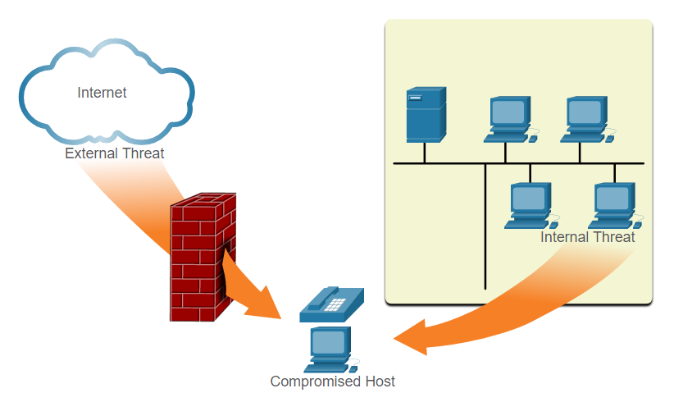

**Note**: A DoS attack occurs when a network device or application is incapacitated and no longer capable of supporting requests from legitimate users. An internal user, such as an employee, can accidentally or intentionally:

* Steal and copy confidential data to removable media, email, messaging software, and other media.
* Compromise internal servers or network infrastructure devices.
* Disconnect a critical network connection and cause a network outage.
* Connect an infected USB drive into a corporate computer system.

Internal threats have the potential to cause greater damage than external threats because internal users have direct access to the building and its infrastructure devices. Employees may also have knowledge of the corporate network, its resources, and its confidential data.

Network security professionals must implement tools and apply techniques for mitigating both external and internal threats.

### 1.1.4. Data Loss

Data is likely to be an organization’s most valuable asset. Organizational data can include research and development data, sales data, financial data, human resource and legal data, employee data, contractor data, and customer data.

Data loss, or data exfiltration, is when data is intentionally or unintentionally lost, stolen, or leaked to the outside world. The data loss can result in:

* Brand damage and loss of reputation
* Loss of competitive advantage
* Loss of customers
* Loss of revenue
* Litigation/legal action that results in fines and civil penalties
* Significant cost and effort to notify affected parties and recover from the breach

Network security professionals must protect the organization’s data. Various Data Loss Prevention (DLP) controls must be implemented that combine strategic, operational, and tactical measures.

Common data loss vectors are displayed in the table.

| **Term** | **Definition** |
| --- | --- |
| Email/Social Networking | The most common vector for data loss includes instant messaging software and social media sites. For instance, intercepted email or IM messages could be captured and reveal confidential information. |
| Unencrypted Devices | A stolen corporate laptop typically contains confidential organizational data. If the data is not stored using an encryption algorithm, then the thief can retrieve valuable confidential data. |
| Cloud Storage Devices | Saving data to the cloud has many potential benefits. However, sensitive data can be lost if access to the cloud is compromised due to weak security settings. |
| Removable Media | One risk is that an employee could perform an unauthorized transfer of data to a USB drive. Another risk is that a USB drive containing valuable corporate data could be lost. |
| Hard Copy | Corporate data should be disposed of thoroughly. For example, confidential data should be shredded when no longer required. Otherwise, a thief could retrieve discarded reports and gain valuable information. |
| Improper Access Control | Passwords are the first line of defense. Stolen passwords or weak passwords which have been compromised can provide an attacker easy access to corporate data. |

## 1.2) Network Topology Overview

### 1.2.1. Campus Area Networks

All networks are targets. However, the main focus of this course is on securing Campus Area Networks (CANs). Campus Area Networks consists of interconnected LANs within a limited geographic area.

Network professionals must implement various network security techniques to protect the organization’s assets from outside and inside threats. Connections to untrusted networks must be checked in-depth by multiple layers of defense before reaching enterprise resources. This is known as defense-in-depth.

The figure displays a sample CAN with a defense in-depth approach that uses various security features and security devices to secure it. The table provides an Eexplanation of the elements of the defense-in-depth design that are shown in the figure.

The figure shows an example of a Campus Area Network using the defense-in-depth approach to security.

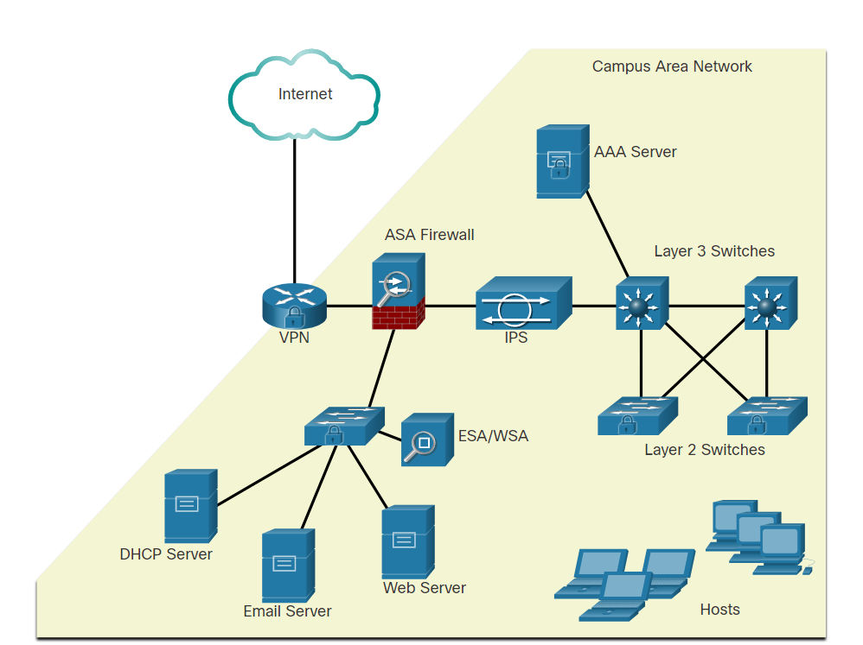

| **Term** | **Definition** |
| --- | --- |
| **VPN** | The Cisco ISR is secured. It protects data in motion that is flowing from the CAN to the outside world by establishing Virtual Private Networks (VPNs). VPNs ensure data confidentiality and integrity from authenticated sources. |
| **ASA Firewall** | A Cisco Adaptive Security Appliance (ASA) firewall performs stateful packet filtering to filter return traffic from the outside network into the campus network. |
| **IPS** | A Cisco Intrusion Prevention System (IPS) device continuously monitors incoming and outgoing network traffic for malicious activity. It logs information about the activity, and attempts to block and report it. |
| **Layer 3 Switches** | These distribution layer switches are secured and provide secure redundant trunk connections to the Layer 2 switches. Several different security features can be implemented, such as ACLs, DHCP snooping, Dynamic ARP Inspection (DAI), and IP source guard. |
| **Layer 2 Switches** | These access layer switches are secured and connect user-facing ports to the network. Several different security features can be implemented, such as port security, DHCP snooping, and 802.1X user authentication. |
| **ESA/WSA** | A Cisco Email Security Appliance (ESA) and Web Security Appliance (WSA) provide advanced threat defense, application visibility and control, reporting, and secure mobility to secure and control email and web traffic. |
| **AAA Server** | An authentication, authorization, and accounting (AAA) server authenticates users, authorizes what they are allowed to do, and tracks what they are doing. |
| **Hosts** | End points are secured using various features including antivirus and antimalware software, Host Intrusion Protection System features, and 802.1X authentication features. |

### 1.2.2. Small Office and Home Office Networks

It is important that all types of networks, regardless of size, are protected. Attackers are also interested in home networks and small office and home office (SOHO) networks. They may want to use someone's internet connection for free, use the internet connection for illegal activity, or view financial transactions, such as online purchases.

Home and SOHO networks are typically protected using a consumer grade router. These routers provide basic security features that adequately protect inside assets from outside attackers.

The figure displays a sample SOHO that uses a consumer-grade wireless router to secure it. A consumer-grade wireless router provides integrated firewall features and secure wireless connections. The Layer 2 Switch is an access layer switch that is hardened with various security measures. It connects user-facing ports that use port security to the SOHO network. Wireless hosts connect to the wireless network using Wireless Protected Access 2 (WPA2) data encryption technology. Hosts typically have antivirus and antimalware software installed. Combined, these security measures provide comprehensive defense at different layers of the network.

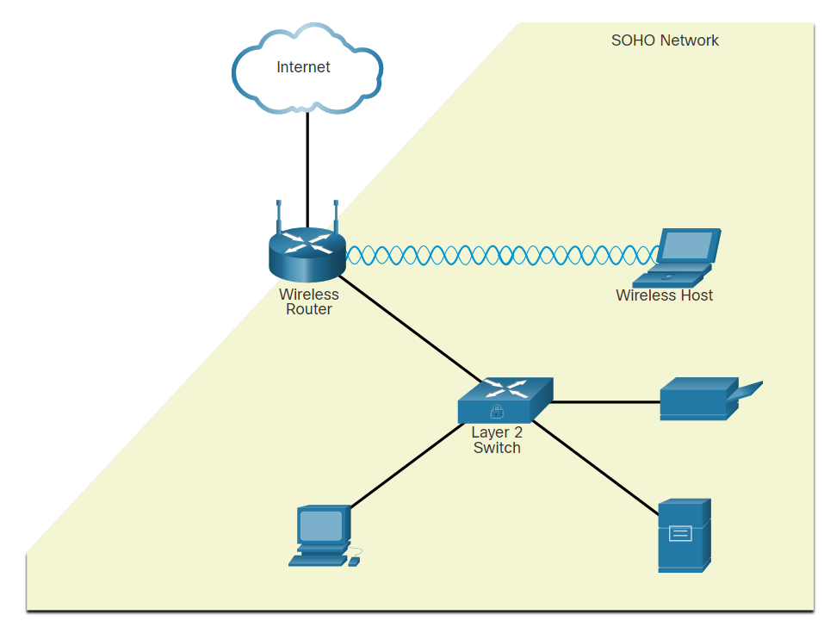

### 1.2.3. Wide Area Networks

Wide Area Networks (WANs), as shown in the figure, span a wide geographical area, often over the public internet. Organizations must ensure secure transport for the data in motion as it travels between sites over the public network.

Network security professionals must use secure devices on the edge of the networks. In the figure, the main site is protected by an ASA, which provides stateful firewall features and establishes secure VPN tunnels to various destinations.

The figure shows a Wide Area Network and ways to secure it.

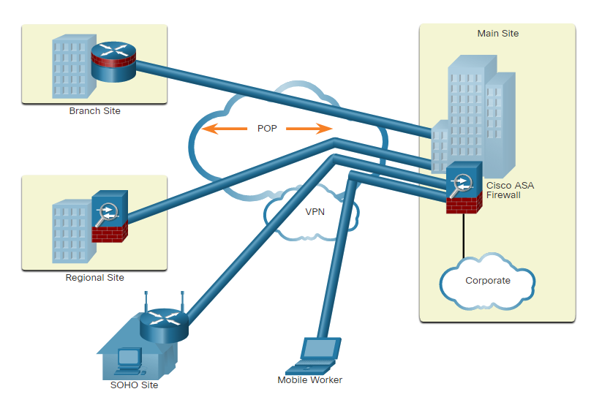

The figure shows a branch site, a regional site, a SOHO site, and a mobile worker. A branch site connects to the corporate main site using a hardened ISR. The ISR can establish a permanent always-on VPN connection to the main site ASA firewall. A regional site is larger than a branch site and connects to the corporate main site using an ASA. The ASA can establish a permanent always-on VPN connection to the main site ASA. A SOHO site is a small branch site that connects to the corporate main site using a Cisco wireless router. The wireless router can establish a permanent always-on VPN connection to the main site ASA. Alternatively, the internal SOHO users could use the Cisco AnyConnect VPN client to establish a secure VPN connection to the main site ASA. A mobile worker is a teleworker who may use the Cisco AnyConnect VPN client to establish a secure VPN connection to the main site ASA from any location.

### 1.2.4. Data Center Networks

Data center networks are typically housed in an off-site facility to store sensitive or proprietary data. These sites are connected to corporate sites using VPN technology with ASA devices and integrated data center switches, such as a high-speed Cisco Nexus switches.

Today’s data centers store vast quantities of sensitive, business-critical information. Therefore, physical security is critical to their operation. Physical security not only protects access to the facility but also protects people and equipment. For example, fire alarms, sprinklers, seismically-braced server racks, redundant heating, ventilation, and air conditioning (HVAC), and UPS systems are in place to protect people, equipment, and data.

As highlighted in the figure, data center physical security can be divided into two areas:

* **Outside perimeter security** - This can include on-premise security officers, fences, gates, continuous video surveillance, and security breach alarms.
* **Inside perimeter security** - This can include continuous video surveillance, electronic motion detectors, security traps, and biometric access and exit sensors.

#### Data Center Physical Security

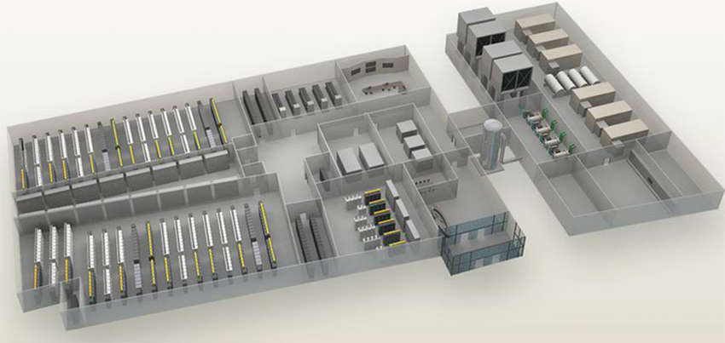

Security traps provide access to the data halls where data center data is stored. As shown in the figure below, a security trap is similar to an air lock. A person must first enter the security trap using their badge ID proximity card. After the person is inside the security trap, facial recognition, fingerprints, or other biometric verifications are used to open the second door. The user must repeat the process to exit the data hall.

The figure shows a data center with the roof removed to display the layout of the building. The security trap is highlighted.

#### Security Traps

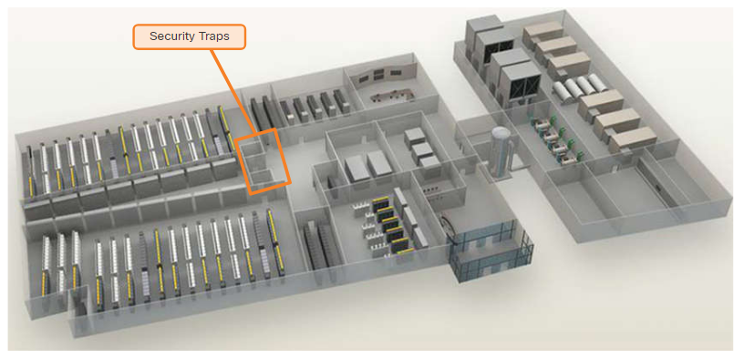

The figure below displays the biometric finger print scanner that is used to secure access to the Cisco Allen Data Center, in Allen, Texas.

#### Biometric Access

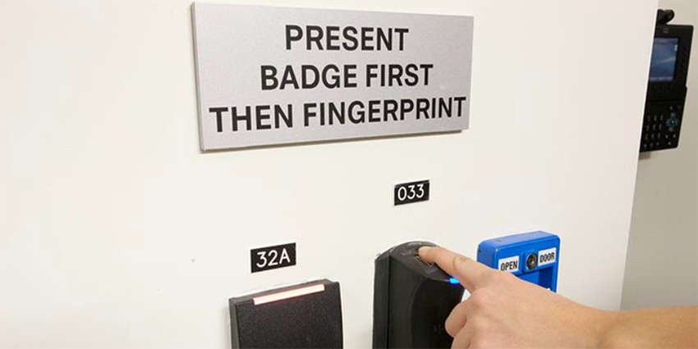

### 1.2.5. Cloud Networks and Virtualization

The cloud is playing an increasing role in enterprise networks. Cloud computing allows organizations to use services such as data storage or cloud-based applications, to extend their capacity or capabilities without adding infrastructure. By its very nature, the cloud is outside of the traditional network perimeter, allowing an organization to have a data center that may or may not reside behind the traditional firewall.

The terms “cloud computing” and “virtualization” are often used interchangeably; however, they mean different things. Virtualization is the foundation of cloud computing. Without it, cloud computing, as it is most-widely implemented, would not be possible. Cloud computing separates the application from the hardware. Virtualization separates the operating system from the hardware.

The cloud network consists of physical and virtual servers which are commonly housed in data centers. However, data centers are increasingly using virtual machines (VM) to provide server services to their clients. Server virtualization takes advantage of idle computing resources and consolidates the number of required servers. This also allows for multiple operating systems to exist on a single hardware platform. However, VMs are also prone to specific targeted attacks as listed below.

* **Hyperjacking** -An attacker could hijack a VM hypervisor (VM controlling software) and then use it as a launch point to attack other devices on the data center network.
* **Instant On Activation** - When a VM that has not been used for a period of time is brought online, it may have outdated security policies that deviate from the baseline security and can introduce security vulnerabilities.
* **Antivirus Storms** - This happens when all VMs attempt to download antivirus data files at the same time.

For security teams, an easy to implement yet comprehensive strategy that addresses business demands and defends the data center is a necessity. Cisco developed the Secure Data Center solution to operate in this unpredictable threat landscape. The Cisco Secure Data Center solution blocks internal and external threats at the data center edge.

The core components of the Cisco Secure Data Center solution provide the following services:

* **Secure Segmentation** - ASA devices and a Virtual Security Gateway integrated into the Cisco Nexus Series switches are deployed in a data center network to provide secure segmentation. This provides granular inter-virtual-machine security.
* **Threat Defense** - ASAs and IPS devices in data center networks use threat intelligence, passive OS fingerprinting, and reputation and contextual analysis to provide threat defense.
* **Visibility** - Visibility solutions are provided using software such as the Cisco Security Manager which help simplify operations and compliance reporting.

### 1.2.6. The Evolving Network Border

In the past, employees and data resources remained within a predefined perimeter that was protected by firewall technology. Employees typically used company-issued computers connected to a corporate LAN that were continuously monitored and updated to meet security requirements.

Today, consumer endpoints, such as iPhones, smartphones, tablets, and thousands of other devices, are becoming powerful substitutes for, or complements to, the traditional PC. More and more people are using these devices to access enterprise information. This trend is known as Bring Your Own Device (BYOD).

To accommodate the BYOD trend, Cisco developed the Borderless Network. In a Borderless Network, access to resources can be initiated by users from many locations, on many types of endpoint devices, using various connectivity methods.

To support this blurred network edge, Cisco devices support Mobile Device Management (MDM) features. MDM features secure, monitor, and manage mobile devices, including corporate-owned devices and employee-owned devices. MDM-supported and managed devices include not only handheld devices, such as smartphones and tablets, but also laptop and desktop computing devices.

* **Data Encryption**: Most devices have built-in encryption capabilities, both at the device and file level. MDM features can ensure that only devices that support data encryption and have it enabled can access the network and corporate content.
* **PIN Enforcement**: Enforcing a PIN lock is the first and most effective step in preventing unauthorized access to a device. Furthermore, strong password policies can also be enforced by an MDM, reducing the likelihood of brute-force attacks.
* **Data Wipe**: Lost or stolen devices can be remotely fully- or partially-wiped, either by the user or by an administrator via the MDM.
* **Data Loss Prevention (DLP)**: While data protection functions (like PIN locking, data encryption and remote data wiping) prevent unauthorized users from accessing data, DLP prevents authorized users from doing careless or malicious things with critical data.
* **Jailbreak/Root Detection**: Jailbreaking (on Apple iOS devices) and rooting (on Android devices) are a means to bypass the management of a device. MDM features can detect such bypasses and immediately restrict a device’s access to the network or other corporate assets.

## 1.3) What Did I Learn in this Module?

**Current State of Affairs**  
Network security relates directly to an organization's business continuity. Network security breaches can disrupt e-commerce, cause the loss of business data, threaten people’s privacy, and compromise the integrity of information. These breaches can result in lost revenue for corporations, theft of intellectual property, lawsuits, and can even threaten public safety. Many tools are available to help network administrators adapt, develop, and implement threat mitigation techniques, including the Cisco Talos Intelligence Group. An attack vector is a path by which a threat actor can gain access to a server, host, or network. Attack vectors originate from inside or outside the corporate network. Data is likely to be an organization’s most valuable asset. Various DLP controls must be implemented, that combine strategic, operational, and tactical measures. Common data loss vectors include email and social networking, unencrypted data devices, cloud storage devices, removable media, hard copy, and improper access control.

**Network Topology Overview**  
There are many types of networks. CANs consist of interconnected LANS within a limited geographical area. Elements of the defense-in-depth design include VPN, ASA firewall, IPS, Layer 3 switches, layer 2 switches, ESA/WSA, AAA server, and hosts. SOHO networks are typically protected using consumer grade routers that provide integrated firewall features and secure wireless connections. Wireless hosts connect to the wireless network using WPA2 data encryption technology. WANs span a wide geographical area. Network security professionals must use secure devices on the edge of the network. Data center networks are typically housed in an off-site facility to store sensitive or proprietary data. Data center physical security is divided into two areas: outside perimeter security and inside perimeter security. Security traps require a person to use their badge ID to enter the first area. After the person is inside the security trap, facial recognition, fingerprints, or other biometric verifications are used to open the second door. Cloud computing allows organizations to use services such as data storage or cloud-based applications, to extend their capacity or capabilities without adding infrastructure. The actual cloud network consists of physical and virtual servers which are commonly housed in data centers. However, data centers are increasingly using VMs to provide server services to their clients. VMs are also prone to specific targeted attacks including hyperjacking, instant on activation, and antivirus storms. The Cisco Secure Data Center solution blocks internal and external threats at the data center edge. The core components of the Cisco Secure Data Center solution provide secure segmentation, threat defense, and visibility. More and more people are using these devices to access enterprise information. This trend is known as BYOD. To accommodate the BYOD trend, Cisco developed the Borderless Network. In a Borderless Network, access to resources can be initiated by users from many locations, on many types of endpoint devices, using various connectivity methods. To support this blurred network edge, Cisco devices support MDM features.

# 2. Network Threats

## 2.0) Introduction

### 2.0.1. Why Should I Take this Module?

Who is attacking our network and why? In this module you will learn about the various threat actors. You will also learn about the techniques and tools used by these “hackers”. Keep reading to learn more!

### 2.0.2. What Will I Learn in this Module?

**Module Title:** Network Threats

**Module Objective**: Explain the various types of threats and attacks.

| **Topic Title** | **Topic Objective** |
| --- | --- |
| **Who is Attacking Our Network?** | Explain how network threats have evolved. |
| **Threat Actor Tools** | Describe the various types of attack tools used by Threat Actors. |
| **Malware** | Describe types of malware. |
| **Common Network Attacks - Reconnaissance, Access, and Social Engineering** | Explain reconnaissance, access, and social engineering network attacks. |
| **Network Attacks - Denial of Service, Buffer Overflows, and Evasion** | Explain Denial of Service, buffer overflow, and evasion attacks. |

## 2.1) Who is Attacking out Network?

### 2.1.1. Threat, Vulnerability, and Risk

We are under attack and attackers want access to our assets. Assets are anything of value to an organization, such as data and other intellectual property, servers, computers, smart phones, tablets, and more.

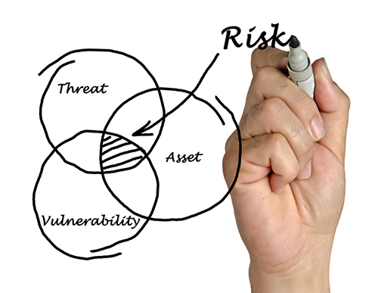

To better understand any discussion of network security, it is important to know the following terms:

| **Term** | **Explanation** |
| --- | --- |
| **Threat** | A potential danger to an asset such as data or the network itself. |
| **Vulnerability** | A weakness in a system or its design that could be exploited by a threat. |
| **Attack surface** | An attack surface is the total sum of the vulnerabilities in a given system that are accessible to an attacker. The attack surface describes different points where an attacker could get into a system, and where they could get data out of the system. For example, your operating system and web browser could both need security patches. They are each vulnerable to attacks and are exposed on the network or the internet. Together, they create an attack surface that the threat actor can exploit. |
| **Exploit** | The mechanism that is used to leverage a vulnerability to compromise an asset. Exploits may be remote or local. A remote exploit is one that works over the network without any prior access to the target system. The attacker does not need an account in the end system to exploit the vulnerability. In a local exploit, the threat actor has some type of user or administrative access to the end system. A local exploit does not necessarily mean that the attacker has physical access to the end system. |
| **Risk** | The likelihood that a particular threat will exploit a particular vulnerability of an asset and result in an undesirable consequence. |

Risk management is the process that balances the operational costs of providing protective measures with the gains achieved by protecting the asset. There are four common ways to manage risk, as shown in the table:

| **Risk Management Strategy** | **Explanation** |
| --- | --- |
| **Risk acceptance** | This is when the cost of risk management options outweighs the cost of the risk itself. The risk is accepted, and no action is taken. |
| **Risk avoidance** | This means avoiding any exposure to the risk by eliminating the activity or device that presents the risk. By eliminating an activity to avoid risk, any benefits that are possible from the activity are also lost. |
| **Risk reduction** | This reduces exposure to risk or reducing the impact of risk by taking action to decrease the risk. It is the most commonly used risk mitigation strategy. This strategy requires careful evaluation of the costs of loss, the mitigation strategy, and the benefits gained from the operation or activity that is at risk. |
| **Risk transfer** | Some or all of the risk is transferred to a willing third party such as an insurance company. |

Other commonly used network security terms include:

* **Countermeasure** - The actions that are taken to protect assets by mitigating a threat or reducing risk.
* **Impact** - The potential damage to the organization that is caused by the threat.

**Note:** A local exploit requires inside network access such as a user with an account on the network. A remote exploit does not require an account on the network to exploit that network’s vulnerability.

### 2.1.2. Hacker vs. Threat Actor

As we know, “hacker” is a common term used to describe a threat actor. However, the term “hacker” has a variety of meanings, as follows:

* A clever programmer capable of developing new programs and coding changes to existing programs to make them more efficient.
* A network professional that uses sophisticated programming skills to ensure that networks are not vulnerable to attack.
* A person who tries to gain unauthorized access to devices on the internet.
* An individual who run programs to prevent or slow network access to a large number of users, or corrupt or wipe out data on servers.

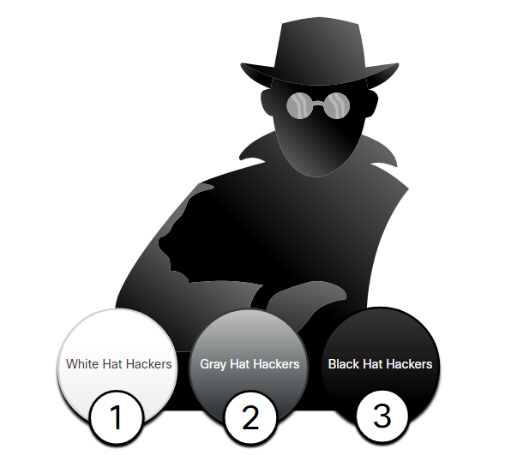

As shown in the figure, the terms white hat hacker, black hat hacker, and grey hat hacker are often used to describe hackers.

1. ***White hat hackers*** are ethical hackers who use their programming skills for good, ethical, and legal purposes. They may perform network penetration tests in an attempt to compromise networks and systems by using their knowledge of computer security systems to discover network vulnerabilities. Security vulnerabilities are reported to developers and security personnel who attempt to fix the vulnerability before it can be exploited. Some organizations award prizes or bounties to white hat hackers when they provide information that helps to identify vulnerabilities.
2. ***Grey hat hackers*** are individuals who commit crimes and do arguably unethical things, but not for personal gain or to cause damage. An example would be someone who compromises a network without permission and then discloses the vulnerability publicly. Grey hat hackers may disclose a vulnerability to the affected organization after having compromised their network. This allows the organization to fix the problem.
3. ***Black hat hackers*** are unethical criminals who violate computer and network security for personal gain, or for malicious reasons, such as attacking networks. Black hat hackers exploit vulnerabilities to compromise computer and network systems.

Good or bad, hacking is an important aspect of network security. In this course, the term threat actor is used when referring to those individuals or groups that could be classified as gray or black hat hackers.

### 2.1.3. Evolution of Threat Actors

Hacking started in the 1960s with phone freaking, or phreaking, which refers to using various audio frequencies to manipulate phone systems. At that time, telephone switches used various tones, or tone dialing, to indicate different functions. Early threat actors realized that by mimicking a tone using a whistle, they could exploit the phone switches to make free long-distance calls.

In the mid-1980s, computer dial-up modems were used to connect computers to networks. Threat actors wrote “war dialing” programs which dialed each telephone number in a given area in search of computers, bulletin board systems, and fax machines. When a phone number was found, password-cracking programs were used to gain access. Since then, general threat actor profiles and motives have changed quite a bit.

There are many different types of threat actors:

* **Script kiddies:** Script kiddies emerged in the 1990s and refers to teenagers or inexperienced threat actors running existing scripts, tools, and exploits, to cause harm, but typically not for profit.
* **Vulnerability brokers:** Vulnerability brokers typically refers to grey hat hackers who attempt to discover exploits and report them to vendors, sometimes for prizes or rewards.
* **Hacktivists:** Hacktivists is a term that refers to grey hat hackers who rally and protest against different political and social ideas. Hacktivists publicly protest against organizations or governments by posting articles, videos, leaking sensitive information, and performing distributed denial of service (DDoS) attacks.
* **Cybercriminals:** Cybercriminal is a term for black hat hackers who are either self-employed or working for large cybercrime organizations. Each year, cyber criminals are responsible for stealing billions of dollars from consumers and businesses.
* **State-sponsored**: State-Sponsored hackers are threat actors who steal government secrets, gather intelligence, and sabotage networks of foreign governments, terrorist groups, and corporations. Most countries in the world participate to some degree in state-sponsored hacking. Depending on a person’s perspective, these are either white hat or black hat hackers.

### 2.1.4. Cybercriminals

Cybercriminals are threat actors who are motivated to make money using any means necessary. While sometimes cybercriminals work independently, they are more often financed and sponsored by criminal organizations. It is estimated that globally, cybercriminals steal billions of dollars from consumers and businesses every year.

Cybercriminals operate in an underground economy where they buy, sell, and trade exploits and tools. They also buy and sell the personal information and intellectual property that they steal from victims. Cybercriminals target small businesses and consumers, as well as large enterprises and industries.

### 2.1.5. Cybersecurity Tasks

Threat actors do not discriminate. They target the vulnerable end devices of home users and small-to-medium sized businesses, as well as large public and private organizations.

To make the internet and networks safer and more secure, we must all develop good cybersecurity awareness. Cybersecurity is a shared responsibility which all users must practice. For example, we must report cybercrime to the appropriate authorities, be aware of potential threats in email and the web, and guard important information from theft.

Organizations must take action and protect their assets, users, and customers. They must develop and practice cybersecurity tasks such as those listed in the figure.

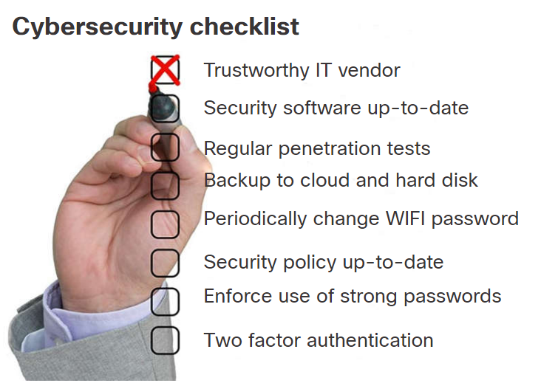

### 2.1.6. Cyber Threat Indicators

Many network attacks can be prevented by sharing information about **indicators of compromise** (IOC). Each attack has unique identifiable attributes. Indicators of compromise are the evidence that an attack has occurred. IOCs can be features that identify malware files, IP addresses of servers that are used in attacks, filenames, and characteristic changes made to end system software, among others. IOCs help cybersecurity personnel identify what has happened in an attack and develop defenses against the attack. A summary of the IOC for a piece of malware is shown in the figure.

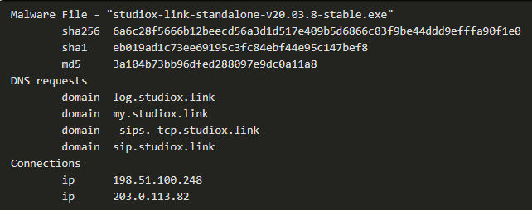

For instance, a user receives an email claiming they have won a big prize. Clicking on the link in the email results in an attack. The IOC could include the fact the user did not enter that contest, the IP address of the sender, the email subject line, the URL to click, or an attachment to download, among others.

**Indicators of attack** (IOA) focus more on the motivation behind an attack and the potential means by which threat actors have, or will, compromise vulnerabilities to gain access to assets. IOAs are concerned with the strategies that are used by attackers. For this reason, rather than informing response to a single threat, IOAs can help generate a proactive security approach. This is because strategies can be reused in multiple contexts and multiple attacks. Defending against a strategy can therefore prevent future attacks that utilize the same, or similar strategy.

### 2.1.7. Threat Sharing and Building Cybersecurity Awareness

Governments are now actively promoting cybersecurity. For instance, the US Cybersecurity Infrastructure and Security Agency (CISA) is leading efforts to automate the sharing of cybersecurity information with public and private organizations at no cost. CISA uses a system called Automated Indicator Sharing (AIS). AIS enables the sharing of attack indicators between the US government and the private sector as soon as threats are verified. CISA offers many resources that help to limit the size of the United States attack surface.

The CISA and the National Cyber Security Alliance (NCSA) promote cybersecurity to all users. For example, they have an annual campaign in every October called “National Cybersecurity Awareness Month” (NCASM). This campaign was developed to promote and raise awareness about cybersecurity.

The theme for the NCASM for 2019 was “**Own IT. Secure IT. Protect IT.**” This campaign encouraged all citizens to be safer and more personally accountable for using security best practices online. The campaign provides material on a wide variety of security topics including:

* Social media safety
* Updating privacy settings
* Awareness of device app security
* Keeping software up-to-date
* Safe online shopping
* Wi-Fi safety
* Protecting customer data

The European Union Agency for Cybersecurity (ENISA) delivers advice and solutions for the cybersecurity challenges of the EU member states. ENISA fills a role in Europe that is similar to the role of CISA in the US.

## 2.2) Threat Actor Tools

### 2.2.1. Introduction of Attack Tools

To exploit a vulnerability, a threat actor must have a technique or tool. Over the years, attack tools have become more sophisticated, and highly automated. These new tools require less technical knowledge to implement.

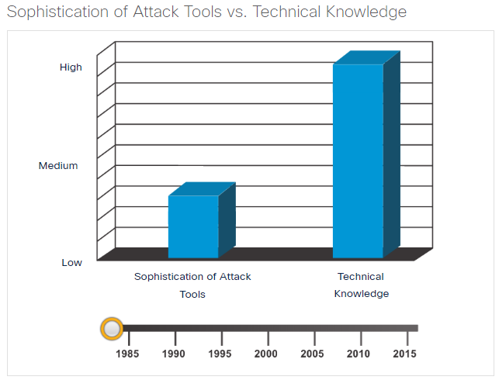 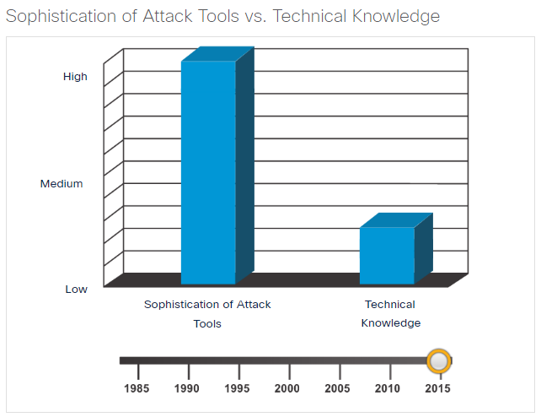

### 2.2.2. Evolution of Security Tools

Ethical hacking involves using many different types of tools to test the network and end devices. To validate the security of a network and its systems, many network penetration testing tools have been developed. However, many of these tools can also be used by threat actors for exploitation.

Threat actors have also created various hacking tools. These tools are explicitly written for nefarious reasons. Cybersecurity personnel must also know how to use these tools when performing network penetration tests.

Explore the categories of common network penetration testing tools. Notice how some tools are used by white hats and black hats. Keep in mind that the list is not exhaustive as new tools are continually being developed.

**Note**: Many of these tools are UNIX or Linux based; therefore, a security professional should have a strong UNIX and Linux background.

| **Categories of Tools** | **Description** |
| --- | --- |
| password crackers | Passwords are the most vulnerable security threat. Password cracking tools are often referred to as password recovery tools and can be used to crack or recover the password. This is accomplished either by removing the original password, after bypassing the data encryption, or by outright discovery of the password. Password crackers repeatedly make guesses in order to crack the password and access the system. Examples of password cracking tools include John the Ripper, Ophcrack, L0phtCrack, THC Hydra, RainbowCrack, and Medusa. |
| wireless hacking tools | Wireless networks are more susceptible to network security threats. Wireless hacking tools are used to intentionally hack into a wireless network to detect security vulnerabilities. Examples of wireless hacking tools include Aircrack-ng, Kismet, InSSIDer, KisMAC, Firesheep, and NetStumbler. |
| network scanning and hacking tools | Network scanning tools are used to probe network devices, servers, and hosts for open TCP or UDP ports. Examples of scanning tools include Nmap, SuperScan, Angry IP Scanner, and NetScanTools. |
| packet crafting tools | Packet crafting tools are used to probe and test a firewall’s robustness using specially crafted forged packets. Examples of such tools include Hping, Scapy, Socat, Yersinia, Netcat, Nping, and Nemesis. |
| packet sniffers | Packet sniffers tools are used to capture and analyze packets within traditional Ethernet LANs or WLANs. Tools include Wireshark, Tcpdump, Ettercap, Dsniff, EtherApe, Paros, Fiddler, Ratproxy, and SSLstrip. |
| rootkit detectors | A rootkit detector is a directory and file integrity checker used by white hats to detect installed root kits. Example tools include AIDE, Netfilter, and PF: OpenBSD Packet Filter. |
| fuzzers to search vulnerabilities | Fuzzers are tools used by threat actors when attempting to discover a computer system’s security vulnerabilities. Examples of fuzzers include Skipfish, Wapiti, and W3af. |
| forensic tools | White hat hackers use forensic tools to sniff out any trace of evidence existing in a particular computer system. Example of tools include Sleuth Kit, Helix, Maltego, and Encase. |
| debuggers | Debugger tools are used by black hats to reverse engineer binary files when writing exploits. They are also used by white hats when analyzing malware. Debugging tools include GDB, WinDbg, IDA Pro, and Immunity Debugger. |
| hacking operating systems | Hacking operating systems are specially designed operating systems preloaded with tools and technologies optimized for hacking. Examples of specially designed hacking operating systems include Kali Linux, SELinux, Knoppix, Parrot OS, and BackBox Linux. |
| encryption tools | These tools safeguard the contents of an organization’s data when it is stored or transmitted. Encryption tools use algorithm schemes to encode the data to prevent unauthorized access to the data. Examples of these tools include VeraCrypt, CipherShed, Open SSH, OpenSSL, OpenVPN, and Stunnel. |
| vulnerability exploitation tools | These tools identify whether a remote host is vulnerable to a security attack. Examples of vulnerability exploitation tools include Metasploit, Core Impact, Sqlmap, Social Engineer Tool Kit, and Netsparker. |
| vulnerability scanners | These tools scan a network or system to identify open ports. They can also be used to scan for known vulnerabilities and scan VMs, BYOD devices, and client databases. Examples of these tools include Nipper, Securia PSI, Core Impact, Nessus, SAINT, and Open VAS. |

### 2.2.3. Categories of Attacks

Threat actors can use the previously mentioned tools or a combination of tools to create various attacks. The table displays common types of attacks. However, the list of attacks is not exhaustive as new ways to attack networks are continually being discovered.

It is important to understand that threat actors use a variety of security tools to carry out these attacks.

| **Category of Attack** | **Description** |
| --- | --- |
| eavesdropping attack | An eavesdropping attack is when a threat actor captures and listens to network traffic. This attack is also referred to as sniffing or snooping. |
| data modification attack | Data modification attacks occur when a threat actor has captured enterprise traffic and has altered the data in the packets without the knowledge of the sender or receiver. |
| IP address spoofing attack | An IP address spoofing attack is when a threat actor constructs an IP packet that appears to originate from a valid address inside the corporate intranet. |
| password-based attacks | Password-based attacks occur when a threat actor obtains the credentials for a valid user account. Threat actors then use that account to obtain lists of other users and network information. They could also change server and network configurations, and modify, reroute, or delete data. |
| denial-of-service (DoS) attack | A DoS attack prevents normal use of a computer or network by valid users. After gaining access to a network, a DoS attack can crash applications or network services. A DoS attack can also flood a computer or the entire network with traffic until a shutdown occurs because of the overload. A DoS attack can also block traffic, which results in a loss of access to network resources by authorized users. |
| man-in-the-middle attack (MiTM) | A MiTM attack occurs when threat actors have positioned themselves between a source and destination. They can now actively monitor, capture, and control the communication transparently. |
| compromised key attack | A compromised-key attack occurs when a threat actor obtains a secret key. This is referred to as a compromised key. A compromised key can be used to gain access to a secured communication without the sender or receiver being aware of the attack. |
| sniffer attack | A sniffer is an application or device that can read, monitor, and capture network data exchanges and read network packets. If the packets are not encrypted, a sniffer provides a full view of the data inside the packet. Even encapsulated (tunneled) packets can be broken open and read unless they are encrypted and the threat actor does not have access to the key. |

## 2.3) Types of Malware

End devices are especially prone to malware attacks. Therefore, the focus of this topic is on threats to end devices. Malware is short for malicious software or malicious code. It is code or software that is specifically designed to damage, disrupt, steal, or generally inflict some other “bad” or illegitimate action on data, hosts, or networks. It is important to know about malware because threat actors and online criminals frequently try to trick users into installing malware to help exploit security gaps. In addition, malware morphs so rapidly that malware-related security incidents are extremely common because antimalware software cannot be updated quickly enough to stop the new threats.

### 2.3.1. Viruses

A virus is a type of malware that spreads by inserting a copy of itself into another program. After the program is run, viruses then spread from one computer to another, infecting the computers. Most viruses require human help to spread. For example, when someone connects an infected USB drive to their PC, the virus will enter the PC. The virus may then infect a new USB drive, and spread to new PCs. Viruses can lay dormant for an extended period and then activate at a specific time and date.

A simple virus may install itself at the first line of code in an executable file. When activated, the virus might check the disk for other executables so that it can infect all the files it has not yet infected. Viruses can be harmless, such as those that display a picture on the screen, or they can be destructive, such as those that modify or delete files on the hard drive. Viruses can also be programmed to mutate to avoid detection.

Most viruses are now spread by USB memory drives, CDs, DVDs, network shares, and email. Email viruses are a common type of virus.

### 2.3.2. Trojan Horses

The term Trojan horse originated from Greek mythology. Greek warriors offered the people of Troy (the Trojans) a giant hollow horse as a gift. The Trojans brought the giant horse into their walled city, unaware that it contained many Greek warriors. At night, after most Trojans were asleep, the warriors burst out of the horse, opened the city gates, and allowed a sizeable force to enter and take over the city.

Trojan horse malware is software that appears to be legitimate, but it contains malicious code which exploits the privileges of the user that runs it, as shown in the figure.

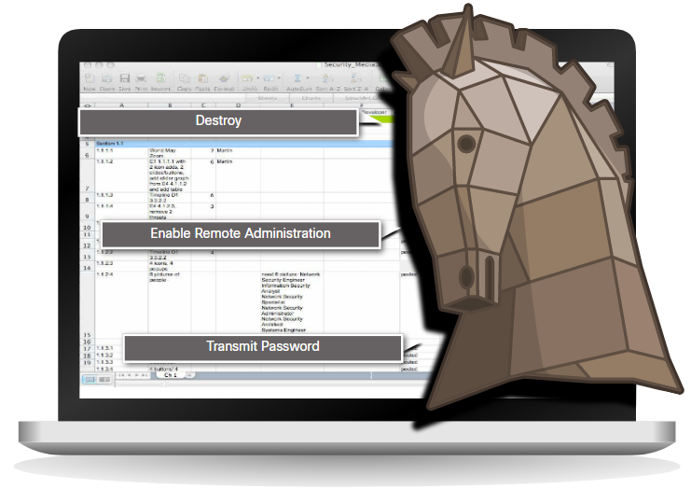

Often, Trojans are found attached to online games. Users are commonly tricked into loading and executing the Trojan horse on their systems. While playing the game, the user will not notice a problem. In the background, the Trojan horse has been installed on the user’s system. The malicious code from the Trojan horse continues operating even after the game has been closed.

The Trojan horse concept is flexible. It can cause immediate damage, provide remote access to the system, or access through a back door. It can also perform actions as instructed remotely, such as "send me the password file once per week." This tendency of malware to send data back to the cybercriminal highlights the need to monitor outbound traffic for attack indicators.

Custom-written Trojan horses, such as those with a specific target, are difficult to detect.

Trojan horses are usually classified according to the damage that they cause, or the manner in which they breach a system, as shown in the table.

| **Type of Trojan Horse** | **Description** |
| --- | --- |
| Remote-access | Enables unauthorized remote access. |
| Data-sending | Provides the threat actor with sensitive data, such as passwords. |
| Destructive | Corrupts or deletes files. |
| Proxy | Uses the victim's computer as the source device to launch attacks and perform other illegal activities. |
| FTP | Enables unauthorized file transfer services on end devices. |
| Security software disabler | Stops antivirus programs or firewalls from functioning. |
| Denial of Service (DoS) | Slows or halts network activity. |
| Keylogger | Actively attempts to steal confidential information, such as credit card numbers, by recording keystrokes entered into a web form. |

### 2.3.3. Worms

Computer worms are similar to viruses because they replicate and can cause the same type of damage. Specifically, worms replicate themselves by independently exploiting vulnerabilities in networks. Worms can slow down networks as they spread from system to system.

Whereas a virus requires a host program to run, worms can run by themselves. Other than the initial infection, they no longer require user participation. After a host is infected, the worm is able to spread very quickly over the network.

Worms are responsible for some of the most devastating attacks on the internet. In 2001, the Code Red worm had initially infected 658 servers. Within 19 hours, the worm had infected over 300,000 servers.

The initial infection of the SQL Slammer worm is known as the worm that ate the internet. SQL Slammer was a denial of service (DoS) attack that exploited a buffer overflow bug in Microsoft’s SQL Server. At its peak, the number of infected servers doubled in size every 8.5 seconds. This is why it was able to infect 250,000+ hosts within 30 minutes. When it was released on the weekend of January 25, 2003, it disrupted the internet, financial institutions, ATM cash machines, and more. Ironically, a patch for this vulnerability had been released 6 months earlier. The infected servers did not have the updated patch applied. This was a wake-up call for many organizations to implement a security policy requiring that updates and patches be applied in a timely fashion.

Worms share similar characteristics. They all exploit an enabling vulnerability, have a way to propagate themselves, and they all contain a payload.

Despite the mitigation techniques that have emerged over the years, worms have continued to evolve and pose a persistent threat. Worms have become more sophisticated over time, but they still tend to be based on exploiting weaknesses in software applications.

Most worm attacks consist of three components, as listed in the animation above.

* **Enabling vulnerability** - A worm installs itself using an exploit mechanism, such as an email attachment, an executable file, or a Trojan horse, on a vulnerable system.
* **Propagation mechanism** - After gaining access to a device, the worm replicates itself and locates new targets.
* **Payload** - Any malicious code that results in some action is a payload. Most often this is used to create a backdoor that allows a threat actor access to the infected host or to create a DoS attack.

Worms are self-contained programs that attack a system to exploit a known vulnerability. Upon successful exploitation, the worm copies itself from the attacking host to the newly exploited system and the cycle begins again. Their propagation mechanisms are commonly deployed in a way that is difficult to detect.

The propagation technique used by the Code Red worm is shown in the figure.

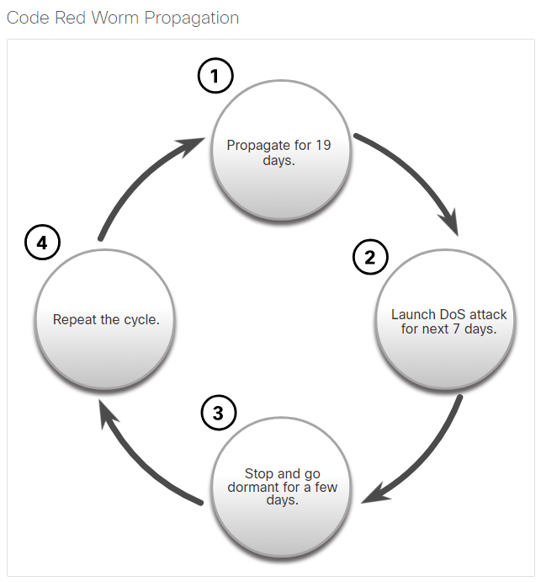

**Note**: Worms never really stop spreading on the internet. After they are released, worms continue to propagate until all possible sources of infection are properly patched.

### 2.3.4. Ransomware

Threat actors have used viruses, worms, and Trojan horses to carry their payloads and for other malicious reasons. However, malware continues to evolve.

Currently, the most dominating malware is ransomware. Ransomware is malware that denies access to the infected computer system or its data. The cybercriminals then demand payment to release the computer system.

Ransomware has evolved to become the most profitable malware type in history. In the first half of 2016, ransomware campaigns targeting both individual and enterprise users became more widespread and potent.

There are dozens of ransomware variants. Ransomware frequently uses an encryption algorithm to encrypt system files and data. The majority of known ransomware encryption algorithms cannot be easily decrypted, leaving victims with little option but to pay the asking price. Payments are typically paid in Bitcoin because users of bitcoin can remain anonymous. Bitcoin is an open-source, digital currency that nobody owns or controls.

Email and malicious advertising, also known as malvertising, are vectors for ransomware campaigns. Social engineering is also used, as when cybercriminals who identify themselves as security technicians call homes and persuade users to connect to a website that downloads the ransomware to the user’s computer.

### 2.3.5. Other Malware

These are some examples of the varieties of modern malware:

| **Type of Malware** | **Description** |
| --- | --- |
| Spyware | Used to gather information about a user and send the information to another entity without the user’s consent. Spyware can be a system monitor, Trojan horse, Adware, tracking cookies, and key loggers. |
| Adware | Displays annoying pop-ups to generate revenue for its author. The malware may analyze user interests by tracking the websites visited. It can then send pop-up advertising pertinent to those sites. |
| Scareware | Includes scam software which uses social engineering to shock or induce anxiety by creating the perception of a threat. It is generally directed at an unsuspecting user and attempts to persuade the user to infect a computer by taking action to address the bogus threat. |
| Phishing | Attempts to convince people to divulge sensitive information. Examples include receiving an email from their bank asking users to divulge their account and PIN numbers. |
| Rootkits | Installed on a compromised system. After it is installed, it continues to hide its intrusion and provide privileged access to the threat actor. |

This list will continue to grow as the internet evolves. New malware will always be developed. A major goal of cybersecurity operations is to learn about new malware and how to promptly mitigate it.

### 2.3.6. Common Malware Behaviors

Cybercriminals continually modify malware code to change how it spreads and infects computers. However, most produce similar symptoms that can be detected through network and device log monitoring.

Computers infected with malware often exhibit one or more of the following symptoms:

* Appearance of strange files, programs, or desktop icons
* Antivirus and firewall programs are turning off or reconfiguring settings
* Computer screen is freezing or system is crashing
* Emails are spontaneously being sent without your knowledge to your contact list
* Files have been modified or deleted
* Increased CPU and/or memory usage
* Problems connecting to networks
* Slow computer or web browser speeds
* Unknown processes or services running
* Unknown TCP or UDP ports open
* Connections are made to hosts on the Internet without user action
* Strange computer behavior

**Note:** Malware behavior is not limited to the above list.

## 2.4) Network Attacks

Malware is a means to get a payload delivered. When it is delivered and installed, the payload can be used to cause a variety of network-related attacks from the inside. Threat actors can also attack the network from outside.

Why do threat actors attack networks? There are many motives including money, greed, revenge, or political, religious, or sociological beliefs. Network security professionals must understand the types of attacks used to counter these threats to ensure the security of the LAN.

To mitigate attacks, it is useful to first categorize the various types of attacks. By categorizing network attacks, it is possible to address types of attacks rather than individual attacks.

Although there is no standardized way of categorizing network attacks, the method used in this course classifies attacks in three major categories.

* Reconnaissance Attacks
* Access Attacks
* DoS Attacks

### 2.4.1. Reconnaissance Attacks

Reconnaissance is information gathering. It is analogous to a thief surveying a neighborhood by going door-to-door pretending to sell something. What the thief is actually doing is looking for vulnerable homes to break into, such as unoccupied residences, residences with easy-to-open doors or windows, and those residences without security systems or security cameras.

Threat actors use reconnaissance (or recon) attacks to do unauthorized discovery and mapping of systems, services, or vulnerabilities. Recon attacks precede access attacks or DoS attacks.

Some of the techniques used by malicious threat actors to conduct reconnaissance attacks are described in the table.

| **Technique** | **Description** |
| --- | --- |
| **Perform an information query of a target** | The threat actor is looking for initial information about a target. Various tools can be used, including the Google search, organizations website, whois, and more. |
| **Initiate a ping sweep of the target network** | The information query usually reveals the target’s network address. The threat actor can now initiate a ping sweep to determine which IP addresses are active. |
| **Initiate a port scan of active IP addresses** | This is used to determine which ports or services are available. Examples of port scanners include Nmap, SuperScan, Angry IP Scanner, and NetScanTools. |
| **Run vulnerability scanners** | This is to query the identified ports to determine the type and version of the application and operating system that is running on the host. Examples of tools include Nipper, Secuna PSI, Core Impact, Nessus v6, SAINT, and Open VAS. |
| **Run exploitation tools** | The threat actor now attempts to discover vulnerable services that can be exploited. A variety of vulnerability exploitation tools exist including Metasploit, Core Impact, Sqlmap, Social Engineer Toolkit, and Netsparker. |

### 2.4.2. Access Attacks

Access attacks exploit known vulnerabilities in authentication services, FTP services, and web services. The purpose of this type of attack is to gain entry to web accounts, confidential databases, and other sensitive information.

Threat actors use access attacks on network devices and computers to retrieve data, gain access, or to escalate access privileges to administrator status.

**Password Attacks**: In a password attack, the threat actor attempts to discover critical system passwords using various methods. Password attacks are very common and can be launched using a variety of password cracking tools.

**Spoofing Attacks**: In spoofing attacks, the threat actor device attempts to pose as another device by falsifying data. Common spoofing attacks include IP spoofing, MAC spoofing, and DHCP spoofing. These spoofing attacks will be discussed in more detail later in this module

Other Access attacks include:

* **Trust exploitations**: In a trust exploitation attack, a threat actor uses unauthorized privileges to gain access to a system, possibly compromising the target. Click Play in the figure to view an example of trust exploitation.
* **Port redirections**: In a port redirection attack, a threat actor uses a compromised system as a base for attacks against other targets. The example in the figure shows a threat actor using SSH (port 22) to connect to a compromised Host A. Host A is trusted by Host B and, therefore, the threat actor can use Telnet (port 23) to access it.
* **Man-in-the-middle attacks**: In a man-in-the-middle attack, the threat actor is positioned in between two legitimate entities in order to read or modify the data that passes between the two parties. The figure displays an example of a man-in-the-middle attack.
* **Buffer overflow attacks**: In a buffer overflow attack, the threat actor exploits the buffer memory and overwhelms it with unexpected values. This usually renders the system inoperable, creating a DoS attack. The figure shows that the threat actor is sending many packets to the victim in an attempt to overflow the victim’s buffer.

### 2.4.3. Social Engineering Attacks

Social engineering is an access attack that attempts to manipulate individuals into performing actions or divulging confidential information. Some social engineering techniques are performed in-person while others may use the telephone or internet.

Social engineers often rely on people’s willingness to be helpful. They also prey on people’s weaknesses. For example, a threat actor could call an authorized employee with an urgent problem that requires immediate network access. The threat actor could appeal to the employee’s vanity, invoke authority using name-dropping techniques, or appeal to the employee’s greed.

Information about social engineering techniques is shown in the table.

| **Social Engineering Attack** | **Description** |
| --- | --- |
| Pretexting | A threat actor pretends to need personal or financial data to confirm the identity of the recipient. |
| Phishing | A threat actor sends fraudulent email which is disguised as being from a legitimate, trusted source to trick the recipient into installing malware on their device, or to share personal or financial information. |
| Spear phishing | A threat actor creates a targeted phishing attack tailored for a specific individual or organization. |
| Spam | Also known as junk mail, this is unsolicited email which often contains harmful links, malware, or deceptive content. |
| Something for Something | Sometimes called “Quid pro quo”, this is when a threat actor requests personal information from a party in exchange for something such as a gift. |
| Baiting | A threat actor leaves a malware infected flash drive in a public location. A victim finds the drive and unsuspectingly inserts it into their laptop, unintentionally installing malware. |
| Impersonation | In this type of attack, a threat actor pretends to be someone else to gain the trust of a victim. |
| Tailgating | This is where a threat actor quickly follows an authorized person into a secure location to gain access to a secure area. |
| Shoulder surfing | This is where a threat actor inconspicuously looks over someone’s shoulder to steal their passwords or other information. |
| Dumpster diving | This is where a threat actor rummages through trash bins to discover confidential documents. |

The Social Engineer Toolkit (SET) was designed to help white hat hackers and other network security professionals create social engineering attacks to test their own networks. It is a set of menu-based tools that help launch social engineering attacks. The SET is for educational purposes only. It is freely available on the internet.

Enterprises must educate their users about the risks of social engineering, and develop strategies to validate identities over the phone, via email, or in person.

The figure shows recommended practices that should be followed by all users.

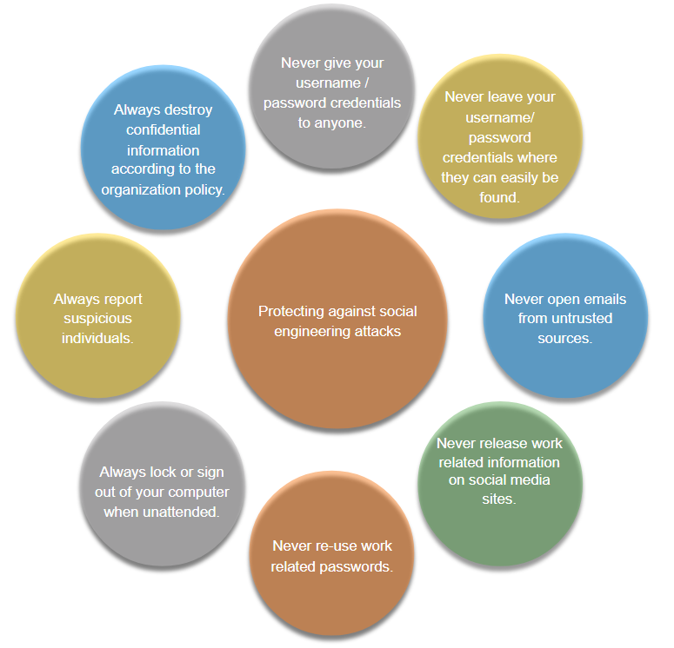

Cybersecurity is only as strong as its weakest link. Since computers and other internet-connected devices have become an essential part of our lives, they no longer seem new or different. People have become very casual in their use of these devices and rarely think about network security. The weakest link in cybersecurity can be the personnel within an organization, and social engineering a major security threat. Because of this, one of the most effective security measures that an organization can take is to train its personnel and create a “security-aware culture.”

### 2.4.4. DoS and DDoS Attacks

A Denial of Service (DoS) attack creates some sort of interruption of network services to users, devices, or applications. There are two major types of DoS attacks:

* **Overwhelming Quantity of Traffic** - The threat actor sends an enormous quantity of data at a rate that the network, host, or application cannot handle. This causes transmission and response times to slow down. It can also crash a device or service.
* **Maliciously Formatted Packets** - The threat actor sends a maliciously formatted packet to a host or application and the receiver is unable to handle it. This causes the receiving device to run very slowly or crash.

**DoS Attack**: DoS attacks are a major risk because they interrupt communication and cause significant loss of time and money. These attacks are relatively simple to conduct, even by an unskilled threat actor.

**DdoS Attack**: A Distributed DoS Attack (DDoS) is similar to a DoS attack, but it originates from multiple, coordinated sources. For example, A threat actor builds a network of infected hosts, known as zombies. The threat actor uses a command and control (CnC) system to send control messages to the zombies. The zombies constantly scan and infect more hosts with bot malware. The bot malware is designed to infect a host, making it a zombie that can communicate with the CnC system. The collection of zombies is called a botnet. When ready, the threat actor instructs the CnC system to make the botnet of zombies carry out a DDoS attack.

If threat actors can compromise many hosts, they can perform a Distributed DoS Attack (DDoS). DDoS attacks are similar in intent to DoS attacks, except that a DDoS attack increases in magnitude because it originates from multiple, coordinated sources, as shown in the figure. A DDoS attack can use hundreds or thousands of sources, as in IoT-based DDoS attacks.

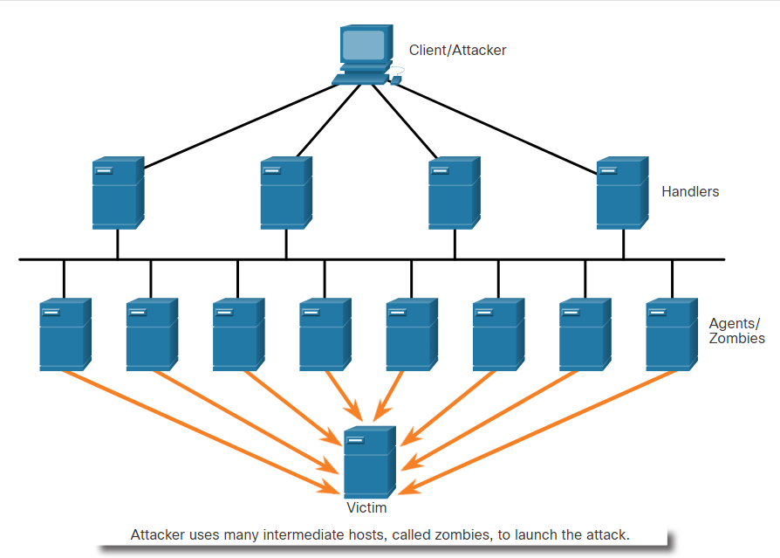

The following terms are used to describe components of a DDoS attack:

| **Component** | **Description** |
| --- | --- |
| zombies | This refers to a group of compromised hosts (i.e., agents). These hosts run malicious code referred to as robots (i.e., bots). The zombie malware continually attempts to self-propagate like a worm. |
| bots | Bots are malware that is designed to infect a host and communicate with a handler system. Bots can also log keystrokes, gather passwords, capture and analyze packets, and more. |
| botnet | This refers to a group of zombies that have been infected using self-propagating malware (i.e., bots) and are controlled by handlers. |
| handlers | This refers to a primary **command-and-control (CnC**or **C2)** server controlling groups of zombies. The originator of a botnet can use Internet Relay Chat (IRC) or a web server on the C2 server to remotely control the zombies. |
| botmaster | This is the threat actor who is in control of the botnet and handlers. |

**Note**: There is an underground economy where botnets can be bought (and sold) for a nominal fee. This can provide threat actors with botnets of infected hosts ready to launch a DDoS attack against the target of choice.

#### Mirai Botnet

Mirai is malware that targeted Internet of Things (IoT) devices that are configured with default login information. Closed-circuit television (CCTV) cameras made up the majority of Mirai’s targets. Using a brute force dictionary attack, Mirai ran through a list of default usernames and passwords that were widely known on the internet.

* root/default
* root/1111
* root/54321
* admin/admin1234
* admin1/password
* guest/12345
* tech/tech
* support/support

After gaining successful access, Mirai targeted the Linux-based BusyBox utilities that run on these devices. These utilities were used to turn the devices into bots that could be remotely controlled as part of a botnet. The botnet was then used as part of a distributed denial of service (DDoS) attack. In September 2016, a Mirai botnet of over 152,000 CCTVs and digital video recorders (DVRs) was responsible for the largest DDoS attack known until that time. With peak traffic of over 1 Tb/s, it took down the hosting services of a France-based web hosting company.

In October 2016 the services of Dyn, a Domain Name System (DNS) provider, were attacked, causing internet outages for millions of users in the United States and Europe.

Play the video to view a demonstration of how a botnet-based DDoS attack makes services unavailable.

Note: In December 2017, three American threat actors pleaded guilty to conspiring to “conduct DDoS attacks against websites and web hosting companies located in the United States and abroad.” The three felons face up to 10 years in prison and $250,000 in fines.

#### Buffer Overflow Attack

The goal of a threat actor when using a buffer overflow DoS attack is to find a system memory-related flaw on a server and exploit it. Exploiting the buffer memory by overwhelming it with unexpected values usually renders the system inoperable, creating a DoS attack.

For example, a threat actor enters input that is larger than expected by the application running on a server. The application accepts the large amount of input and stores it in memory. The result is that it may consume the associated memory buffer and potentially overwrite adjacent memory, eventually corrupting the system and causing it to crash.

An early example of using malformed packets was the **Ping of Death**. In this legacy attack, the threat actor sent a ping of death, which was an echo request in an IP packet larger than the maximum packet size of 65,535 bytes. The receiving host would not be able to handle a packet of that size and it would crash.

Buffer overflow attacks are continually evolving. For instance, a remote denial of service attack vulnerability was recently discovered in Microsoft Windows 10. Specifically, a threat actor created malicious code to access out-of-scope memory. When this code is accessed by the Windows AHCACHE.SYS process, it attempts to trigger a system crash, denying service to the user. Search the Internet on “TALOS-2016-0191 blog” to go to the Cisco Talos threat intelligence website and read a description of such an attack.

**Note**: It is estimated that one third of malicious attacks are the result of buffer overflows.

### 2.4.5. Evasion Methods

Threat actors learned long ago that “to hide is to thrive”. This means their malware and attack methods are most effective when they are undetected. For this reason, many attacks use stealthy evasion techniques to disguise an attack payload. Their goal is to prevent detection by evading network and host defenses.

Some of the evasion methods used by threat actors include:

| **Evasion Method** | **Description** |
| --- | --- |
| Encryption and tunneling | This evasion technique uses tunneling to hide, or encryption to scramble, malware files. This makes it difficult for many security detection techniques to detect and identify the malware. Tunneling can mean hiding stolen data inside of legitimate packets. |
| Resource exhaustion | This evasion technique makes the target host too busy to properly use security detection techniques. |
| Traffic fragmentation | This evasion technique splits a malicious payload into smaller packets to bypass network security detection. After the fragmented packets bypass the security detection system, the malware is reassembled and may begin sending sensitive data out of the network. |
| Protocol-level misinterpretation | This evasion technique occurs when network defenses do not properly handle features of a PDU like a checksum or TTL value. This can trick a firewall into ignoring packets that it should check. |
| Traffic substitution | In this evasion technique, the threat actor attempts to trick an IPS by obfuscating the data in the payload. This is done by encoding it in a different format. For example, the threat actor could use encoded traffic in Unicode instead of ASCII. The IPS does not recognize the true meaning of the data, but the target end system can read the data. |
| Traffic insertion | Similar to traffic substitution, but the threat actor inserts extra bytes of data in a malicious sequence of data. The IPS rules miss the malicious data, accepting the full sequence of data. |
| Pivoting | This technique assumes the threat actor has compromised an inside host and wants to expand their access further into the compromised network. An example is a threat actor who has gained access to the administrator password on a compromised host and is attempting to login to another host using the same credentials. |
| Rootkits | A rootkit is a complex attacker tool used by experienced threat actors. It integrates with the lowest levels of the operating system. When a program attempts to list files, processes, or network connections, the rootkit presents a sanitized version of the output, eliminating any incriminating output. The goal of the rootkit is to completely hide the activities of the attacker on the local system. |
| Proxies | Network traffic can be redirected through intermediate systems in order to hide the ultimate destination for stolen data. In this way, known command-and-control not be blocked by an enterprise because the proxy destination appears benign. Additionally, if data is being stolen, the destination for the stolen data can be distributed among many proxies, thus not drawing attention to the fact that a single unknown destination is serving as the destination for large amounts of network traffic. |

New attack methods are constantly being developed. Network security personnel must be aware of the latest attack methods in order to detect them.

## 2.5) What Did I Learn in this Module?

**Who is Attacking Our Network?**  
Understanding network security requires you to understand the following terms: threat, vulnerability, attack surface, exploit, and risk. Risk management is the process that balances the operational costs of providing protective measures with the gains achieved by protecting the asset. Four common ways to manage risk are risk acceptance, risk avoidance, risk reduction, and risk transfer. Hacker is a term used to describe a threat actor. White hat hackers are ethical hackers using their skills for good, ethical, and legal purposes. Grey hat hackers are individuals who commit crimes and do unethical things, but not for personal gain or to cause damage. Black hat hackers are criminals who violate computer and network security for personal gain, or for malicious reasons, such as attacking networks. Threat actors include script kiddies, vulnerability brokers, hacktivists, cybercriminals, and state-sponsored hackers. Many network attacks can be prevented by sharing information about IOCs. Many governments are promoting cybersecurity. CISA and NCSA are examples of such organizations.

**Introduction of Attack Tools**  
Threat actors use a technique or tool. Attack tools have become more sophisticated, and highly automated. Many of the tools are Linux or UNIX based and a knowledge of these are useful to a cybersecurity professional. Tools include password crackers, wireless hacking tools, network security scanning and hacking tools, packet crafting tools, packet crafting tools, packet sniffers, rootkit detectors, fuzzers to search vulnerabilities, forensic tools, debuggers, hacking operating systems, encryption tools, vulnerability exploitation tools, and vulnerability scanners. Categories of attacks include eavesdropping attacks, data modification attacks, IP address spoofing attacks, password-based attacks, denial-of-service attacks, man-in the-middle attacks, compromised key attacks, and sniffer attacks.

**Malware**  
Malware is short for malicious software or malicious code. Threat actors frequently try to trick users into installing malware to help exploit end device vulnerabilities. Often antimalware software cannot be updated quickly enough to stop new threats. Three common types are virus, worm, and Trojan horse. A virus is a type of malware that spreads by inserting a copy of itself into another program. Most viruses are spread through USB memory drives, CDs, DVDs, network shares, and email. Trojan horse malware is software that appears to be legitimate, but it contains malicious code that exploits the privileges of the user that runs it. Often, Trojans are found on online games. Trojan horses are usually classified according to the damage they cause. Types of Trojan horses include remote-access, data-sending, destructive, proxy, FTP, security software disabler, DoS, and keylogger. Worms are similar to viruses because they replicate and can cause the same type of damage. Viruses require a host program to run. Worms can run themselves. Most worm attacks consist of three components: enabling vulnerability, propagation mechanism, and payload. Currently, ransomware is the most dominant malware. It denies access to the infected system or its data. The cybercriminals then demand payment to release the computer system. Other malware examples include spyware, adware, scareware, phishing, and rootkits.

**Common Network Attacks – Reconnaissance, Access, and Social Engineering**  
Threat actors can also attack the network from outside. To mitigate attacks, it is useful to categorize the various types of attacks. The three major categories are reconnaissance, access, and DoS attacks. Reconnaissance is information gathering. Threat actors do unauthorized discovery and mapping of systems, services, or vulnerabilities. Recon attacks precede access or DoS attacks. Some of the techniques used include the following: performing an information query of a target, initiating a ping sweep of the target network, initiating a port scan of active IP addresses, running vulnerability scanners, and running exploitation tools. Access attacks exploit known vulnerabilities in authentication services, FTP services, and web services. These attacks include password attacks, spoofing attacks, trust exploitation attacks, port redirections, man-in-the-middle attacks, and buffer overflow attacks. Social engineering is an access attack that attempts to manipulate individuals into performing unsafe actions or divulging confidential information. These attacks include pretexting, phishing, spear phishing, spam, something for something, baiting, impersonation, tailgating, shoulder surfing, and dumpster diving.

**Network Attacks – Denial of Service, Buffer Overflows, and Evasion**  
DoS attacks create some sort of interruption of network services to users, devices, or applications. There are two major types: overwhelming quantity of traffic, and maliciously formatted packets. DDoS attacks are similar in intent to DoS attacks, except that the DDoS attack increases in magnitude because it originates from multiple, coordinated sources. The following terms are used to describe DDoS attacks: zombies, bots, botnet, handlers, and botmaster. Mirai is malware that targets IoT devices configured with default login information. Mirai uses a brute force dictionary attack. After successful access, Mirai targets the Linux-based BusyBox utilities that are designed for these devices. The goal of a threat actor when using a buffer overflow DoS attack is to find a system memory-related flaw on a server and exploit it. Exploiting the buffer memory by overwhelming it with unexpected values usually renders the system inoperable, creating a DoS attack. Many attacks use stealthy evasion techniques to disguise an attack payload. Evasion methods include encrypting and tunneling, resource exhaustion, traffic fragmentation, protocol-level misinterpretation, traffic substitution, traffic insertion, pivoting, rootkits, and proxies.

# 3. Mitigating Threats

## 3.0) Introduction

### 3.0.1. Why Should I Take this Module?

Defending the network is the job of a security professional. How can you stay informed of the current security climate? What organizations can help keep you informed of the latest risks and tools? What do onions and artichokes have to do with security? Take this module to learn more!

### 3.0.2. What Will I Learn in this Module?

**Module Title:** Mitigating Threats

**Module Objective**: Explain tools and procedures to mitigate the effects of malware and common network attacks.

| **Topic Title** | **Topic Objective** |
| --- | --- |
| **Defending the Network** | Describe methods and resources to protect the network. |
| **Network Security Policies** | Explain several types of network security policies. |
| **Secure the Network** | Explain the purpose of security platforms. |
| **Mitigating Common Network Attacks** | Describe the techniques used to mitigate common network attacks. |
| **Cisco Network Foundation Protection Framework** | Explain how to secure the three functional areas of Cisco routers and switches. |

## 3.1) Defending the Network

### 3.1.1. Network Security Professionals

Organizations experience productivity loss when their networks are slow or unresponsive. Business goals and profits are negatively impacted by data loss and data corruption. Therefore, from a business perspective, it is necessary to minimize the effects of hackers with bad intentions.

Network security professionals are responsible for maintaining data assurance for an organization and ensuring the integrity and confidentiality of information. Ironically, hacking has had the unintended effect of creating a high demand for network security professionals. As a result of increasing hacker exploits, the sophistication of hacker tools, and because of government legislation, network security solutions developed rapidly in the 1990s, creating new job opportunities in the field of network security.

Security specialist job roles within an enterprise include Chief Information Officer (CIO), Chief Information Security Officer (CISO), Security Operations (SecOps) Manager, Chief Security Officer (CSO), Security Manager, and Network Security Engineer. Regardless of job titles, network security professionals must always stay one step ahead of the hackers:

* They must constantly upgrade their skill set to keep abreast of the latest threats.
* They must attend training and workshops.
* They must subscribe to real-time feeds regarding threats.
* They must peruse security websites on a daily basis.
* They must maintain familiarity with network security organizations. These organizations often have the latest information on threats and vulnerabilities.

The Cyber Security Education organization describes a number of Cyber Security careers and provides resources that can help prepare you for those careers.

**Note**: Relative to other technology professions, network security has a very steep learning curve and requires a commitment to continuous professional development.

### 3.1.2. Network Intelligence Communities

To effectively protect a network, security professionals must stay informed about threats and vulnerabilities as they evolve. There are many security organizations which provide network intelligence. They provide resources, workshops, and conferences to help security professionals. These organizations often have the latest information on threats and vulnerabilities.

The table lists a few important network security organizations.

| **Organization** | **Description** |
| --- | --- |
| SANS | SysAdmin, Audit, Network, Security (SANS) Institute resources are largely free upon request and include:   * The Internet Storm Center - the popular internet early warning system * NewsBites, the weekly digest of news articles about computer security. * @RISK, the weekly digest of newly discovered attack vectors, vulnerabilities with active exploits, and explanations of how recent attacks worked * Flash security alerts * Reading Room - more than 1,200 award-winning, original research papers. * SANS also develops security courses. |
| Mitre | The Mitre Corporation maintains a list of common vulnerabilities and exposures (CVE) used by prominent security organizations making it easier for them to share data. The CVE serves as a dictionary of common names (i.e., CVE Identifiers) for known cybersecurity vulnerabilities. |
| FIRST | Forum of Incident Response and Security Teams (FIRST) is a security organization that brings together a variety of computer security incident response teams from government, commercial, and educational organizations to foster cooperation and coordination in information sharing, incident prevention and rapid reaction. |
| SecurityNewsWire | A security news portal that aggregates the latest breaking news pertaining to alerts, exploits, and vulnerabilities. |
| (ISC)2 | International Information Systems Security Certification Consortium (ISC2) provides vendor neutral education products and career services to more than 75,000+ industry professionals in more than 135 countries. |
| CIS | The Center for Internet Security (CIS) is a focal point for cyber threat prevention, protection, response, and recovery for state, local, tribal, and territorial (SLTT) governments through the Multi-State Information Sharing and Analysis Center (MS-ISAC). The MS-ISAC offers 24x7 cyber threat warnings and advisories, vulnerability identification, and mitigation and incident response. |

To remain effective, a network security professional must:

* **Keep abreast of the latest threats** - This includes subscribing to real-time feeds regarding threats, routinely perusing security-related websites, following security blogs and podcasts, and more.
* **Continue to upgrade skills** - This includes attending security-related training, workshops, and conferences.

**Note**: Network security has a very steep learning curve and requires a commitment to continuous professional development.

### 3.1.3. Network Security Certifications

Hundreds of thousands of network security-related jobs go unfilled each year. The demand for network security professionals greatly outstrips the number of qualified applicants. Obtaining recognized network security certifications greatly enhances your qualifications for these positions. Numerous certifications exist. Certifications for network security professionals are offered by the following organizations:

* Global Information Assurance Certification (GIAC)
* International Information System Security Certification Consortium (ISC)2
* Information Systems Audit and Control Association (ISACA)
* International Council of E-Commerce Consultants (EC-Council)
* Certified Wireless Security Professional (CWSP)

Cisco has replaced the Cisco Certified Network Associate Security (210-260 IINS) certification with a new CCNP Security certification. This certification consists of two exams, a security core exam, and a concentration exam. Only one concentration exam is required. The Implementing and Operating Cisco Security Core Technologies (350-701 SCOR) exam serves as a gateway to both CCNP and CCIE Security certifications. It also provides security core certification. The core exam covers security concepts, threats, and mitigation techniques and technologies. The specializations place in-depth focus on specific Cisco security technologies. The Cisco Certified Specialist security concentration exams are as follows:

* 300-710 SNCF - Network Security Firepower
* 300-715 SISE - Implementing and Configuring Cisco Identity Services Engine
* 300-720 SESA - Securing Email with Cisco Email Security Appliance
* 300-725 SWSA - Securing the Web with Cisco Web Security Appliance
* 300-730 SVPN - Implementing Secure Solutions with Virtual Private Networks
* 300-735 SAUTO - Automating and Programming Cisco Security Solutions

There are many ways to prepare for these certifications including self-study, private exam education, and higher education. The Learning at Cisco organization, along with its learning partners, provides information and training for most of the Cisco certification exams.

### 3.1.4. Communications Security: CIA

Information security deals with protecting information and information systems from unauthorized access, use, disclosure, disruption, modification, or destruction. The CIA Triad serves as a conceptual foundation for the field.

The CIA triad consists of three components of information security:

* **Confidentiality** - Only authorized individuals, entities, or processes can access sensitive information.
* **Integrity** - This refers to the protection of data from unauthorized alteration.
* **Availability** - Authorized users must have uninterrupted access to the network resources and data that they require.

Network data can be encrypted (made unreadable to unauthorized users) using various cryptography applications. The conversation between two IP phone users can be encrypted. The files on a computer can also be encrypted. These are just a few examples. Cryptography can be used almost anywhere that there is data communication. In fact, the trend is toward all communication being encrypted.

## 3.2) Network Security Policies

### 3.2.1. Network Security Domains

It is vital for network security professionals to understand the reasons for network security. They must also be familiar with the organizational requirements for network security as embodied by the 14 network security domains.

Domains provide a framework for discussing network security and understanding the operational needs that should be addressed by each organization.

There are 14 network security domains specified by the International Organization for Standardization (ISO)/International Electrotechnical Commission (IEC). Described by ISO/IEC 27001, these 14 domains serve to organize, at a high level, the vast realm of information and activities under the umbrella of network security. These domains have some significant parallels with domains defined by the Certified Information Systems Security Professional (CISSP) certification.

The 14 domains are intended to serve as a common basis for developing organizational security standards and effective security management practices. They also help to facilitate communication between organizations.

These 14 domains provide a convenient separation of the elements of network security. While it is not important to memorize these 14 domains, it is important to be aware of their existence and formal declaration by the ISO. In the ISO 27001 standard these are known as the 14 control sets of Annex A. They will serve as a useful reference in your work as a network security professional.

The table below gives a brief description of each domain.

| **Network Security Domain** | **Description** |
| --- | --- |
| Information Security Policies | This annex is designed to ensure that security policies are created, reviewed, and maintained. |
| Organization of Information Security | This is the governance model set out by an organization for information security. It assigns responsibilities for information security tasks within an organization. |
| Human Resources Security | This addresses security responsibilities relating to employees joining, moving within, and leaving an organization. |
| Asset Management | This concerns the way that organizations create an inventory of and classification scheme for information assets. |
| Access Control | This describes the restriction of access rights to networks, systems, applications, functions, and data. |
| Cryptography | This concerns data encryption and the management of sensitive information to protect confidentiality, integrity, and availability of data. |
| Physical and Environmental Security | This describes the protection of the physical computer facilities and equipment within an organization. |
| Operations Security | This describes the management of technical security controls in systems and networks including malware defenses, data backup, logging and monitoring, vulnerability management, and audit considerations. This domain is also concerned with the integrity of software that is used in business operations. |
| Communications Security | This concerns the security of data as it is communicated on networks, both within an organization or between and organization and third parties such as customers or suppliers. |
| System Acquisition, Development, and Maintenance | This ensures that information security remains a central concern in an organization’s processes across the entire lifecycle, in both private and public networks. |
| Supplier Relationships | This concerns the specification of contractual agreements that protect an organization’s information and technology assets that are accessible by third parties that provide supplies and services to the organization. |
| Information Security Incident Management | This describes how to anticipate and respond to information security breaches. |
| Business Continuity Management | This describes the protection, maintenance, and recovery of business-critical processes and systems. |
| Compliance | This describes the process of ensuring conformance with information security policies, standards, and regulations. |

### 3.2.2. Business Policies

Business policies are the guidelines that are developed by an organization to govern its actions. The policies define standards of correct behavior for the business and its employees. In networking, policies define the activities that are allowed on the network. This sets a baseline of acceptable use. If behavior that violates business policy is detected on the network, it is possible that a security breach has occurred.

An organization may have several guiding policies, as listed in the table.

| **Policy** | **Description** |
| --- | --- |
| **Company policies** | * These policies establish the rules of conduct and the responsibilities of both employees and employers. * Policies protect the rights of workers as well as the business interests of employers. * Depending on the needs of the organization, various policies and procedures establish rules regarding employee conduct, attendance, dress code, privacy and other areas related to the terms and conditions of employment. |
| **Employee policies** | * These policies are created and maintained by human resources staff to identify employee salary, pay schedule, employee benefits, work schedule, vacations, and more. * They are often provided to new employees to review and sign. |
| **Security policies** | * These policies identify a set of security objectives for a company, define the rules of behavior for users and administrators, and specify system requirements. * These objectives, rules, and requirements collectively ensure the security of a network and the computer systems in an organization. * Much like a continuity plan, a security policy is a constantly evolving document based on changes in the threat landscape, vulnerabilities, and business and employee requirements. |

### 3.2.3. Security Policy

A comprehensive security policy has a number of benefits, including the following:

* Demonstrates an organization’s commitment to security
* Sets the rules for expected behavior
* Ensures consistency in system operations, software and hardware acquisition and use, and maintenance
* Defines the legal consequences of violations
* Gives security staff the backing of management

Security policies are used to inform users, staff, and managers of an organization’s requirements for protecting technology and information assets. A security policy also specifies the mechanisms that are needed to meet security requirements and provides a baseline from which to acquire, configure, and audit computer systems and networks for compliance.

The table lists policies that may be included in a security policy.

| **Policy** | **Description** |
| --- | --- |
| **Identification and authentication policy** | Specifies authorized persons that can have access to network resources and identity verification procedures. |
| **Password policies** | Ensures passwords meet minimum requirements and are changed regularly. |
| **Acceptable Use Policy (AUP)** | Identifies network applications and uses that are acceptable to the organization. It may also identify ramifications if this policy is violated. |
| **Remote access policy** | Identifies how remote users can access a network and what is accessible via remote connectivity. |
| **Network maintenance policy** | Specifies network device operating systems and end user application update procedures. |
| **Incident handling procedures** | Describes how security incidents are handled. |

One of the most common security policy components is an AUP. This can also be referred to as an appropriate use policy. This component defines what users are allowed and not allowed to do on the various system components. This includes the type of traffic that is allowed on the network. The AUP should be as explicit as possible to avoid misunderstanding.

For example, an AUP might list specific websites, newsgroups, or bandwidth-intensive applications that are prohibited from being accessed by company computers or from the company network. Every employee should be required to sign an AUP, and the signed AUPs should be retained for the duration of employment.

### 3.2.4. BYOD Policies

Many organizations must now also support Bring Your Own Device (BYOD). This enables employees to use their own mobile devices to access company systems, software, networks, or information. BYOD provides several key benefits to enterprises, including increased productivity, reduced IT and operating costs, better mobility for employees, and greater appeal when it comes to hiring and retaining employees.

However, these benefits also bring an increased information security risk because BYOD can lead to data breaches and greater liability for the organization.

A BYOD security policy should be developed to accomplish the following:

* Specify the goals of the BYOD program.
* Identify which employees can bring their own devices.
* Identify which devices will be supported.
* Identify the level of access employees are granted when using personal devices.
* Describe the rights to access and activities permitted to security personnel on the device.
* Identify which regulations must be adhered to when using employee devices.
* Identify safeguards to put in place if a device is compromised.

The table lists BYOD security best practices to help mitigate BYOD vulnerabilities.

| **Best Practice** | **Description** |
| --- | --- |
| Password protected access | Use unique passwords for each device and account. |
| Manually control wireless connectivity | Turn off Wi-Fi and Bluetooth connectivity when not in use. Connect only to trusted networks. |
| Keep updated | Always keep the device OS and other software updated. Updated software often contains security patches to mitigate against the latest threats or exploits. |
| Back up data | Enable backup of the device in case it is lost or stolen. |
| Enable “Find my Device” | Subscribe to a device locator service with remote wipe feature. |
| Provide antivirus software | Provide antivirus software for approved BYOD devices. |
| Use Mobile Device Management (MDM) software | MDM software enables IT teams to implement security settings and software configurations on all devices that connect to company networks. |

## 3.3) Security Tools, Platforms and Services

### 3.3.1. The Security Onion and The Security Artichoke

There are two common analogies that are used to describe a defense-in-depth approach.

**Security Onion**: A common analogy used to describe a defense-in-depth approach is called “the security onion.” As illustrated in figure, a threat actor would have to peel away at a network’s defenses layer by layer in a manner similar to peeling an onion. Only after penetrating each layer would the threat actor reach the target data or system.

**Note**: The security onion described on this page is a way of visualizing defense-in-depth. This is not to be confused with the Security Onion suite of network security tools.

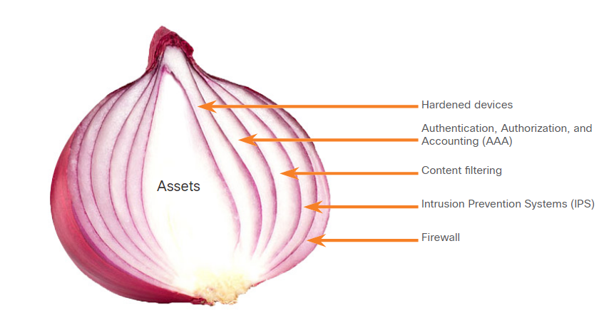

**Security Artichoke**: The changing landscape of networking, such as the evolution of borderless networks, has changed this analogy to the “security artichoke”, which benefits the threat actor.

As illustrated in the figure, threat actors no longer have to peel away each layer. They only need to remove certain “artichoke leaves.” The bonus is that each “leaf” of the network may reveal sensitive data that is not well secured.

For example, it’s easier for a threat actor to compromise a mobile device than it is to compromise an internal computer or server that is protected by layers of defense. Each mobile device is a leaf. And leaf after leaf, it all leads the hacker to more data. The heart of the artichoke is where the most confidential data is found. Each leaf provides a layer of protection while simultaneously providing a path to attack.

Not every leaf needs to be removed in order to get at the heart of the artichoke. The hacker chips away at the security armor along the perimeter to get to the “heart” of the enterprise.

While internet-facing systems are usually very well protected and boundary protections are typically solid, persistent hackers, aided by a mix of skill and luck, do eventually find a gap in that hard-core exterior through which they can enter and go where they please.

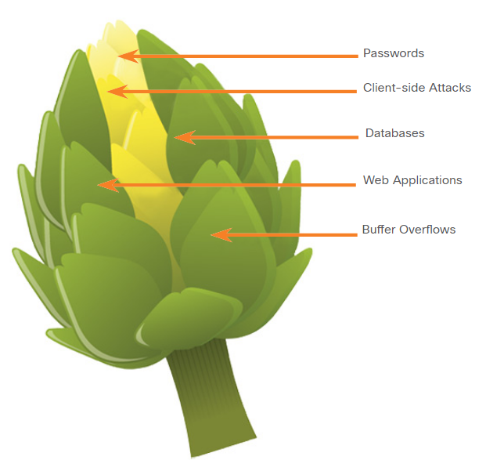

### 3.3.2. Security Testing Tools

Ethical hacking involves using many different types of tools to test the network and end devices. To validate the security of a network and its systems, many network security testing tools have been developed. Penetration testing involves the use of hacker techniques and tools to evaluate the strength of network security measures. However, many of these tools can also be used by threat actors for exploitation.

Threat actors have also created various hacking tools. These tools are explicitly written for nefarious reasons. Cybersecurity personnel must also know how to use these tools when performing network penetration tests.

Explore the categories of common network penetration testing tools. Notice how some tools are used by white hats and black hats. Keep in mind that the list is not exhaustive as new tools are continually being developed.

**Note**: Many of these tools are UNIX or Linux based; therefore, a security professional should have a strong UNIX and Linux background.

| **Categories of Tools** | **Description** |
| --- | --- |
| password crackers | Passwords are the most vulnerable security threat. Password cracking tools are often referred to as password recovery tools and can be used to crack or recover the password. This is accomplished either by removing the original password, after bypassing the data encryption, or by outright discovery of the password. Password crackers repeatedly make guesses in order to crack the password and access the system. Examples of password cracking tools include John the Ripper, Ophcrack, L0phtCrack, THC Hydra, RainbowCrack, and Medusa. |
| wireless hacking tools | Wireless networks are more susceptible to network security threats. Wireless hacking tools are used to intentionally hack into a wireless network to detect security vulnerabilities. Examples of wireless hacking tools include Aircrack-ng, Kismet, InSSIDer, KisMAC, Firesheep, and NetStumbler. |
| network scanning and hacking tools | Network scanning tools are used to probe network devices, servers, and hosts for open TCP or UDP ports. Examples of scanning tools include Nmap, SuperScan, Angry IP Scanner, and NetScanTools. |
| packet crafting tools | Packet crafting tools are used to probe and test a firewall’s robustness using specially crafted forged packets. Examples of such tools include Hping, Scapy, Socat, Yersinia, Netcat, Nping, and Nemesis. |
| packet sniffers | Packet sniffers tools are used to capture and analyze packets within traditional Ethernet LANs or WLANs. Tools include Wireshark, Tcpdump, Ettercap, Dsniff, EtherApe, Paros, Fiddler, Ratproxy, and SSLstrip. |
| rootkit detectors | A rootkit detector is a directory and file integrity checker used by white hats to detect installed root kits. Example tools include AIDE, Netfilter, and PF: OpenBSD Packet Filter. |
| fuzzers to search vulnerabilities | Fuzzers are tools used by threat actors when attempting to discover a computer system’s security vulnerabilities. Examples of fuzzers include Skipfish, Wapiti, and W3af. |
| forensic tools | White hat hackers use forensic tools to sniff out any trace of evidence existing in a particular computer system. Example of tools include Sleuth Kit, Helix, Maltego, and Encase. |
| debuggers | Debugger tools are used by black hats to reverse engineer binary files when writing exploits. They are also used by white hats when analyzing malware. Debugging tools include GDB, WinDbg, IDA Pro, and Immunity Debugger. |
| hacking operating systems | Hacking operating systems are specially designed operating systems preloaded with tools and technologies optimized for hacking. Examples of specially designed hacking operating systems include Kali Linux, SELinux, Knoppix, Parrot OS, and BackBox Linux. |
| encryption tools | These tools safeguard the contents of an organization’s data when it is stored or transmitted. Encryption tools use algorithm schemes to encode the data to prevent unauthorized access to the data. Examples of these tools include VeraCrypt, CipherShed, Open SSH, OpenSSL, OpenVPN, and Stunnel. |
| vulnerability exploitation tools | These tools identify whether a remote host is vulnerable to a security attack. Examples of vulnerability exploitation tools include Metasploit, Core Impact, Sqlmap, Social Engineer Tool Kit, and Netsparker. |
| vulnerability scanners | These tools scan a network or system to identify open ports. They can also be used to scan for known vulnerabilities and scan VMs, BYOD devices, and client databases. Examples of these tools include Nipper, Securia PSI, Core Impact, Nessus, SAINT, and Open VAS. |

### 3.3.3. Data Security Platforms

Data Security Platforms (DSP) are an integrated security solution that combines traditionally independent tools into a suite of tools that are made to work together. Security tools that protect and monitor networks are often made by different vendors. It can be difficult to integrate these tools in such a way that a single view of network security can be achieved. Significant resources can be required to have different devices and software under a single controlling solution. In addition, integrating data from such diverse tools into a comprehensive monitoring view of the network can be very difficult to create and maintain.

One such DSP is the Helix platform from FireEye. FireEye Helix is a cloud-based security operations platform that enables organizations to integrate many security functionalities into a single platform. Helix provides event management, network behavior analytics, advanced threat detection, and incident security orchestration, automation, and response (SOAR) for response to threats as they are detected. Helix also draws on FireEye Mandiant threat intelligence, incident response, and security expertise.



Another integrated DSP is Cisco SecureX. SecureX goes a step farther with its strong integration with the Cisco Secure portfolio. The Cisco Secure portfolio consists of a broad set of technologies that function as a team - providing interoperability with the security infrastructure, including third-party technologies. This results in unified visibility, automation, and stronger defenses. The Cisco SecureX platform works with diverse products that combine to safeguard your network, users and endpoints, cloud edge, and applications. SecureX functionality is built in to a large and diverse portfolio of Cisco security products including next-generation firewalls, VPN, network analytics, identity service engine, advanced malware protection (AMP), and many other systems that work to secure all aspects of a network. SecureX also integrates a range of third-party security tools.

### 3.3.5. Security Services

Threat intelligence and security services allow the exchange of threat information such as vulnerabilities, indicators of compromise (IOC), and mitigation techniques. This information is not only shared with personnel, but also with security systems. As threats emerge, threat intelligence services create and distribute firewall rules and IOCs to the devices that have subscribed to the service.

One such service is the Cisco Talos Threat Intelligence Group, shown in the figure. Talos is one of the largest commercial threat intelligence teams in the world, and is comprised of world-class researchers, analysts, and engineers. The goal of Talos is to help protect enterprise users, data, and infrastructure from active adversaries. The Talos team collects information about active, existing, and emerging threats. Talos then provides comprehensive protection against these attacks and malware to its subscribers.

Cisco Security products can use Talos threat intelligence in real time to provide fast and effective security solutions. Cisco Talos also provides free software, services, resources, and data. Talos maintains the security incident detection rule sets for the Snort.org, ClamAV, and SpamCop network security tools.

A number of managed network security services are available from providers such as Cisco, Sentinel Intrusion Prevention Systems, IBM, AT&T, and Core Security. These organizations provide a wide range of services including comprehensive managed Security as a Service (SECcaaS or SaaS).

## 3.4) Mitigating Common Network Attacks

### 3.4.1. Defending the Network

Constant vigilance and ongoing education are required to defend your network against attack. The following are best practices for securing a network:

* Develop a written security policy for the company.
* Educate employees about the risks of social engineering, and develop strategies to validate identities over the phone, via email, or in person.
* Control physical access to systems.
* Use strong passwords and change them often.
* Encrypt and password-protect sensitive data.
* Implement security hardware and software such as firewalls, IPSs, virtual private network (VPN) devices, antivirus software, and content filtering.
* Perform backups and test the backed-up files on a regular basis.
* Shut down unnecessary services and ports.
* Keep patches up-to-date by installing them weekly or daily, if possible, to prevent buffer overflow and privilege escalation attacks.
* Perform security audits to test the network.

### 3.4.2. Mitigating Malware

Malware, including viruses, worms, and Trojan horses, can cause serious problems on networks and end devices. Network administrators have several means of mitigating these attacks.

**Note**: Mitigation techniques are often referred to in the security community as “countermeasures”.

One way of mitigating virus and Trojan horse attacks is antivirus software. Antivirus software helps prevent hosts from getting infected and spreading malicious code. It requires much more time to clean up infected computers than it does to maintain up-to-date antivirus software and antivirus definitions on the same machines.

Antivirus software is the most widely deployed security product on the market today. Several companies that create antivirus software, such as Symantec, McAfee, and Trend Micro, have been in the business of detecting and eliminating viruses for more than a decade. Many corporations and educational institutions purchase volume licensing for their users. The users are able to log in to a website with their account and download the antivirus software on their desktops, laptops, or servers.

Antivirus products have update automation options so that new virus definitions and new software updates can be downloaded automatically or on demand. This practice is the most critical requirement for keeping a network free of viruses and should be formalized in a network security policy.

Antivirus products are host-based. These products are installed on computers and servers to detect and eliminate viruses. However, they do not prevent viruses from entering the network, so a network security professional must be aware of the major viruses and keep track of security updates regarding emerging viruses.

Another way to mitigate malware threats is to prevent malware files from entering the network at all. Security devices at the network perimeter can identify known malware files based on their indicators of compromise. The files can be removed from the incoming data stream before they can cause an incident. Unfortunately, threat actors are aware of this countermeasure and frequently alter their malware enough that it evades detection. These exploits will enter the network and will also evade antivirus software. No mitigation technique can be 100% effective. Security incidents are going to happen.

### 3.4.3. Mitigating Worms

Worms are more network-based than viruses. Worm mitigation requires diligence and coordination on the part of network security professionals.

As shown in the figure, the response to a worm attack can be broken down into four phases: containment, inoculation, quarantine, and treatment.

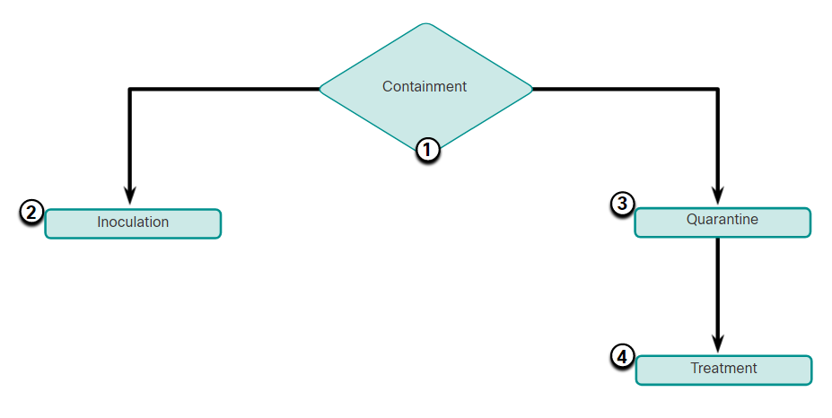

| **Phase** | **Response** |
| --- | --- |
| 1. Containment | The containment phase involves limiting the spread of a worm infection to areas of the network that are already affected. This requires compartmentalization and segmentation of the network to slow down or stop the worm and to prevent currently infected hosts from targeting and infecting other systems. Containment requires using both outgoing and incoming ACLs on routers and firewalls at control points within the network. |
| 2. Inoculation | The inoculation phase runs parallel to or subsequent to the containment phase. During the inoculation phase, all uninfected systems are patched with the appropriate vendor patch. The inoculation process further deprives the worm of any available targets. |
| 3. Quarantine | The quarantine phase involves tracking down and identifying infected machines within the contained areas and disconnecting, blocking, or removing them. This isolates these systems appropriately for the treatment phase. |
| 4. Treatment | The treatment phase involves actively disinfecting infected systems. This can involve terminating the worm process, removing modified files or system settings that the worm introduced, and patching the vulnerability the worm used to exploit the system. Alternatively, in more severe cases, the system may need to be reinstalled to ensure that the worm and its by-products are removed. |

### 3.4.4. Mitigating Reconnaissance Attacks

Reconnaissance attacks are typically the precursor to other attacks that have the intent of gaining unauthorized access to a network or disrupting network functionality. A network security professional can detect when a reconnaissance attack is underway by receiving notifications from preconfigured alarms. These alarms are triggered when certain parameters are exceeded, such as the number of ICMP requests per second. A variety of technologies and devices can be used to monitor this type of activity and generate an alarm. Cisco’s Adaptive Security Appliance (ASA) provides intrusion prevention in a standalone device. Additionally, the Cisco ISR supports network-based intrusion prevention through the Cisco IOS security image.

Reconnaissance attacks can be mitigated in several ways, including the following:

* Implementing authentication to ensure proper access.
* Using encryption to render packet sniffer attacks useless.
* Using anti-sniffer tools to detect packet sniffer attacks.
* Implementing a switched infrastructure.
* Using a firewall and IPS.

Anti-sniffer software and hardware tools detect changes in the response time of hosts to determine whether the hosts are processing more traffic than their own traffic loads would indicate. While this does not completely eliminate the threat, as part of an overall mitigation system, it can reduce the number of instances of threat.

Encryption is also effective for mitigating packet sniffer attacks. If traffic is encrypted, using a packet sniffer is of little use because captured data is not readable.

It is impossible to mitigate port scanning, but using an intrusion prevention system (IPS) and firewall can limit the information that can be discovered with a port scanner. Ping sweeps can be stopped if ICMP echo and echo-reply are turned off on edge routers; however, when these services are turned off, network diagnostic data is lost. Additionally, port scans can be run without full ping sweeps. The scans simply take longer because inactive IP addresses are also scanned.

### 3.4.5. Mitigating Access Attacks

Several techniques are available for mitigating access attacks. These include strong password security, principle of minimum trust, cryptography, applying operating system and application patches.

A surprising number of access attacks are carried out through simple password guessing or brute-force dictionary attacks against passwords. To defend against this, create and enforce a strong authentication policy which includes:

* **Use strong passwords** - Strong passwords are at least eight characters and contain uppercase letters, lowercase letters, numbers, and special characters.
* **Disable accounts after a specified number of unsuccessful logins has occurred** - This practice helps to prevent continuous password attempts.

The network should also be designed using the principle of minimum trust. This means that systems should not use one another unnecessarily. For example, if an organization has a trusted server that is used by untrusted devices, such as web servers, the trusted server should not trust the untrusted devices unconditionally.

Cryptography is a critical component of any modern secure network. Using encryption for remote access to a network is recommended. Routing protocol traffic should also be encrypted. The more that traffic is encrypted, the fewer opportunities hackers have for intercepting data with man-in-the-middle attacks.

The use of encrypted or hashed authentication protocols, along with a strong password policy, greatly reduces the probability of successful access attacks.

Finally, educate employees about the risks of social engineering, and develop strategies to validate identities over the phone, via email, or in person. Multifactor authentication (MFA) has become increasingly common. In this approach, authentication requires two or more independent means of verification. For example, a password may be combined with a code that is sent over a text message. Software or separate devices may be used to generate tokens that are good for only one use. These token values, when provided with a password, provide an additional layer of security that prevents the use of passwords that have been guessed or stolen by threat actors.

In general, access attacks can be detected by reviewing logs, bandwidth utilization, and process loads. The network security policy should specify that logs are formally maintained for all network devices and servers. By reviewing logs, network security personnel can determine if an unusual number of failed login attempts have occurred.

### 3.4.6. Mitigating DoS Attacks

One of the first signs of a DoS attack is a large number of user complaints about unavailable resources or unusually slow network performance. To minimize the number of attacks, a network utilization software package should be running at all times. Network behavior analysis can detect unusual patterns of usage that indicate that a DoS attack is occurring. A means of detecting unusual network behavior should be required by the organization’s network security policy. A network utilization graph showing unusual activity could also indicate a DoS attack.

DoS attacks could be a component of a larger offensive. DoS attacks can lead to problems in the network segments of the computers being attacked. For example, the packet-per-second capacity of a router between the internet and a LAN might be exceeded by an attack, compromising not only the target system but also the network devices that the traffic must pass through. If the attack is conducted on a sufficiently large scale, entire geographical regions of internet connectivity could be compromised.

Historically, many DoS attacks were sourced from spoofed addresses. Cisco routers and switches support a number of antispoofing technologies, such as port security, Dynamic Host Configuration Protocol (DHCP) snooping, IP Source Guard, Dynamic Address Resolution Protocol (DAI) Inspection, and access control lists (ACLs).

## 3.5) Cisco Network Foundation Protection Framework

### 3.5.1. NFP Framework

The Cisco Network Foundation Protection (NFP) framework provides comprehensive guidelines for protecting the network infrastructure. These guidelines form the foundation for continuous delivery of service.

NFP logically divides routers and switches into three functional areas, as shown in the figure:

* **Control plane** - Responsible for routing data correctly. Control plane traffic consists of device-generated packets required for the operation of the network itself, such as ARP message exchanges, or OSPF routing advertisements.
* **Management plane** - Responsible for managing network elements. Management plane traffic is generated either by network devices or network management stations using processes and protocols such as Telnet, SSH, TFTP, FTP, NTP, AAA, SNMP, syslog, TACACS+, RADIUS, and NetFlow.
* **Data plane (Forwarding plane)** - Responsible for forwarding data. Data plane traffic normally consists of user-generated packets being forwarded between end devices. Most traffic travels through the router, or switch, via the data plane.

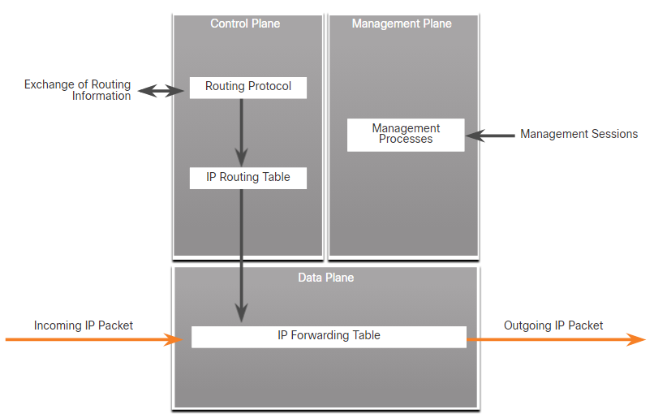

### 3.5.2. Securing the Control Plane

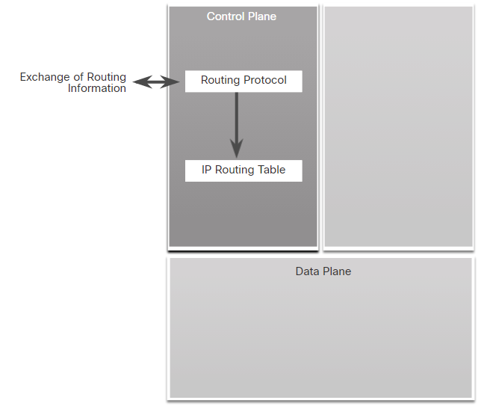Control plane traffic consists of device-generated packets required for the operation of the network itself. Control plane security can be implemented using the following features, as shown in the figure:

* **Routing protocol authentication** - Routing protocol authentication, or neighbor authentication, prevents a router from accepting fraudulent routing updates. Most routing protocols support neighbor authentication.
* **Control Plane Policing (CoPP)** - CoPP is a Cisco IOS feature designed to allow users to control the flow of traffic that is handled by the route processor of a network device.
* **AutoSecure** - AutoSecure can lock down the management plane functions and the forwarding plane services and functions of a router.

CoPP is designed to prevent unnecessary traffic from overwhelming the route processor. The CoPP feature treats the control plane as a separate entity with its own ingress (input) and egress (output) ports. A set of rules can be established and associated with the ingress and egress ports of the control plane.

### 3.5.3. Securing the Management Plane

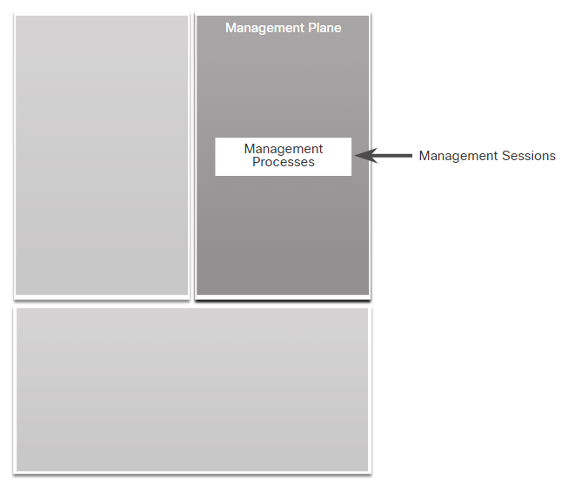Management plane traffic is generated either by network devices or network management stations using processes and protocols such as Telnet, SSH, and TFTP, etc. The management plane is a very attractive target to hackers. For this reason, the management module was built with several technologies designed to mitigate such risks.

The information flow between management hosts and the managed devices can be out-of-band (OOB), where information flows within a network on which no production traffic resides. It can also be in-band, where information flows across the enterprise production network, the internet, or both.

Management plane security can be implemented using the following features, as shown in the figure:

* **Login and password policy** - Restricts device accessibility. Limits the accessible ports and restricts the “who” and “how” methods of access.
* **Present legal notification** - Displays legal notices. These are often developed by legal counsel of a corporation.
* **Ensure the confidentiality of data** - Protects locally stored sensitive data from being viewed or copied. Uses management protocols with strong authentication to mitigate confidentiality attacks aimed at exposing passwords and device configurations.
* **Role-based access control (RBAC)** - Ensures access is only granted to authenticated users, groups, and services. RBAC and authentication, authorization, and accounting (AAA) services provide mechanisms to effectively manage access control.
* **Authorize actions** - Restricts the actions and views that are permitted by any particular user, group, or service.
* **Enable management access reporting** - Logs and accounts for all access. Records who accessed the device, what occurred, and when it occurred.

RBAC restricts user access based on the role of the user. Roles are created according to job or task functions, and assigned access permissions to specific assets. Users are then assigned to roles, and are granted the permissions that are defined for that role.

In Cisco IOS, the role-based CLI access feature implements RBAC for router management access. The feature creates different “views” that define which commands are accepted and what configuration information is visible. For scalability, users, permissions, and roles are usually created and maintained in a central repository server. This makes the access control policy available to multiple devices. The central repository server can be a Cisco Identity Services Engine (ISE) which can provide authentication, authorization, and accounting (AAA) network services.

### 3.5.3. Securing the Data Plane

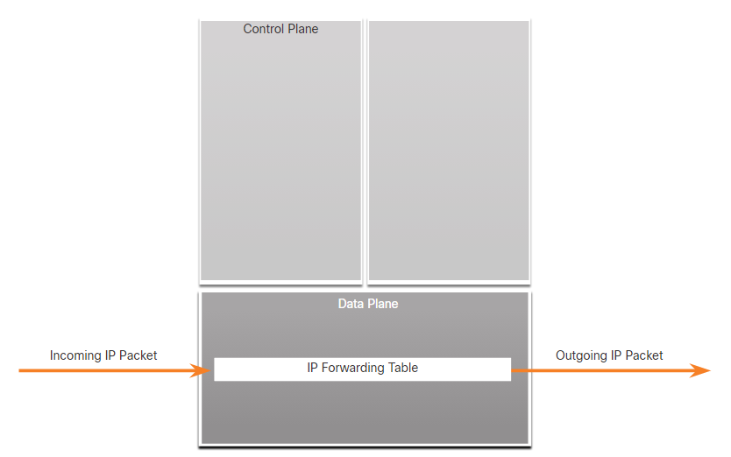Data plane traffic consists mostly of user packets being forwarded through the router via the data plane. Data plane security can be implemented using ACLs, antispoofing mechanisms, and Layer 2 security features, as shown in the figure.

ACLs perform packet filtering to control which packets move through the network and where those packets are allowed to go. ACLs are used to secure the data plane in a variety of ways:

* **Blocking unwanted traffic or users** - ACLs can filter incoming or outgoing packets on an interface. They can be used to control access based on source addresses, destination addresses, or user authentication.
* **Reducing the chance of DoS attacks** - ACLs can be used to specify whether traffic from hosts, networks, or users, can access the network. The ASA TCP intercept feature is a mechanism that can be used to protect end hosts, especially servers, from TCP SYN-flooding attacks.
* **Mitigating spoofing attacks** - ACLs allow security practitioners to implement recommended practices to mitigate spoofing attacks.
* **Providing bandwidth control** - ACLs on a slow link can prevent excess traffic.
* **Classifying traffic to protect the Management and Control planes** - ACLs can be applied on the vty lines.

ACLs can also be used as an antispoofing mechanism by discarding traffic that has an invalid source address. This means that attacks must be initiated from valid, reachable IP addresses, which allows the packets to be traced to the originator of an attack.

Features, such as Unicast Reverse Path Forwarding (uRPF), can be used to complement the antispoofing strategy.

Cisco Catalyst switches can use integrated features to help secure the Layer 2 infrastructure. The following Layer 2 security tools are integrated into the Cisco Catalyst switches:

* **Port security** - Prevents MAC address spoofing and MAC address flooding attacks.
* **DHCP snooping** - Prevents client attacks on the DHCP server and switch.
* **Dynamic ARP Inspection (DAI)** - Adds security to ARP by using the DHCP snooping table to minimize the impact of ARP poisoning and spoofing attacks.
* **IP Source Guard (IPSG)** - Prevents spoofing of IP addresses by using the DHCP snooping table.

This course focuses on the various technologies and protocols used to secure the Management and Data planes.

## 3.6) What Did I Learn in this Module?

**Defending the Network**  
Network security professionals are responsible for maintaining data assurance for an organization and ensuring the integrity and confidentiality of information. A security professional must stay informed about threats and vulnerabilities as they evolve. There are several network security organizations to keep you informed, including SANS, Mitre, FIRST, SecurityNewsWire, ISC2, and CIS. Certifications for network security professionals are offered by the following organizations:

* GIAC
* ISC2
* ISACA
* EC-Council
* CWSP

Information security deals with protecting information and information systems from unauthorized access, use, disclosure, disruption, modification, or destruction. The CIA Triad serves as a conceptual foundation for the field. The CIA triad consists of three components of information security: Confidentiality, Integrity, and Availability.

**Network Security Policies**  
There are 14 network security domains specified by the ISO/IEC. Described by ISO/IEC 27002, these 14 domains serve to organize, at a high level, the vast realm of information under the umbrella of network security. These domains have some significant parallels with domains defined by the CISSP certification. The 14 domains are intended to serve as a common basis for developing organizational security standards and effective security management practices. They also help to facilitate communication between organizations. In networking, policies define the activities that are allowed on the network. Policies that may be included in a security policy include identification and authentication policy, password policies, acceptable use policy, remote access policy, network maintenance policy, and incident handling procedures. A security policy is a "living document", meaning that the document is regularly updated as technology, business, and employee requirements change. Many companies also need to place policies around BYOD. There are also external regulations regarding network security. Network security professionals must be familiar with the laws and codes of ethics that are binding on INFOSEC professionals.

**Security Tools, Platforms, and Services**  
There are two common analogies that are used to describe a defense-in-depth approach: Security Onion and Security Artichoke. With Security Onion, a threat actor would have to peel away at a network’s defenses layer by layer in a manner similar to peeling an onion. The changing landscape of networking, such as the evolution of borderless networks, has changed this analogy to the “security artichoke”, which benefits the threat actor. Threat actors no longer have to peel away each layer. They only need to remove certain “artichoke leaves.” To validate the security of a network and its systems, many network penetration testing tools have been developed. Categories of these tools include password crackers, wireless hacking tools, network scanning and hacking tools, packet crafting tools, packet sniffers, rootkit detectors, fuzzers to search for vulnerabilities, forensic tools, debuggers, hacking operating systems, encryption tools, vulnerability exploitation tools, and vulnerability scanners. Threat intelligence services allow the exchange of threat information such as vulnerabilities, IOCs, and mitigation techniques. One such service is the Cisco Talos Threat Intelligence Group.

**Mitigating Common Network Attacks**  
The following best practices are used for securing a network: develop a written security policy, educate employees, control physical access to systems, use strong passwords and change them often, encrypt and password- protect sensitive data, implement security hardware and software, perform backups and test the back up files, shut down unnecessary services and ports, keep patches up-to-date, and perform security audits and tests. Network administrators have several means of mitigating malware attacks. The primary means of mitigating virus and Trojan horse attacks is antivirus software, the most widely deployed security product on the market today. However, they do not prevent viruses from entering the network, so a network security professional must be aware of the major viruses and keep track of security updates regarding emerging viruses. Worms are more network-based than viruses. The response to a worm attack can be broken down into four phases: containment, inoculation, quarantine, and treatment. Reconnaissance attacks are typically the precursor to additional attacks, with the intent of gaining unauthorized access to a network or disrupting network functionality. A network security professional can detect when a reconnaissance attack is underway by receiving notifications from preconfigured alarms. Reconnaissance attacks can be mitigated in several ways, including the following: implement authentication to ensure proper access, use encryption to render packet sniffer attacks useless, use anti-sniffer tools to detect packet sniffer attacks, implement a switched infrastructure, and use a firewall and IPS. Encryption is also effective for mitigating packet sniffer attacks. Several techniques are available for mitigating access attacks. These include strong password security, principle of minimum trust, cryptography, applying operating system and application patches. To minimize the number of DoS attacks, a network utilization software package should be running at all times. DoS attacks could be a component of a larger offensive. DoS attacks can lead to problems in the network segments of the computers being attacked. Historically, many DoS attacks were sourced from spoofed addresses. Cisco routers and switches support a number of antispoofing technologies, such as port security, DHCP snooping, IP Source Guard, Dynamic ARP Inspection, and ACLs.

**Cisco Network Foundation Protection Framework**  
The Cisco NFP framework provides comprehensive guidelines for protecting the network infrastructure. These guidelines form the foundation for continuous delivery of service. NFP logically divides routers and switches into three functional areas: control plane, management plane, and data plane (forwarding plane). Control plane security can be implemented using the following features: routing protocol authentication, CoPP, and AutoSecure. CoPP is designed to prevent unnecessary traffic from overwhelming the route processor. The management module was built with several technologies designed to mitigate risks from threat actors. Management plane security can be implemented using the following features: login and password policy, present legal notification, ensure the data confidentiality, RBAC, authorize actions, and enable management access reporting. Data plane security can be implemented using ACLs, antispoofing mechanisms, and Layer 2 security features. ACLs are used to secure the data in a variety of ways including: blocking unwanted traffic or users, reducing the chance of DoS attacks, mitigating spoofing attacks, providing bandwidth control, classifying traffic to protect the Management and Control planes. ACLs can also be used as an antispoofing mechanism by discarding traffic that has an invalid source address. features, such as uRPF, can be used to complement the antispoofing strategy. The following Layer 2 security tools are integrated into the Cisco Catalyst switches: port security, DHCP snooping, DAI, and IPSG. The Cisco NFP framework provides comprehensive guidelines for protecting the network infrastructure. These guidelines form the foundation for continuous delivery of service. NFP logically divides routers and switches into three functional areas: control plane, management plane, and data plane (forwarding plane). Control plane security can be implemented using the following features: routing protocol authentication, CoPP, and AutoSecure. CoPP is designed to prevent unnecessary traffic from overwhelming the route processor. The management module was built with several technologies designed to mitigate risks from threat actors. Management plane security can be implemented using the following features: login and password policy, present legal notification, ensure the data confidentiality, RBAC, authorize actions, and enable management access reporting. Data plane security can be implemented using ACLs, antispoofing mechanisms, and Layer 2 security features. ACLs are used to secure the data in a variety of ways including: blocking unwanted traffic or users, reducing the chance of DoS attacks, mitigating spoofing attacks, providing bandwidth control, classifying traffic to protect the Management and Control planes. ACLs can also be used as an antispoofing mechanism by discarding traffic that has an invalid source address. features, such as uRPF, can be used to complement the antispoofing strategy. The following Layer 2 security tools are integrated into the Cisco Catalyst switches: port security, DHCP snooping, DAI, and IPSG.

# 4. Secure Device Access

## 4.0) Introduction

### 4.0.1. Why Should I Take this Module?

Securing device access is a critical task for a network security professional. You can think of a router as the locked gate to your fenced in yard. If someone gains entry to that gate, they are one step closer to gaining access to your property in your yard and in your house! Who should be allowed access? How do you secure the edge router? What steps do you take to configure secure administrative access? How can you configure enhanced security for virtual logins? Keep reading to learn more!

### 4.0.2. What Will I Learn in this Module?

**Module Title:** Secure Device Access

**Module Objective**: Configure secure administrative access.

| **Topic Title** | **Topic Objective** |
| --- | --- |
| **Secure the Edge Router** | Explain how to secure a network perimeter. |
| **Configure Secure Administrative Access** | Use the correct commands to configure passwords on a Cisco IOS device. |
| **Configure Enhanced Security for Virtual Logins** | Use the correct commands to configure enhanced security for virtual logins. |
| **Configure SSH** | Configure an SSH daemon for secure remote management. |

## 4.1) Secure the Edge Router

### 4.1.1. Secure the Network Infrastructure

Securing the network infrastructure is critical to overall network security. The network infrastructure includes routers, switches, servers, endpoints, and other devices.

Consider a disgruntled employee casually looking over the shoulder of a network administrator while the administrator is logging into an edge router. It is a surprisingly easy way for an attacker to gain unauthorized access.

If an attacker gains access to a router, the security and management of the entire network can be compromised. For example, an attacker can erase the startup configuration and is make the router reload in five minutes. When the router reboots, it will not have a startup configuration.

To prevent unauthorized access to all infrastructure devices, appropriate security policies and controls must be implemented. Routers are a primary target for attacks because these devices act as traffic police, which direct traffic into, out of, and between networks.

The edge router shown in the figure is the last router between the internal network and an untrusted network, such as the internet. All of an organization’s internet traffic goes through an edge router, which often functions as the first and last line of defense for a network. The edge router helps to secure the perimeter of a protected network and implements security actions that are based on the security policies of the organization. For these reasons, securing network routers is imperative.

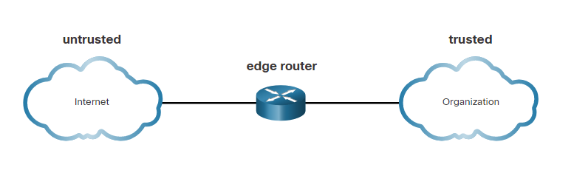

### 4.1.2. Edge Router Security Approaches

The edge router implementation varies depending on the size of the organization and the complexity of the required network design. Router implementations can include a single router protecting an entire inside network or a router functioning as the first line of defense in a defense-in-depth approach. Simplified topologies for the three approaches are shown in the figure.

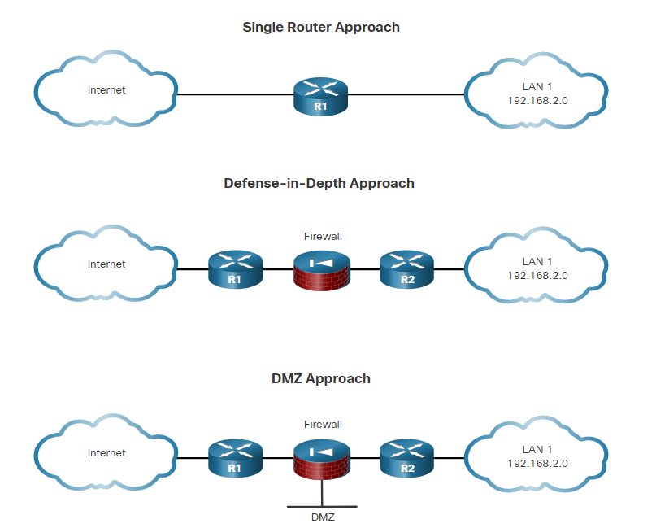**Single Router Approach**

In the figure, a single router connects the protected network or internal local area network (LAN), to the internet. All security policies are configured on this device. This is more commonly deployed in smaller site implementations, such as branch and small office, home office (SOHO) sites. In smaller networks, the required security features can be supported by Integrated Services Routers (ISRs) without impeding the router’s performance capabilities.

**Defense-in-Depth Approach**

A defense-in-depth approach is more secure than the single router approach. It uses multiple layers of security prior to traffic entering the protected LAN. There are three primary layers of defense: the edge router, the firewall, and an internal router that connects to the protected LAN. The edge router acts as the first line of defense and is known as a screening router. After performing initial traffic filtering, the edge router passes all connections that are intended for the internal LAN to the second line of defense, which is the firewall.

The firewall typically picks up where the edge router leaves off and performs additional filtering. It provides additional access control by tracking the state of the connections and acts as a checkpoint device. By default, the firewall denies the initiation of connections from the outside (untrusted) networks to the inside (trusted) network. However, it allows internal users to establish connections to the untrusted networks and permits the responses to come back through the firewall. It can also perform user authentication (authentication proxy) in which users must be authenticated to gain access to network resources.

Routers are not the only devices that can be used in a defense-in-depth approach. Other security tools, such as intrusion prevention systems (IPSs), web security appliances (proxy servers), and email security appliances (spam filtering) can also be implemented.

**DMZ Approach**

A variation of the defense-in-depth approach is shown in the figure. This approach includes an intermediate area, often called the demilitarized zone (DMZ). The DMZ can be used for servers that must be accessible from the internet or some other external network. The DMZ can be set up between two routers, with an internal router connecting to the protected network and an external router connecting to the unprotected network. Alternatively, the DMZ can simply be an additional port off of a single router. The firewall is located between the protected and unprotected networks. The firewall is set up to permit the required connections, such as HTTP, from the outside (untrusted) networks to the public servers in the DMZ. The firewall serves as the primary protection for all devices in the DMZ.

### 4.1.3. Three Areas of Router Security

Securing the edge router is a critical first step in securing the network. If there are other internal routers, they also must be securely configured. Three areas of router security must be maintained.

**Physical Security**

Provide physical security for the routers:

* Place the router and physical devices that connect to it in a secure locked room that is accessible only to authorized personnel, is free of electrostatic or magnetic interference, has fire suppression, and has temperature and humidity controls.
* Install an uninterruptible power supply (UPS) or diesel backup power generator. Use redundant power supplies in network devices if possible. This reduces the possibility of a network outage from power loss or failed power equipment.

**Operating System Security**

There are a few procedures involved in securing the features and performance of router operating systems:

* Equip routers with the maximum amount of memory possible. The availability of memory can help mitigate risks to the network from some denial of service (DoS) attacks while supporting the widest range of security services.
* Use the latest, stable version of the operating system that meets the feature specifications of the router or network device. Security and encryption features in an operating system are improved and updated over time, which makes it critical to have the most up-to-date version.
* Keep a secure copy of router operating system images and router configuration files as backups.

**Router Hardening**

Eliminate potential abuse of unused ports and services:

* Secure administrative control. Ensure that only authorized personnel have access and that their level of access is controlled.
* Disable unused ports and interfaces. Reduce the number of ways a device can be accessed.
* Disable unnecessary services. Similar to many computers, a router has services that are enabled by default. Some of these services are unnecessary and can be used by an attacker to gather information about the router and the network. This information can then be used in an exploitation attack.

### 4.1.4. Secure Administrative Access

Securing administrative access is an extremely important security task. If an unauthorized person gains administrative access to a router, that person could alter routing parameters, disable routing functions, or discover and gain access to other systems within the network.

Several important tasks are involved in securing administrative access to an infrastructure device:

* **Restrict device accessibility** - Limit the accessible ports, restrict the permitted communicators, and restrict the permitted methods of access.
* **Log and account for all access** - Record anyone who accesses a device, what happened during the access, and when the access occurred for auditing purposes.
* **Authenticate access** - Ensure that access is granted only to authenticated users, groups, and services. Limit the number of failed login attempts and the time allowed between logins.
* **Authorize actions** - Restrict the actions and views permitted by any particular user, group, or service.
* **Present legal notification** - Display a legal notice, which should be developed with company legal counsel, for different types of access to the device.
* **Ensure the confidentiality of data** - Protect locally stored and sensitive data from being viewed and copied. Consider the vulnerability of data in transit over a communication channel to sniffing, session hijacking, and man-in-the-middle (MITM) attacks.

### 4.1.5. Secure Local and Remote Access

A router can be accessed for administrative purposes locally or remotely:

* **Local access** - All network infrastructure devices can be accessed locally. Local access to a router usually requires a direct connection to a console port on the Cisco router, and using a computer that is running terminal emulation software, as shown in the figure. The administrator must have physical access to the router and use a console cable to connect to the console port. Local access is typically used for initial configuration of the device.
* **Remote access** - Administrators can also access infrastructure devices remotely, as shown in the figure. Although the aux port option is available, the most common remote access method involves allowing Telnet, SSH, HTTP, HTTPS, or SNMP connections to the router from a computer. The computer can be on the local network or a remote network. However, if network connectivity to the device is down, the only way to access it might be over telephone lines.

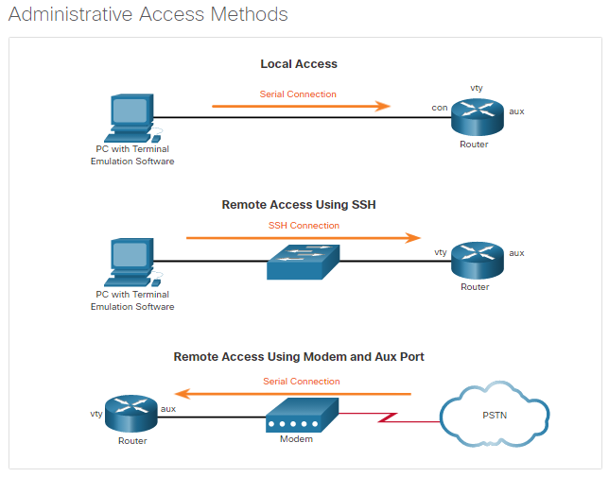Some remote access protocols send data, including usernames and passwords, to the router in plaintext. If an attacker can collect network traffic while an administrator is remotely logging in to a router, the attacker can capture passwords or router configuration information. For this reason, it is preferable to allow only local access to the router. However, in some situations, remote access might still be necessary. Precautions should be taken when accessing the network remotely:

* Encrypt all traffic between the administrator computer and the router. For example, instead of using Telnet, use SSH version 2; or instead of using HTTP, use HTTPS.
* Establish a dedicated management network. The management network should include only identified administration hosts and connections to a dedicated interface on the router. Access to this network can be strictly controlled.
* Configure a packet filter to allow only the identified administration hosts and preferred protocols to access the router. For example, permit only SSH requests from the IP address of an administration host to initiate a connection to the routers in the network.
* Configure and establish a VPN connection to the local network before connecting to a router management interface.

These precautions are valuable, but they do not protect the network completely. Other methods of defense must also be implemented. One of the most basic and important methods is the use of secure passwords.

## 4.2) Configure Secure Administrative Access

### 4.2.1. Passwords

To protect network devices, it is important to use strong passwords. Here are standard guidelines to follow:

* Use a password length of at least eight characters, preferably 10 or more characters. A longer password is a more secure password.
* Make passwords complex. Include a mix of uppercase and lowercase letters, numbers, symbols, and spaces, if allowed.
* Avoid passwords based on repetition, common dictionary words, letter or number sequences, usernames, relative or pet names, biographical information, such as birthdates, ID numbers, ancestor names, or other easily identifiable pieces of information.
* Deliberately misspell a password. For example, Smith = Smyth = 5mYth or Security = 5ecur1ty.
* Change passwords often. If a password is unknowingly compromised, the window of opportunity for the threat actor to use the password is limited.
* Do not write passwords down and leave them in obvious places such as on the desk or monitor.

The tables show examples of strong and weak passwords.

| **Weak Password** | **Why it is Weak** |
| --- | --- |
| secret | Simple dictionary password |
| smith | Maiden name of mother |
| toyota | Make of a car |
| bob1967 | Name and birthday of the user |
| Blueleaf23 | Simple words and numbers |
| **Strong Password** | **Why it is Strong** |
| b67n42d39c | Combines alphanumeric characters |
| 12^h u4@1p7 | Combines alphanumeric characters, symbols, and includes a space |

On Cisco routers, leading spaces are ignored for passwords, but spaces after the first character are not. Therefore, one method to create a strong password is to use the space bar and create a phrase made of many words. This is called a passphrase. A passphrase is often easier to remember than a simple password. It is also longer and harder to guess.

**PasswordManagers**  
Use a password manager to secure passwords for your online internet activity. Considered to be the best practice to secure passwords, the password manager automatically generates complex passwords for you and will automatically enter them when you access those sites. You only have to enter a primary password to enable this feature.

**Multi-Factor Authentication**  
Use multi-factor authentication when available. This means that authentication requires two or more independent means of verification. For example when you enter a password, you would also have to enter a code that is sent to you through email or text message.

### 4.2.2. Configure Passwords

When you initially connect to a device, you are in user EXEC mode. This mode is secured using the console.

To secure user EXEC mode access, enter line console configuration mode using the **line console 0** global configuration command, as shown in the example. The zero is used to represent the first (and in most cases the only) console interface. Next, specify the user EXEC mode password using the **password** *password* command. Finally, enable user EXEC access using the **login** command.

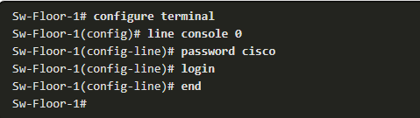

Console access will now require a password before allowing access to the user EXEC mode.

To have administrator access to all IOS commands including configuring a device, you must gain privileged EXEC mode access. It is the most important access method because it provides complete access to the device.

To secure privileged EXEC access, use the **enable secret** *password* global config command, as shown in the example.

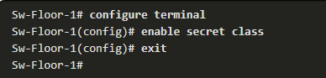

Virtual terminal (VTY) lines enable remote access using Telnet or SSH to the device. Many Cisco switches support up to 16 VTY lines that are numbered 0 to 15. Most routers support four VTY lines that are number 0 to 4. In this example, we are configuring an access layer switch.

To secure VTY lines, enter line VTY mode using the **line vty 0 15** global config command. Next, specify the VTY password using the **password** *password* command. Last, enable VTY access using the **login** command.

An example of securing the VTY lines on a switch is shown.

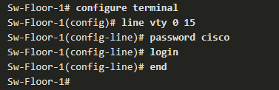

### 4.2.3. Encrypt Passwords

Strong passwords are only useful if they are secret. There are several steps that can be taken to help ensure that passwords remain secret on a Cisco router and switch including these:

* Encrypting all plaintext passwords
* Setting a minimum acceptable password length
* Deterring brute-force password guessing attacks
* Disabling an inactive privileged EXEC mode access after a specified amount of time.

The startup-config and running-config files display most passwords in plaintext. This is a security threat because anyone can discover the passwords if they have access to these files.

To encrypt all plaintext passwords, use the **service password-encryption** global config command as shown in the example.

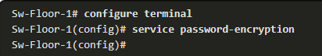

The command applies weak encryption to all unencrypted passwords. This encryption applies only to passwords in the configuration file, not to passwords as they are sent over the network. The purpose of this command is to keep unauthorized individuals from viewing passwords in the configuration file.

Use the **show running-config** command to verify that passwords are now encrypted.

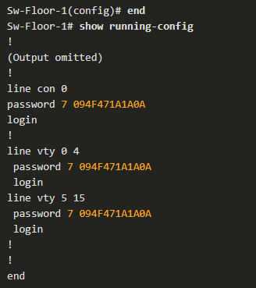

### 4.2.4. Additional Password Security

As shown in the sample configuration, the **service password-encryption** global configuration command prevents unauthorized individuals from viewing plaintext passwords in the configuration file. This command encrypts all plaintext passwords. Notice in the example, that the password "cisco" has been encrypted as "094F471A1A0A".

To ensure that all configured passwords are a minimum of a specified length, use the **security passwords min-length** *length* command in global configuration mode.

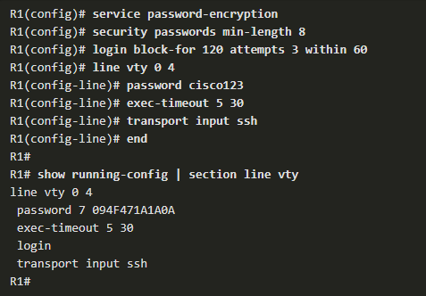Threat actors may use password cracking software to conduct a brute-force attack on a network device. This attack continuously attempts to guess the valid passwords until one works. Use the **login block-for** *seconds* **attempts** *number* **within** *seconds* global configuration command to deter this type of attack.

Network administrators can become distracted and accidently leave a privileged EXEC mode session open on a terminal. This could enable an internal threat actor access to change or erase the device configuration. By default, Cisco routers will logout an EXEC session after 10 minutes of inactivity. However, you can reduce this setting using the **exec-timeout** *minutes seconds* line configuration command. This command can be applied online console, auxiliary, and vty lines.

For example, the following commands configure:

* All plaintext passwords are encrypted.
* New configured passwords must be eight characters or more.
* If there are more than three failed VTY login attempts within 60 seconds, then lockout the VTY lines for 120 seconds.
* Set the router to automatically disconnect an inactive user on a VTY line if the line has been idle for 5 minutes and 30 seconds.

### 4.2.5. Secret Password Algorithms

MD5 hashes are no longer considered secure because attackers can reconstruct valid certificates. This can allow attackers to spoof any website. The **enable secret** password command shown in the figure uses an MD5 hash by default. Therefore, it is now recommended that you configure all secret passwords using either type 8 or type 9 passwords. Type 8 and type 9 were introduced in Cisco IOS 15.3(3)M. Type 8 and type 9 use SHA encryption. Because type 9 is slightly stronger than type 8, it will be used throughout this course whenever it is allowed by the Cisco IOS.

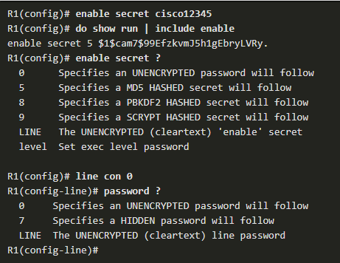

The figure shows that configuring type 9 encryption is not as easy as it may appear. You cannot simply enter enable secret 9 and the unencrypted password. To use this form of the command, you must paste in the encrypted password, which can be copied from another router configuration.

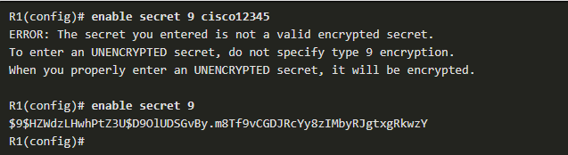

To enter an unencrypted password, use the **enable algorithm-type** command syntax:

Router(config)# **enable algorithm-type** { **md5** | **scrypt** | **sha256** | **secret** } *unencrypted password*

|  |  |
| --- | --- |
| **Algorithm Keyword** | **Description** |
| **md5** | Type 5; selects the message digest algorithm 5 (MD5) as the hashing algorithm. |
| **scrypt** | Type 9; selects scrypt as the hashing algorithm. |
| **sha256** | Type 8; selects Password-Based Key Derivation Function 2 (PBKDF2) with Secure Hash Algorithm, 256-bits (SHA-256) as the hashing algorithm. |

An example configuration is shown in the figure. Notice that the running configuration now shows a type 9 enable secret password.

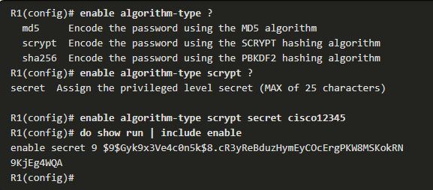

Type 8 and type 9 encryption was also introduced in Cisco IOS 15.3(3)M for the **username secret** command. Similar to the enable secret command, if you simply enter a user with the username secret command, the default encryption will be MD5. Use the **username** name **algorithm-type** command to specify type 9 encryption. The syntax is shown followed by an example.

Router(config)# **username** name **algorithm-type** { **md5** | **scrypt** | **sha256** | **secret** } unencrypted password

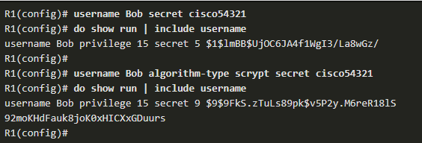

For backwards compatibility reasons, the **enable password**, **username password**, and **line password** commands are available in the Cisco IOS. These commands use no encryption by default. At best, they can only use type 7 encryption, as shown in the figure. Therefore, these commands will not be used in this course.

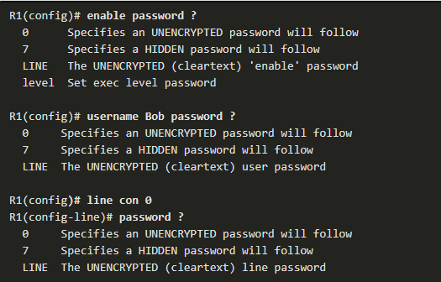

## 4.3) Configure Enhanced Security for Virtual Logins

### 4.3.1. Enhance the Login Process

Assigning passwords and local authentication does not prevent a device from being targeted for attack. The Cisco IOS login enhancements provide more security by slowing down attacks, such as dictionary attacks and DoS attacks. Enabling a detection profile allows you to configure a network device to react to repeated failed login attempts by refusing further connection requests (or login blocking). This block can be configured for a period of time, which is called a quiet period. Access control lists (ACLs) can be used to permit legitimate connections from addresses of known system administrators.

Banners are disabled by default and must be explicitly enabled. Use the **banner** global configuration mode command to specify appropriate messages.

Router(config)# **banner** { **motd** | **exec** | **login** } delimiter message delimiter

Banners protect the organization from a legal perspective. Choosing the appropriate wording to place in banner messages is important and should be reviewed by legal counsel before being placed on network routers. Never use the word welcome or any other familiar greeting that may be misconstrued as an invitation to use the network.

### 4.3.2. Configure Login Enhancement Features

The Cisco IOS login enhancements commands, which are shown below, increase the security of virtual login connections.

Router(config)# **login block-for** seconds **attempts** tries **within** seconds  
 Router(config)# **login quiet-mode access-class** {acl-name | acl-number}  
 Router(config)# **login delay** seconds  
 Router(config)# **login on-success log** [**every** login]  
 Router(config)# **login on-failure log** [**every** login]

The figure shows an example configuration. The **login block-for** command can defend against DoS attacks by disabling logins after a specified number of failed login attempts. The **login quiet-mode** command maps to an ACL that identifies the permitted hosts. This ensures that only authorized hosts can attempt to login to the router. The **login delay** command specifies a number of seconds the user must wait between unsuccessful login attempts. The **login on-success** and **login on-failure** commands log successful and unsuccessful login attempts.

These login enhancements do not apply to console connections. When dealing with console connections, it is assumed that only authorized personnel have physical access to the devices.

**Note**: These login enhancements can only be enabled if the local database is used for authentication for local and remote access. If the lines are configured for password authentication only, then the enhanced login features are not enabled.

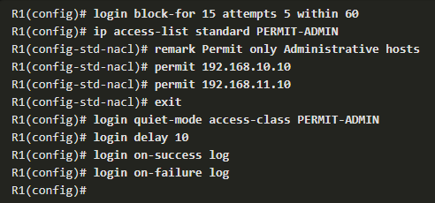

### 4.3.3. Enable Login Enhancements

To help a Cisco IOS device provide DoS detection, use the **login block-for** command. All other login enhancement features are disabled until the **login block-for** command is configured.

Specifically, the **login block-for** command monitors login device activity and operates in two modes:

* **Normal mode** - This is also known as watch mode. The router keeps count of the number of failed login attempts within an identified amount of time.
* **Quiet mode** - This is also known as the quiet period. If the number of failed logins exceeds the configured threshold, all login attempts using Telnet, SSH, and HTTP are denied for the time specified in the **login block-for** command.

When quiet mode is enabled, all login attempts, including valid administrative access, are not permitted. However, to provide critical hosts, such as specific administrative hosts access at all times, this behavior can be overridden using an ACL. The ACL is created and identified using the **login quiet-mode access-class** command. Only the hosts identified in the ACL have access to the device during quiet mode.

The example in the figure shows a configuration that uses an ACL that is named PERMIT-ADMIN. Hosts that match the PERMIT-ADMIN conditions are exempt from quiet mode.

R1(config)# **ip access-list standard PERMIT-ADMIN**

R1(config-std-nacl)# **remark Permit only Administrative hosts**

R1(config-std-nacl)# **permit 192.168.10.10**

R1(config-std-nacl)# **permit 192.168.11.10**

R1(config-std-nacl)# **exit**

R1(config)# **login quiet-mode access-class**  **PERMIT-ADMIN**

When implementing the **login block-for** command, a one-second delay between login attempts is automatically invoked. To make it more difficult for an attacker, the delay time between login attempts can be increased using the **login delay** *seconds* command, as shown in the figure. The command introduces a uniform delay between successive login attempts. The delay occurs for all login attempts, including failed or successful attempts. The example configures, a delay of three seconds between successive login attempt.

This command helps mitigate dictionary attacks. It is an optional command. If it is not set, a default delay of one second is enforced after the **login block-for** command is configured.

The **login block-for**, **login quiet-mode access-class** and **login delay** commands help block failed login attempts for a limited period of time. However, they cannot prevent an attacker from trying again. How can an administrator know when someone tries to gain access to the network by guessing the password?

R1(config)# **login delay**  **3**

### 4.3.4. Log Failed Attempts

There are three commands that can be configured to help an administrator detect a password attack, as shown in the figure. Each command enables a device to generate syslog messages for failed or successful login attempts.

The first two commands, **login on-success log** and **login on-failure log**, generate syslog messages for successful and unsuccessful login attempts. The number of login attempts before a logging message is generated can be specified using the [**every** login] syntax, where the default login value is 1 attempt. The valid range is from 1 to 65,535.

Router(config)# **login on-success log** [**every** login]  
 Router(config)# **login on-failure log** [**every** login]

As an alternative to the **login on-failure log** command, the **security authentication failure rate** command can be configured to generate a log message when the login failure rate is exceeded.

Router(config)# **security authentication failure rate threshold-rate log**

Use the **show login** command to verify the **login block-for** command settings and current mode. In the figure, R1 was configured to block login hosts for 120 seconds if more than five login requests fail within 60 seconds. R1 also confirms that the current mode is normal and that there have been four login failures within the last 55 seconds because there are five seconds left in normal mode.

R1# **show login**

A login delay for 10 sec is applied.

Quiet-Mode access list PERMIT-ADMIN is applied.

Router enabled to watch for login Attacks.

If more than 5 login failures occur in 60 sec or less,

login will be disabled for 120 secs.

Router presently in Normal-Mode.

Current Watch Window

Time remaining: 5 seconds.

Login failures for current window: 4.

Total login failures:4.

The following command output displays the resulting status using the **show login** command. Notice that it is now in quiet mode and will remain in quiet mode for another 105 seconds. R1 also identifies that the PERMIT-ADMIN ACL contains a list of hosts allowed to connect during quiet mode.

R1#

*Dec 10 15:38:54.455: %SEC_LOGIN-1-QUIET_MODE_ON: Still timeleft for watching failures

is 12 secs, [user: admin] [Source: 10.10.10.10] [localport: 23] [Reason: Login

Authentication Failed - BadUser] [ACL: PERMIT-ADMIN] at 15:38:54 UTC Wed Dec 10 2008

R1# **show login**

A login delay of 3 seconds is applied.

Quiet-Mode access list PERMIT-ADMIN is applied.

Router enabled to watch for login Attacks.

If more than 5 login failures occur in 60 seconds or

less,logins will be disabled for 120 seconds.

Router presently in Quiet-Mode.

Will remain in Quiet-Mode for 105 seconds.

Restricted logins filtered by applied ACL PERMIT-ADMIN.

R1#

The **show login failures** command displays additional information regarding the failed attempts, such as the IP address from which the failed login attempts originated. The figure displays sample output of the **show login failures** command.

R1# **show login failures**

Total failed logins: 22

Detailed information about last 50 failures

Username SourceIPAddr lPort Count TimeStamp

admin 1.1.2.1 23 5 15:38:54 UTC Wed Dec 10 2008

Admin 10.10.10.10 23 13 15:58:43 UTC Wed Dec 10 2008

admin 10.10.10.10 23 3 15:57:14 UTC Wed Dec 10 2008

cisco 10.10.10.10 23 1 15:57:21 UTC Wed Dec 10 2008

R1#

## 4.4) Configure SSH

### 4.4.1. Enable SSH

Telnet simplifies remote device access, but it is not secure. Data contained within a Telnet packet is transmitted unencrypted. For this reason, it is highly recommended to enable Secure Shell (SSH) on devices for secure remote access.

It is possible to configure a Cisco device to support SSH using the following six steps:

**Step 1.** **Configure a unique device hostname**. A device must have a unique hostname other than the default.

**Step 2. Configure the IP domain name**. Configure the IP domain name of the network by using the global configuration mode command **ip domain name** name. In the example, router R1 is configured in the span.com domain. This information is used along with the bit value specified in the **crypto key generate rsa general-keys modulus** command to create an encryption key

**Step 3. Generate a key to encrypt SSH traffic**. SSH encrypts traffic between source and destination. However, to do so, a unique authentication key must be generated by using the global configuration command **crypto key generate rsa general-keys modulus** bits. The modulus bits determines the size of the key and can be configured from 360 bits to 2048 bits. The larger the bit value, the more secure the key. However, larger bit values also take longer to encrypt and decrypt information. The minimum recommended modulus length is 1024 bits.

**Step 4.** **Verify or create a local database entry**. Create a local database username entry using the **username** global configuration command. In the example, the parameter **secret** is used so that the password will be encrypted using MD5.

**Step 5.** **Authenticate against the local database**. Use the **login local** line configuration command to authenticate the vty line against the local database.

**Step 6. Enable vty inbound SSH sessions**. By default, no input session is allowed on vty lines. You can specify multiple input protocols including Telnet and SSH using the **transport input {ssh | telnet}** command.

Router# **configure terminal**

Router(config)# **hostname R1**

R1(config)# **ip domain name span.com**

R1(config)# **crypto key generate rsa general-keys modulus 1024**

The name for the keys will be: Rl.span.com % The key modulus size is 1024 bits

% Generating 1024 bit RSA keys, keys will be non-exportable...[OK]

Dec 13 16:19:12.079: %SSH-5-ENABLED: SSH 1.99 has been enabled

R1(config)#

R1(config)# **username Bob secret cisco**

R1(config)# **line vty 0 4**

R1(config-line)# **login local**

R1(config-line)# **transport input ssh**

R1(config-line)# **exit**

R1(config)#

To verify SSH and display the generated keys, use the **show crypto key mypubkey rsa** command in privileged EXEC mode. If there are existing key pairs, it is recommended that they are overwritten using the **crypto key zeroize rsa** command. If there are existing key pairs, it is recommended that they are removed using the **crypto key zeroize rsa** command. Figure 2 provides an example of verifying the SSH crypto keys and removing the old keys.

R1# **show crypto key mypubkey rsa**

% Key pair was generated at: 21:18:41 UTC Feb 16 2015

Key name: R1.span.com

Key type: RSA KEYS

Storage Device: not specified

Usage: General Purpose Key

Key is not exportable.

Key Data:

30819F30 0D06092A 864886F7 0D010101 05000381 8D003081 89028181 00CF35DB

A58A1BDB F7C7E600 F189C2F3 2EC6E584 D923EE5B 71841D98 B5472A03 D19CD620

ED125825 5A58412B B7F29234 DE2A1809 6C421AC3 07F298E6 80BE149D 2A262E13

74888DAF CAC8F187 B11111AF A413E76F 6C157CDF DFEF0D82 2961B58C BE1CAD21

176E82B9 6D81F893 06E66C93 94E1C508 887462F6 90AC63CE 5E169845 C1020301 0001

% Key pair was generated at: 21:18:42 UTC Feb 16 2015

Key name: R1.span.com.server

Key type: RSA KEYS

Temporary key

Usage: Encryption Key

Key is not exportable.

Key Data:

307C300D 06092A86 4886F70D 01010105 00036B00 30680261 00AB914D 8172DFBE

DE57ACA9 7B844239 1F3B5942 3943AC0D F54E7746 3895CF54 606C3961 8A44FEB3

1A019F27 D9E71AAE FC73F423 A59CB8F5 50289272 3392CEBC 4C3CBD6D DB9233DE

9DDD9DAD 79D56165 4293AA62 FD1CBAB2 7AB859DC 2890C795 ED020301 0001

R1# **conf t**

Enter configuration commands, one per line. End with CNTL/Z.

R1(config)# **crypto key zeroize rsa**

% All keys will be removed.

% All router certs issued using these keys will also be removed.

Do you really want to remove these keys? [yes/no]: **yes**

R1(config)#

### 4.4.2. Enhance SSH Login Security

To verify the optional SSH command settings, use the **show ip ssh** command, as shown in the figure. You can also modify the default SSH timeout interval and the number of authentication tries. Use the **ip ssh time-out** seconds global configuration mode command to modify the default 120-second timeout interval. This configures the number of seconds that SSH can use to authenticate a user. After it is authenticated, an EXEC session starts and the standard exec-timeout configured for the vty applies.

By default, a user logging in has three attempts to enter the correct password before being disconnected. To configure a different number of consecutive SSH retries, use the **ip ssh authentication-retries** integer global configuration mode command.

R1# **show ip ssh**

SSH Enabled - version 2.0

Authentication methods:publickey,keyboard-interactive,password

Authentication timeout: 120 secs; Authentication retries: 3

(output omitted)

R1# **conf t**

Enter configuration commands, one per line. End with CNTL/Z.

R1(config)# **ip ssh time-out 60**

R1(config)# **ip ssh authentication-retries 2**

R1(config)# **^Z**

R1#

*Feb 16 21:23:51.237: %SYS-5-CONFIG_I: Configured from console by console

R1# **show ip ssh**

SSH Enabled - version 2.0

Authentication methods:publickey,keyboard-interactive,password

Authentication timeout: 60 secs; Authentication retries: 2

(output omitted)

### 4.4.3. Connect a Router to an SSH-Enabled Router

To verify the status of the client connections, use the **show ssh** command. There are two different ways to connect to an SSH-enabled router.

By default, when SSH is enabled, a Cisco router can act as an SSH server or SSH client. As a server, a router can accept SSH client connections. As a client, a router can connect via SSH to another SSH-enabled router shown in the following three steps.

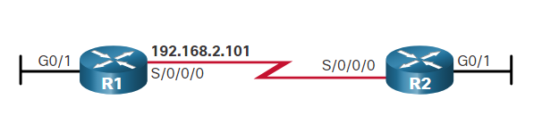

In the following examples, the administrator on R1 uses the **show ssh** command to check for current SSH connections. Then another administrator logs into R1 from R2. The administrator on R1 checks again for current SSH connections.

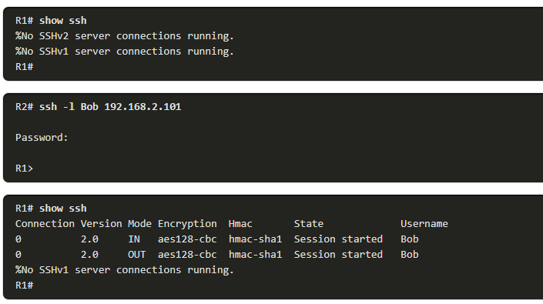

## 4.5) What Did I Learn in this Module?

**Secure the Edge Router**  
Routers are a primary target for attacks because these devices act as traffic police, which direct traffic into, out of, and between networks. The edge router is the last router between the internal network and an untrusted network, such as the internet. Securing the router is imperative. The three approaches to this are the single router approach, defense-in-depth approach, and the DMZ approach. In the single router approach, all security is configured on this router. This is common for smaller sites such as SOHO sites. A defense-in-depth approach is more secure than the single router approach. It uses multiple layers of security prior to traffic entering the protected LAN. There are three primary layers of defense: the edge router, the firewall, and an internal router that connects to the protected LAN. Other security tools, such as intrusion prevention systems (IPSs), web security appliances (proxy servers), and email security appliances (spam filtering) can also be implemented. The DMZ approach includes an intermediate area, often called the demilitarized zone (DMZ). The DMZ can be set up between two routers, with an internal router connecting to the protected network and an external router connecting to the unprotected network. Alternatively, the DMZ can simply be an additional port off of a single router. The firewall serves as the primary protection for all devices in the DMZ. The three areas of router security that must be maintained are physical security, operating system security, and router hardening. Securing administrative access to prevent an unauthorized person from gaining access to an infrastructure device includes restricting device accessibility, logging and accounting for all access, authenticating access, authorizing actions, presenting legal notification, and ensuring the confidentiality of data. A router can be accessed for administrative purposes locally or remotely. Additional precautions should be taken when accessing the network remotely.

**Configure Secure Administrative Access**  
To protect network devices, it is important to use strong passwords. The standard guidelines to follow are using longer passwords (10 or more characters), complex passwords, avoid common dictionary words, change passwords often, and keep passwords confidential. Passwords and VTY lines should be secured. To encrypt all plaintext passwords, use the **service password-encryption** global config command. Use the **show running-config** command to verify that passwords are now encrypted. The **service password-encryption** global configuration command prevents unauthorized individuals from viewing plaintext passwords in the configuration file. MD5 hashes are no longer considered secure because attackers can reconstruct valid certificates. It is now recommended that you configure all secret passwords using either type 8 or type 9 passwords.

**Configure Enhanced Security for Virtual Logins**  
The Cisco IOS login enhancements provide more security by slowing down attacks, such as dictionary attacks and DoS attacks. Enabling a detection profile allows you to configure a network device to react to repeated failed login attempts by refusing further connection requests (or login blocking). This block can be configured for a period of time, which is called a quiet period. Access control lists (ACLs) can be used to permit legitimate connection from addresses of known system administrators. Banners protect the organization from a legal perspective. The Cisco IOS login enhancements commands increase the security of virtual login connections. The **login block-for** command can defend against DoS attacks by disabling logins after a specified number of failed login attempts. The **login quiet-mode** command maps to an ACL that identifies the permitted hosts. This ensures that only authorized hosts can attempt to login to the router. The **login delay** command specifies a number of seconds the user must wait between unsuccessful login attempts. The **login on-success** and **login on-failure** commands log successful and unsuccessful login attempts. To enhance security, you can also modify the default SSH timeout interval and the number of authentication tries. Use the i**p ssh time-out** seconds global configuration mode command to modify the default 120-second timeout interval. There are two different ways to connect to an SSH-enabled router. By default, when SSH is enabled, a Cisco router can act as an SSH server or SSH client. As a server, a router can accept SSH client connections. As a client, a router can connect via SSH to another SSH-enabled router

**Configure SSH**  
Telnet simplifies remote device access, but it is not secure. Data contained within a Telnet packet is transmitted unencrypted. For this reason, it is highly recommended to enable Secure Shell (SSH) on devices for secure remote access. It is possible to configure a Cisco device to support SSH using the following six steps: configure a unique device hostname, configure the IP domain name, generate a key to encrypt SSH traffic, verify or create a local database entry, authenticate against the local database, and enable vty inbound SSH sessions.

# 5. Assigning Administrative Roles

## 5.0) Introduction

### 5.0.1. Why Should I Take this Module?

In this module, you will learn how to configure administrative privilege levels and role-based CLI. These steps are critical of limiting access to network devices based on the job role of administrative users. Let’s get started!

### 5.0.2. What Will I Learn in this Module?

**Module Title:** Assigning Administrative Roles

**Module Objective**: Configure command authorization using privilege levels and role-based CLI.

| **Topic Title** | **Topic Objective** |
| --- | --- |
| **Configure Privilege Levels** | Use the correct commands to configure administrative privilege levels to control command availability. |
| **Configure Role-Based CLI** | Use the correct commands to configure role-based CLI access to control command availability. |

5.1) Configure Privilege Levels

### 5.1.1. Limiting Command Availability

Large organizations have many varied job functions within an IT department. Not all job functions should have the same level of access to the infrastructure devices. Cisco IOS software has two methods of providing infrastructure access: privilege level and role-based CLI. Both methods help determine who should be allowed to connect to the device and what that person should be able to do with it. Role-based CLI access provides more granularity and control.

By default, the Cisco IOS software CLI has two levels of access to commands:

* **User EXEC mode (privilege level 1)** - This provides the lowest EXEC mode user privileges and allows only user-level commands available at the Router> prompt.
* **Privileged EXEC mode (privilege level 15)** - This includes all enable-level commands at the Router# prompt.

There are 16 privilege levels in total, as listed below. The higher the privilege level, the more router access a user has. Commands that are available at lower privilege levels are also executable at higher levels.

* **Level 0:** Predefined for user-level access privileges. Seldom used, but includes five commands: **disable**, **enable**, **exit**, **help**, and **logout**.
* **Level 1**: The default level for login with the router prompt Router >. A user cannot make any changes or view the running configuration file.
* **Levels 2 -14**: May be customized for user-level privileges. Commands from lower levels may be moved up to another higher level, or commands from higher levels may be moved down to a lower level.
* **Level 15**: Reserved for the enable mode privileges (**enable** command). Users can change configurations and view configuration files.

To assign commands to a custom privilege level, use the **privilege** global configuration mode command shown below.

Router(config)# **privilege** *mode* {**level** *level*|**reset**} *command*

| **Command** | **Description** |
| --- | --- |
| *mode* | Specifies the configuration mode. Use the **privilege** **?** command to see a complete list of router configuration modes available on your router. |
| **level** | (Optional) Enables setting a privilege level with a specified command. |
| *level* | (Optional) The privilege level that is associated with a command. You can specify up to 16 privilege levels, using numbers 0 to 15. |
| **reset** | (Optional) Resets the privilege level of a command. |
| *command* | (Optional) Argument to use when you want to reset the privilege level. |

### 5.1.2. Configuring and Assigning Privilege Levels

To configure a privilege level with specific commands, use the **privilege exec level** *level* **[***command***]**. The example shows examples for three different privilege levels.

* Privilege level 5 has access to all the commands available for the predefined level 1 and the **ping** command.
* Privilege level 10 has access to all the commands available for level 5 as well as the **reload** command.
* Privilege level 15 is predefined and does not need to be explicitly configured. This privilege level has access to all commands including viewing and changing the configuration.
* R1# **conf t**  
   R1(config)# !Level 5 and SUPPORT user configuration  
   R1(config)# **privilege exec level 5 ping**  
   R1(config)# **enable algorithm-type scrypt secret level 5 cisco5**  
   R1(config)# **username SUPPORT privilege 5 algorithm-type scrypt secret cisco5**  
   R1(config)# !Level 10 and JR-ADMIN user configuration  
   R1(config)# **privilege exec level 10 reload**   
   R1(config)# **enable algorithm-type scrypt secret level 10 cisco10**   
   R1(config)# **username JR-ADMIN privilege 10 algorithm-type scrypt secret cisco10**   
   R1(config)# !Level 15 and ADMIN user configuration  
   R1(config)# **enable algorithm-type scrypt secret level 15 cisco123**  
   R1(config)# **username ADMIN privilege 15 algorithm-type scrypt secret cisco123**

There are two methods for assigning passwords to the different privilege levels:

* To a user that is granted a specific privilege level, use the **username** *name* **privilege** *level* **secret** *password* global configuration mode command
* To the privilege level, use the **enable secret level** *level password* global configuration mode command

**Note**: Both the **username secret** and the **enable secret** commands are configured for type 9 encryption.

Use the **username** command to assign a privilege level to a specific user. Use the **enable secret** command to assign a privilege level to a specific EXEC mode password. For example, the SUPPORT user is assigned privilege level 5 with the password cisco5. However, as shown in the example below, any user can access privilege level 5 if that user knows that the enable secret password is cisco5. The example also demonstrates that privilege level 5 cannot reload the router.

R1> **enable 5**

Password: <cisco5>

R1**# show privilege** Current privilege level is 5

R1# **ping 10.1.1.1**

Type escape sequence to abort.

Sending 5, 100-byte ICMP Echos to 10.1.1.1, timeout is 2 seconds:

!!!!!

Success rate is 100 percent (5/5), round-trip min/avg/max = 1/2/4 ms

R1# **reload**

Translating "reload"

% Bad IP address or host name

Translating "reload"

% Unknown command or computer name, or unable to find computer address

R1#

In the example below, the user enables privilege level 10 which has access to the **reload** command. However, users at privilege level 10 cannot view the running configuration.

R1# **enable 10**

Password: <cisco10>

R1# **show privilege**

Current privilege level is 10

R1# **ping 10.1.1.1**

Type escape sequence to abort.

Sending 5, 100-byte ICMP Echos to 10.1.1.1, timeout is 2 seconds:

!!!!!

Success rate is 100 percent (5/5), round-trip min/avg/max = 1/2/4 ms

R1# **reload**

System configuration has been modified. Save? [yes/no]: ^C

R1# **show running-config**

^

% Invalid input detected at '^' marker.

R1#

In the next example, the user enables privilege level 15 which has full access to view and change the configuration, including viewing the running configuration.

R1# **enable 15**

Password:

R1# **show privilege**

Current privilege level is 15

R1# **show running-config** Building configuration...

Current configuration : 1979 bytes

!

! Last configuration change at 15:30:07 UTC Tue Feb 17 2015

!

version 15.4

R1#

### 5.1.3. Limitations of Privilege Levels

The use of privilege levels has its limitations:

* There is no access control to specific interfaces, ports, logical interfaces, and slots on a router.
* Commands available at lower privilege levels are always executable at higher levels.
* Commands specifically set at a higher privilege level are not available for lower privileged users.
* Assigning a command with multiple keywords allows access to all commands that use those keywords. For example, allowing access to **show ip route** allows the user access to all **show** and **show ip** commands.

**Note**: If an administrator must create a user account that has access to most but not all commands, privilege exec statements need to be configured for every command that must be executed at a privilege level lower than 15.

## 5.2) Configure Role-Based CLI

### 5.2.1. Role-Based CLI Access

In an effort to provide more flexibility than privilege levels allow, Cisco introduced the role-based CLI access feature in Cisco IOS Release 12.3(11)T. This feature provides finer, more granular access by controlling which commands are available to specific roles. Role-based CLI access enables the network administrator to create different views of router configurations for different users. Each view defines the CLI commands that each user can access.

**Security**: Role-based CLI access enhances the security of the device by defining the set of CLI commands that are accessible by a specific user. Additionally, administrators can control user access to specific ports, logical interfaces, and slots on a router. This prevents a user from accidentally or purposely changing a configuration or collecting information to which they should not have access.

**Availability**: Role-based CLI access prevents unintentional execution of CLI commands by unauthorized personnel and minimizes downtime.

**Operational Efficiency**: Users only see the CLI commands applicable to the ports and CLI to which they have access. Therefore, the router appears to be less complex, and commands are easier to identify when using the help feature on the device.

### 5.2.2. Role-Based Views

Role-based CLI provides three types of views that dictate which commands are available:

**Root View**: To configure any view for the system, the administrator must be in root view. Root view has the same access privileges as a user who has level 15 privileges. However, a root view is not the same as a level 15 user. Only a root view user can configure a new view and add or remove commands from the existing views.

**CLI View**: A specific set of commands can be bundled into a CLI view. Unlike privilege levels, a CLI view has no command hierarchy and no higher or lower views. Each view must be assigned all commands associated with that view. A view does not inherit commands from any other view. Additionally, the same commands can be used in multiple views.

**Superview**: A superview consists of one or more CLI views. Administrators can define which commands are accepted and which configuration information is visible. Superviews allow a network administrator to assign users and groups of users multiple CLI views at once, instead of having to assign a single CLI view per user with all commands associated with that one CLI view.

Superviews have several specific characteristics:

* A single CLI view can be shared within multiple superviews.
* Commands cannot be configured for a superview. An administrator must add commands to the CLI view and add that CLI view to the superview.
* Users who are logged into a superview can access all the commands that are configured for any of the CLI views that are part of the superview.
* Each superview has a password that is used to switch between superviews or from a CLI view to a superview.
* Deleting a superview does not delete the associated CLI views. The CLI views remain available to be assigned to another superview.

### 5.2.3. Configure Role-Based Views

Before an administrator can create a view, AAA must be enabled using the **aaa new-model** command. To configure and edit views, an administrator must log in as the root view using the **enable view** privileged EXEC command. The **enable view root** command can also be used. When prompted, enter the **enable secret** password.

There are five steps to create and manage a specific view.

**Step 1.** Enable AAA with the **aaa new-model** global configuration mode command. Exit and enter the root view with the **enable view** command.

| **Parameter** | **Description** |
| --- | --- |
| **view** | This parameter enters root view if no view-name is specified, which enables an administrator to configure CLI views. The view parameter is required to configure a CLI view. |
| *view-name* | (Optional) This parameter enters or exits a specified CLI view. This parameter can be used to switch from one CLI view to another CLI view. |

Router# **enable** [**view** [*view-name*]]

**Step 2.** Create a view using the **parser view** *view-name* global configuration mode command. This enables the view configuration mode. Excluding the root view, there is a maximum limit of 15 views in total.

Router(config)# **parser view** *view-name*

**Step 3.** Assign a secret password to the view using the **secret** *password* view configuration mode command.

This sets a password to protect access to the view. The password must be created immediately after creating a view, otherwise, an error message will appear.

Router(config-view)# **secret** *password*

**Step 4.** Assign commands to the selected view using the **commands** *parser-mode* command in view configuration mode.

Router(config-view)# **commands** *parser-mode* {**include** | **include-exclusive** | **exclude**} [**all**] [**interface** *interface-name* | *command*]

| **Commands** | **Description** |
| --- | --- |
| **commands** | Adds commands or interfaces to a view. |
| *parser-mode* | The mode in which the specified command exists; for example, EXEC mode. |
| **include** | Adds a command or an interface to the view and allows the same command or interface to be added to other views. |
| **include-exclusive** | Adds a command or an interface to the view and excludes the same command or interface from being added to all other views. |
| **exclude** | Excludes a command or an interface from the view. |
| **all** | A "wildcard" that allows every command in a specified configuration mode that begins with the same keyword or every subinterface for a specified interface to be part of the view. |
| **interface** *interface-name* | Interface that is added to the view. |
| *command* | Command that is added to the view. |

**Step 5.** Exit view configuration mode by typing the **exit** command.

The example below shows the configuration of three views. Notice in the example, that the **secret** command only supports MD5 encryption (type 5). Also, notice that when a command was added to a view before the password was assigned, an error occurred.

R1(config)# **aaa new-model**

R1(config)# **parser view SHOWVIEW**

R1(config-view)#  **secret ?**

0 Specifies an UNENCRYPTED password will follow

5 Specifies an ENCRYPTED secret will follow

LINE The UNENCRYPTED (cleartext) view secret string

R1(config-view)# **secret cisco**

R1(config-view)# **commands exec include show**

R1(config-view)# **exit**

R1(config)#  **parser view VERIFYVIEW**

R1(config-view)#  **commands exec include ping**

% Password not set for the view VERIFYVIEW

R1(config-view)#  **secret cisco5**

R1(config-view)#  **commands exec include ping**

R1(config-view)# **exit**

R1(config)# **parser view REBOOTVIEW**

R1(config-view)# **secret cisco10**

R1(config-view)# **commands exec include reload**

R1(config-view)# **exit**

R1(config)#

Verify the view configuration using the **show running-config** command.

R1# **show running-config**

<output omitted>

parser view SHOWVIEW

secret 5 $1$GL2J$8njLecwTaLAc0UuWo1/Fv0

commands exec include show

!

parser view VERIFYVIEW

secret 5 $1$d08J$1zOYSI4WainGxkn0Hu7lP1

commands exec include ping

!

parser view REBOOTVIEW

secret 5 $1$L7lZ$1Jtn5IhP43fVE7SVoF1pt.

commands exec include reload

!

### 5.2.4. Configure Role-Based CLI Superviews

The steps to configure a superview are essentially the same as configuring a CLI view, except that the **view** view-name command is used to assign commands to the superview. The administrator must be in root view to configure a superview. To confirm that root view is being used, use either the **enable view** or **enable view root** command. When prompted, enter the **secret** password.

There are four steps to create and manage a superview:

**Step 1**: Create a view using the **parser view** view-name **superview** command and enter superview configuration mode. Appending the keyword **superview** to parser view creates a superview and enters configuration mode.

Router(config)# **parser view** view-name **superview**

**Step 2**: Assign a secret password to the view using the **secret** password command. This sets a password to protect access to the superview. The password must be created immediately after creating a view; otherwise an error message will appear.

Router(config-view)# **secret** password

**Step 3**: Assign an existing view using the **view** view-name command in view configuration mode. This adds a CLI view to superview. Multiple views can be added. Views may be shared between superviews.

Router(config-view)# **view** view-name

**Step 4**: Exit superview configuration mode by typing the **exit** command.

More than one view can be assigned to a superview, and views can be shared between superviews. The example shows configuring three superviews: the USER, SUPPORT, and JR-ADMIN.

R1(config)# **parser view USER superview**

R1(config-view)# **secret cisco**

R1(config-view)# **view SHOWVIEW**

R1(config-view)# **exit**

R1(config)#

R1(config)# **parser view SUPPORT superview**

R1(config-view)# **secret cisco1**

R1(config-view)# **view** **SHOWVIE**

% Invalid view name SHOWVIE

R1(config-view)# **view** **SHOWVIEW**

R1(config-view)# **view** **VERIFYVIEW**

R1(config-view)# **exit**

R1(config)#

R1(config)# **parser view JR-ADMIN superview**

R1(config-view)# **secret cisco2**

R1(config-view)# **view SHOWVIEW**

R1(config-view)# **view VERIFYVIEW**

R1(config-view)# **view REBOOTVIEW**

R1(config-view)# **exit**

R1(config)#

The example below displays the configured superviews in the running configuration.

To access existing views, enter the **enable view** view-name command in user mode and enter the password that was assigned to the custom view. Use the same command to switch from one view to another.

R1# **show running-config**

<output omitted>

!

parser view SUPPORT superview

secret 5 $1$Vp1O$BBB1N68Z2ekr/aLHledts.

view SHOWVIEW

view VERIFYVIEW

!

parser view USER superview

secret 5 $1$E4k5$ukHyfYP7dHOC48N8pxm4s/

view SHOWVIEW

!

parser view JR-ADMIN superview

secret 5 $1$8kx2$rbAe/ji220OmQ1yw.568g0

view SHOWVIEW

view VERIFYVIEW

view REBOOTVIEW

!

### 5.2.5. Verify Role-Based CLI Views

To verify a view, use the **enable view** command. Enter the name of the view to verify, and provide the password to log into the view. Use the question mark (**?**) command to verify that the commands available in the view are correct.

The example enables the USER superview and lists the commands available in the view.

R1# **enable view USER**

Password: <cisco1>

R1# **?**

Exec commands:

<0-0>/<0-4> Enter card slot/sublot number

do-exec Mode-independent "do-exec" prefix support

enable Turn on privileged commands

exit Exit from the EXEC

show Show running system information

R1# **show ?** banner Display banner information

flash0: display information about flash0: file system

flash1: display information about flash1: file system

flash: display information about flash: file system

parser Display parser information

usbflash0: display information about usbflash0: file system

The example below enables the SUPPORT superview and lists the commands available in the view.

R1# **enable view SUPPORT**

Password: <cisco1>

R1# **?**

Exec commands:

<0-0>/<0-4> Enter card slot/sublot number

do-exec Mode-independent "do-exec" prefix support

enable Turn on privileged commands

exit Exit from the EXEC

ping Send echo messages

show Show running system information

R1#

This example enables the JR-ADMIN view and lists the commands available in the view.

R1# **enable view JR-ADMIN**

Password:

R1# **?**

Exec commands:

<0-0>/<0-4> Enter card slot/sublot number

do-exec Mode-independent "do-exec" prefix support

enable Turn on privileged commands

exit Exit from the EXEC

ping Send echo messages

reload Halt and perform a cold restart

show Show running system information

R1#

By not specifying a view for the **enable view** command, as shown here, you can log in as root. From the root view, use the **show parser view all** command to see a summary of all views. Notice how the asterisk identifies superviews.

R1# **show parser view**

Current view is 'JR-ADMIN'

R1# **enable view**

Password:

R1# **show parser view**

Current view is 'root'

R1# **show parser view all**

Views/SuperViews Present in System:

SHOWVIEW

VERIFYVIEW

REBOOTVIEW

USER *

SUPPORT *

JR-ADMIN *

-------(*) represent superview-------

R1#

5.3) What Did I Learn in this Module?

**Configure Privilege Levels**  
Cisco IOS software has two methods of providing infrastructure access: privilege level and role-based CLI. By default, the Cisco IOS software CLI has two levels of access to commands: User EXEC mode (privilege level 1) and Privileged EXEC mode (privilege level 15). There are 16 privilege levels in total. The higher the privilege level, the more router access a user has. To configure a privilege level with specific commands, use the **privilege exec level** *level* [*command*]. Use the **username** command to assign a privilege level to a specific user. Use the **enable secret** command to assign a privilege level to a specific EXEC mode password. The use of privilege levels has its limitations:

* There is no access control to specific interfaces, ports, logical interfaces, and slots on a router.
* Commands available at lower privilege levels are always executable at higher levels.
* Commands specifically set at a higher privilege level are not available for lower privileged users.
* Assigning a command with multiple keywords allows access to all commands that use those keywords. For example, allowing access to **show ip route** allows the user access to all **show** and **show ip** commands.

**Configure Role-Based CLI**  
In an effort to provide more flexibility than privilege levels allow, Cisco introduced the role-based CLI access feature in Cisco IOS Release 12.3(11)T. Role-based CLI access enables the network administrator to create different views of router configurations for different users. Role-based CLI provides three types of views that dictate which commands are available. Root view has the same access privileges as a user who has level 15 privileges. However, a root view is not the same as a level 15 user. Only a root view user can configure a new view and add or remove commands from the existing views. A specific set of commands can be bundled into a CLI view. Unlike privilege levels, a CLI view has no command hierarchy and no higher or lower views. A view does not inherit commands from any other view. A superview consists of one or more CLI views. Administrators can define which commands are accepted and which configuration information is visible. Superviews allow a network administrator to assign users and groups of users multiple CLI views at once, instead of having to assign a single CLI view per user with all commands associated with that one CLI view. Before an administrator can create a view, AAA must be enabled using the **aaa new-model** command. To configure and edit views, an administrator must log in as the root view using the **enable view** privileged EXEC command. The **enable view root** command can also be used. When prompted, enter the **enable secret** password. There are five steps to create and manage a specific view. The steps to configure a superview are essentially the same as configuring a CLI view, except that the **view** *view-name* command is used to assign commands to the superview.

# 6. Device Monitoring and Management

6.0) Introduction

### 6.0.1. Why Should I Take this Module?

Cybercriminals try to exploit every vulnerability possible. For example, cybercriminals could:

* Gain access to your core edge router and erase the IOS and Startup configuration files (known collectively as the bootset files).
* Access an unused service that is still operational on the device.
* Inject false routing information into a converged OSPF network.

The first part of the module will provide mitigation techniques against such attacks.

How would you know if your network is under attack? The second part of this module discusses network monitoring and network monitoring tools help us defend and protect the network.

### 6.0.2. What Will I Learn in this Module?

**Module Title:** Device Monitoring and Management

**Module Objective**: Implement the secure management and monitoring of network devices.

| **Topic Title** | **Topic Objective** |
| --- | --- |
| **Secure Cisco IOS Image and Configuration Files** | Explain how the Cisco IOS resilient configuration feature and Secure Copy are used to secure the Cisco IOS image and configuration files. |
| **Lock Down a Router Using AutoSecure** | Use the correct commands for AutoSecure to enable security on IOS-based routers. |
| **Routing Protocol Authentication** | Use the correct command to configure routing protocol authentication. |
| **Secure Management and Reporting** | Compare in-band and out-of-band management access. |
| **Network Security Using Syslog** | Explain how to configure syslog to log system events. |
| **NTP Configuration** | Configure NTP to enable accurate timestamping between all devices. |
| **SNMP Configuration** | Configure SNMP to monitor system status. |

6.1) Secure Cisco IOS Image and Configuration Files

### 6.1.1. Cisco IOS Resilient Configuration Feature

The Cisco IOS resilient configuration feature allows for faster recovery if someone maliciously or unintentionally reformats flash memory or erases the startup configuration file in nonvolatile random-access memory (NVRAM). The feature maintains a secure working copy of the router IOS image file and a copy of the running configuration file. These secure files cannot be removed by the user and are referred to as the primary bootset.

Here are a few facts about the Cisco IOS resilient configuration:

* The configuration file in the primary bootset is a copy of the running configuration that was in the router when the feature was first enabled.
* The feature secures the smallest working set of files to preserve persistent storage space.
* No extra space is required to secure the primary Cisco IOS image file. The feature automatically detects image or configuration version mismatch.
* Only local storage is used for securing files, eliminating scalability maintenance challenges from storing multiple images and configurations on TFTP servers.
* The feature can be disabled only through a console session.

**Note**: The feature is only available on older routers that support a PCMCIA Advanced Technology Attachment (ATA) flash interface. Newer routers such as the ISR 4000 do not support this feature.

### 6.1.2. Enable the IOS Image Resilience Feature

The commands to secure the IOS image and running configuration file are shown in the example. To secure the IOS image and enable Cisco IOS image resilience, use the **secure boot-image** global configuration mode command. When enabled for the first time, the running Cisco IOS image is secured and a log entry is generated. The Cisco IOS image resilience feature can only be disabled through a console session using the **no** form of the command. This command functions properly only when the system is configured to run an image from a flash drive with an ATA interface. Additionally, the running image must be loaded from persistent storage to be secured as primary. Images that are loaded from a remote location, such as a TFTP server, cannot be secured.

To take a snapshot of the router running configuration and securely archive it in persistent storage, use the **secure boot-config** global configuration mode command, as shown in the figure. A log message is displayed on the console notifying the user that configuration resilience is activated. The configuration archive is hidden and cannot be viewed or removed directly from the CLI prompt. You can use the **secure boot-config** command repeatedly to upgrade the configuration archive to a newer version after new configuration commands have been issued.

Secured files do not appear in the output of a **dir** command that is issued from the CLI. This is because the Cisco IOS file system prevents secure files from being listed. The running image and running configuration archives are not visible in the **dir** command output. Use the **show secure bootset** command to verify the existence of the archive, as shown in the figure.

R1(config)# **secure boot-image**

R1(config)#

Sep 22 12:47:10.183: %IOS_RESILIENCE-5-IMAGE_RESIL_ACTIVE: Successfully secured running image

R1(config)#

R1(config)# **secure boot-config**

R1(config)#

Sep 22 12:47:18.259: %IOS_RESILIENCE-5-CONFIG_RESIL_ACTIVE: Successfully secured config archive [flash0:.runcfg-20200922-124717.ar]

R1(config)#

R1(config)# **exit**

R1#

Sep 22 12:47:22.783: %SYS-5-CONFIG_I: Configured from console by console

R1# **show secure bootset**

IOS resilience router id FTX1449AJBJ

IOS image resilience version 15.4 activated at 12:47:09 UTC Tue Sep 22 2020

Secure archive flash0:c2900-universalk9-mz.SPA.154-3.M.bin type is image (elf) []

file size is 103727964 bytes, run size is 103907016 bytes

Runnable image, entry point 0x81000000, run from ram

IOS configuration resilience version 15.4 activated at 12:47:18 UTC Tue Sep 22 2020

Secure archive flash0:.runcfg-20200922-124717.ar type is config

configuration archive size 1683 bytes

R1#

### 6.1.3. The Primary Bootset Image

Restore a primary bootset from a secure archive after the router has been tampered with, as shown in the following steps and example:

**Step 1**. Reload the router using the **reload** command. If necessary, issue the break sequence to enter ROM monitor (ROMmon) mode.

**Step 2**. From ROMmon mode, enter the **dir** command to list the contents of the device that contains the secure bootset file.

**Step 3**. Boot the router with the secure bootset image using the **boot** command followed by the flash memory location (e.g. flash0), a colon, and the filename found in Step 2.

**Step 4**. Enter global configuration mode and restore the secure configuration to a filename of your choice using the **secure boot-config restore** command followed by the flash memory location (e.g. flash0), a colon, and a filename of your choice. In the figure, the filename rescue-cfg is used.

**Step 5**. Exit global configuration mode and issue the **copy** command to copy the rescued configuration file to the running configuration.

Router# **reload**

<Issue Break sequence, if necessary>

rommon 1 > **dir flash0:**

program load complete, entry point: 0x80803000, size: 0x1b340

Directory of flash0:

4 103727964 -rw- c2900-universalk9-mz.SPA.154-3.M.bin

rommon 2 > **boot flash0:c2900-universalk9-mz.SPA.154-3.M.bin** <Router reboots with specified image>

Router> **enable**

Router# **conf t**

Enter configuration commands, one per line. End with CNTL/Z.

Router(config)# **secure boot-config restore flash0:rescue-cfg**

ios resilience:configuration successfully restored as flash0:rescue-cfg

Router(config)# **end**

Router# **copy flash0:rescue-cfg running-config**

Destination filename [running-config]?

%IOS image resilience is already active

%IOS configuration resilience is already active

2182 bytes copied in 0.248 secs (8798 bytes/sec)

R1#

### 6.1.4. Configure Secure Copy

The Cisco IOS Resilient feature provides a method for securing the IOS image and configuration files locally on the device. The Secure Copy Protocol (SCP) feature is used to remotely copy these files. SCP provides a secure and authenticated method for copying router configuration or router image files to a remote location.

SCP relies on:

* SSH to secure communication
* AAA to provide authentication and authorization

**Note**: AAA configuration will be covered in greater detail in a later chapter.

Use the following steps to configure a router for server-side SCP with local AAA:

**Step 1**. Configure SSH, if not already configured.

**Step 2**. For local authentication, configure at least one local database user with privilege level 15.

**Step 3**. Enable AAA with the **aaa new-model** global configuration mode command.

**Step 4**. Use the **aaa authentication login default local** command to specify that the local database be used for authentication.

**Step 5**. Use the **aaa authorization exec default local** command to configure command authorization. In this example, all local users will have access to EXEC commands.

**Step 6**. Enable SCP server-side functionality with the **ip scp server enable** command.

In the example, R1 is now an SCP server and will use SSH connections to accept secure copy transfers from authenticated and authorized users. Transfers can originate from any SCP client whether that client is another router, switch, or workstation.

R1(config)# **ip domain-name span.com**

R1(config)# **crypto key generate rsa general-keys modulus 2048**

R1(config)# **username Bob privilege 15 algorithm-type scrypt secret cisco12345**

R1(config)# **aaa new-model**

R1(config)# **aaa authentication login default local**

R1(config)# **aaa authorization exec default local**

R1(config)# **ip scp server enable**

Now assume that we want to securely copy the backup configuration of a router named R2 to the SCP server, which is R1. As shown in the command output below, we would use the **copy** command on R2, and specify specify the source file location first (flash0:R2backup.cfg), and then the destination (scp:). After answering the series of prompts to establish a connection to the SCP server on R1, the file will be copied.

R2# **copy flash0:R2backup.cfg scp:**

Address or name of remote host []? **10.1.1.1**

Destination username [R2]? **Bob**

Destination filename [R2backup.cfg]?

Writing R2backup.cfg

Password: **<cisco12345>**

!

1381 bytes copied in 8.596 secs (161 bytes/sec)

R2#

On R1, you can enter the **debug ip scp** command to watch the transfer proceed, as shown in the following example. The most common authentication issue is an incorrect username/password combination. There is also an authentication failure if the username/password combination was not configured with the **privilege 15** *keyword* on the SCP server.

R1# **debug ip scp**

Incoming SCP debugging is on

R1#

*Feb 18 20:37:15.363: SCP: [22 -> 10.1.1.2:61656] send *Feb 18 20:37:15.367: SCP: [22 <- 10.1.1.2:61656] recv C0644 1381 R2backup.cfg *Feb 18 20:37:15.367: SCP: [22 -> 10.1.1.2:61656] send

### 6.1.5. Recover a Router Password

If a router is compromised or needs to be recovered from a misconfigured password, an administrator must use password recovery procedures, such as those shown in the steps below. For security reasons, password recovery requires the administrator to have physical access to the router through a console cable. Depending on the device, the detailed procedure for password recovery varies.

**Step 1**. Connect to the console port.

**Step 2**. Use the **show version** command to display the configuration register setting and document the value (e.g., 0x2102).

**Step 3**. Power cycle the router.

**Step 4**. Issue the break sequence (e.g., **CTRL-BREAK**) to enter ROMMON mode.

**Step 5**. Change the default configuration register with the **confreg 0x2142** command.

**Step 6**. Reboot the router by using the **reset** command in ROMMON mode.

**Step 7**. Press **Ctrl-C** to skip the initial setup procedure.

**Step 8**. Enter privileged EXEC mode.

**Step 9**. Copy the startup configuration to the running configuration using the **copy startup-config running-config** command.

**Step 10**. Verify the configuration.

**Step 11**. Change the enable secret password.

**Step 12**. Enable all interfaces using the **no shutdown** command.

**Step 13**. Return the configuration register setting to the original setting that was documented in Step 2 with the **config-register** global configuration command. On the next reboot, the router will use these settings and load the new startup configuration file that contains the changed password.

**Step 14**. Save the configuration changes.

### 6.1.6. Password Recovery

If someone gained physical access to a router, they could potentially gain control of that device through the password recovery procedure. This procedure, if performed correctly, leaves the router configuration intact. If the attacker makes no major changes, this type of attack is difficult to detect. An attacker can use this attack method to discover the router configuration and other pertinent information about the network, such as traffic flows and access control restrictions.

An administrator can mitigate this potential security breach by using the **no service password-recovery** global configuration mode command. This command is a hidden Cisco IOS command and has no arguments or keywords. If a router is configured with the **no service password-recovery** command, all access to ROMmon mode is disabled.

When the **no service password-recovery** command is entered, a warning message displays and must be acknowledged before the feature is enabled, as shown in the example.

R1(config)# **no service password-recovery**

WARNING:

Executing this command will disable password recovery

mechanism.

Do not execute this command without another plan for

password recovery.

Are you sure you want to continue? [yes/no]: **yes**

R1(config)#

When it is configured, the **show running-config** command displays a **no service password-recovery** statement, as shown here.

R1# **show running-config**

Building configuration...

Current configuration : 836 bytes

!

version 12.4

service timestamps debug datetime msec

service timestamps log datetime msec

service password-encryption

no service password-recovery

As shown below, when the router is booted, the initial boot sequence displays a message stating PASSWORD RECOVERY FUNCTIONALITY IS DISABLED.

System Bootstrap, Version 12.4(13r)T, RELEASE SOFTWARE (fc1)

Technical Support: http://www.cisco.com/techsupport

Copyright (c) 2006 by cisco Systems, Inc.

PLD version 0x10

GIO ASIC version 0x127

c1841 platform with 131072 Kbytes of main memory

Main memory is configured to 64 bit mode with parity disabled

PASSWORD RECOVERY FUNCTIONALITY IS DISABLED

program load complete, entry point: 0x8000f000, size:0xcb80

To recover a device after the **no service password-recovery** command is entered, initiate the break sequence within five seconds after the image decompresses during the boot. You are prompted to confirm the break key action. After the action is confirmed, the startup configuration is completely erased, the password recovery procedure is enabled, and the router boots with the factory default configuration. If you do not confirm the break action, the router boots normally with the **no service password-recovery** command enabled.

**CAUTION**: If the router flash memory does not contain a valid Cisco IOS image because of corruption or deletion, the ROMmon xmodem command cannot be used to load a new flash image. To repair the router, an administrator must obtain a new Cisco IOS image on a flash SIMM or on a PCMCIA card. However, if an administrator has access to ROMmon they can restore an IOS file to flash memory using a TFTP server. Refer to Cisco.com for more information regarding backup flash images.

6.2) Lock Down a Router Using AutoSecure

### 6.2.1. Discovery Protocols CDP and LLDP

Cisco routers are initially deployed with many services that are enabled by default. This is done for convenience and to simplify the configuration process required to get the device operational. However, some of these services can make the device vulnerable to attack if security is not enabled. Administrators can also enable services on Cisco routers that can expose the device to significant risk. Both of these scenarios must be considered when securing the network.

The Cisco Discovery Protocol (CDP) is an example of a service that is enabled by default on Cisco routers. The Link Layer Discovery Protocol (LLDP) is an open standard that can be enabled on Cisco devices, as well as other vendor devices that support LLDP.

LLDP configuration and verification is similar to CDP. In the figure, R1 and S1 are both configured with LLDP, using the **lldp run** global configuration command. Both devices are running CDP by default. The output for **show cdp neighbors detail** and **show lldp neighbors detail** will reveal a device’s address, platform, and operating system details.

R1(config)# **lldp run**

R1(config)# **end**

R1# **show cdp neighbors detail**

-------------------------

Device ID: S1

Entry address(es):

IP address: 192.168.1.254

Platform: cisco WS-C2960-24TT-L, Capabilities: Switch IGMP

Interface: GigabitEthernet0/1, Port ID (outgoing port): FastEthernet0/5

Holdtime : 164 sec

Version :

Cisco IOS Software, C2960 Software (C2960-LANBASEK9-M), Version 15.0(2)SE7,

RELEASE SOFTWARE (fc1)

<output omitted>

R1# **show lldp neighbors detail**

------------------------------------------------

Local Intf: Gi0/1

Chassis id: 0022.9121.0380

Port id: Fa0/5

Port Description: FastEthernet0/5

System Name: S1

System Description:

Cisco IOS Software, C2960 Software (C2960-LANBASEK9-M), Version 15.0(2)SE7,

RELEASE SOFTWARE (fc1)

<output omitted>

Unfortunately, attackers do not need to have CDP-enabled or LLDP-enabled devices to gather this sensitive information. Readily available software, such as Universal Network CDP & LLDP Evaluator (UNCLE), enable any computer on the network to capture and view CDP and LLDP information that is sent on a LAN. In addition, CDP is vulnerable to CDP spoofing attacks because CDP uses a well known multicast MAC address. This is a form of denial of service attack that can overwhelm device CDP tables with false CDP messages.

### 6.2.2. Settings for Protocols and Services

Attackers choose services and protocols that make the network more vulnerable to malicious exploitation.

Many of these features should be disabled or restricted in their capabilities based on the security needs of an organization. These features range from network discovery protocols, such as CDP and LLDP, to globally available protocols such as ICMP and other scanning tools.

Some of the default settings in Cisco IOS software are there for historical reasons. They were logical default settings at the time the software was originally written. Other default settings make sense for most systems, but can create security exposures if they are used in devices that form part of a network perimeter defense. Still other defaults are required by standards but are not always desirable from a security point of view.

The table summarizes the feature and default settings for protocols and services.

| **Feature** | **Default** |
| --- | --- |
| Cisco Discovery Protocol (CDP) | Enabled |
| Link Layer Discovery Protocol (LLDP) | Disabled |
| Configuration autoloading | Disabled |
| FTP server | Disabled |
| TFTP server | Disabled |
| Network Time Protocol (NTP) service | Disabled |
| Packet assembler/disassembler (PAD) service | Enabled |
| TCP and User Datagram Protocol (UDP) minor services | Enabled in versions 11.3 and later |
| Maintenance Operation Protocol (MOP) service | Enabled on most Ethernet interfaces |
| Simple Network Management Protocol (SNMP) | Enabled |
| HTTP or HTTPS configuration and monitoring | Setting is Cisco device dependent. |
| Domain Name System (DNS) | Enabled |
| Internet Control Message Protocol (ICMP) redirects | Enabled |
| IP source routing | Enabled |
| Finger service | Enabled |
| ICMP unreachable notifications | Enabled |
| ICMP mask reply | Disabled |
| IP identification service | Enabled |
| TCP keepalives | Disabled |
| Gratuitous ARP (GARP) | Enabled |
| Proxy ARP | Enabled |

The table below shows recommended security settings for protocols and services.

There are several important practices available to help ensure a device is secure:

* Disable unnecessary services and interfaces.
* Disable and restrict commonly configured management services, such as SNMP.
* Disable probes and scans, such as ICMP. Ensure terminal access security.
* Disable gratuitous and proxy Address Resolution Protocols (ARPs).
* Disable IP-directed broadcasts.

| **Feature** | **Recommendation** |
| --- | --- |
| Cisco Discovery Protocol (CDP) | Should be disabled globally or on a per-interface basis if it is not required. |
| Link Layer Discovery Protocol (LLDP) | Should be disabled globally or on a per-interface basis if it is not required. |
| Configuration autoloading | Should remain disabled when not in use by the router. |
| FTP server | Should be disabled when it is not required. |
| TFTP server | It should be disabled when it is not required. |
| Network Time Protocol (NTP) service | It should remain disabled when it is not required. |
| Packet assembler/disassembler (PAD) service | It should be explicitly disabled when not in use. |
| TCP and User Datagram Protocol (UDP) minor services | Disable this service explicitly. |
| Maintenance Operation Protocol (MOP) service | It should be explicitly disabled when it is not in use. |
| Simple Network Management Protocol (SNMP) | Disable this service when it is not required. |
| HTTP or HTTPS configuration and monitoring | Disable service if it is not required. If this service is required, restrict access to the router HTTP or HTTPS service using access control lists (ACLs). |
| Domain Name System (DNS) | Disable when it is not required. If the DNS lookup service is required, ensure that you set the DNS server address explicitly. |
| Internet Control Message Protocol (ICMP) redirects | Disable when it is not required. |
| IP source routing | Disable this service when it is not required. |
| Finger service | Disable this service when it is not required. |
| ICMP unreachable notifications | Disable on interfaces to untrusted networks. |
| ICMP mask reply | Disable on interfaces to untrusted networks. |
| IP identification service | Service should be explicitly disabled. |
| TCP keepalives | Should be enabled globally to manage TCP connections and prevent certain denial of service (DoS) attacks. Service is enabled in Cisco IOS Software releases before Cisco IOS Release 12.0 and is disabled in Cisco IOS Release 12.0 and later. Disable this service when it is not required. |
| Gratuitous ARP (GARP) | Disable gratuitous ARPs on each router interface unless this service is needed. |
| Proxy ARP | Disable this service on each interface unless the router is being used as a LAN bridge. |

### 6.2.3. Cisco AutoSecure

Released in IOS version 12.3, Cisco AutoSecure is a feature that is initiated from the CLI and executes a script. AutoSecure first makes recommendations for fixing security vulnerabilities and then modifies the security configuration of the router, as shown in the figure.

AutoSecure can lock down the management plane functions and the forwarding plane services and functions of a router. There are several management plane services and functions:

* Secure BOOTP, CDP, FTP, TFTP, PAD, UDP, and TCP small servers, MOP, ICMP (redirects, mask-replies), IP source routing, Finger, password encryption, TCP keepalives, gratuitous ARP, proxy ARP, and directed broadcast
* Legal notification using a banner
* Secure password and login functions
* Secure NTP
* Secure SSH access
* TCP intercept services

There are three forwarding plane services and functions that AutoSecure enables:

* Cisco Express Forwarding (CEF)
* Traffic filtering with ACLs
* Cisco IOS firewall inspection for common protocols

AutoSecure is often used in the field to provide a baseline security policy on a new router. Features can then be altered to support the security policy of the organization.

R1# **auto secure**

--- AutoSecure Configuration ---

*** AutoSecure configuration enhances the security

of the router but it will not make router

absolutely secure from all security attacks ***

All the configuration done as part of AutoSecure

will be shown here. For more details of why and

how this configuration is useful, and any possible

side effects, please refer to Cisco documentation of

AutoSecure.

At any prompt you may enter '?' for help.

Use ctrl-c to abort this session at any prompt.

Gathering information about the router for

AutoSecure

Is this router connected to internet? [no]:**yes**

### 6.2.4. Cisco AutoSecure Command Syntax

Use the **auto secure** command to enable the Cisco AutoSecure feature setup. This setup can be interactive or non-interactive. The figure shows the command syntax for the **auto secure** command.

Router# **auto secure** {**no-interact** | **full**} [**forwarding** | **management**] [**ntp** | **login** | **ssh** | **firewall** | **top-intercept**]

Here are the command parameters.

R1# **auto secure ?**

forwarding Secure Forwarding Plane

management Secure Management Plane

no-interact Non-interactive session of AutoSecure

<cr>

**Note**: Options may vary by platform.

In interactive mode, the router prompts with options to enable and disable services and other security features. This is the default mode, but it can also be configured using the **auto secure full** command.

The non-interactive mode is configured with the **auto secure no-interact** command. This will automatically execute the Cisco AutoSecure feature with the recommended Cisco default settings. The **auto secure** command can also be entered with keywords to configure specific components, such as the management plane (**management** *keyword*) and forwarding plane (**forwarding** *keyword*).

| **Optional Parameters** | **Description** |
| --- | --- |
| **no-interact** | The user will not be prompted for any interactive configurations. No interactive dialogue parameters will be configured, including usernames or passwords. |
| **full** | The user will be prompted for all interactive questions. This is the default setting. |
| **forwarding** | Only the forwarding plane will be secured. |
| **management** | Only the management plane will be secured. |
| **ntp** | Specifies the configuration of the NTP feature in the AutoSecure CLI. |
| **login** | Specifies the configuration of the login feature in the AutoSecure CLI. |
| **ssh** | Specifies the configuration of the SSH feature in the AutoSecure CLI. |
| **firewall** | Specifies the configuration of the firewall feature in the AutoSecure CLI. |
| **tcp-intercept** | Specifies the configuration of the TCP intercept feature in the AutoSecure CLI. |

### 6.2.5. Cisco AutoSecure Configuration Example

When the **auto secure** command is initiated, a CLI wizard steps the administrator through the configuration of the device. User input is required.

R1# **auto secure**

--- AutoSecure Configuration ---

*** AutoSecure configuration enhances the security of the router, but it will not make it

absolutely resistant to all security attacks ***

AutoSecure will modify the configuration of your device. All configuration changes will be

shown. For a detailed explanation of how the configuration changes enhance security and any

possible side effects, please refer to Cisco.com for Autosecure documentation.

At any prompt you may enter '?' for help.

Use ctrl-c to abort this session at any prompt.

Gathering information about the router for AutoSecure

<continued>

Gathering information about the router for AutoSecure

Is this router connected to internet? [no]: **yes**

Enter the number of interfaces facing the internet [1]:

Interface IP-Address OK? Method Status Protocol

FastEthernet0/0 192.168.10.1 YES manual up up

FastEthernet0/1 192.168.11.1 YES manual up up

FastEthernet0/1/0 unassigned YES unset up down

FastEthernet0/1/1 unassigned YES unset up down

FastEthernet0/1/2 unassigned YES unset up down

FastEthernet0/1/3 nassigned YES unset up down

Serial0/0/0 192.168.2.101 YES manual up up

Serial0/0/1 unassigned YES manual administratively down down

Vlan1 unassigned YES manual up down

Enter the interface name that is facing the internet: **Serial 0/0/0**

Invalid interface name

Enter the interface name that is facing the internet: **Serial0/0/0**

<continued>

Securing Management plane services...

Disabling service finger

Disabling service pad

Disabling udp & tcp small servers

Enabling service password encryption

Enabling service tcp-keepalives-in

Enabling service tcp-keepalives-out

Disabling the cdp protocol

Disabling the bootp server

Disabling the http server

Disabling the finger service

Disabling source routing

Disabling gratuitous arp

<continued>

Here is a sample Security Banner to be shown at every access to device. Modify it

to suit your enterprise requirements.

Authorized Access only

This system is the property of So-&-So-Enterprise.

UNAUTHORIZED ACCESS TO THIS DEVICE IS PROHIBITED.

You must have explicit permission to access this

device. All activities performed on this device

are logged. Any violations of access policy will result

in disciplinary action.

Enter the security banner {Put the banner between k and k, where k is any character}:

**#**

**\*\*\*\*\*\*\*\*\* AUTHORIZED ACCESS ONLY \*\*\*\*\*\*\*\*\*\*\***

**UNAUTHORIZED ACCESS TO THIS DEVICE IS PROHIBITED.**

**You must have explicit permission to access this**

**device. Any violations of access policy will result**

**in disciplinary action.**

**#**

<continued>

Enable secret is either not configured or is the same as enable password

Enter the new enable secret: **cisco123**

Confirm the enable secret : **cisco123**

Enter the new enable password: **cisco1**

% Password too short - must be at least 6 characters. Password configuration failed

Enter the new enable password: **cisco321**

Confirm the enable password: **cisco321**

Configuring AAA local authentication

Configuring Console, Aux and VTY lines for local authentication, exec-timeout,

and transport

Securing device against Login Attacks

Configure the following parameters

Blocking Period when Login Attack detected: **120**

Maximum Login failures with the device: **2**

Maximum time period for crossing the failed login attempts: **60**

Configure SSH server? [yes]: **y**

<continued>

Configuring interface specific AutoSecure services

Disabling the following ip services on all interfaces:

no ip redirects

no ip proxy-arp

no ip unreachables

no ip directed-broadcast

no ip mask-reply

Disabling mop on Ethernet interfaces

<continued>

Securing Forwarding plane services...

Enabling CEF (This might impact the memory requirements for your platform)

Enabling unicast rpf on all interfaces connected to internet

Configure CBAC Firewall feature? [yes/no]: **yes**

When the wizard is complete, a running configuration displays all configuration settings and changes.

**Note**: AutoSecure should be used when a router is initially being configured. It is not recommended on production routers.

## 6.3) Routing Protocol Authentication

### 6.3.1. Dynamic Routing Protocols

Dynamic routing protocols are used by routers to automatically share information about the reachability and status of remote networks. Dynamic routing protocols perform several activities, including network discovery and maintaining routing tables.

Important advantages of dynamic routing protocols are the ability to select a best path, and the ability to automatically discover a new best path when there is a change in the topology.

Network discovery is the ability of a routing protocol to share information about the networks that it knows about with other routers that are also using the same routing protocol. Instead of depending on manually configured static routes to remote networks on every router, a dynamic routing protocol allows the routers to automatically learn about these networks from other routers. These networks, and the best path to each, are added to the routing table of the router, and identified as a network learned by a specific dynamic routing protocol.

The figure shows routers R1 and R2 using a common routing protocol to share network information.

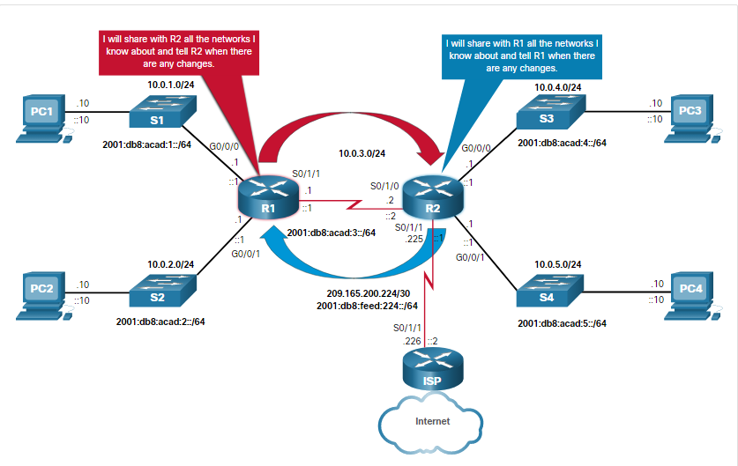

### 6.3.2. Routing Protocol Spoofing

Routing systems can be attacked by disrupting peer network routers, or by falsifying or spoofing the information carried within the routing protocols. Spoofing routing information may generally be used to cause systems to misinform (lie to) each other, cause a DoS attack, or cause traffic to follow a path it would not normally follow. There are several consequences of routing information being spoofed:

* Redirecting traffic to create routing loops
* Redirecting traffic so it can be monitored on an insecure link
* Redirecting traffic to discard it

Click the Play button on the animation to see an example of an attack that creates a routing loop.

Assume an attacker has been able to connect directly to the link between R1and R2. The attacker sends R1 false routing information indicating that R2 is the preferred destination to the 192.168.10.0/24 network. Although R1 already has a routing table entry to the 192.168.10.0/24 network, the new route has a lower metric and therefore is the preferred entry in the routing table.

Consequently, when PC3 sends a packet to PC1 (192.168.10.10/24), R3 forward the packet to R2 which in turn forwards it to R1. R1 does not forward the packet to the PC1 host. Instead, it routes the packet to R2 because the apparent best path to 192.168.10.0 /24 is through R2. When R2 gets the packet, it looks in its routing table and finds a legitimate route to the 192.168.10.0/24 network through R1 and forwards the packet back to R1, creating the loop. The loop was caused by the misinformation injected into R1.

For more information about generic threats to routing protocols, search the internet for RFC 4593. Mitigate against routing protocol attacks by configuring OSPF authentication.

### 6.3.3. OSPF MD5 Routing Protocol Authentication

OSPF supports routing protocol authentication using MD5. MD5 authentication can be enabled globally for all interfaces or on a per interface basis.

Enable OSPF MD5 authentication globally:

* **ip ospf message-digest-key** *key* **md5** *password* interface configuration command.
* **area** *area-id* **authentication message-digest** router configuration command.
* This method forces authentication on all OSPF enabled interfaces. If an interface is not configured with th**e ip ospf message-digest-key** command, it will not be able to form adjacencies with other OSPF neighbors.

Enable MD5 authentication on a per interface basis:

* **ip ospf message-digest-key** *key* **md5** *password* interface configuration command.
* **ip ospf authentication message-digest** interface configuration command.

The interface setting overrides the global setting. MD5 authentication passwords do not have to be the same throughout an area. However, they do need to be the same between neighbors.

In this figure, R1 and R2 are configured with OSPF and routing is functioning properly. However, OSPF messages are not authenticated or encrypted.

#### OSPF Configured Without Authentication



R1# **show run | begin router ospf**

router ospf 1

passive-interface GigabitEthernet0/1

network 10.1.1.0 0.0.0.3 area 0

network 192.168.1.0 0.0.0.255 area 0

!

<output omitted>

!--------------------------------

R2# **show run | begin router ospf**

router ospf 1

passive-interface GigabitEthernet0/1

network 10.1.1.0 0.0.0.3 area 0

network 192.168.2.0 0.0.0.255 area 0

!

<output omitted>

In the figure below, R1 and R2 are configured with OSPF MD5 authentication. Authentication is configured on a per interface basis because both routers are using only one interface to form OSPF adjacencies. Notice that when R1 is configured, OSPF adjacency is lost with R2 until R2 is configured with the matching MD5 authentication.

The figure shows two routers connected via a serial connection. Each router is also connected to a gigabit ethernet network.

#### OSPF Configured With MD5 Authentication



R1# **conf t**

R1(config)# **interface s0/0/0**

R1(config-if)# **ip ospf message-digest-key 1 md5 cisco12345**

R1(config-if)# **ip ospf authentication message-digest**

R1(config-if)#

000209: Feb 20 13:59:35.091 UTC: %OSPF-5-ADJCHG: Process 1, Nbr 10.1.1.2 on

Serial0/0/0 from FULL to DOWN, Neighbor Down: Dead timer expired

R1(config-if)#

000210: Feb 20 14:01:09.975 UTC: %OSPF-5-ADJCHG: Process 1, Nbr 10.1.1.2 on

Serial0/0/0 from LOADING to FULL, Loading Done

----------------------------

R2# **conf t**

000137: Feb 20 13:59:35.091 UTC: %OSPF-5-ADJCHG: Process 1, Nbr 192.168.1.1 on

Serial0/0/0 from FULL to DOWN, Neighbor Down: Dead timer expired

R2(config)# **interface s0/0/0**

R2(config-if)# **ip ospf message-digest-key 1 md5 cisco12345**

R2(config-if)# **ip ospf authentication message-digest**

R2(config-if)#

000138: Feb 20 14:01:09.975 UTC: %OSPF-5-ADJCHG: Process 1, Nbr 192.168.1.1 on

Serial0/0/0 from LOADING to FULL, Loading Done

R2(config-if)#

### 6.3.4. OSPF SHA Routing Protocol Authentication

MD5 is now considered vulnerable to attacks and should only be used when stronger authentication is not available. Cisco IOS release 15.4(1)T added support for OSPF SHA authentication, as detailed in RFC 5709. Therefore, the administrator should use SHA authentication as long as all of the router operating systems support OSPF SHA authentication.

OSPF SHA authentication includes two major steps. The syntax for the commands is shown in the figure:

**Step 1.** Specify an authentication key chain in global configuration mode:

* Configure a key chain name with the **key chain** command.
* Assign the key chain a number and a password with the **key** and **key-string** commands.
* Specify SHA authentication with the **cryptographic-algorithm** command.
* (Optional) Specify when this key will expire with the **send-lifetime** command.

The syntax for these commands are as follows:

Router(config)# **key chain** *name*  
 Router(config-keychain)# **key** *key-id*  
 Router(config-keychain-key)# **key-string** *string*  
 Router(config-keychain-key)# **cryptographic-algorithm** {**hmac-sha-1** | **hmac-sha-256** | **hmac-sha-384** | **hmac-sha-512** | **md5**}   
 Router(config-keychain-key)# **send-lifetime start-time** {**infinite** | **end-time** | **duration** *seconds*}

**Step 2.** Use the following syntax to assign the authentication key to the desired interfaces with the **ip ospf authentication key-chain** command.

Router(config)# **interface** *type number*   
 Router(config-if)# **ip ospf authentication key-chain** *name*

In the example that follows the figure, R1 and R2 are configured with OSPF SHA authentication using a key named **SHA256** and the key string **ospfSHA256**. Notice that when R1 is configured, OSPF adjacency is lost with R2 until R2 is configured with the matching SHA authentication.



R1(config)# **key chain SHA256**

R1(config-keychain)# **key 1**

R1(config-keychain-key)# **key-string ospfSHA256**

R1(config-keychain-key)# **cryptographic-algorithm hmac-sha-256**

R1(config-keychain-key)# **exit**

R1(config-keychain)# **exit**

R1(config)# **interface s0/0/0**

R1(config-if)# **ip ospf authentication key-chain SHA256**

R1(config-if)#

000218: Feb 20 15:06:07.607 UTC: %OSPF-5-ADJCHG: Process 1, Nbr 10.1.1.2 on Serial0/0/0

from FULL to DOWN, Neighbor Down: Dead timer expired

R1(config-if)#

--------------------------------------

R2(config)# **key chain SHA256**

R2(config-keychain)# **key 1**

R2(config-keychain-key)# **key-string ospfSHA256**

R2(config-keychain-key)# **cryptographic-algorithm hmac-sha-256**

R2(config-keychain-key)# **exit**

R2(config-keychain)# **exit**

R2(config)# **interface s0/0/0**

R2(config-if)# **ip ospf authentication key-chain SHA256**

R2(config-if)#

000142: Feb 20 15:07:22.631: %OSPF-5-ADJCHG: Process 1, Nbr 192.168.1.1 on Serial0/0/0

from LOADING to FULL, Loading Done

R2(config-if)#

## 6.4) Secure Management and Reporting

### 6.4.1. Types of Management Access

In a small network, managing and monitoring a small number of network devices is a straightforward operation. However, in a large enterprise with hundreds of devices, monitoring, managing, and processing log messages can be challenging. From a reporting standpoint, most networking devices can send log data that can be invaluable when troubleshooting network problems or security threats. This data can be viewed in real time, on demand, and in scheduled reports.

When logging and managing information, the information flow between management hosts and the managed devices can take two paths:

* **In-band** - Information flows across an enterprise production network, the internet, or both, using regular data channels.
* **Out-of-band (OOB)** - Information flows on a dedicated management network on which no production traffic resides.

For example, the network in the figure has two network segments separated by a Cisco IOS router that is providing firewall services to protect the management network. The connection to the production network allows management hosts to access the internet and provides limited in-band management traffic. In-band management occurs only when OOB management is not possible or available. If in-band management is required, then that traffic should be sent securely using a private encrypted tunnel or VPN tunnel.

The figure illustrates in-band management.

#### In-Band Management

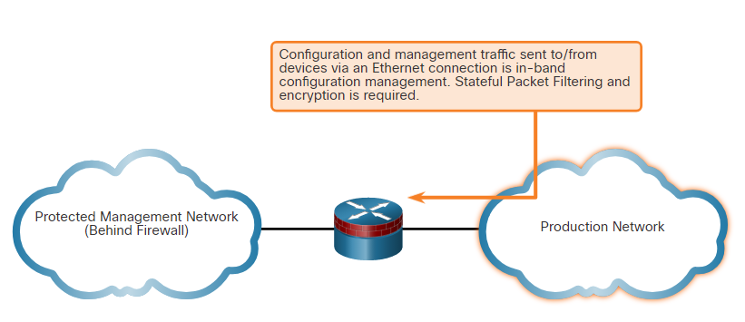

The figure below shows more detail for the protected management network. This is where the management hosts and terminal servers reside. When placed within the management network, terminal servers offer OOB direct console connections over the management network to any network device requiring management on the production network. Most devices should be connected to this management segment and be configured using OOB management.

Because the management network has administrative access to nearly every area of the network, it can be a very attractive target for hackers. The management module on the firewall incorporates several technologies designed to mitigate such risks. The primary threat is a hacker attempting to gain access to the management network. This can be accomplished through a compromised managed host that a management device must access. To mitigate the threat of a compromised device, strong access control should be implemented at the firewall and at every other device. Management devices should be set up in a fashion that prevents direct communication with other hosts on the same management subnet by using separate LAN segments or VLANs.

#### Out of-Band Management

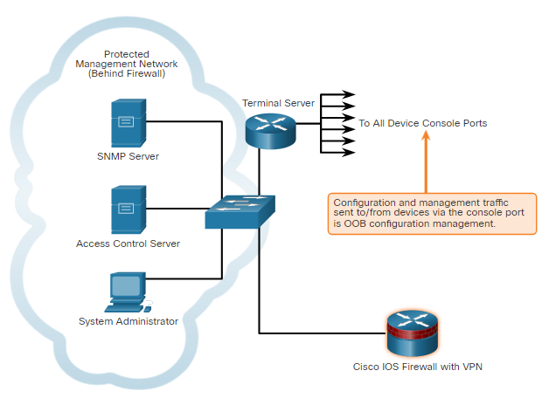

### 6.4.2. Out-of-Band and In-Band Access

As a general rule, for security purposes, OOB management is appropriate for large enterprise networks. However, it is not always desirable. The decision to use OOB management depends on the type of management applications running and the protocols being monitored. For example, consider a situation in which two core switches are managed and monitored using an OOB network. If a critical link between these two core switches fails on the production network, the application monitoring those devices may never determine that the link has failed and never alert the administrator. This is because the OOB network makes all devices appear to be attached to a single OOB management network. The OOB management network remains unaffected by the downed link. With management applications such as these, it is preferable to run the management application in-band in a secure fashion.

OOB management guidelines are :

* Provide the highest level of security.
* Mitigate the risk of passing insecure management protocols over the production network.

In-band management is recommended in smaller networks as a means of achieving a more cost-effective security deployment. In such architectures, management traffic flows in-band in all cases. It is made as secure as possible using secure management protocols, for example using SSH instead of Telnet. Another option is to create secure tunnels, using protocols such as IPsec, for management traffic. If management access is not necessary at all times, temporary holes can be placed in a firewall while management functions are performed. This technique should be used cautiously, and all holes should be closed immediately when management functions are completed.

In-band management guidelines are:

* Apply only to devices that need to be managed or monitored.
* Use IPsec, SSH, or SSL when possible.
* Decide whether the management channel needs to be open at all times.

Finally, if using remote management tools with in-band management, be wary of the underlying security vulnerabilities of the management tool itself. For example, SNMP managers are often used to ease troubleshooting and configuration tasks on a network. However, SNMP should be treated with the utmost care because the underlying protocol has its own set of security vulnerabilities.

## 6.5) Network Security Using Syslog

### 6.5.1. Introduction to Syslog

Like a Check Engine light on your car dashboard, the components in your network can tell you if there is something wrong. The syslog protocol was designed to ensure that you can receive and understand these messages. When certain events occur on a network, networking devices have trusted mechanisms to notify the administrator with detailed system messages. These messages can be either non-critical or significant. Network administrators have a variety of options for storing, interpreting, and displaying these messages. They can also be alerted to those messages that could have the greatest impact on the network infrastructure.

The most common method of accessing system messages is to use a protocol called syslog.

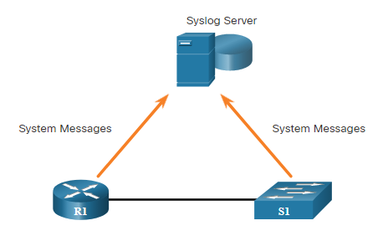Syslog is a term used to describe a standard. It is also used to describe the protocol developed for that standard. The syslog protocol was developed for UNIX systems in the 1980s but was first documented as RFC 3164 by IETF in 2001.

Many networking devices support syslog, including routers, switches, application servers, firewalls, and other network appliances. The syslog protocol allows networking devices to send their system messages across the network to syslog servers.

Specifically, syslog uses UDP port 514 to send event notification messages across IP networks to event message collectors. For example, the figure displays a router (R1) and a switch (S1) sending system messages to a syslog server.

There are several syslog server software packages for Windows and UNIX available. Many of them are freeware.

The syslog logging service provides three primary functions, as follows:

* The ability to gather logging information for monitoring and troubleshooting
* The ability to select the type of logging information that is captured
* The ability to specify the destinations of captured syslog messages

### 6.5.2. Syslog Operation

On Cisco network devices, the syslog protocol starts by sending system messages and **debug** output to a local logging process that is internal to the device. How the logging process manages these messages and outputs is based on device configurations. For example, syslog messages may be sent across the network to an external syslog server. Messages on the syslog server can then be filtered without needing to access the actual device. Log messages and outputs stored on the external server can be pulled into various reports for easier reading.

Alternatively, syslog messages may be sent to an internal buffer. Messages sent to the internal buffer are only viewable through the CLI of the device.

Finally, the network administrator may specify that only certain types of system messages be sent to various destinations. For example, the device may be configured to forward all system messages to an external syslog server. However, debug-level messages are forwarded to the internal buffer and are only accessible by the administrator from the CLI.

As shown in the figure, popular destinations for syslog messages include the:

* Logging buffer (RAM inside a router or switch)
* Console line
* Terminal line
* Syslog server

It is possible to remotely monitor system messages by viewing the logs on a syslog server, or by accessing the device through Telnet, SSH, or through the console port.

### 6.5.3. Syslog Message Format

Cisco devices produce syslog messages as a result of network events. Every syslog message contains a severity level and a facility.

The smaller numerical levels are the more critical syslog alarms. The severity level of the messages can be set to control where each type of message is displayed (i.e. on the console or the other destinations). The complete list of syslog levels is shown in the table.

| **Severity Name** | **Severity Number** | **Description** |
| --- | --- | --- |
| Emergency | Level 0 | System Unusable |
| Alert | Level 1 | Immediate Action Needed |
| Critical | Level 2 | Critical Condition |
| Error | Level 3 | Error Condition |
| Warning | Level 4 | Warning Condition |
| Notification | Level 5 | Normal, but Significant Condition |
| Informational | Level 6 | Informational Message |
| Debugging | Level 7 | Debugging Message |

Each syslog level has its own meaning:

* **Emergency Level 0 - Warning Level 4**: These messages are error messages about software or hardware malfunctions; these types of messages mean that the functionality of the device is affected. The severity of the issue determines the actual syslog level applied.
* **Notification Level 5**: This notifications level is for normal, but significant events. For example, interface up or down transitions, and system restart messages are displayed at the notifications level.
* **Informational Level 6**: This is a normal information message that does not affect device functionality. For example, when a Cisco device is booting, you might see the following informational message: %LICENSE-6-EULA_ACCEPT_ALL: The Right to Use End User License Agreement is accepted.
* **Debugging Level 7**: This level indicates that the messages are output generated from issuing various **debug** commands.

### 6.5.4. Syslog Facilities

In addition to specifying the severity, syslog messages also contain information on the facility. Syslog facilities are service identifiers that identify and categorize system state data for error and event message reporting. The logging facility options that are available are specific to the networking device. For example, Cisco 2960 Series switches running Cisco IOS Release 15.0(2) and Cisco 1941 routers running Cisco IOS Release 15.2(4) support 24 facility options that are categorized into 12 facility types.

Some common syslog message facility codes reported on Cisco IOS routers include:

* **IF** - Identifies that the syslog message was generated by an interface.
* **IP** - Identifies that the syslog message was generated by IP.
* **OSPF** - Identifies that the syslog message was generated by the OSPF routing protocol.
* **SYS** - Identifies that the syslog message was generated by the device operating system.
* **IPSEC** - Identifies that the syslog message was generated by the IP Security encryption protocol.

By default, the format of syslog messages on the Cisco IOS Software is as follows:

%facility-severity-MNEMONIC: description

For example, sample output on a Cisco switch for an EtherChannel link changing state to up is:

%LINK-3-UPDOWN: Interface Port-channel1, changed state to up

Here the facility is LINK and the severity level is 3, with a MNEMONIC of UPDOWN.

The most common messages are link up and down messages, and messages that a device produces when it exits from configuration mode. If ACL logging is configured, the device generates syslog messages when packets match a parameter condition.

### 6.5.5. Configure Syslog Timestamps

By default, log messages are not timestamped. In the example, the R1 GigabitEthernet 0/0/0 interface is shutdown. The message logged to the console does not identify when the interface state was changed. Log messages should be timestamped so that when they are sent to another destination, such as a Syslog server, there is record of when the message was generated.

Use the command **service timestamps log datetime** to force logged events to display the date and time. As shown in the command output, when the R1 GigabitEthernet 0/0/0 interface is reactivated, the log messages now contain the date and time.

R1# **configure terminal**

R1(config)# **interface g0/0/0**

R1(config-if)# **shutdown**

%LINK-5-CHANGED: Interface GigabitEthernet0/0/0, changed state to administratively down

%LINEPROTO-5-UPDOWN: Line protocol on Interface GigabitEthernet0/0/0, changed state to down

R1(config-if)# **exit**

R1(config)# **service timestamps log datetime**

R1(config)# **interface g0/0/0**

R1(config-if)# **no shutdown**

*Mar 1 11:52:42: %LINK-3-UPDOWN: Interface GigabitEthernet0/0/0, changed state to down

*Mar 1 11:52:45: %LINK-3-UPDOWN: Interface GigabitEthernet0/0/0, changed state to up

*Mar 1 11:52:46: %LINEPROTO-5-UPDOWN: Line protocol on Interface GigabitEthernet0/0/0,

changed state to up

R1(config-if)#

**Note**: When using the **datetime** keyword, the clock on the networking device must be set, either manually or through NTP, as previously discussed.

### 6.5.6. Syslog Systems

Syslog implementations always contain two types of systems:

* **Syslog servers** - Also known as log hosts, these systems accept and process log messages from syslog clients.
* **Syslog clients** - Routers or other types of equipment that generate and forward log messages to syslog servers.

The topology in the figure identifies the syslog server at IP address 10.2.2.6. The rest of the servers and devices in the topology can be configured as syslog clients, which send syslog messages to the syslog server.

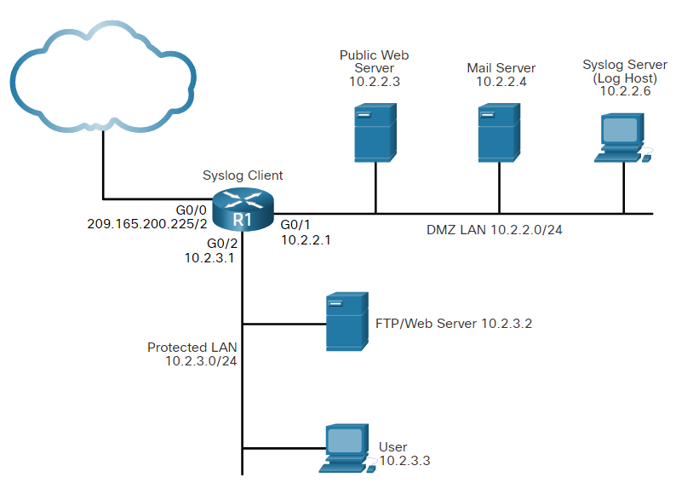

### 6.5.7. Syslog Configuration

Configure system logging:

**Step 1**. Set the destination logging host using the **logging** [**host**] command.

Identify the destination syslog server using the **logging** **host** command

| **Parameter** | **Description** |
| --- | --- |
| *hostname* | Specifies the name of the host you want to use as a syslog server. |
| *ip-address* | Specifies the IP address of the host you want to use as a syslog server. |

Router(config)# **logging host** [hostname | ip-address]

**Step 2**. (Optional) Set the log severity (trap) level using the **logging trap** command.

(Optional) Set the log severity (trap) level using the **logging trap** command

**Note:** An ISR defaults to Level 7 (debugging).

Router(config)# **logging trap** level

**Step 3**. (Optional) Set the source interface using the **logging source-interface** command.

(Optional) Set the source interface using the **logging source-interface** command. This command specifies that syslog packets contain the IPv4 or IPv6 address of a specific interface (e.g., a loopback interface), regardless of which interface the packet uses to exit the router.

| **Parameter** | **Description** |
| --- | --- |
| *interface-type* | Specifies the interface type. |
| *interface-number* | Specifies the interface number (for example, 0/1). |

Router(config)# **logging source-interface** interface-type interface-number

**Step 4**. (Optional) Enable logging to all enabled destinations with the **logging on** command.

(Optional) Enable logging to all enabled destinations with the **logging on** command.

**Note:** Syslog logging is enabled by default.

Router(config)# **logging on**

The figure below shows a sample syslog configuration for R1. Use the **show logging** command to view logging configuration and buffered syslog messages.

R1(config)# **logging 10.2.2.6**

R1(config)#

*Sep 25 12:57:14.120: %SYS-6-LOGGINGHOST_STARTSTOP: Logging to host 10.2.2.6 port 514 started - CLI initiated

R1(config)#

R1(config)# **logging trap informational**

R1(config)# **logging source-interface lo0**

R1(config)# **logging on**

R1(config)# **exit**

R1#

*Sep 25 12:58:29.591: %SYS-5-CONFIG_I: Configured from console by console

R1#

R1# **show logging**

Syslog logging: enabled (0 messages dropped, 2 messages rate-limited, 0 flushes, 0 overruns, xml disabled, filtering disabled)

<Output omitted>

Trap logging: level informational, 83 message lines logged

Logging to 10.2.2.6 (udp port 514, audit disabled,

link up),

7 message lines logged,

0 message lines rate-limited,

0 message lines dropped-by-MD,

xml disabled, sequence number disabled

filtering disabled

Logging Source-Interface: VRF Name:

Loopback0

<Output omitted>

## 6.6) NTP Configuration

### 6.6.1. Time and Calendar Services

Before you get really deep into network management, the one thing that will help keep you on track is ensuring that all of your components are set to the same time and date.

The software clock on a router or switch starts when the system boots. It is the primary source of time for the system. It is important to synchronize the time across all devices on the network because all aspects of managing, securing, troubleshooting, and planning networks require accurate timestamping. When the time is not synchronized between devices, it will be impossible to determine the order of the events and the cause of an event.

The date and time settings on a router or switch can be manually configured, as shown in the example.

R1# **clock set 16:01:00 sept 25 2020**

*Sep 25 16:01:00.000: %SYS-6-CLOCKUPDATE: System clock has been updated from 13:09:49 UTC Fri Sep 25 2020 to 16:01:00 UTC Fri Sep 25 2020, configured from console by console.

Sep 25 16:01:00.001: %PKI-6-AUTHORITATIVE_CLOCK: The system clock has been set.

R1#

Although manually setting the time is easy, it is not practical in most networks. As a network grows, it becomes difficult if not impossible to ensure that all infrastructure devices are operating with synchronized time. Even in a smaller network environment, the manual method is not ideal. If a router reboots, how will it get an accurate date and timestamp?

A better and more scalable solution is to implement Network Time Protocol (NTP) which is documented in RFC 1305. NTP enables network devices (i.e., NTP clients) to synchronize their time settings with an NTP authoritative time source such as an NTP server. The NTP time source can be a device (e.g., a router) on the network that is selected as the private primary clock or it can be a publicly available NTP server on the internet.

NTP source and clients open UDP port 123 to send and receive timestamps.

### 6.6.2. NTP Operation

NTP networks use a hierarchical system of time sources. Each level in this hierarchical system is called a stratum. The stratum level is defined as the number of hop counts from the authoritative source.

The figure displays a sample NTP network.

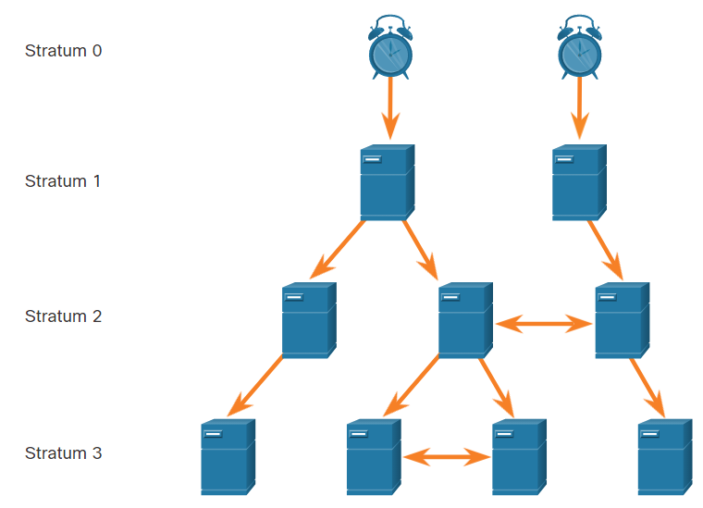

The sample network consists of four stratum levels who acquire their times as follows:

* Stratum 1 server gets its time from the stratum 0 time source.
* Stratum 2 server gets its time from the stratum 1 server.
* Stratum 3 server gets its time from the stratum 2 server.

**Stratum 0**

This identifies a device providing the most authoritative time source. Stratum 0 devices including atomic and GPS clocks are the most accurate authoritative time sources.

Specifically, NTP stratum 0 devices are non-network high-precision timekeeping devices assumed to be accurate and with little or no delay associated with them. In the figure, they are represented by the clock icon.

**Stratum 1**

NTP stratum 1 devices are network devices that are directly connected to the authoritative time sources. They function as the primary network time standard to stratum 2 devices.

**Stratum 2 and Lower**

NTP stratum 2 servers are connected on a network to a stratum 1 device. Stratum 2 devices are NTP clients and synchronize their time by using the NTP packets from a stratum 1 server such as a router. They in turn can be NTP servers for stratum 3 devices.

NTP stratum levels are based on a scale of 0 (highest stratum level) to 15 (lowest stratum level). For example, an NTP server in a low number stratum level is closer to the authorized time source than a server in a high number stratum level.

The maximum stratum hop count is 15 (i.e., 0 – 15). Note that an NTP client that is not synchronized with a server is assigned a stratum 16 level.

NTP servers in the same stratum level can be configured as peers to provide redundant time sources for clients or to synchronize each other.

### 6.6.3. Configure and Verify NTP

The figure shows the topology used to demonstrate NTP configuration and verification.

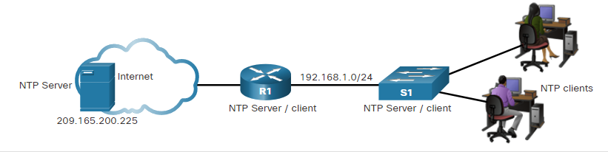

Before NTP is configured on the network, the **show clock** command displays the current time on the software clock, as shown in the example. With the **detail** option, notice that the time source is user configuration. That means the time was manually configured with the **clock** command.

R1# **show clock detail**

20:55:10.207 UTC Fri Nov 15 2019

Time source is user configuration

In our topology, and internet NTP server is the authoritative time source. However, a local network device could be selected as the NTP authoritative time source using the **ntp master** [stratum] global configuration command.

In the topology, R1 is an NTP client of the NTP server. Use the **ntp server** ip-address global config command to configure 209.165.200.225 as the NTP server for R1.

To verify the time source is set to NTP, use the **show clock detail** command. Notice that now the time source is NTP.

R1(config)# **ntp server 209.165.200.225**

R1(config)# **end**

R1# **show clock detail**

21:01:34.563 UTC Fri Nov 15 2019

Time source is NTP

In the next example, the **show ntp associations** and **show ntp status** commands are used to verify that R1 is synchronized with the NTP server at 209.165.200.225. Notice that R1 is synchronized with a stratum 1 NTP server at 209.165.200.225, which is synchronized with a GPS clock. The **show ntp status** command displays that R1 is now a stratum 2 device that is synchronized with the NTP server at 209.165.220.225.

**Note**: The highlighted **st** stands for stratum.

R1# **show ntp associations**

address ref clock st when poll reach delay offset disp

*~209.165.200.225 .GPS. 1 61 64 377 0.481 7.480 4.261

* sys.peer, # selected, + candidate, - outlyer, x falseticker, ~ configured

R1# **show ntp status**

Clock is synchronized, stratum 2, reference is 209.165.200.225

nominal freq is 250.0000 Hz, actual freq is 249.9995 Hz, precision is 2**19

ntp uptime is 589900 (1/100 of seconds), resolution is 4016

reference time is DA088DD3.C4E659D3 (13:21:23.769 PST Fri Nov 15 2019)

clock offset is 7.0883 msec, root delay is 99.77 msec

root dispersion is 13.43 msec, peer dispersion is 2.48 msec

loopfilter state is 'CTRL' (Normal Controlled Loop), drift is 0.000001803 s/s

system poll interval is 64, last update was 169 sec ago.

Next, the clock on S1 is configured to synchronize to R1 with the **ntp server** command and then the configuration is verified with the **show ntp associations** command, as displayed.

S1(config)# **ntp server 192.168.1.1**

S1(config)# **end**

S1# **show ntp associations**

address ref clock st when poll reach delay offset disp

*~192.168.1.1 209.165.200.225 2 12 64 377 1.066 13.616 3.840

* sys.peer, # selected, + candidate, - outlyer, x falseticker, ~ configured

Output from the **show ntp associations** command verifies that the clock on S1 is now synchronized with R1 at 192.168.1.1 via NTP. R1 is a stratum 2 device and NTP server to S1. Now S1 is a stratum 3 device that can provide NTP service to other devices in the network, such as end devices.

S1# **show ntp status**

Clock is synchronized, stratum 3, reference is 192.168.1.1

nominal freq is 119.2092 Hz, actual freq is 119.2088 Hz, precision is 2**17

reference time is DA08904B.3269C655 (13:31:55.196 PST Tue Nov 15 2019)

clock offset is 18.7764 msec, root delay is 102.42 msec

root dispersion is 38.03 msec, peer dispersion is 3.74 msec

loopfilter state is 'CTRL' (Normal Controlled Loop), drift is 0.000003925 s/s

system poll interval is 128, last update was 178 sec ago.

6.7) SNMP Configuration

### 6.7.1. Introduction to SNMP

Now that your network is mapped and all of your components are using the same clock, it is time to look at how you can manage your network by using Simple Network Management Protocol (SNMP).

SNMP was developed to allow administrators to manage nodes such as servers, workstations, routers, switches, and security appliances, on an IP network. It enables network administrators to monitor and manage network performance, find and solve network problems, and plan for network growth.

SNMP defines how management information is exchanged between network management applications and management agents. It is an application layer protocol that provides a message format for communication between managers and agents. The SNMP system consists of three elements:

* SNMP manager
* SNMP agents (managed node)
* Management Information Base (MIB)

To configure SNMP on a networking device, it is first necessary to define the relationship between the manager and the agent.

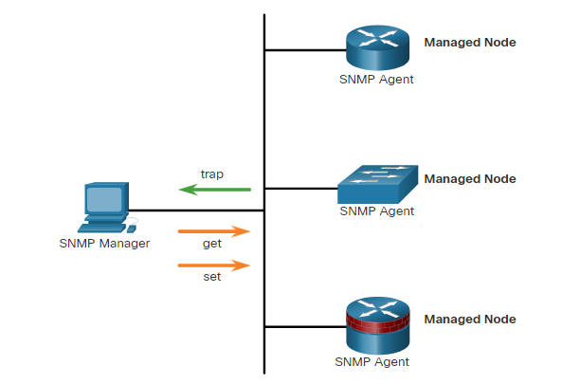The SNMP manager is part of a network management system (NMS). The SNMP manager runs SNMP management software.

As shown in the figure, the SNMP manager can collect information from an SNMP agent by using the “get” action. It can change configurations on an agent by using the “set” action. In addition, SNMP agents can forward information directly to a network manager by using “traps”.

The SNMP agent and MIB reside on SNMP client devices. Network devices that must be managed, such as switches, routers, servers, firewalls, and workstations, are equipped with an SNMP agent software module. The MIB stores data and operational statistics about the device.

The SNMP Manager sends a get request to SNMP agent to access stored data in the local MIB. Specifically, the SNMP manager polls the agents and queries the MIB for SNMP agents on UDP port 161. SNMP agents send any SNMP traps to the SNMP manager on UDP port 162.

### 6.7.2. SNMP Operation

SNMP agents that reside on managed devices collect and store information about the device and its operation. This information is stored by the agent locally in the MIB. The SNMP manager then uses the SNMP agent to access information within the MIB.

There are two primary SNMP manager requests:

* **get request** - Used by the NMS to query the device for data.
* **set request** - Used by the NMS to change configuration variables in the agent device. A set request can also initiate actions within a device. For example, a set request can cause a router to reboot, send a configuration file, or receive a configuration file.

The SNMP manager uses the **get** and **set** actions to perform the operations described in the table.

| **Operation** | **Description** |
| --- | --- |
| **get-request** | Retrieves a value from a specific variable. |
| **get-next-request** | Retrieves a value from a variable within a table; the SNMP manager does not need to know the exact variable name. A sequential search is performed to find the needed variable from within a table. |
| **get-bulk-request** | Retrieves large blocks of data, such as multiple rows in a table, that would otherwise require the transmission of many small blocks of data. (Only works with SNMPv2 or later.) |
| **get-response** | Replies to a **get-request, get-next-request,**and **set-request**sent by an NMS. |
| **set-request** | Stores a value in a specific variable. |

The SNMP agent responds to SNMP manager requests as follows:

* **Get an MIB variable** - The SNMP agent performs this function in response to a GetRequest-PDU from the network manager. The agent retrieves the value of the requested MIB variable and responds to the network manager with that value.
* **Set an MIB variable** - The SNMP agent performs this function in response to a SetRequest-PDU from the network manager. The SNMP agent changes the value of the MIB variable to the value specified by the network manager. An SNMP agent reply to a set request includes the new settings in the device.

### 6.7.3. Management Information Base (MIB)

The MIB organizes variables hierarchically. MIB variables enable the management software to monitor and control the network device. Formally, the MIB defines each variable as an object ID (OID). OIDs uniquely identify managed objects in the MIB hierarchy. The MIB organizes the OIDs based on RFC standards into a hierarchy of OIDs, usually shown as a tree.

The MIB tree for any given device includes some branches with variables common to many networking devices and some branches with variables specific to that device or vendor.

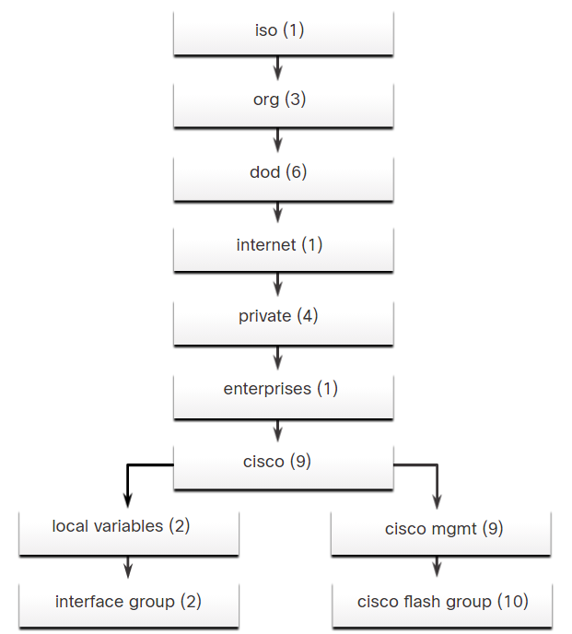RFCs define some common public variables. Most devices implement these MIB variables. In addition, networking equipment vendors, like Cisco, can define their own private branches of the tree to accommodate new variables specific to their devices.

The figure shows portions of the MIB structure defined by Cisco. Note how the OID can be described in words or numbers to help locate a particular variable in the tree. OIDs belonging to Cisco, are numbered as follows: .iso (1).org (3).dod (6).internet (1).private (4).enterprises (1).cisco (9). Therefore, the OID is 1.3.6.1.4.1.9.

### 6.7.4. SNMP Versions

There are several versions of SNMP:

* **SNMPv1** - This is the Simple Network Management Protocol, a Full Internet Standard, that is defined in RFC 1157.
* **SNMPv2c** - This is defined in RFCs 1901 to 1908. It uses a community-string-based Administrative Framework.
* **SNMPv3** - This is an interoperable standards-based protocol originally defined in RFCs 2273 to 2275. It provides secure access to devices by authenticating and encrypting packets over the network. It includes these security features: message integrity to ensure that a packet was not tampered with in transit, authentication to determine that the message is from a valid source, and encryption to prevent the contents of a message from being read by an unauthorized source.

All versions use SNMP managers, agents, and MIBs. Cisco IOS software supports the above three versions. Version 1 is a legacy solution and is not often encountered in networks today. Therefore, this course focuses on versions 2c and 3.

Both SNMPv1 and SNMPv2c use a community-based form of security. The community of managers that is able to access the MIB of the agent is defined by a community string.

Unlike SNMPv1, SNMPv2c includes a bulk retrieval mechanism and more detailed error message reporting to management stations. The bulk retrieval mechanism retrieves tables and large quantities of information, minimizing the number of round-trips required. The SNMPv2c improved error-handling includes expanded error codes that distinguish different kinds of error conditions. These conditions are reported through a single error code in SNMPv1. Error return codes in SNMPv2c include the error type.

**Note**: SNMPv1 and SNMPv2c offer minimal security features. Specifically, SNMPv1 and SNMPv2c can neither authenticate the source of a management message nor provide encryption. SNMPv3 is most currently described in RFCs 3410 to 3415. It adds methods to ensure the secure transmission of critical data between managed devices.

SNMPv3 provides for both security models and security levels. A security model is an authentication strategy set up for a user and the group within which the user resides. A security level is the permitted level of security within a security model. A combination of the security level and the security model determine which security mechanism is used when handling an SNMP packet.

There are available security models for SNMPv1, SNMPv2c, and SNMPv3. The table identifies the characteristics of the different combinations of security models and levels.

| **SNMPv1** | |
| --- | --- |
| **Level** | noAuthNoPriv |
| **Authentication** | Community string |
| **Encryption** | No |
| **Result** | Uses a community string match for authentication. |
| **SNMPv2c** | |
| **Level** | noAuthNoPriv |
| **Authentication** | Community string |
| **Encryption** | No |
| **Result** | Uses a community string match for authentication. |
| **SNMPv3 noAuthNoPriv** | |
| **Level** | noAuthNoPriv |
| **Authentication** | Username |
| **Encryption** | No |
| **Result** | Uses a username match for authentication (an improvement over SNMPv2c). |
| **SNMPv3 authNoPriv** | |
| **Level** | authNoPriv |
| **Authentication** | Message Digest 5 (MD5) or Secure Hash Algorithm (SHA) |
| **Encryption** | No |
| **Result** | Provides authentication based on the HMAC-MD5 or HMAC-SHA algorithms. |
| **SNMPv3 authPriv** | |
| **Level** | authPriv (requires the cryptographic software image) |
| **Authentication** | MD5 or SHA |
| **Encryption** | Data Encryption Standard (DES) or Advanced Encryption Standard (AES) |
| **Result** | Provides authentication based on the HMAC-MD5 or HMAC-SHA algorithms. Allows specifying the User-based Security Model (USM) with these encryption algorithms:   * DES 56-bit encryption in addition to authentication based on the CBC-DES (DES-56) standard * 3DES 168-bit encryption * AES 128-bit, 192-bit, or 256-bit encryption |

A network administrator must configure the SNMP agent to use the SNMP version supported by the management station. Because an agent can communicate with multiple SNMP managers, it is possible to configure the software to support communications by using SNMPv1, SNMPv2c, or SNMPv3.

### 6.7.5. SNMP Vulnerabilities

In any network topology, at least one manager node should run SNMP management software. Network devices that can be managed, such as switches, routers, servers, and workstations, are equipped with the SNMP agent software module. These agents are responsible for providing the SNMP manager access to a local MIB, which stores data about device operation.

SNMP is vulnerable to attack precisely because SNMP agents can be polled with get requests and accept configuration changes with set requests, as shown in the figure. For example, a set request can cause a router to reboot, send a configuration file, or receive a configuration file. An SNMP agent can also be configured to send out traps or notifications. In SNMPv1 and SNMPv2c, these requests and notifications are not authenticated or encrypted.

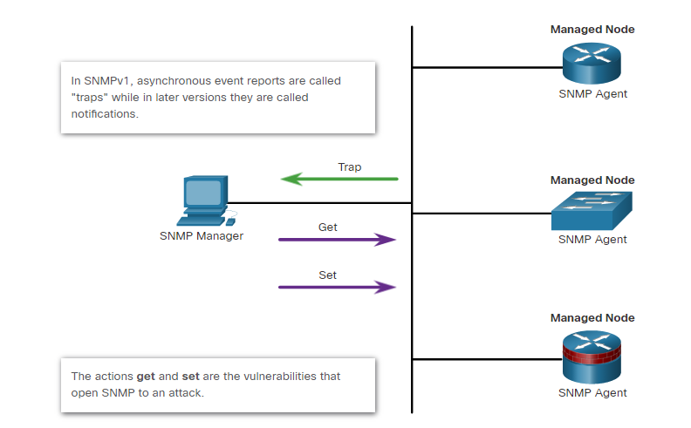

### 6.7.6. SNMPv3

SNMPv3 authenticates and encrypts packets over the network to provide secure access to devices. This addressed the vulnerabilities of earlier versions of SNMP.

SNMPv3 provides three security features:

* **Message integrity and authentication** - Ensures that a packet has not been tampered with in transit, and is from a valid source.
* **Encryption** - Scrambles the contents of a packet to prevent it from being seen by an unauthorized source.
* **Access control** - Restricts each principal to certain actions on specific portions of data.

#### SNMPv3 Security Configuration

SNMPv3 can be secured with only a few commands, as shown in the following steps.

**Note**: A full discussion of the configuration options for SNMPv3 is beyond the scope of this course.

**Step 1**. Configure an ACL that will permit access to authorized SNMP managers.

Router(config)# **ip access-list** *acl-name*  
 Router(config-std-nacl)# **permit** *source_net*

**Step 2**. Configure an SNMP view with the **snmp-server view** command to identify the MIB OIDs that the SNMP manager will be able to read. Configuring a view is required to limit SNMP messages to read-only access.

Router(config)# **snmp-server view** *view-name oid-tree*

SNMPv3 can be secured with only a few commands, as shown in the figure.

**Step 3**. Configure SNMP group features with the **snmp-server group** command:

* Configure a name for the group.
* Set the SNMP version to 3 with the **v3** keyword.
* Require authentication and encryption with the **priv** keyword.
* Associate a view to the group and give it read only access with the **read** command.
* Specify the ACL configured in Step 1.

Router(config)# **snmp-server group** *group-name* **v3 priv read** *view-name* **access** [*acl-number* | *acl-name*]

**Step 4**. Configure SNMP group user features with the **snmp-server user** command:

* Configure a username and associate the user with the group name configured in Step 3.
* Set the SNMP version to 3 with the **v3** keyword.
* Set the authentication type to either **md5** or **sha** and configure an authentication password. SHA is preferred and should be supported by the SNMP management software.
* Require encryption with the **priv** keyword and configure an encryption password.

Router(config)# **snmp-server user** *username group-name* **v3 auth** {**md5** | **sha**} *auth-password* **priv** {**des** | **3des** | **aes** {**128** | **192** | **256**}} *priv-password*

#### SNMPv3 Security Configuration Example

The figure shows an example configuration for securing SNMPv3.

**Step 1**. A standard ACL is named PERMIT-ADMIN and is configured to permit only the 192.168.1.0/24 network. All hosts attached to this network will be allowed to access the SNMP agent running on R1.

**Step 2**. An SNMP view is named SNMP-RO and is configured to include the entire iso tree from the MIB. On a production network, the network administrator would probably configure this view to include only the MIB OIDs that were necessary for monitoring and managing the network.

**Step 3**. An SNMP group is configured with the name ADMIN. SNMP is set to version 3 with authentication and encryption required. The group is allowed read-only access to the view (SNMP-RO). Access for the group is limited by the PERMIT-ADMIN ACL.

**Step 4**. An SNMP user, BOB, is configured as a member of the group ADMIN. SNMP is set to version 3. Authentication is set to use SHA, and an authentication password is configured. Although R1 supports up to AES 256 encryption, the SNMP management software only supports AES 128. So, the encryption is set to AES 128, and an encryption password is configured.

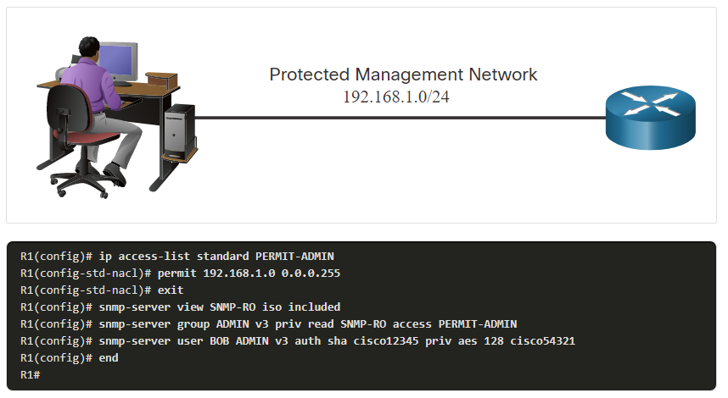

#### SNMPv3 Verification

Verify most of the SNMPv3 security configuration by viewing the running configuration, as shown in in the figure. Notice that the snmp-server user configuration is hidden. Use the **show snmp user** command to view the user information.

R1# **show run | include snmp**

snmp-server group ADMIN v3 priv read SNMP-RO access PERMIT-ADMIN

snmp-server view SNMP-RO iso included

R1# **show snmp user**

User name: BOB

Engine ID: 80000009030030F70DA30DA0

storage-type: nonvolatile active

Authentication Protocol: SHA

Privacy Protocol: AES128

Group-name: ADMIN

R1#

Verify that the SNMP manager can send get requests to R1 by using an SNMP management tool, such as the ManageEngine’s free SNMP MIB Browser. Configure the tool with the user details, as shown in the figure. When a user is configured, use the SNMP management tool’s features to test that the configured user can access the SNMP agent.

## 6.8) What Did I Learn in this Module?

**Secure Cisco IOS Image and Configuration Files**  
The Cisco IOS resilient configuration feature allows for faster recovery if someone maliciously or unintentionally reformats flash memory or erases the startup configuration file in nonvolatile random-access memory (NVRAM). The feature maintains a secure working copy of the router IOS image file and a copy of the running configuration file. These secure files cannot be removed by the user and are referred to as the primary bootset. The feature is only available on older routers that support a PCMCIA Advanced Technology Attachment (ATA) flash interface. Newer routers such as the ISR 4000 do not support this feature. To secure the IOS image and enable Cisco IOS image resilience, use the **secure boot-image** global configuration mode command. When enabled for the first time, the running Cisco IOS image is secured and a log entry is generated. To take a snapshot of the router running configuration and securely archive it in persistent storage, use the **secure boot-config** global configuration mode command. The router can be configured to boot the secure image from ROMmon mode. The configuration file can be copied from the secure location with **secure boot-config restore** command. The Secure Copy Protocol (SCP) feature provides a secure and authenticated method for copying router configuration or router image files to a remote location. SCP relies on SSH for secure communication and AAA for authentication and authorization. If a router has been compromised and the passwords changed to unknown values, a password recovery procedure exists for booting the router without its configuration so passwords can be changed to known values. This procedure may differ between different device models. Physical access to the router and ROMmon mode are required. It is possible to disable access to the password recovery procedure with the **no service password-recovery** command.

**Lock Down a Router Using AutoSecure**  
Cisco routers are initially deployed with many services that are enabled by default. However, some of these services, such as Cisco Discovery Protocol (CDP) and Link Layer Discovery Protocol (LLDP), can make the network vulnerable to attack. Both of these protocols can allow attackers to learn detailed information about a router. Guidelines are provided for how each service on the router should be configured for maximum security. The Cisco AutoSecure feature executes a script that makes recommendations for fixing security vulnerabilities and then modifies the security configuration of the router. AutoSecure enables three forwarding plane services, Cisco Express Forwarding (CEF), traffic filtering with ACLs, and Cisco IOS firewall inspection. AutoSecure is often used in the field to provide a baseline security policy on a new router. Features can then be altered to support the security policy of the organization. When the **auto secure** command is entered, the device will display the AutoSecure welcome message. AutoSecure will then gather information about the current device configuration and enter a configuration dialog. It will then disable and enable services and make other configuration changes to the device. When the wizard is complete, the running configuration displays all configuration settings and changes. AutoSecure should be used when a router is initially being configured. It is not recommended on production routers.

**Routing Protocol Authentication**  
Dynamic routing protocols are used by routers to automatically share information about the reachability and status of remote networks. Dynamic routing protocols perform several activities, including network discovery and maintaining routing tables. Important advantages of dynamic routing protocols are the ability to select a best path and the ability to automatically discover a best new path when there is a change in the topology. Network discovery is the ability of a routing protocol to dynamically share information about the networks that it knows about with other routers that are using the same routing protocol. Routing systems can be attacked by disrupting peer network routers, or by falsifying or spoofing the information carried within the routing protocols. This may be used to cause systems to misinform (lie to) each other, cause a DoS attack, or cause traffic to follow a path it would not normally follow. Routing protocol updates can be configured to use MD5 or SHA authentication. This helps ensure that routing protocol updates are coming from trusted sources. MD5 authentication is available for the OSPF routing protocol, however SHA is preferred for greater security.

**Secure Management and Reporting**  
Most network devices can gather and transmit log information that can be very valuable for diagnosing network problems and detecting security incidents. In a small network, managing and monitoring a small number of network devices is a straightforward operation. However, in a large enterprise with hundreds of devices, monitoring, managing, and processing log messages can be challenging. Information flow between log file collecting hosts and managed network devices can take two paths. In-band information paths use the production network, the internet or both. Management traffic is sent on the same network as user traffic. Out-of-band (OOB) management paths use dedicated management networks which do not transmit user traffic. As a general rule, for security purposes, OOB management is appropriate for large enterprise networks. However, it is not always desirable. It depends on the management applications and protocols being monitored. In-band management is recommended in smaller networks as a means of achieving a more cost-effective security deployment. OOB management security guidelines are to provide the highest level of security and mitigate the risk of passing insecure management protocols over the production network. For in-band management, guidelines are to apply only to devices that need to be managed or monitored, use IPSec, SSH, or SSL when possible, and decide whether the management channel needs to be available at all times. If using remote management tools with in-band management, be wary of the underlying security vulnerabilities of the management tool itself.

**Network Security Using Syslog**  
The most common method of accessing system messages is to use a protocol called syslog. Many networking devices support the syslog standard. The syslog protocol allows networking devices to send their system messages across the network to syslog servers. The syslog logging service provides the ability to gather logging information, select the type of information that is logged, and specify the destination devices that will receive and store syslog messages. On Cisco network devices, the syslog protocol can send system messages and **debug** command output to a local logging process that is internal to the device or can send messages to an internal buffer. Messages sent to the internal buffer can only be viewed through the CLI of the device. A device can be configured to send syslog messages to a logging buffer, the console line, a terminal line, or an external syslog server. Syslog messages contain a severity level that can range from Level 0 to Level 7. The lower the level number, the higher the severity. For example, messages at Level 0 to Level 4 are about software or hardware malfunctions. Level 5 messages indicate normal operation but are significant. Level 6 regards normal operating events, and Level 7 is for debugging messages. In addition, syslog messages include a syslog facility code. Some facilities indicate the system, component, or protocol that reported the message. The **service timestamps log datetime** command configures the device to use system timestamps for all messages. The timestamps can come from the local device clock, or can be synchronized between devices that are using the Network Time Protocol (NTP) for system time. Syslog implementations consist of syslog servers, known as log hosts, that receive and store syslog messages from across the network, and syslog clients that generate and forward syslog messages to the syslog servers. A Cisco device is configured to use syslog by specifying the logging host with the logging command, optionally setting the severity level of the messages to be logged with the **logging trap** command, optionally setting the interface that should be a message source with the **logging source-interface** command, and activating the logging process with the **logging on** command.

**NTP Configuration**  
The software clock on a router or switch starts when the system boots. It is the primary source of time for the system. It is important to synchronize the time across all devices on the network because all aspects of managing, securing, troubleshooting, and planning networks require accurate timestamping. When the time is not synchronized between devices, it will be impossible to determine the order of the events and the cause of an event. Although the system time can be manually set, it is much more desirable to configure devices to use the Network Time protocol (NTP) to synchronize time between all network devices. NTP enables network devices (i.e., NTP clients) to synchronize their time settings with an NTP authoritative time source such as an NTP server. The NTP time source can be a device (e.g., a router) on the network that is selected as the private primary clock or it can be a publicly available NTP server on the internet. NTP uses a hierarchical system of time sources that are arranged in strata. Stratum 0 is the most authoritative time source and it may use atomic or GPS clocks. Stratum 1 devices obtain their time information from Stratum 0 sources. Stratum 1 devices are connected to the Stratum 0 time sources and are also accessible to enterprise networks. Stratum 2 and lower devices function as network servers that provide time information to network devices. They are connected to Stratum 1 devices or other network devices that are acting as NTP servers. There are up to 16 NTP strata. The lower the strata number, the closer the source is to the Strata 0 authoritative source. NTP is configured on a device with the **ntp server** command.

**SNMP Configuration**  
Simple Network Management Protocol (SNMP) was developed to allow administrators to manage nodes such as servers, workstations, routers, switches, and security appliances, on an IP network. SNMP defines how management information is exchanged between network management applications and management agents. It is an application layer protocol that provides a message format for communication between managers and agents. The SNMP system requires three elements and consists of an SNMP manager, SNMP agent, and the management information base (MIB). The SNMP manager is part of a network management system (NMS) that runs SNMP management software. SNMP agents reside on network devices and enable network data collection and sharing. The MIB stores standardized variables that contain network data. The network manager can send a get request to retrieve information from an agent's local MIB, or it can send a set request to change the value of a variable in the MIB. The MIB organizes variables hierarchically. MIB variables enable the management software to monitor and control the network device. RFCs define some common public variables that most devices support. In addition, networking equipment vendors, like Cisco, can define their own private branches of the tree to accommodate new variables specific to their devices. There are three versions of SNMP. SNMPv1 is obsolete and mentioned only but SNMPv2c and SNMPv3 are relevant to this course. SNMPv2c should be used at a minimum with SNMPv3 strongly recommended. SNMPv1 and SNMPv2c offer minimal security features. Specifically, SNMPv1 and SNMPv2c can neither authenticate the source of a management message nor provide encryption. SNMPv3 adds methods to ensure the secure transmission of critical data between managed devices. SNMPv3 provides for both security models and security levels. A security model is an authentication strategy set up for a user and the group within which the user resides. A security level is the permitted level of security within a security model. A combination of the security level and the security model determine which security mechanism is used when handling an SNMP packet. SNMPv3 authenticates and encrypts packets over the network to provide secure access to devices. This addressed the vulnerabilities of earlier versions of SNMP.

# 7. Authentication, Authorization, and Accounting (AAA)

## 7.0) Introduction

### 7.0.1. Why Should I Take this Module?

AAA is a technology that allows authentication and authorization of users based on user ID and password. AAA can be configured locally on networking devices or AAA servers can be used. Accounting can log details of user sessions for the purposes of billing or for visibility into user behavior. It is important that network security personnel have a strong understanding of AAA and how to configure it.

### 7.0.2. What Will I Learn in this Module?

**Module Title:** Authentication, Authorization and Accounting (AAA)

**Module Objective**: Configure AAA to secure a network.

| **Topic Title** | **Topic Objective** |
| --- | --- |
| **AAA Characteristics** | Describe AAA. |
| **Configure Local AAA Authentication** | Configure AAA authentication to validate users against a local database. |
| **Server-Based AAA Characteristics and Protocols** | Describe the server-based AAA protocols. |
| **Configure Server-Based Authentication** | Configure server-based AAA authentication on Cisco routers. |
| **Configure Server-Based Authorization** | Use correct commands to configure server-based AAA authorization and accounting. |

## 7.1) AAA Characteristics

### 7.1.1. Authentication without AAA

Network hackers can potentially gain access to sensitive network equipment and services. Access control limits who or what can use specific resources. It also limits the services or options that are available after access is granted. Many types of authentication can be performed on a Cisco device, and each method offers varying levels of security.

The simplest method of remote access authentication is to configure a login and password combination on console, vty lines, and aux ports, as shown in the figure.

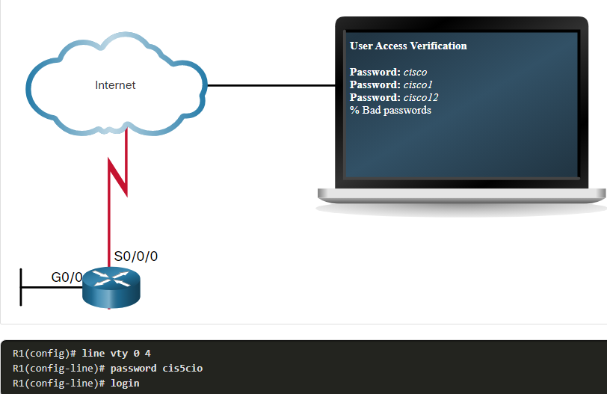This method is the easiest to implement, but it is also the weakest and least secure. This method provides no accountability. Anyone with the password can gain entry to the device and alter the configuration.

SSH is a more secure form of remote access. It requires both a username and a password, both of which are encrypted during transmissions. The local database method provides additional security because an attacker is required to know a username and a password. It also provides more accountability because the username is recorded when a user logs in. Although Telnet can be configured using a username and password, both are sent in plaintext, which makes it vulnerable to being captured and exploited. The local database method has some limitations. The user accounts must be configured locally on each device, as shown for the configuration of SSH in the figure.

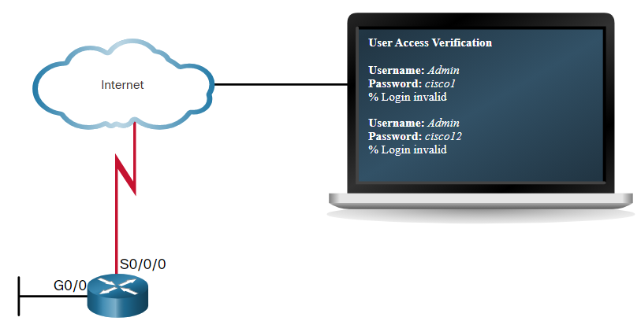

R1(config)# **username Admin algorithm-type scrypt secret Str0ng5rPa55w0rd**

R1(config)# **ip domain-name netsec.com**

R1(config)# **crypto key generate rsa general-keys modulus 2048**

The name for the keys will be: R1.netsec.com

% The key modulus size is 2048 bits

% Generating 2048 bit RSA keys, keys will be non-exportable...

[OK] (elapsed time was 1 seconds)

*Jan 17 14:32:53.846: %CRYPTO_ENGINE-5-KEY_ADDITION: A key named R1.netsec.com has been generated or imported by crypto-engine

*Jan 17 14:32:53.847: %SSH-5-ENABLED: SSH 1.99 has been enabled

*Jan 17 14:32:54.116: %CRYPTO_ENGINE-5-KEY_ADDITION: A key named R1.netsec.com.server has been generated or imported by crypto-engine

R1(cofig)#

R1(config)# **line vty 0 4**

R1(config-line)# **transport input ssh**

R1(config-line)# **login local**

In a large enterprise environment that has multiple routers and switches to manage, it can take time to implement and change local databases on each device. Additionally, the local database configuration provides no fallback authentication method. For example, what if the administrator forgets the username and password for that device? With no backup method available for authentication, password recovery becomes the only option.

A better solution is to have all devices refer to the same database of usernames and passwords from a central server. This module explores the various methods of securing network access using AAA to secure Cisco routers.

### 7.1.2. AAA Components

AAA network security services provide the primary framework to set up access control on a network device. AAA is a way to control who is permitted to access a network (authenticate) and what they can do while they are there (authorize). AAA also allows auditing of the actions that users perform while accessing the network (accounting).

Network and administrative AAA security in the Cisco environment has three functional components:

* **Authentication** - Users and administrators must prove their identity before accessing the network and network resources. Authentication can be established using username and password combinations, challenge and response questions, token cards, and other methods. For example: “I am user ‘student’ and I know the password to prove it.”
* **Authorization** - After the user is authenticated, authorization services determine which resources the user can access and which operations the user is allowed to perform. An example is “User ‘student’ can access host serverXYZ using SSH only.”
* **Accounting and auditing** - Accounting records what the user does, including what is accessed, the amount of time the resource is accessed, and any changes that were made. Accounting keeps track of how network resources are used. An example is "User 'student' accessed host serverXYZ using SSH for 15 minutes."

This concept is similar to using a credit card, as indicated by the figure. The credit card identifies who can use it, how much that user can spend, and keeps account of what items or services the user purchased.

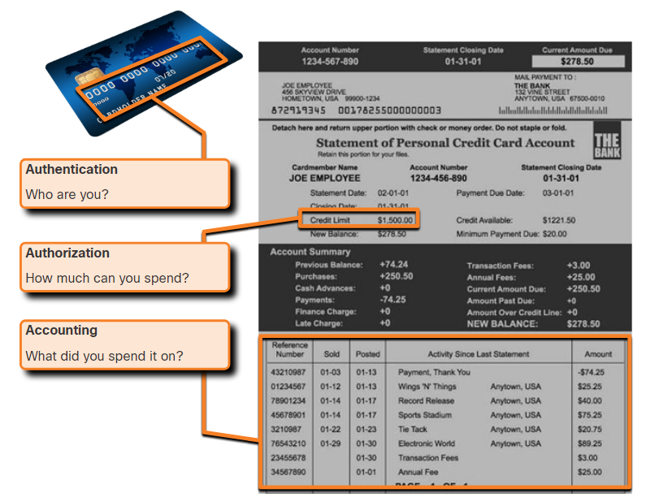

### 7.1.3. Authentication Modes

AAA Authentication can be used to authenticate users for administrative access or it can be used to authenticate users for remote network access. Cisco provides two common methods of implementing AAA services:

* **Local AAA Authentication** -Local AAA uses a local database for authentication. This method is sometimes known as self-contained authentication. In this course, it will be referred to as local AAA authentication. This method stores usernames and passwords locally in the Cisco router, and users authenticate against the local database, as shown in the figure. This database is the same one that is required for establishing role-based CLI. Local AAA is ideal for small networks.

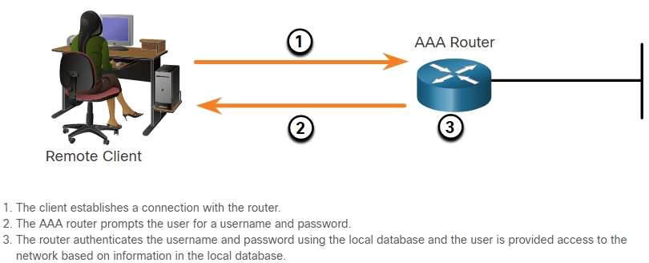

* **Server-Based AAA Authentication** - With the server-based method, the router accesses a central AAA server, such as the Cisco Secure Access Control System (ACS) for Windows, which is shown in the figure. The central AAA server contains the usernames and password for all users. The router uses either the Remote Authentication Dial-In User Service (RADIUS) or Terminal Access Controller Access Control System (TACACS+) protocols to communicate with the AAA server. When there are multiple routers and switches, server-based AAA is more appropriate because accounts can be administered from a central location rather than on individual devices.

**Note:** In this course, the focus is on implementing network security with IPv4 on Cisco routers, switches, and Adaptive Security Appliances. On occasion, references are made to IPv6-specific technologies and protocols.

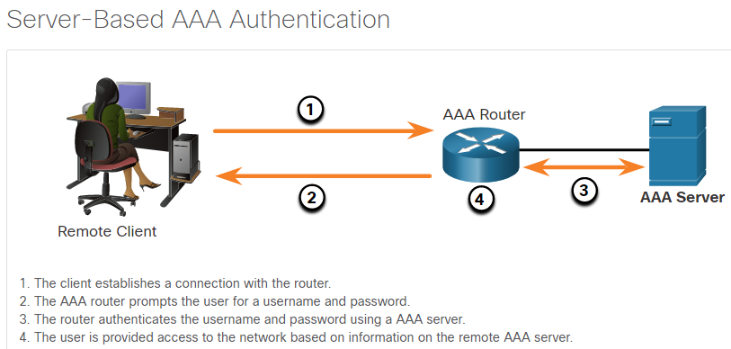

### 7.1.4. Authorization

After users are successfully authenticated against the selected AAA data source, either local or server-based, they are then authorized for specific network resources, as shown in the figure.

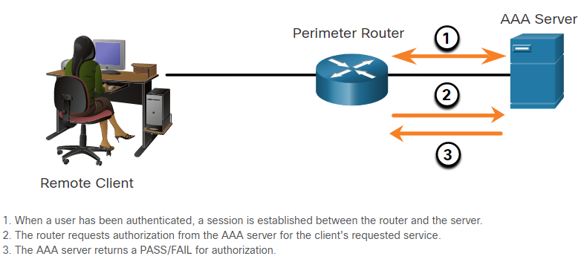

Authorization controls what users can and cannot do on the network after they are authenticated. This is similar to how privilege levels and role-based CLI give users specific rights and privileges to certain commands on the router.

Authorization is typically implemented using a AAA server. Authorization uses a set of attributes that describes the user’s access to the network. These attributes are compared to the information contained within the AAA database, and a determination of restrictions for that user is made and delivered to the local router where the user is connected.

Authorization is automatic and does not require users to perform additional steps after authentication. Authorization is implemented immediately after the user is authenticated.

### 7.1.5. Accounting

AAA Accounting collects and reports usage data. This data can be used for such purposes as auditing or billing. The collected data might include the start and stop connection times, the commands executed, the number of packets, and the number of bytes.

Accounting is implemented using a AAA server. This service reports usage statistics back to the ACS server. These statistics can be extracted to create detailed reports about the configuration of the network.

One widely deployed use of accounting is to combine it with AAA authentication. This helps with managing access to internetworking devices by network administrative staff. Accounting provides more security than just authentication. The AAA servers keep a detailed log of exactly what the authenticated user does on the device, as shown in the figure. This includes all EXEC and configuration commands issued by the user. The log contains numerous data fields, including the username, the date and time, and the actual command that was entered by the user. This information is useful when troubleshooting devices. It also provides leverage against individuals who perform malicious actions.

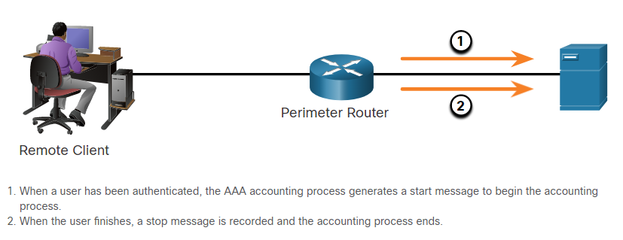

**Network Accounting:** Network accounting collects usage records for network access over various remote access connections.

**Connection Accounting:** Connection accounting captures information about all outbound connections made from the AAA client, such as Telnet or SSH.

**EXEC Accounting:** EXEC accounting captures information about user EXEC terminal sessions (user shells) on the network access server, including username, date, start and stop times, and the access server IP address.

**System Accounting:** System accounting captures information about all system-level events (for example, when the system reboots or when accounting is turned on or off).

**Command Accounting:** Command accounting captures information about the EXEC shell commands for a specified privilege level that are being executed on a network access server. Each command accounting record includes a list of the commands executed for that privilege level, as well as the date and time each command was executed, and the user who executed it.

## 7.2) Configure Local AAA Authentication

### 7.2.1. Authenticate Administrative Access

Local AAA Authentication should be configured for smaller networks. Smaller networks are those networks that have one or two networking devices that provide access to a limited number of users. This method uses the local usernames and passwords that have been configured and stored on a device. The system administrator must populate the local security database by specifying username and password profiles for each user that might log in.

The Local AAA Authentication method is similar to using the **login local** command with one exception. AAA also provides a way to configure backup methods of authentication.

Configuring local AAA services to authenticate administrator access requires a few basic steps:

**Step 1**. Add usernames and passwords to the local router database for users that need administrative access to the router.

**Step 2**. Enable AAA globally on the router.

**Step 3**. Configure AAA parameters on the router.

**Step 4**. Confirm and troubleshoot the AAA configuration.

The **aaa authentication login** command in the figure allows the ADMIN and JR-ADMIN users to log into the router via the console or vty terminal lines. The **default** keyword means that the authentication method applies to all lines, except those for which a specific line configuration overrides the default. The authentication is case-sensitive, indicated by the **local-case** keyword. This means that both the password and the username are case sensitive.

R1(config)# **username JR-ADMIN algorithm-type scrypt secret Str0ng5rPa55w0rd**

R1(config)# **username ADMIN algorithm-type scrypt secret Str0ng5rPa55w0rd**

R1(config)# **aaa new-model**

R1(config)# **aaa authentication login default local-case**

### 7.2.2. Authentication Methods

To enable AAA, the **aaa new-mode**l global configuration command must first be configured. To disable AAA, use the **no** form of this command.

No other AAA commands are available until this command is entered.

**Note:** It is important to know that when the **aaa new-model** command is first entered, that an unseen “default” authentication using the local database is automatically applied to all lines except the console. For this reason, always configure a local database entry before enabling AAA.

Use the **aaa authentication login** command, shown below, to enable authentication of the console, aux, and vty lines. The **default** keyword applies authentication to all lines. Alternatively, a custom authentication method can be configured using a *list-name*.

Router(config)# **aaa authentication login** {**default** | list-name} method1…[ method4 ]

| **Command** | **Description** |
| --- | --- |
| **default** | Uses the listed authentication methods that follow this keyword as the default list of methods when a user logs in. |
| *list-name* | Instead of using **default** list name, the administrator may wish to specify a name for documentation purposes. The name can be up to 31 characters. |
| *method1...*[*method4*] | Identifies the list of methods that the AAA authentication process will query in the given sequence. At least one method must be specified. A maximum of four methods may be specified. |

The final portion of the command identifies the type of methods that will be queried to authenticate the users. Up to four methods can be defined, providing fallback methods should one method not be available. When a user attempts to log in, the first method listed is used. Cisco IOS software attempts authentication with the next listed authentication method only when there is no response or an error from the previous method occurs. If the authentication method denies the user access, the authentication process stops and no other authentication methods are allowed.

To enable local authentication using a preconfigured local database, use the keyword **local** or **local-case**. The difference between the two options is that **local** accepts a username regardless of case, whereas **local-case** is case-sensitive. For example, if a local database entry with the username ADMIN was configured, the **local** method would accept ADMIN, Admin, or even admin. If the **local-case** method was configured, then only ADMIN would be acceptable.

To specify that a user can authenticate using the enable password, use the **enable** keyword. To ensure that the authentication succeeds even if all methods return an error, specify **none** as the final method.

**Note**: For security purposes, use the **none** keyword only when testing the AAA configuration. It should never be applied on a live network.

The table displays common methods that can be specified.

| **Method Type Keywords** | **Description** |
| --- | --- |
| **enable** | Uses the enable password for authentication. |
| **local** | Uses the local username database for authentication. |
| **local-case** | Uses case-sensitive local username authentication. |
| **none** | Uses no authentication. |
| **group radius** | Uses the list of all RADIUS servers for authentication. |
| **group tacacs+** | Uses the list of all TACACS+ servers for authentication. |
| **group** *group-name* | Uses a subset of RADIUS or TACACS+ servers for authentication as defined by the aaa group server radius or aaa group server tacacs+ command. |

### 7.2.3. Default and Named Methods

For flexibility, different method lists can be applied to different interfaces and lines using the **aaa authentication login** *list-name* command.

For example, an administrator could apply a special login for SSH and then have the default login method for the line console, as shown in the example.

R1(config)# **username JR-ADMIN algorithm-type scrypt secret Str0ng5rPa55w0rd**

R1(config)# **username ADMIN algorithm-type scrypt secret Str0ng5rPa55w0rd**

R1(config)# **aaa new-model**

R1(config)# **aaa authentication login default local-case enable**

R1(config)# **aaa authentication login SSH-LOGIN local-case**

R1(config)# **line vty 0 4**

R1(config-line)# **login authentication SSH-LOGIN**

In this example, the vty line would only use the local database for authentication. All other lines (i.e., console and aux lines) would use the local database and use the enable password as a fallback if there were no database entries on the device.

Notice that the named list has to be explicitly enabled on the line using the **login authentication** line configuration command. If a line has a custom authentication method list applied to it, that method list overrides the default method list for that interface.

When a custom authentication method list is applied to an interface, it is possible to return to the default method list by using the **no authentication login** command.

### 7.2.4. Fine-Tuning the Authentication Configuration

Additional security can be implemented on the line using the **aaa local authentication attempts max-fail** global configuration mode command, as show in the example. This command secures AAA user accounts by locking out accounts that have excessive failed attempts.

Router(config)# **aaa local authentication attempts max-fail** [number-of-unsuccessful-attempts]

| **Command** | **Description** |
| --- | --- |
| *number-of-unsuccessful-attempts* | Number of unsuccessful authentication attempts before a connection is dropped and the user account is locked. |

Unlike the **login delay** command which introduces a delay between failed login attempts without locking the account, the **aaa local authentication attempts max-fail** command locks the user account if the authentication fails. The locked out user account remains locked until it is manually cleared by an administrator using the **clear aaa local user lockout** privileged EXEC mode command.

To display a list of all locked-out users, use the **show aaa local user lockout** command in privileged EXEC mode, as shown in the example.

R1# **show aaa local user lockout**

Local-user Lock time

JR-ADMIN 04:28:49 UTC Tue Feb 16 2021

When a user logs into a Cisco router that uses AAA, a unique ID is assigned to that user's session. Throughout the life of the session, various attributes that are related to the session are collected and stored internally within the AAA database. These attributes can include the IP address of the user, the protocol that is used to access the router (e.g., PPP), the speed of the connection, and the number of packets or bytes that are received or transmitted.

To display the attributes that are collected for one AAA session, use the **show aaa user** command in privileged EXEC mode. This command does not provide information for all users who are logged into a device, but only for those who have been authenticated or authorized using AAA, or whose sessions are being accounted for by the AAA module.

The **show aaa sessions** command can be used to show the unique ID of a session, as shown in the example.

R1# **show aaa sessions**

Total sessions since last reload: 4

Session Id: 1

Unique Id: 175

User Name: ADMIN

IP Address: 192.168.1.10

Idle Time: 0

CT Call Handle: 0

## 7.3) Server-Based AAA Characteristics and Protocols

### 7.3.1. Compare Local AAA and Server-Based AAA Implementations

Local implementations of AAA are acceptable in very small networks. However, local authentication does not scale well.

Most corporate environments have multiple routers, switches, and other infrastructure devices, multiple router administrators, and hundreds or thousands of users needing access to the corporate LAN. Maintaining a local database on each device for this size of network is not feasible.

To solve this challenge, one or more AAA servers can be used to manage the user and administrative access needs for an entire corporate network. AAA server software can create a central user and administrative access database to which all devices in the network can refer. It may also work with many external databases, including Active Directory and Lightweight Directory Access Protocol (LDAP). These databases store user account information and passwords, allowing for central administration of user accounts. For increased redundancy, multiple servers can be implemented. The figure shows the process of authenticating router administrator users .

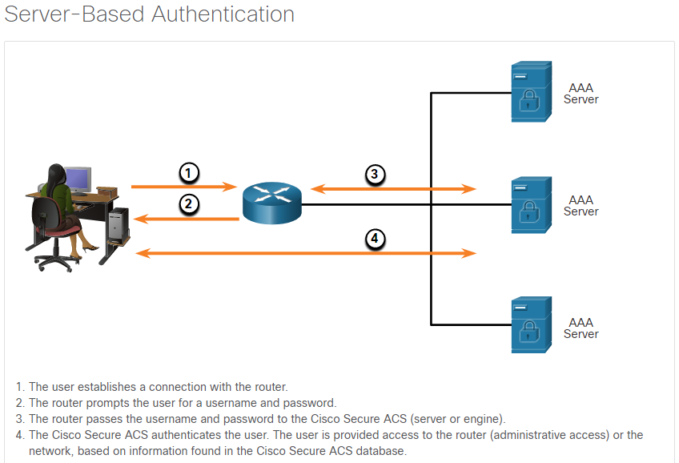

### 7.3.2. Cisco Identity Services Engine (ISE)

Cisco Identity Services Engine (ISE) is an identity and access control policy platform that enables enterprises to enforce compliance, enhance infrastructure security, and streamline their service operations. The architecture of Cisco ISE allows enterprises to gather real-time contextual information from networks, users, and devices. The administrator can then use that information to make proactive governance decisions by tying identity to various network elements. These network elements include access switches, wireless LAN controllers (WLCs), VPNs, gateways, and data center switches.

BYOD (Bring Your Own Device) is becoming more common and even necessary in many enterprises. Cisco ISE defines fair access policies and enforces compliance for all end devices including BYOD.

Cisco ISE is the main policy component for Cisco TrustSec and is a Cisco technology that protects assets such as data, applications, and mobile devices from unauthorized access. Cisco ISE combines policy definition, control, and reporting in one appliance. ISE works with existing network infrastructure to provide network administrators with information about the end devices (known as endpoints) that attach to the network.

Several features of ISE are:

* **Asset Visibility** - Provides visibility and control over who and what is on the network consistently, across wireless, wired, and VPN connections. Cisco ISE uses probes and device sensors to listen to the way devices connect to the network. The Cisco ISE profile database, which is extensive, then classifies the device. This gives the visibility and context that is required to grant the right level of network access..
* **Posture assessment** – Determines if the device complies with device security policies before it connects to the network. It can determine if a device is clean of viruses and suspicious applications and can even make sure that a device’s antivirus software is up to date.
* **Segmentation** - Cisco ISE uses contextual data about network devices and endpoints to facilitate network segmentation. Security group tags, access control lists, network access protocols, and policy sets that define authorization, access, and authentication, are some ways in which Cisco ISE enables secure network segmentation.
* **Guest management and secure wireless** – Enables providing secure network access to visitors, contractors, consultants, and customers.
* **Threat Containment** - If Cisco ISE detects threat or vulnerability attributes from an endpoint, adaptive network control policies are sent to dynamically change the access levels of the endpoint. After the threat or vulnerability is evaluated and addressed, the endpoint can be given back its original access policy.

ISE provides context-aware identity management:

* To determine whether users are accessing the network on an authorized, policy-compliant device
* To establish user identity, location, and access history, which can be used for compliance and reporting
* To assign services based on the assigned user role, group, and associated policy (job role, location, device type, etc.)
* To grant authenticated users access to specific segments of the network, or specific applications and services, or both, based on authentication results

### 7.3.3. The TACACS+ and RADIUS Protocols

TACACS+ and RADIUS are both authentication protocols that are used to communicate with AAA servers. As shown in the table, each supports different capabilities.

| **Capabilities** | **TACACS+** | **RADIUS** |
| --- | --- | --- |
| **Functionality** | Separates AAA according to the AAA architecture, allowing modularity of the security server implementation | Combines authentication and authorization but separates accounting, allowing less flexibility in implementation than TACACS+ |
| **Standard** | Mostly Cisco supported | Open/RFC standard |
| **Transport Protocol** | TCP | UDP |
| **CHAP** | Bidirectional challenge and response as used in Challenge Handshake Authentication Protocol (CHAP) | Unidirectional challenge and response from the RADIUS security server to the RADIUS client |
| **Confidentiality** | Entire packet encrypted | Password encrypted |
| **Customization** | Provides authorization of router commands on a per-user or per-group basis | Has no option to authorize router commands on a per-user or per-group basis |
| **Accounting** | Limited | Extensive |

Whether TACACS+ or RADIUS is selected depends on the needs of the organization. For example, a large ISP might select RADIUS because it supports the detailed accounting required for billing users. An organization with various user groups might select TACACS+ because it requires authorization policies to be applied on a per-user or per-group basis.

It is important to understand the many differences between the TACACS+ and RADIUS protocols.

These are three critical factors for TACACS+:

* Separates authentication and authorization
* Encrypts all communication
* Utilizes TCP port 49

These are four critical factors for RADIUS:

* Combines RADIUS authentication and authorization as one process
* Encrypts only the password
* Utilizes UDP
* Supports remote-access technologies, 802.1X, and Session Initiation Protocol (SIP)

While both protocols can be used to communicate between a router and AAA servers, TACACS+ is considered the more secure protocol. This is because all TACACS+ protocol exchanges are encrypted, while RADIUS only encrypts the user’s password. RADIUS does not encrypt user names, accounting information, or any other information carried in the RADIUS message.

#### TACACS+ Authentication

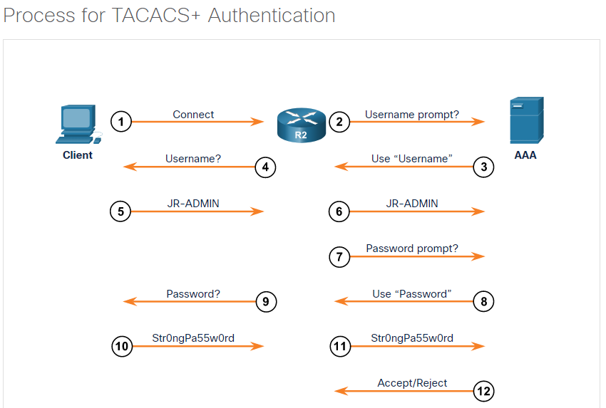TACACS+ is a Cisco enhancement to the original TACACS protocol. Despite its name, TACACS+ is an entirely new protocol that is incompatible with any previous version of TACACS. TACACS+ is supported by the Cisco family of routers and access servers.

TACACS+ provides separate AAA services. Separating the AAA services provides flexibility in implementation because it is possible to use TACACS+ for authorization and accounting while using another method of authentication.

The extensions to the TACACS+ protocol provide more types of authentication requests and response codes than were in the original TACACS specification. TACACS+ offers multiprotocol support, such as IP and legacy AppleTalk. Normal TACACS+ operation encrypts the entire body of the packet for more secure communications and utilizes TCP port 49.

#### RADIUS Authentication

RADIUS, which was developed by Livingston Enterprises, is an open IETF standard AAA protocol for applications such as network access or IP mobility. RADIUS works in both local and roaming situations and is commonly used for accounting purposes. RADIUS is currently defined by RFCs 2865, 2866, 2867, 2868, 3162 and 6911.

The RADIUS protocol hides passwords during transmission, even with the Password Authentication Protocol (PAP), using a rather complex operation that involves Message Digest 5 (MD5) hashing and a shared secret. However, the rest of the packet is sent in plaintext.

RADIUS combines authentication and authorization as one process. When a user is authenticated, that user is also authorized. RADIUS uses UDP port 1645 or 1812 for authentication and UDP port 1646 or 1813 for accounting.

RADIUS is widely used by VoIP service providers. It passes login credentials of a SIP endpoint, such as a broadband phone, to a SIP registrar using digest authentication, and then to a RADIUS server using RADIUS. RADIUS is also a common authentication protocol that is utilized by the 802.1X security standard.

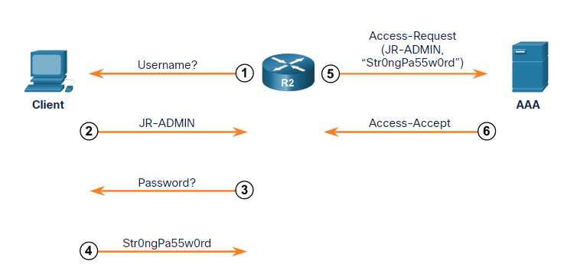

## 7.4) Configure Server-Based Authentication

### 7.4.1. Steps to Configure Server-Based AAA Authentication

Unlike Local AAA Authentication, server-based AAA must identify various TACACS+ and RADIUS servers that the AAA service should consult when authenticating and authorizing users.

There are four basic steps to configure server-based authentication.

**Step 1**. Globally enable AAA to allow the use of all AAA elements. This step is a prerequisite for all other AAA commands.

**Step 2**. Specify the server that will provide AAA services for the router. This can be a TACACS+ or RADIUS server.

**Step 3**. Configure the encryption key needed to encrypt the data transfer between the network device and AAA server.

**Step 4**. Configure the AAA authentication method list to refer to the TACACS+ or RADIUS server. For redundancy, it is possible to configure more than one server.

#### Configure TACACS+ Servers

TACACS+ and RADIUS protocols are used to communicate between clients and the AAA security servers. The figure displays the AAA reference topology for this topic.

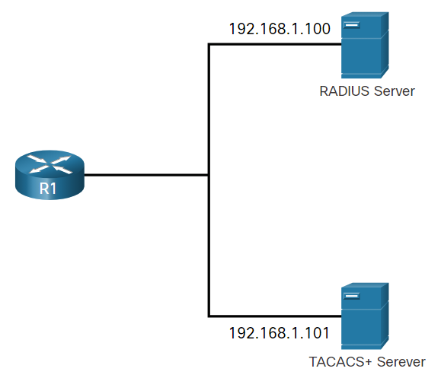To configure a TACACS+ server, globally enable AAA using the **aaa new-model** command. Next, use the **tacacs server** *name* command. In TACACS+ server configuration mode, configure the IPv4 address of the TACACS+ server using the **address ipv4** command. The **address ipv4** command allows the option to modify the authentication port and the accounting port. You can also specify an IPv6 address with the **address ipv6** *ipv6-address* command.

Next, use the **single-connection** command to enhance TCP performance by maintaining a single TCP connection for the life of the session. Otherwise, by default, a TCP connection is opened and closed for each session. If required, multiple TACACS+ servers can be identified by entering their respective IPv4 addresses using the **tacacs server** *name* command.

The **key** *key* command is used to configure the shared secret key to encrypt the data transfer between the TACACS+ server and AAA-enabled router. This key must be configured exactly the same way on both the router and the TACACS+ server.

The example displays a sample TACACS+ server configuration.

R1(config)# **aaa new-model**

R1(config)#

R1(config)# **tacacs server Server-T**

R1(config-server-tacacs)# **address ipv4 192.168.1.101**

R1(config-server-tacacs)# **single-connection**

R1(config-server-tacacs)# **key TACACS-Pa55w0rd**

R1(config-server-tacacs)# **exit**

#### Configure RADIUS Servers

To configure a RADIUS server, use the **radius server** *name* command. This puts you into radius server configuration mode.

Because RADIUS uses UDP, there is no equivalent **single-connection** keyword. If required, multiple RADIUS servers can be identified by entering a **radius server** *name* command for each server.

In RADIUS server configuration mode, configure the IPv4 address of the RADIUS server using the **address ipv4** *ipv4-address* command. You can also specify an IPv6 address with the **address ipv6** *ipv6-address* command.

By default, Cisco routers use port 1645 for the authentication and port 1646 for the accounting. However, IANA has reserved ports 1812 for the RADIUS authentication port and 1813 for the RADIUS accounting port. It is important to make sure these ports match between the Cisco router and the RADIUS server.

To configure the shared secret key for encrypting the password, use the **key** command. This key must be configured exactly the same way on the router and the RADIUS server.

The example displays a sample RADIUS server configuration.

R1(config)# **aaa new-model**

R1(config)#

R1(config)# **radius server SERVER-R**

R1(config-radius-server)# **address ipv4 192.168.1.100 auth-port 1812 acct-port 1813**

R1(config-radius-server)# **key RADIUS-Pa55w0rd**

R1(config-radius-server)# **exit**

### 7.4.2. Authenticate to the AAA Server Configuration Commands

When the AAA security servers have been identified, the servers must be included in the method list of the **aaa authentication login** command. AAA servers are identified using the **group tacacs+** or **group radius** keywords. Refer to the example to see command syntax options available with the **aaa authentication login** command.

R1(config)# **aaa authentication login default ?**

cache Use Cached-group

enable Use enable password for authentication.

group Use Server-group

krb5 Use Kerberos 5 authentication.

krb5-telnet Allow logins only if already authenticated via Kerberos V

Telnet.

line Use line password for authentication.

local Use local username authentication.

local-case Use case-sensitive local username authentication.

none NO authentication.

passwd-expiry enable the login list to provide password aging support

R1(config)# **aaa authentication login default group ?**

WORD Server-group name

ldap Use list of all LDAP hosts.

radius Use list of all Radius hosts.

tacacs+ Use list of all Tacacs+ hosts.

To configure a method list for the default login to authenticate first using a TACACS+ server, second with a RADIUS server, and finally with a local username database, specify the order with the **aaa authentication login defaul**t command, as highlighted in the example. It is important to realize that R1 will only attempt to authenticate using RADIUS if the TACACS+ server is not reachable. Likewise, R1 would only attempt to authenticate using the local database if the TACACS+ and RADIUS servers are unavailable.

R1(config)# **aaa new-model**

R1(config)#

R1(config)# **tacacs server Server-T**

R1(config-server-tacacs)# **address ipv4 192.168.1.100**

R1(config-server-tacacs)# **single-connection**

R1(config-server-tacacs)# **key TACACS-Pa55w0rd**

R1(config-server-tacacs)# **exit**

R1(config)#

R1(config)# **radius server SERVER-R**

R1(config-radius-server)# **address ipv4 192.168.1.101 auth-port 1812 acct-port 1813**

R1(config-radius-server)# **key RADIUS-Pa55w0rd**

R1(config-radius-server)# **exit**

R1(config)#

R1(config)# **aaa authentication login default group tacacs+ group radius local-case**

## 7.5) Configure Server-Based Authorization and Accounting

### 7.5.1. Introduction to Server-Based AAA Authorization

While authentication must ensure that the device or end user is legitimate, authorization is concerned with allowing and disallowing authenticated users access to functions of the network device interface.

The TACACS+ protocol allows the separation of authentication from authorization. A router can be configured to restrict the user to performing only certain functions after successful authentication. Keep in mind that RADIUS does not separate the authentication from the authorization process.

Another important aspect of authorization is the ability to control user access to specific services. Controlling access to configuration commands greatly simplifies the infrastructure security in large enterprise networks.

By default, TACACS+ establishes a new TCP session for every authorization request, which can lead to delays when users enter commands. To improve performance, AAA supports persistent TCP sessions that are configured with the **single-connection** tacacs server configuration mode command.

To configure authorization, use the **aaa authorization** command, as shown in the examples below . The authorization type can specify the types of commands or services:

* **network** - for network services such as PPP and SLIP
* **exec** - for User EXEC terminal sessions
* **commands** *level* - command authorization attempts authorization for all EXEC mode commands, including global configuration commands, associated with a specific privilege level

Router(config)# **aaa authorization** (**network** | **exec** | **commands** level){**default** | list-name} method1… [method4]

R1(config)# **aaa authorization exec ?**

WORD Named authorization list.

default The default authorization list.

R1(config)# **aaa authorization exec default ?**

cache Use Cached-group

group Use server-group.

if-authenticated Succeed if user has authenticated.

krb5-instance Use Kerberos instance privilege maps.

local Use local database.

none No authorization (always succeeds).

R1(config)# **aaa authorization exec default group ?**

WORD Server-group name

ldap Use list of all LDAP hosts.

radius Use list of all Radius hosts.

tacacs+ Use list of all Tacacs+ hosts.

When AAA authorization is not enabled, all users are allowed full access. After authentication is started, the default changes to allow no access. This means that the administrator must create a user with full access rights before authorization is enabled, as shown in the example. Failure to do so immediately locks the administrator out of the system the moment the aaa authorization command is entered. The only way to recover from this is to reboot the router. If this is a production router, rebooting might be unacceptable. Be sure that at least one user always has full rights.

R1(config)# **username JR-ADMIN algorithm-type scrypt secret Str0ng5rPa55w0rd**

R1(config)# **username ADMIN algorithm-type scrypt secret Str0ng5rPa55w0rd**

R1(config)# **aaa new-model**

R1(config)# **aaa authorization exec default group tacacs+**

R1(config)# **aaa authorization network default group tacacs+**

### 7.5.2. Introduction to Server-Based AAA Accounting

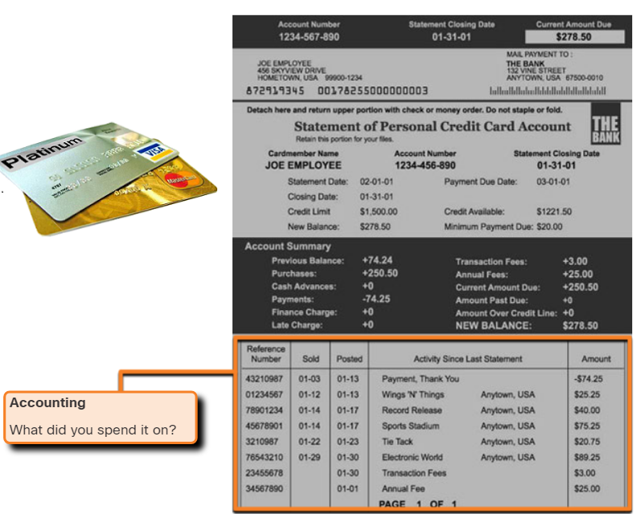Companies often need to keep track of which resources individuals or groups use. AAA accounting enables usage tracking. An example of usage tracking is when one department charges another department for access, or when one company provides internal support to another company. The accounting function is similar to the accounting information provided in a credit card billing statement as shown in the figure.

Although accounting is generally considered a network management or financial management issue, it is discussed briefly here because it is so closely linked with security. One security issue that is addressed by accounting is the creation of a list of users and the time of day they logged into the system. If, for example, the administrator knows that a worker logs in to the system in the middle of the night, this information can be used to further investigate the purpose of the login.

Another reason to implement accounting is to create a list of changes occurring on the network, the user that made the changes, and the exact nature of the changes. Knowing this information helps the troubleshooting process if the changes cause unexpected results.

When accounting is configured on a AAA server it functions as a central repository for accounting information. It tracks events that occur on the network, similar to the way in which financial activity is tracked for a credit card account. Each session that is established through Cisco Secure ACS can be fully accounted for and stored on the server. This stored information can be very helpful for management, security audits, capacity planning, and network usage billing.

Like authentication and authorization method lists, method lists for accounting define the way accounting is performed and the sequence in which these methods are performed. After it is enabled, the default accounting method list is automatically applied to all interfaces, except those that have a user-defined, or custom, accounting method list that has been explicitly defined.

To configure AAA accounting, use the **aaa accounting** command that is shown in the example.

The following three parameters are commonly used **aaa accounting** keywords:

* **network** - Runs accounting for all network-related service requests, including PPP.
* **exec** - Runs accounting for the EXEC shell session.
* **connection** - Runs accounting on all outbound connections such as SSH and Telnet.

Router(config)# **aaa accounting** {**network** | **exec** | **connection**} {**default** | list-name} {**start-stop** | **stop-only** | **none** } [**broadcast**] method1...[method4]

R1(config)# **aaa accounting exec ?**

WORD Named Accounting list.

default The default accounting list

As with AAA authentication, either the keyword **default** or a *list-name* can be used.

Next, the record type, or trigger, is configured. The trigger specifies what actions cause accounting records to be updated. Possible triggers include:

* **start-stop** - Sends a "start" accounting notice at the beginning of a process and a "stop" accounting notice at the end of a process.
* **stop-only** - Sends a "stop" accounting record for all cases including authentication failures.
* **none** - Disables accounting services on a line or interface.

The examples show the command syntax and method list options available.

R1(config)# **aaa accounting exec default start-stop ?**

broadcast Use Broadcast for Accounting

group Use Server-group

R1(config)# **aaa accounting exec default start-stop group ?**

WORD Server-group name

radius Use list of all Radius hosts.

tacacs+ Use list of all Tacacs+ hosts.

The example shows an accounting configuration that logs the use of EXEC commands and network connections.

R1(config)# **username JR-ADMIN algorithm-type scrypt secret Str0ng5rPa5w0rd**

R1(config)# **username ADMIN algorithm-type scrypt secret Str0ng5rPa55w0rd**

R1(config)# **aaa new-model**

R1(config)# **aaa authentication login default group tacacs+**

R1(config)# **aaa authorization exec default group tacacs+**

R1(config)# **aaa authorization network default group tacacs+**

R1(config)# **aaa accounting exec default start-stop group tacacs+**

R1(config)# **aaa accounting network default start-stop group tacacs**+

## 7.6) What Did I Learn in this Module?

**AAA Characteristics**  
Local authentication can be configured on networking devices with usernames and passwords that protect console, vty lines, and User EXEC mode. This is the easiest authentication to implement, but also the weakest and least secure. SSH should be used for remote access to vty lines because telnet is not secure. AAA provides a means by which users can be authenticated against a centralized database of users. AAA authentication requires users and admins to prove their identity with usernames and passwords or through other methods. AAA authorization can be used to limit the access of users or groups of users to only the network resources that they need to access. It also can control what the user can do with various resources. Authorization can be configured to control what different users can do on network devices. AAA accounting records user actions including when the user accessed the network or device, the length of time for the session, and the resources or functions that were accessed by the user. AAA can be configured to access a local user database that has been configured on a router or switch, or centralized AAA server. After authentication has successfully occurred, authorization for user access is determined. After successful authentication, AAA accounting records the beginning of the session.

**Configure Local AAA Authentication**  
Local AAA authentication should be configured for smaller networks. Usernames and passwords are configured on the networking device, similar to when **login local** is configured on the console and vty lines. AAA local authentication provides additional options that are not available when AAA is not used. For example, different authentication methods can be configured on different lines, including using local authentication for some lines and server-based authentication for others. In addition, local AAA authentication can be configured to lock users out after a specified number of login attempts. The user will remain locked out until an administrator manually clears the user from the list of locked-out local users.

**Server-Based AAA Characteristics and Protocols**  
Local authentication does not scale well to large networks that have many networking devices and users. The legacy Cisco Secure ACS AAA server has been replaced by Cisco ISE. ISE provides many access-related security functions beyond AAA functionality. The TACACS+ and RADIUS protocols provide communication between a network device and a AAA server. The choice of protocol defends on the needs of the enterprise. TACACS+ encrypts all communication while RADIUS only encrypts passwords. TACACS+ separates the authentication and authorization processes, while they are combined in RADIUS. In addition, TACACS+ uses TCP while RADIUS uses UDP. It is important to note that RADIUS supports remote access technologies such as 802.1X and SIP. There are other important differences between the protocols.

TACACS+ is a Cisco enhancement of the original TACACS protocol and is not compatible with the original version. RADIUS is an open standard IETF protocol. It is widely used with VoIP because it supports SIP. The next generation protocol that is an alternative to RADIUS is Diameter AAA.

**Configure Server-Based Authentication**  
There are four basic steps to configuring AAA server-based authentication. First AAA must be globally enabled on the device. Second, the AAA server IP address and protocol are specified. Then, the matching encryption key that will be used by the network device and AAA server is specified. The device must also be configured to use the AAA server or servers for authentication by specifying the **aaa authentication** method list that includes the login group as either RADIUS, TACACS+ or both. Note that by default, Cisco routers use port 1645 for authentication and port 1646 for accounting. However, IANA has reserved ports 1812 for RADIUS authentication and 1813 for RADIUS accounting. It is important to make sure these ports match between the networking device and the RADIUS server.

**Configure Server-Based Authentication and Accounting**  
AAA authorization is concerned with allowing authenticated users access to only the resources that they need to access. For network administrators, the type of access that is permitted to the device command line and network services can be controlled. The type of authorization is configured with the **aaa authorization** command. Types can be **network**, for network services, **exec**, for the User EXEC mode, and **command** for all EXEC mode commands including configuration commands. When AAA authorization is not enabled, all users are allowed full access. After authentication is started, the default changes to allow no access. This means that the administrator must create a user with full access rights before authorization is enabled. Failure to do so immediately locks the administrator out of the system the moment the **aaa authorization** command is entered. The only way to recover from this is to reboot the router.

AAA accounting tracks the resources accessed by a user, or the device functions that an administrator has accessed. One reason to implement accounting is to create a list of changes that occurred on the network device, the user that made the changes, and the exact nature of the changes. Knowing this information helps the troubleshooting process if the changes cause unexpected results. The **aaa accounting** command options track the following types of information:

* **network** - all network-related service requests, including PPP
* **exec** - accounting for the EXEC shell session
* **connection** - accounting on all outbound connections such as SSH and Telnet

The record type or trigger specifies what actions cause accounting records to be updated. Triggers include the beginning and end of a process or authentication failures. Accounting can also be disabled on a device line or interface.

# 8. Access Control Lists (ACLs)

## 8.0) Introduction

### 8.0.1. Why Should I Take this Module?

In the gated community where your grandparents live, there are rules for who can enter and leave the premises. The guard will not raise the gate to let you in to the community until someone confirms that you are on an approved visitor list. Much like the guard in the gated community, network traffic passing through an interface configured with an access control list (ACL) has permitted and denied traffic. How do you configure these ACLs? How do you modify them if they are not working correctly or if they require other changes? Get started with this module to learn more!

### 8.0.2. What Will I Learn in this Module?

**Module Title:** Access Control Lists

**Module Objective**: Implement access control lists (ACLs) to filter traffic and mitigate network attacks.

| **Topic Title** | **Topic Objective** |
| --- | --- |
| **Introduction to Access Control Lists** | Describe standard and extended IPv4 ACLs. |
| **Wildcard Masks** | Explain how ACLs use wildcard masks. |
| **Configure ACLs** | Explain how to configure ACLs. |
| **Modify ACLs** | Use sequence numbers to edit existing standard IPv4 ACLs |
| **Implement ACLs** | Implement ACLs. |
| **Mitigate Attacks with ACLs** | Use ACLs to mitigate common network attacks. |
| **IPv6 ACLs** | Configure IPv6 ACLs using the CLI. |

## 8.1) Introduction to ACL

### 8.1.1. What is an ACL?

Routers make routing decisions based on information in the packet header. Traffic entering a router interface is routed solely based on information within the routing table. The router compares the destination IP address with routes in the routing table to find the best match and then forwards the packet based on the best match route. That same process can be used to filter traffic using an access control list (ACL).

An ACL is a series of IOS commands that are used to filter packets based on information found in the packet header. By default, a router does not have any ACLs configured. However, when an ACL is applied to an interface, the router performs the additional task of evaluating all network packets as they pass through the interface to determine if the packet can be forwarded.

An ACL uses a sequential list of permit or deny statements, known as access control entries (ACEs).

**Note:** ACEs are also commonly called ACL statements.

When network traffic passes through an interface configured with an ACL, the router compares the information within the packet against each ACE, in sequential order, to determine if the packet matches one of the ACEs. This process is called packet filtering.

Several tasks performed by routers require the use of ACLs to identify traffic. The table lists some of these tasks with examples.

| **Task** | **Example** |
| --- | --- |
| Limit network traffic to increase network performance | * A corporate policy prohibits video traffic on the network to reduce the network load. * A policy can be enforced using ACLs to block video traffic. |
| Provide traffic flow control | * A corporate policy requires that routing protocol traffic be limited to certain links only. * A policy can be implemented using ACLs to restrict the delivery of routing updates to only those that come from a known source. |
| Provide a basic level of security for network access | * Corporate policy demands that access to the Human Resources network be restricted to authorized users only. * A policy can be enforced using ACLs to limit access to specified networks. |
| Filter traffic based on traffic type | * Corporate policy requires that email traffic be permitted into a network, but that Telnet access be denied. * A policy can be implemented using ACLs to filter traffic by type. |
| Screen hosts to permit or deny access to network services | * Corporate policy requires that access to some file types (e.g., FTP or HTTP) be limited to user groups. * A policy can be implemented using ACLs to filter user access to services. |
| Provide priority to certain classes of network traffic | * Corporate traffic specifies that voice traffic be forwarded as fast as possible to avoid any interruption. * A policy can be implemented using ACLs and QoS services to identify voice traffic and process it immediately. |

### 8.1.2. Packet Filtering

Packet filtering controls access to a network by analyzing the incoming and/or outgoing packets and forwarding them or discarding them based on given criteria. Packet filtering can occur at Layer 3 or Layer 4, as shown in the figure.

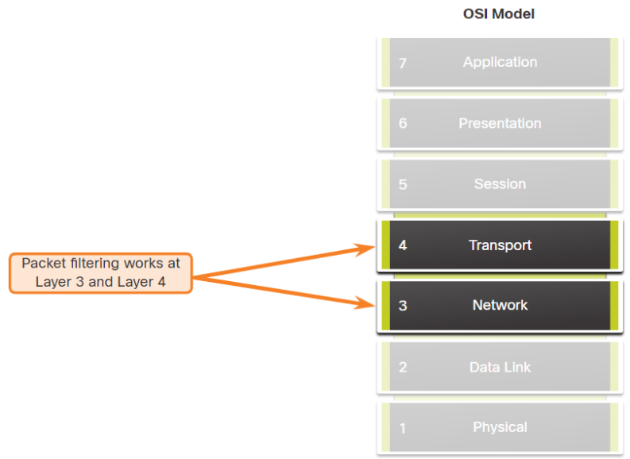Cisco routers support two types of ACLs:

* **Standard ACLs** - ACLs only filter at Layer 3 using the source IPv4 address only.
* **Extended ACLs** - ACLs filter at Layer 3 using the source and / or destination IPv4 address. They can also filter at Layer 4 using TCP, UDP ports, and optional protocol type information for finer control.

### 8.1.3. Numbered and Named ACLs

**Numbered ACLs**: ACLs number 1 to 99, or 1300 to 1999 are standard ACLs while ACLs number 100 to 199, or 2000 to 2699 are extended ACLs, as shown in the output.

R1(config)# **access-list ?**

<1-99> IP standard access list

<100-199> IP extended access list

<1100-1199> Extended 48-bit MAC address access list

<1300-1999> IP standard access list (expanded range)

<200-299> Protocol type-code access list

<2000-2699> IP extended access list (expanded range)

<700-799> 48-bit MAC address access list

rate-limit Simple rate-limit specific access list

template Enable IP template acls

**Named ACLs**: Named ACLs is the preferred method to use when configuring ACLs. Specifically, standard and extended ACLs can be named to provide information about the purpose of the ACL. For example, naming an extended ACL FTP-FILTER is far better than having a numbered ACL 100.

The **ip** **access-list** global configuration command is used to create a named ACL, as shown in the following example.

R1(config)# **ip access-list extended FTP-FILTER**

R1(config-ext-nacl)# **permit tcp 192.168.10.0 0.0.0.255 any eq ftp**

R1(config-ext-nacl)# **permit tcp 192.168.10.0 0.0.0.255 any eq ftp-data**

The following summarizes the rules to follow for named ACLs.

* Assign a name to identify the purpose of the ACL.
* Names can contain alphanumeric characters.
* Names cannot contain spaces or punctuation.
* It is suggested that the name be written in CAPITAL LETTERS.
* Entries can be added or deleted within the ACL.

### 8.1.4. ACL Operation

ACLs define the set of rules that give added control for packets that enter inbound interfaces, packets that relay through the router, and packets that exit outbound interfaces of the router.

ACLs can be configured to apply to inbound traffic and outbound traffic, as shown in the figure.

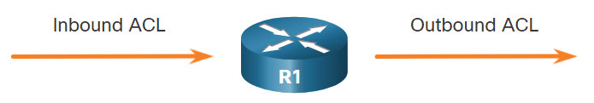

**Note**: ACLs do not act on packets that originate from the router itself.

An inbound ACL filters packets before they are routed to the outbound interface. An inbound ACL is efficient because it saves the overhead of routing lookups if the packet is discarded. If the packet is permitted by the ACL, it is then processed for routing. Inbound ACLs are best used to filter packets when the network attached to an inbound interface is the only source of packets that need to be examined.

An outbound ACL filters packets after being routed, regardless of the inbound interface. Incoming packets are routed to the outbound interface and then they are processed through the outbound ACL. Outbound ACLs are best used when the same filter will be applied to packets coming from multiple inbound interfaces before exiting the same outbound interface.

When an ACL is applied to an interface, it follows a specific operating procedure. For example, here are the operational steps used when traffic has entered a router interface with an inbound standard IPv4 ACL configured.

1. The router extracts the source IPv4 address from the packet header.
2. The router starts at the top of the ACL and compares the source IPv4 address to each ACE in a sequential order.
3. When a match is made, the router carries out the instruction, either permitting or denying the packet, and the remaining ACEs in the ACL, if any, are not analyzed.
4. If the source IPv4 address does not match any ACEs in the ACL, the packet is discarded because there is an implicit deny ACE automatically applied to all ACLs.

The last ACE statement of an ACL is always an implicit deny that blocks all traffic. By default, this statement is automatically implied at the end of an ACL even though it is hidden and not displayed in the configuration.

**Note**: An ACL must have at least one permit statement otherwise all traffic will be denied due to the implicit deny ACE statement.

## 8.2) Wildcard Masking

### 8.2.1. Wildcard Mask Overview

In the previous topic, you learned about the purpose of ACLs. This topic explains how ACLs use wildcard masks. An IPv4 ACE uses a 32-bit wildcard mask to determine which bits of the address to examine for a match. Wildcard masks are also used by the Open Shortest Path First (OSPF) routing protocol.

A wildcard mask is similar to a subnet mask in that it uses the ANDing process to identify which bits in an IPv4 address to match. However, they differ in the way they match binary 1s and 0s. Unlike a subnet mask, in which binary 1 is equal to a match and binary 0 is not a match, in a wildcard mask, the reverse is true.

Wildcard masks use the following rules to match binary 1s and 0s:

* **Wildcard mask bit 0** - Match the corresponding bit value in the address
* **Wildcard mask bit 1** - Ignore the corresponding bit value in the address

The table lists some examples of wildcard masks and what they would identify.

| **Wildcard Mask** | **Last Octet (in Binary)** | **Meaning (0 - match, 1 - ignore)** |
| --- | --- | --- |
| **0.0.0.0** | **00000000** | Match all octets. |
| **0.0.0.63** | **00111111** | * Match the first three octets * Match the two left most bits of the last octet * Ignore the last 6 bits |
| **0.0.0.15** | **00001111** | * Match the first three octets * Match the four left most bits of the last octet * Ignore the last 4 bits of the last octet |
| **0.0.0.252** | **11111100** | * Match the first three octets * Ignore the six left most bits of the last octet * Match the last two bits |
| **0.0.0.255** | **11111111** | * Match the first three octet * Ignore the last octet |

### 8.2.2. Wildcard Mask Types

Using wildcard masks will take some practice. Refer to the examples to learn how the wildcard mask is used to filter traffic for one host, one subnet, and a range IPv4 addresses.

**Wildcard to Match a Host**

In this example, the wildcard mask is used to match a specific host IPv4 address. Assume ACL 10 needs an ACE that only permits the host with IPv4 address 192.168.1.1. Recall that “0” equals a match and “1” equals ignore. To match a specific host IPv4 address, a wildcard mask consisting of all zeroes (i.e., 0.0.0.0) is required.

The table lists in binary, the host IPv4 address, the wildcard mask, and the permitted IPv4 address.

The 0.0.0.0 wildcard mask stipulates that every bit must match exactly. Therefore, when the ACE is processed, the wildcard mask will permit only the 192.168.1.1 address. The resulting ACE in ACL 10 would be **access-list 10 permit 192.168.1.1 0.0.0.0.**

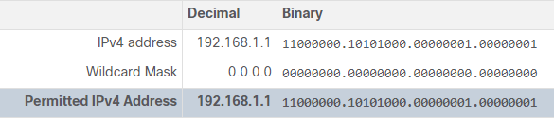

**Wildcard Mask to Match an IPv4 Subnet**

In this example, ACL 10 needs an ACE that permits all hosts in the 192.168.1.0/24 network. The wildcard mask 0.0.0.255 stipulates that the very first three octets must match exactly but the fourth octet does not.

The table lists in binary, the host IPv4 address, the wildcard mask, and the permitted IPv4 addresses.

When processed, the wildcard mask 0.0.0.255 permits all hosts in the 192.168.1.0/24 network. The resulting ACE in ACL 10 would be **access-list 10 permit 192.168.1.0 0.0.0.255.**

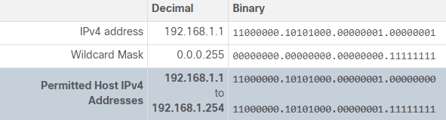

**Wildcard Mask to Match an IPv4 Address Range**

In this example, ACL 10 needs an ACE that permits all hosts in the 192.168.16.0/24, 192.168.17.0/24, …, 192.168.31.0/24 networks. The wildcard mask 0.0.15.255 would correctly filter that range of addresses.

The table lists in binary the host IPv4 address, the wildcard mask, and the permitted IPv4 addresses.

The highlighted wildcard mask bits identify which bits of the IPv4 address must match. When processed, the wildcard mask 0.0.15.255 permits all hosts in the 192.168.16.0/24 to 192.168.31.0/24 networks. The resulting ACE in ACL 10 would be **access-list 10 permit 192.168.16.0 0.0.15.255.**

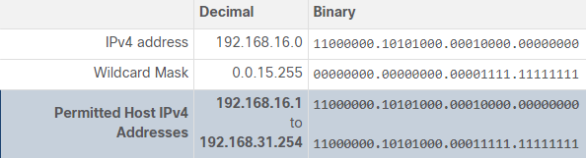

### 8.2.3. Wildcard Mask Keywords

Working with decimal representations of binary wildcard mask bits can be tedious. To simplify this task, the Cisco IOS provides two keywords to identify the most common uses of wildcard masking. Keywords reduce ACL keystrokes but more importantly, keywords make it easier to read the ACE.

The two keywords are:

* **host** - This keyword substitutes for the 0.0.0.0 mask. This mask states that all IPv4 address bits must match to filter just one host address.
* **any** - This keyword substitutes for the 255.255.255.255 mask. This mask says to ignore the entire IPv4 address or to accept any addresses.

For example, in the command output, two ACLs are configured. The ACL 10 ACE permits only the 192.168.10.10 host and the ACL 11 ACE permits all hosts.

R1(config)# **access-list 10 permit 192.168.10.10**  **0.0.0.0**

R1(config)# **access-list 11 permit**  **0.0.0.0 255.255.255.255**

Alternatively, the keywords **host** and **any** could have been used to replace the highlighted output. The following commands accomplishes the same task as the previous commands.

R1(config)# **access-list 10 permit**  **host**  **192.168.10.10**

R1(config)# **access-list 11 permit**  **any**

## 8.3) Configure ACLs

### 8.3.1. Create an ACL

In a previous topic, you learned about what an ACL does and why it is important. In this topic, you will learn about creating ACLs.

All access control lists (ACLs) must be planned. However, this is especially true for ACLs requiring multiple access control entries (ACEs).

When configuring a complex ACL, it is suggested that you:

* Use a text editor and write out the specifics of the policy to be implemented.
* Add the IOS configuration commands to accomplish those tasks.
* Include remarks to document the ACL.
* Copy and paste the commands onto the device.
* Always thoroughly test an ACL to ensure that it correctly applies the desired policy.

These recommendations enable you to create the ACL thoughtfully without impacting the traffic on the network.

#### Numbered Standard IPv4 ACL Syntax

Router(config)# **access-list** access-list-number {**deny** | **permit** | **remark** text} source [source-wildcard] [**log**]

Use the **no access-list** *access-list-number* global configuration command to remove a numbered standard ACL.

The table provides a detailed explanation of the syntax for a standard ACL.

| **Parameter** | **Description** |
| --- | --- |
| *access-list-number* | * This is the decimal number of the ACL. * Standard ACL number range is 1 to 99 or 1300 to 1999. |
| **deny** | This denies access if the condition is matched. |
| **permit** | This permits access if the condition is matched. |
| **remark** *text* | * (Optional) This adds a text entry for documentation purposes. * Remarks are extremely useful, especially in longer or more complex ACLs. * Each remark is limited to 100 characters. |
| *source* | * This identifies the source network or host address to filter. * Use the **any** keyword to specify all networks. * Use the **host** *ip-address* keyword or simply enter an *ip-address* (without the **host**keyword) to identify a specific IP address. |
| *source-wildcard* | (Optional) This is a 32-bit wildcard mask that is applied to the source. If omitted, a default 0.0.0.0 mask is assumed. |
| **log** | * (Optional) This keyword generates an informational message whenever the ACE is matched. * Message includes ACL number, matched condition (i.e., permitted or denied), source address, and number of packets. * This message is generated for the first matched packet. * Unfortunately, ACL logging can be CPU intensive and can negatively affect other functions therefore it should only be implemented for troubleshooting or security reasons. |

#### Named Standard IPv4 ACL Syntax

Router(config)# **ip access-list standard** access-list-name

This command enters the named standard configuration mode where you configure the ACL ACEs.

ACL names are alphanumeric, case sensitive, and must be unique. Capitalizing ACL names is not required but makes them stand out when viewing the running-config output. It also makes it less likely that you will accidentally create two different ACLs with the same name but with different uses of capitalization.

**Note**: Use the **no ip access-list** **standard** *access-list-name* global configuration command to remove a named standard IPv4 ACL.

In the example, a named standard IPv4 ACL called NO-ACCESS is created. Notice that the prompt changes to named standard ACL configuration mode. ACE statements are entered in the named standard ACL sub configuration mode. Use the help facility to view all the named standard ACL ACE options.

The three highlighted options are configured similar to the numbered standard ACL. Unlike the numbered ACL method, there is no need to repeat the initial **ip access-list** command for each ACE.

R1(config)# **ip access-list standard NO-ACCESS**

R1(config-std-nacl)# **?**

Standard Access List configuration commands:

<1-2147483647> Sequence Number

default Set a command to its defaults

deny Specify packets to reject

exit Exit from access-list configuration mode

no Negate a command or set its defaults

permit Specify packets to forward

remark Access list entry comment

#### Numbered Extended IPv4 ACL Syntax

The procedural steps for configuring extended ACLs are the same as for standard ACLs. The extended ACL is first configured, and then it is activated on an interface. However, the command syntax and parameters are more complex to support the additional features provided by extended ACLs.

To create a numbered extended ACL, use the following global configuration command:

Router(config-if)# **ip access-group** 0 0

Use the **no access-list** *access-list-number* global configuration command to remove an extended ACL.

Although there are many keywords and parameters for extended ACLs, it is not necessary to use all of them when configuring an extended ACL. The table provides a detailed explanation of the syntax for an extended ACL.

| **Parameter** | **Description** |
| --- | --- |
| *access-list-number* | * This is the decimal number of the ACL. * Extended ACL number range is 100 to 199 and 2000 to 2699. |
| **deny** | This denies access if the condition is matched. |
| **permit** | This permits access if the condition is matched. |
| **remark** *text* | * (Optional) Adds a text entry for documentation purposes. * Each remark is limited to 100 characters. |
| *protocol* | * Name or number of an internet protocol. * Common keywords include **ip**, **tcp**, **udp**, and **icmp**. * The **ip**keyword matches all IP protocols. |
| *source* | * This identifies the source network or host address to filter. * Use the **any** keyword to specify all networks. * Use the **host** *ip-address* keyword or simply enter an *ip-address* (without the **host**keyword) to identify a specific IP address. |
| *source-wildcard* | (Optional) A 32-bit wildcard mask that is applied to the source. |
| *destination* | * This identifies the destination network or host address to filter. * Use the **any** keyword to specify all networks. * Use the **host** *ip-address* keyword or *ip-address*. |
| *destination-wildcard* | (Optional) This is a 32-bit wildcard mask that is applied to the destination. |
| *operator* | * (Optional) This compares source or destination ports. * Some operators include **lt** (less than), **gt** (greater than), **eq** (equal), and **neq** (not equal). |
| *port* | (Optional) The decimal number or name of a TCP or UDP port. |
| **established** | * (Optional) For the TCP protocol only. * This is a 1st generation firewall feature. |
| **log** | * (Optional) This keyword generates and sends an informational message whenever the ACE is matched. * This message includes ACL number, matched condition (i.e., permitted or denied), source address, and number of packets. * This message is generated for the first matched packet. * This keyword should only be implemented for troubleshooting or security reasons. |

The command to apply an extended IPv4 ACL to an interface is the same as the command used for standard IPv4 ACLs.

Router(config-if)# **ip access-group** {access-list-number | access-list-name} {**in** | **out**}

To remove an ACL from an interface, first enter the **no ip access-group** interface configuration command. To remove the ACL from the router, use the **no access-list** global configuration command.

**Note**: The internal logic applied to the ordering of standard ACL statements does not apply to extended ACLs. The order in which the statements are entered during configuration is the order they are displayed and processed.

#### Named Extended IPv4 ACL Syntax

Router(config)# **ip access-list extended** access-list-name

This command enters the named extended configuration mode. Recall that ACL names are alphanumeric, case sensitive, and must be unique.

In the example, a named extended ACL called NO-FTP-ACCESS is created and the prompt changed to named extended ACL configuration mode. ACE statements are entered in the named extended ACL sub configuration mode.

R1(config)# **ip access-list extended NO-FTP-ACCESS**

Named extended ACLs are created in essentially the same way that named standard ACLs are created.

The topology in the figure is used to demonstrate configuring and applying two named extended IPv4 ACLs to an interface:

* **SURFING** - This will permit inside HTTP and HTTPS traffic to exit to the internet.
* **BROWSING** - This will only permit returning web traffic to the inside hosts while all other traffic exiting the R1 G0/0/0 interface is implicitly denied.

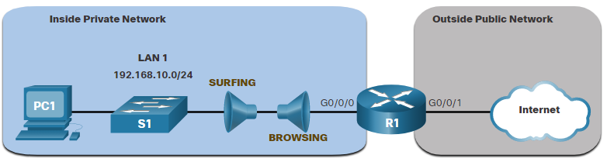

The example shows the configuration for the inbound SURFING ACL and the outbound BROWSING ACL.

The SURFING ACL permits HTTP and HTTPS traffic from inside users to exit the G0/0/1 interface connected to the internet. Web traffic returning from the internet is permitted back into the inside private network by the BROWSING ACL.

The SURFING ACL is applied inbound and the BROWSING ACL applied outbound on the R1 G0/0/0 interface, as shown in the output.

Inside hosts have been accessing the secure web resources from the internet. **The show access-lists** command is used to verify the ACL statistics. Notice that the permit secure HTTPS counters (i.e., eq 443) in the SURFING ACL and the return established counters in the BROWSING ACL have increased.

R1(config)# **ip access-list extended SURFING**

R1(config-ext-nacl)# **Remark Permits inside HTTP and HTTPS traffic**

R1(config-ext-nacl)# **permit tcp 192.168.10.0 0.0.0.255 any eq 80**

R1(config-ext-nacl)# **permit tcp 192.168.10.0 0.0.0.255 any eq 443**

R1(config-ext-nacl)# **exit**

R1(config)#

R1(config)# **ip access-list extended BROWSING**

R1(config-ext-nacl)# **Remark Only permit returning HTTP and HTTPS traffic**

R1(config-ext-nacl)# **permit tcp any 192.168.10.0 0.0.0.255 established**

R1(config-ext-nacl)# **exit**

R1(config)# **interface g0/0/0**

R1(config-if)# **ip access-group SURFING in**

R1(config-if)# **ip access-group BROWSING out**

R1(config-if)# **end**

R1# **show access-lists**

Extended IP access list SURFING

10 permit tcp 192.168.10.0 0.0.0.255 any eq www

20 permit tcp 192.168.10.0 0.0.0.255 any eq 443 (124 matches)

Extended IP access list BROWSING

10 permit tcp any 192.168.10.0 0.0.0.255 established (369 matches)

### 8.3.2. Protocols and Port Numbers

**Protocol Options**

The four highlighted protocols are the most popular options.

**Note**: Use the **?** to get help when entering a complex ACE.

**Note:** If an internet protocol is not listed, then the IP protocol number could be specified. For instance, the ICMP protocol number 1, TCP is 6, and UDP is 17.

R1(config)# **access-list 100 permit ?**

<0-255> An IP protocol number

ahp Authentication Header Protocol

dvmrp dvmrp

eigrp Cisco's EIGRP routing protocol

esp Encapsulation Security Payload

gre Cisco's GRE tunneling

icmp Internet Control Message Protocol

igmp Internet Gateway Message Protocol

ip Any Internet Protocol

ipinip IP in IP tunneling

nos KA9Q NOS compatible IP over IP tunneling

object-group Service object group

ospf OSPF routing protocol

pcp Payload Compression Protocol

pim Protocol Independent Multicast

tcp Transmission Control Protocol

udp User Datagram Protocol

**Port Keyword Options**

Selecting a *protocol* influences *port* options. For instance, selecting the:

* **tcp** protocol would provide TCP related ports options
* **udp** protocol would provide UDP specific ports options
* **icmp** protocol would provide ICMP related ports (i.e., message) options

Again, notice how many TCP port options are available. The highlighted ports are popular options.

Port names or number can be specified. However, port names make it easier to understand the purpose of an ACE. Notice how some common ports names (e.g., SSH and HTTPS) are not listed. For these protocols, port numbers will have to be specified.

R1(config)# **access-list 100 permit tcp any any eq ?**

<0-65535> Port number

bgp Border Gateway Protocol (179)

chargen Character generator (19)

cmd Remote commands (rcmd, 514)

daytime Daytime (13)

discard Discard (9)

domain Domain Name System (53)

echo Echo (7)

exec Exec (rsh, 512)

finger Finger (79)

ftp File Transfer Protocol (21)

ftp-data FTP data connections (20)

gopher Gopher (70)

hostname NIC hostname server (101)

ident Ident Protocol (113)

irc Internet Relay Chat (194)

klogin Kerberos login (543)

kshell Kerberos shell (544)

login Login (rlogin, 513)

lpd Printer service (515)

msrpc MS Remote Procedure Call (135)

nntp Network News Transport Protocol (119)

onep-plain Onep Cleartext (15001)

onep-tls Onep TLS (15002)

pim-auto-rp PIM Auto-RP (496)

pop2 Post Office Protocol v2 (109)

pop3 Post Office Protocol v3 (110)

smtp Simple Mail Transport Protocol (25)

sunrpc Sun Remote Procedure Call (111)

syslog Syslog (514)

tacacs TAC Access Control System (49)

talk Talk (517)

telnet Telnet (23)

time Time (37)

uucp Unix-to-Unix Copy Program (540)

whois Nicname (43)

www World Wide Web (HTTP, 80)

Extended ACLs can filter on different port number and port name options. This example configures an extended ACL 100 to filter HTTP traffic. The first ACE uses the **www** port name. The second ACE uses the port number **80**. Both ACEs achieve exactly the same result.

R1(config)# **access-list 100 permit tcp any any eq www**

R1(config)# **!or...**

R1(config)# **access-list 100 permit tcp any any eq 80**

Configuring the port number is required when there is not a specific protocol name listed such as SSH (port number 22) or an HTTPS (port number 443), as shown in the next example.

R1(config)# **access-list 100 permit tcp any any eq 22**

R1(config)# **access-list 100 permit tcp any any eq 443**

### 8.3.3. TCP Established Extended ACL

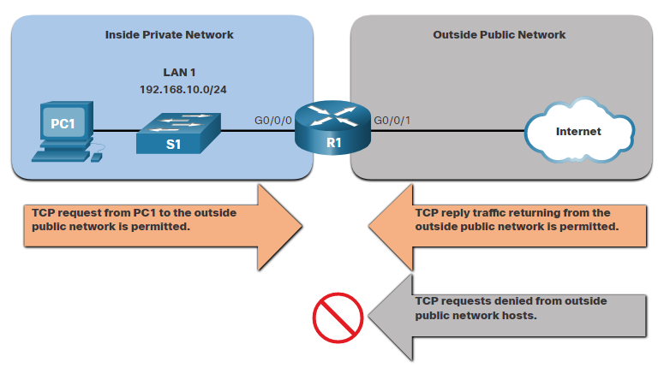TCP can also perform basic stateful firewall services using the TCP **established** keyword. The keyword enables inside traffic to exit the inside private network and permits the returning reply traffic to enter the inside private network, as shown in the figure.

However, TCP traffic generated by an outside host and attempting to communicate with an inside host is denied.

The **established** keyword can be used to permit only the return HTTP traffic from requested websites, while denying all other traffic.

In the topology, the design for this example shows that ACL 110, which was previously configured, will filter traffic from the inside private network. ACL 120, using the **established** keyword, will filter traffic coming into the inside private network from the outside public network.

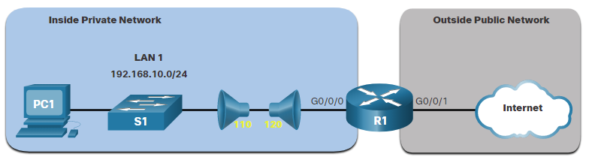

In the example, ACL 120 is configured to only permit returning web traffic to the inside hosts. The new ACL is then applied outbound on the R1 G0/0/0 interface. The **show access-lists** command displays both ACLs. Notice from the match statistics that inside hosts have been accessing the secure web resources from the internet.

R1(config)# **access-list 120 permit tcp any 192.168.10.0 0.0.0.255 established**

R1(config)# **interface g0/0/0**

R1(config-if)# **ip access-group 120 out**

R1(config-if)# **end**

R1# **show access-lists**

Extended IP access list 110

10 permit tcp 192.168.10.0 0.0.0.255 any eq www

20 permit tcp 192.168.10.0 0.0.0.255 any eq 443 (657 matches)

Extended IP access list 120

10 permit tcp any 192.168.10.0 0.0.0.255 established (1166 matches)

Notice that the permit secure HTTPS counters (i.e., eq 443) in ACL 110 and the return established counters in ACL 120 have increased.

The **established** parameter allows only responses to traffic that originates from the 192.168.10.0/24 network to return to that network. Specifically, a match occurs if the returning TCP segment has the ACK or reset (RST) flag bits set. This indicates that the packet belongs to an existing connection. Without the **established** parameter in the ACL statement, clients could send traffic to a web server, and receive traffic returning from the web server. All traffic would be permitted.

## 8.4) Modify ACLs

After an ACL is configured, it may need to be modified. ACLs with multiple ACEs can be complex to configure. Sometimes the configured ACE does not yield the expected behaviors. For these reasons, ACLs may initially require a bit of trial and error to achieve the desired filtering result.

This section will discuss two methods to use when modifying an ACL:

* Use a Text Editor
* Use Sequence Numbers

### 8.4.1. Text Editor Method

ACLs with multiple ACEs should be created in a text editor. This allows you to plan the required ACEs, create the ACL, and then paste it into the router interface. It also simplifies the tasks to edit and fix an ACL.

For example, assume ACL 1 was entered incorrectly using **19** instead of **192** for the first octet, as shown in the running configuration.

R1# **show run | section access-list**

access-list 1 deny 19.168.10.10

access-list 1 permit 192.168.10.0 0.0.0.255

In the example, the first ACE should have been to deny the host at 192.168.10.10. However, the ACE was incorrectly entered.

To correct the error:

* Copy the ACL from the running configuration and paste it into the text editor.
* Make the necessary changes.
* Remove the previously configured ACL on the router. Otherwise, pasting the edited ACL commands will only append (i.e., add) to the existing ACL ACEs on the router.
* Copy and paste the edited ACL back to the router.

Assume that ACL 1 has now been corrected. Therefore, the incorrect ACL must be deleted, and the corrected ACL 1 statements must be pasted in global configuration mode, as shown in the output.

R1(config)# **no access-list 1**

R1(config)#

R1(config)# **access-list 1 deny 19.168.10.10**

R1(config)# **access-list 1 permit 192.168.10.0 0.0.0.255**

### 8.4.2. Sequence Number Method

An ACL ACE can also be deleted or added using the ACL sequence numbers. Sequence numbers are automatically assigned when an ACE is entered. These numbers are listed in the **show access-lists** command. The **show running-config** command does not display sequence numbers.

In the previous example, the incorrect ACE for ACL 1 is using sequence number 10, as shown in the example.

R1# **show access-lists**

Standard IP access list 1

10 deny 19.168.10.10

20 permit 192.168.10.0, wildcard bits 0.0.0.255

Use the **ip access-list standard** command to edit an ACL. Statements cannot be overwritten using the same sequence number as an existing statement. Therefore, the current statement must be deleted first with the **no 10** command. Then the correct ACE can be added using sequence number 10 is configured. Verify the changes using the **show access-lists** command, as shown in the example.

R1# **conf t**

R1(config)# **ip access-list standard 1**

R1(config-std-nacl)# **no 10**

R1(config-std-nacl)# **10 deny host 192.168.10.10**

R1(config-std-nacl)# **end**

R1# **show access-lists**

Standard IP access list 1

10 deny 192.168.10.10

20 permit 192.168.10.0, wildcard bits 0.0.0.255

## 8.5) Implement ACLs

### 8.5.1. ACL Configuration Guidelines

An ACL is made up of one or more access control entries (ACEs) or statements. When configuring and applying an ACL, be aware of the guidelines summarized in this list:

* Create an ACL globally and then apply it.
* Ensure the last statement is an implicit **deny any** or **deny ip any any**.
* Remember that statement order is important because ACLs are processed top-down.
* As soon as a statement is matched the ACL is exited.
* Always filter from the most specific to the most generic. For example, deny a specific host and then permit all other hosts.
* Remember that only one ACL is allowed per interface, per protocol, per direction.
* Remember that new statements for an existing ACL are added to the bottom of the ACL by default.
* Remember that router-generated packets are not filtered by outbound ACLs.
* Place standard ACLs as close to the destination as possible.
* Place extended ACLs as close to the source as possible.

### 8.5.2. Apply an ACL

After creating an ACL, the administrator can apply it in a number of different ways. The following shows the command syntax to apply an ACL to an interface or to the vty lines.

Router(config-if)# **ip access-group** {acl-# | name} {**in** | **out**}

Router(config-line)# **access-class** {acl-# | name} {**in** | **out**}

The figure below shows a named standard ACL applied to outbound traffic.

#### Named Standard ACL Example

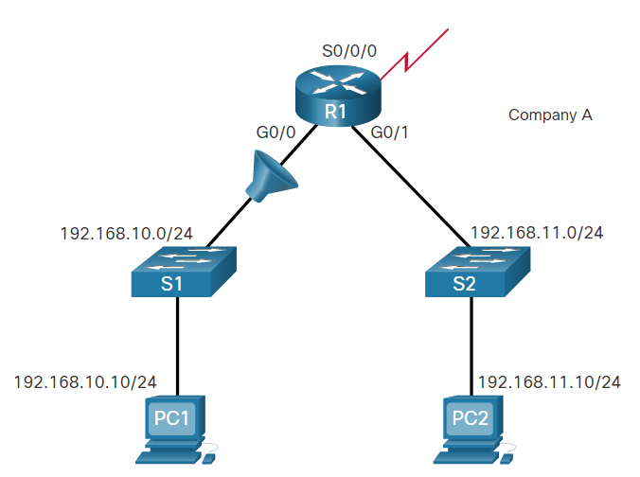

R1(config)# **ip access-list standard NO_ACCESS**

R1(config-std-nacl)# **deny host 192.168.11.10**

R1(config-std-nacl)# **permit any**

R1(config-std-nacl)# **exit**

R1(config)# **interface g0/0**

R1(config-if)# **ip access-group NO_ACCESS out**

#### Named Extended ACL Example

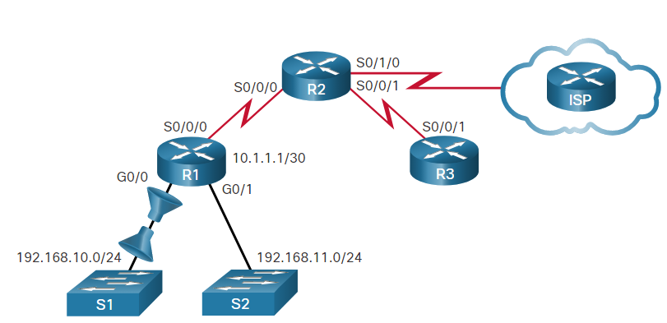

R1(config)# **ip access-list extended SURFING**

R1(config-ext-nacl)# **permit tcp 192.168.10.0 0.0.0.255 any eq 80**

R1(config-ext-nacl)# **permit tcp 192.168.10.0 0.0.0.255 any eq 443**

R1(config-ext-nacl)# **exit**

R1(config)# **ip access-list extended BROWSING**

R1(config-ext-nacl)# **permit tcp any 192.168.10.0 0.0.0.255 established**

R1(config-ext-nacl)# **exit**

R1(config)# **interface g0/0**

R1(config-if)# **ip access-group SURFING in**

R1(config-if)# **ip access-group BROWSING out**

#### Named ACL on VTY Lines with Logging

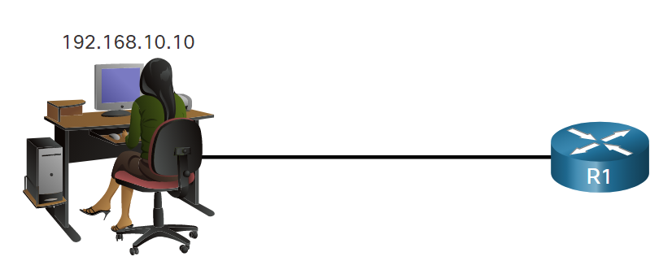

Enabling the **log** parameter on a Cisco router or switch seriously affects the performance of that device. The log parameter should only be used when the network is under attack, and an administrator is trying to determine who the attacker is.

Applying ACLs to interfaces and lines is just one of their many possible uses. ACLs are also an integral part of other security configurations, such as network address translation (NAT), zone-based firewalls, and virtual private networks.

R1(config)# **ip access-list standard VTY_ACCESS**

R1(config-std-nacl)# **permit 192.168.10.10 log**

R1(config-std-nacl)# **deny any**

R1(config-std-nacl)# **exit**

R1(config)# **line vty 0 4**

R1(config-line)# **access-class VTY_ACCESS in**

R1(config-line)# **end**

R1#

R1# **!The administrator accesses the vty lines from 192.168.10.10**

R1#

*Feb 26 18:58:30.579: %SEC-6-IPACCESSLOGNP: list VTY_ACCESS permitted 0

192.168.10.10 -> 0.0.0.0, 5 packets

R1# **show access-lists**

Standard IP access list VTY_ACCESS

10 permit 192.168.10.10 log (6 matches)

20 deny any

To remove an ACL from an interface, first enter the no ip access-group interface configuration command. However, the ACL will still be configured on the router. To remove the ACL from the router, use the no access-list global configuration command.

### 8.5.3. Where to Place ACLs

Every ACL should be placed where it is the most efficient.

The figure illustrates where standard and extended ACLs should be located in an enterprise network. Assume the objective is to prevent traffic that originates in the 192.168.10.0/24 network from reaching the 192.168.30.0/24 network.

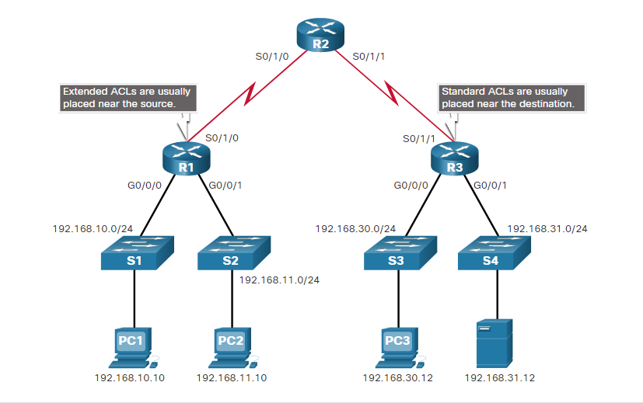

Extended ACLs should be located as close as possible to the source of the traffic to be filtered. This way, undesirable traffic is denied close to the source network without crossing the network infrastructure.

Standard ACLs should be located as close to the destination as possible. If a standard ACL was placed at the source of the traffic, the "permit" or "deny" will occur based on the given source address no matter where the traffic is destined.

Placement of the ACL and therefore, the type of ACL used, may also depend on a variety of factors as listed in the table.

| **Factors Influencing ACL Placement** | **Explanation** |
| --- | --- |
| **The extent of organizational control** | Placement of the ACL can depend on whether or not the organization has control of both the source and destination networks. |
| **Bandwidth of the networks involved** | It may be desirable to filter unwanted traffic at the source to prevent transmission of bandwidth-consuming traffic. |
| **Ease of configuration** | * It may be easier to implement an ACL at the destination, but traffic will use bandwidth unnecessarily. * An extended ACL could be used on each router where the traffic originated. This would save bandwidth by filtering the traffic at the source, but it would require creating extended ACLs on multiple routers. |

#### Standard ACL Placement Example

Following the guidelines for ACL placement, standard ACLs should be located as close to the destination as possible.

In the figure, the administrator wants to prevent traffic originating in the 192.168.10.0/24 network from reaching the 192.168.30.0/24 network.

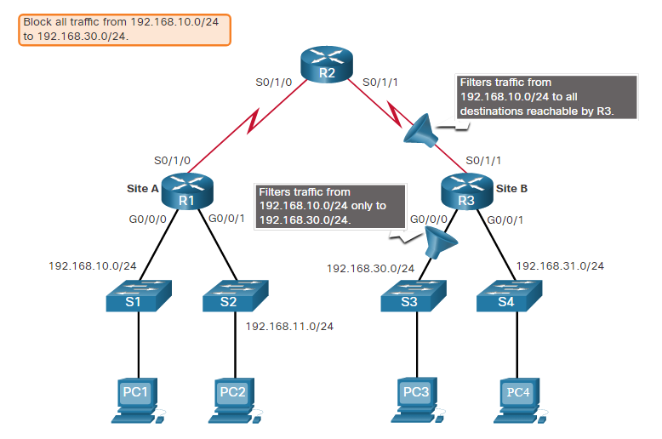

Following the basic placement guidelines, the administrator would place a standard ACL on router R3. There are two possible interfaces on R3 to apply the standard ACL:

* **R3 S0/1/1 interface** **(inbound)** - The standard ACL can be applied inbound on the R3 S0/1/1 interface to deny traffic from .10 network. However, it would also filter .10 traffic to the 192.168.31.0/24 (.31 in this example) network. Therefore, the standard ACL should not be applied to this interface.
* **R3 G0/0/0 interface** **(outbound)** - The standard ACL can be applied outbound on the R3 G0/0/0 interface. This will not affect other networks that are reachable by R3. Packets from .10 network will still be able to reach the .31 network. This is the best interface to place the standard ACL to meet the traffic requirements.

#### Extended ACL Placement Example

Extended ACLs should be located as close to the source as possible. This prevents unwanted traffic from being sent across multiple networks only to be denied when it reaches its destination.

However, the organization can only place ACLs on devices that they control. Therefore, the extended ACL placement must be determined in the context of where organizational control extends.

In the figure, for example, Company A wants to deny Telnet and FTP traffic to Company B’s 192.168.30.0/24 network from their 192.168.11.0/24 network while permitting all other traffic.

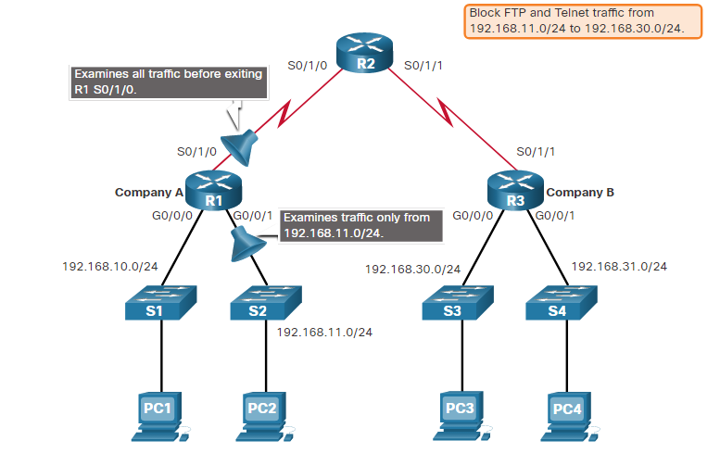

There are several ways to accomplish these goals. An extended ACL on R3 would accomplish the task, but the administrator does not control R3. In addition, this solution allows unwanted traffic to cross the entire network, only to be blocked at the destination. This affects overall network efficiency.

The solution is to place an extended ACL on R1 that specifies both source and destination addresses.

There are two possible interfaces on R1 to apply the extended ACL:

* **R1 S0/1/0 interface (outbound)** - The extended ACL can be applied outbound on the S0/1/0 interface. However, this solution will process all packets leaving R1 including packets from 192.168.10.0/24.
* **R1 G0/0/1 interface (inbound)** - The extended ACL can be applied inbound on the G0/0/1 so that only packets from the 192.168.11.0/24 network are subject to ACL processing on R1. Because the filter is to be limited to only those packets leaving the 192.168.11.0/24 network, applying the extended ACL to G0/0/1 is the best solution.

## 8.6) Mitigate Attacks with ACLs

### 8.6.1. Mitigate Spoofing Attacks

ACLs can be used to mitigate many network threats, such as IP address spoofing and denial of service (DoS) attacks. Most DoS attacks use some type of spoofing. IP address spoofing overrides the normal packet creation process by inserting a custom IP header with a different source IP address. Attackers can hide their identity by spoofing the source IP address.

There are many well-known classes of IP addresses that should never be seen as source IP addresses for traffic entering an organization’s network. For example, in the figure the S0/0/0 interface is attached to the internet and should never accept inbound packets from the following addresses:

* All zeros addresses
* Broadcast addresses
* Local host addresses (127.0.0.0/8)
* Automatic Private IP Addressing (APIPA) addresses (169.254.0.0/16)
* Reserved private addresses (RFC 1918)
* IP multicast address range (224.0.0.0/4)

The 192.168.1.0/24 network is attached to the R1 G0/0 interface. This interface should only allow inbound packets with a source address from that network. The ACL for G0/0 shown in the figure will only permit inbound packets from the 192.168.1.0/24 network. All others will be discarded.

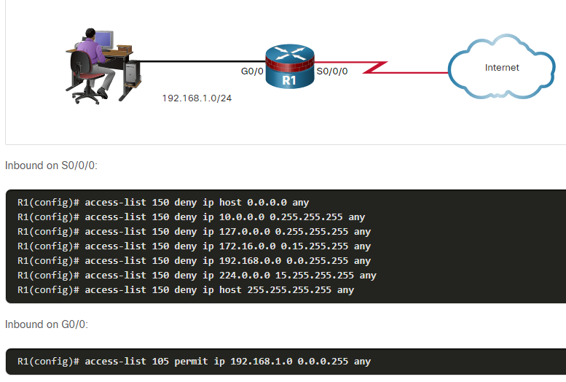

### 8.6.2. Permit Necessary Traffic through a Firewall

An effective strategy for mitigating attacks is to explicitly permit only certain types of traffic through a firewall. For example, Domain Name System (DNS), Simple Mail Transfer Protocol (SMTP), and File Transfer Protocol (FTP) are services that often must be allowed through a firewall. It is also common to configure a firewall so that it permits administrators remote access through the firewall. Secure Shell (SSH), syslog, and Simple Network Management Protocol (SNMP) are examples of services that a router may need to include. While many of these services are useful, they should be controlled and monitored. Exploitation of these services leads to security vulnerabilities.

The figure shows an example topology with ACL configurations to permit specific services on the Serial 0/0/0 interface.

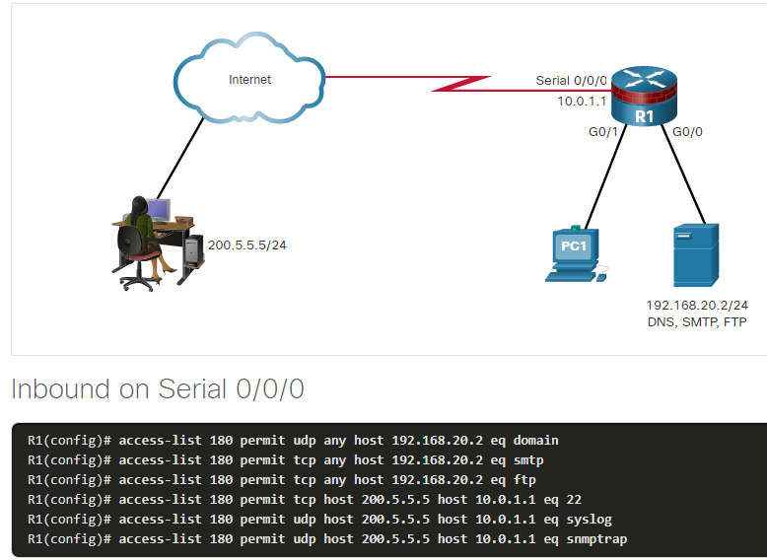

### 8.6.3. Mitigate ICMP Attacks

Hackers can use Internet Control Message Protocol (ICMP) echo packets (pings) to discover subnets and hosts on a protected network and to generate DoS flood attacks. Hackers can use ICMP redirect messages to alter host routing tables. Both ICMP echo and redirect messages should be blocked inbound by the router.

Several ICMP messages are recommended for proper network operation and should be allowed into the internal network:

* **Echo reply** - Allows users to ping external hosts.
* **Source quench** - Requests that the sender decrease the traffic rate of messages.
* **Unreachable** - Generated for packets that are administratively denied by an ACL.

Several ICMP messages are required for proper network operation and should be allowed to exit the network:

* **Echo** - Allows users to ping external hosts.
* **Parameter problem** - Informs the host of packet header problems.
* **Packet too big** - Enables packet maximum transmission unit (MTU) discovery.
* **Source quench** - Throttles down traffic when necessary.

As a rule, block all other ICMP message types outbound.

ACLs are used to block IP address spoofing, selectively permit specific services through a firewall, and to allow only required ICMP messages. The figure shows a sample topology and possible ACL configurations to permit specific ICMP services on the G0/0 and S0/0/0 interfaces.

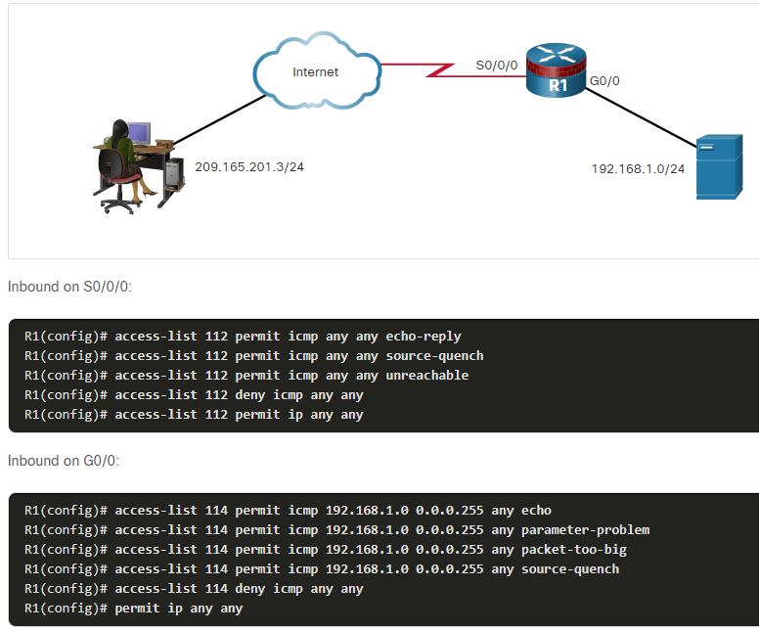

### 8.6.4. Mitigate SNMP Attacks

Management protocols, such as SNMP, are useful for remote monitoring and management of networked devices. However, they can still be exploited. If SNMP is necessary, exploitation of SNMP vulnerabilities can be mitigated by applying interface ACLs to filter SNMP packets from non-authorized systems. An exploit may still be possible if the SNMP packet is sourced from an address that has been spoofed and is permitted by the ACL.

These security measures are helpful, but the most effective means of exploitation prevention is to disable the SNMP server on IOS devices for which it is not required. As shown in the figure, use the command **no snmp-server** to disable SNMP services on Cisco IOS devices.

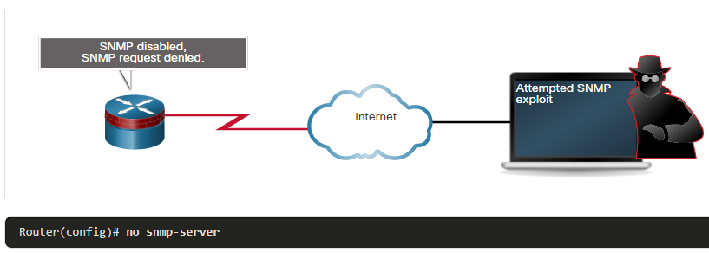

## 8.7) IPv6 ACLs

### 8.7.1. IPv6 ACL Overview

In recent years, many networks have begun the transition to an IPv6 environment. Part of the need for the transition to IPv6 is because of the inherent weaknesses in IPv4.

Unfortunately, as the migration to IPv6 continues, IPv6 attacks are becoming more pervasive. IPv4 will not disappear overnight. IPv4 will coexist with IPv6 and then gradually be replaced by IPv6. This creates potential security holes. An example of a security concern is threat actors leveraging IPv4 to exploit IPv6 in dual stack environments. Dual stack is an integration method in which a device has connectivity to both IPv4 and IPv6 networks. In a dual stack environment devices operate with two IP protocol stacks.

Threat actor can accomplish stealth attacks that result in trust exploitation by using dual-stacked hosts, rogue Neighbor Discovery Protocol (NDP) messages, and tunneling techniques. Teredo tunneling, for example, is an IPv6 transition technology that provides automatic IPv6 address assignment when IPv4/IPv6 hosts are located behind IPv4 network address translation (NAT) devices. It accomplishes this by embedding the IPv6 packets inside IPv4 UDP packets. The threat actor gains a foothold in the IPv4 network. The compromised host sends rogue router advertisements (RAs), which triggers dual stacked hosts to obtain an IPv6 address. The threat actor can then use this foothold to move around, or pivot, inside the network. The threat actor can compromise additional hosts before sending traffic back out of the network, as shown in the figure.

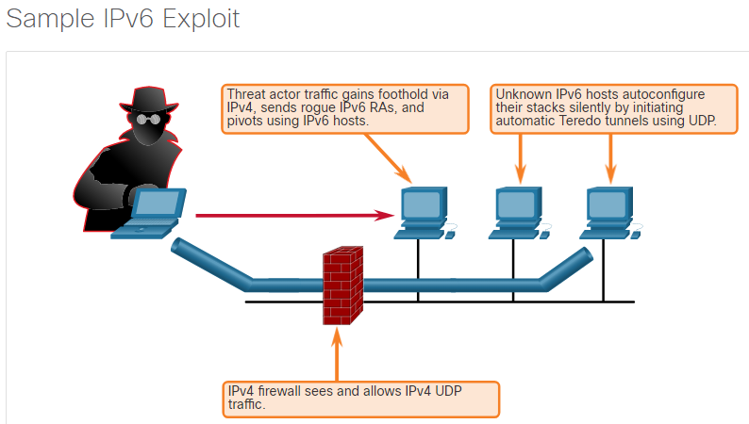

It is necessary to develop and implement a strategy to mitigate attacks against IPv6 infrastructures and protocols. This mitigation strategy should include filtering at the edge using various techniques, such as IPv6 ACLs.

### 8.7.2. IPv6 ACL Syntax

The ACL functionality in IPv6 is similar to ACLs in IPv4. However, there is no equivalent to IPv4 standard ACLs. In addition, all IPv6 ACLs must be configured with a name. IPv6 ACLs allow filtering based on source and destination addresses that are traveling inbound and outbound to a specific interface. They also support traffic filtering based on IPv6 option headers and optional, upper-layer protocol type information for finer granularity of control, similar to extended ACLs in IPv4. To configure an IPv6 ACL, use the **ipv6 access-list** command to enter into IPv6 ACL configuration mode. Next, use the syntax shown in the figure to configure each access list entry to specifically permit or deny traffic. The syntax shown is a simplified version of the IPv6 ACE syntax. There are additional options. It should be clear from the provided syntax that IPv6 ACLs are considerably more flexible than IPv4 ACLs.

Apply an IPv6 ACL to an interface with the **ipv6 traffic-filter** command.

Router(config)# **ipv6 access-list** access-list-name

Router(config-ipv6-acl)# **deny** | **permit** protocol {source-ipv6-prefix **/** prefix-length | **any** | **host** source-ipv6-address} [ operator [ port-number ]] { destination-ipv6-prefix **/** prefix-length | **any** | **host** destination-ipv6-address } [ operator [ port-number ]] [ **dscp** value ] [ **fragments** ] [ **log** ] [ **log-input** ] [ **sequence** value ] [ **time-range** name ]

| **Parameter** | **Description** |
| --- | --- |
| **deny** | **permit** | Specifies whether to deny or permit the packet. |
| *protocol* | Enter the name or number of an Internet protocol, or an integer representing an IPv6 protocol number. |
| *source-ipv6-prefix* **/**   *prefix-length  destination-ipv6-address* **/** *prefix-length* | The source or destination IPv6 network or class of networks for which to set **deny** or **permit** conditions. |
| **any** | Enter **any** as an abbreviation for the IPv6 prefix ::/0. This matches all addresses. |
| **host** | For **host** *source-ipv6-address* or *destination-ipv6-address* , enter the source or destination IPv6 host address for which to set **deny** or **permit** conditions. |
| *operator* | (Optional) An operand that compares the source or destination ports of the specified protocol. Operands are **lt** (less than), **gt** (greater than), **eq** (equal), **neq** (not equal), and **range**. |
| *port-number* | (Optional) A decimal number or the name of a TCP or UDP port for filtering TCP or UDP, respectively. |
| **dscp** | (Optional) Matches a differentiated services codepoint value against the traffic class value in the Traffic Class field of each IPv6 packet header. The acceptable range is from 0 to 63. |
| **fragments** | (Optional) Matches non-initial fragmented packets where the fragment extension header contains a non-zero fragment offset. The **fragments** keyword is an option only if the *operator* [*port-number* ] arguments are not specified. When this keyword is used, it also matches when the first fragment does not have Layer 4 information. |
| **log** | (Optional) Causes an informational logging message about the packet that matches the entry to be sent to the console. (The level of messages logged to the console is controlled by the **logging console** command.) |
| **log input** | (Optional) Provides the same function as the **log** keyword, except that the logging message also includes the input interface. |
| **sequence** *value* | (Optional) Specifies the sequence number *value* for the access list statement. The acceptable range is from 1 to 4294967295. |
| **time-range** *name* | (Optional) Specifies the time range that applies to the permit statement. The *name* of the time range and its restrictions are specified by the **time-range** and **absolute** or **periodic** commands, respectively. |

### 8.7.3. Configure IPv6 ACLs

An IPv6 ACL contains an implicit **deny ipv6 any any**. Each IPv6 ACL also contains implicit permit rules to enable IPv6 neighbor discovery. The IPv6 Neighbor Discovery Protocol (NDP) requires the use of the IPv6 network layer to send neighbor advertisements (NAs) and neighbor solicitations (NSs). If an administrator configures the **deny ipv6 any any** command without explicitly permitting neighbor discovery, then the NDP will be disabled.

In the figure, R1 is permitting inbound traffic on G0/0 from the 2001:DB8:1:1::/64 network. NA and NS packets are explicitly permitted. Traffic sourced from any other IPv6 address is explicitly denied. If the administrator only configured the first permit statement, the ACL would have the same effect. However, it is a good practice to document the implicit statements by explicitly configuring them.

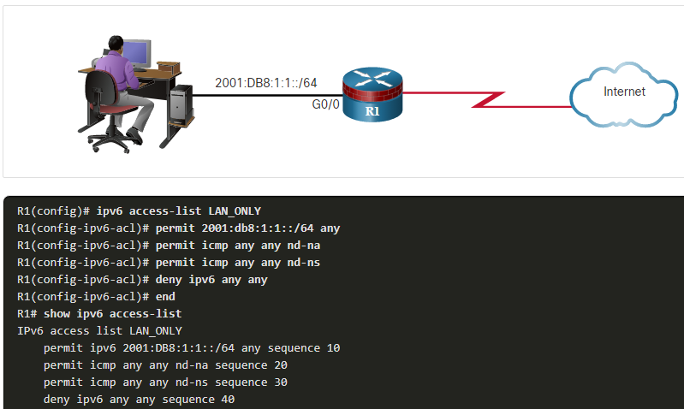

## 8.8) What Did I Learn in this Module?

**Introduction to Access Control Lists**  
An ACL is a series of IOS commands that are used to filter packets based on information found in the packet header. By default, a router does not have any ACLs configured. An ACL uses a sequential list of permit or deny statements, known as ACEs. The packet filtering process occurs when network traffic passes through an interface configured with an ACL, and the router compares the information within the packet against each ACE, in sequential order, to determine if the packet matches one of the ACEs. Packet filtering can occur at Layer 3 or Layer 4. Cisco routers support Standard ACLs and Extended ACLs. ACLs number 1 to 99, or 1300 to 1999 are standard ACLs while ACLs number 100 to 199, or 2000 to 2699 are extended ACLs. Named ACLs are the preferred method to use when configuring ACLs. The name provides information about the purpose of the ACL. ACLs define the set of rules that give added control for packets that enter inbound interfaces, packets that relay through the router, and packets that exit outbound interfaces of the router.

**Wildcard masking**  
An IPv4 ACE uses a 32-bit wildcard mask to determine which bits of the address to examine for a match. Wildcard masks are also used by the OSPF routing protocol. A wildcard mask is similar to a subnet mask in that it uses the ANDing process to identify which bits in an IPv4 address to match. However, they differ in the way they match binary 1s and 0s. Unlike a subnet mask, in which binary 1 is equal to a match and binary 0 is not a match, in a wildcard mask, the reverse is true. One shortcut method to calculate wildcard masks is to subtract the subnet mask from 255.255.255.255. The Cisco IOS provides two keywords, **host** and **any**, to simplify the most common uses of wildcard masking. Keywords reduce ACL keystrokes and make it easier to read the ACE.

**Configuring ACLs**  
When configuring a complex ACL, it is suggested that you use a text editor and write out the specifics of the policy to be implemented, add the IOS configuration commands to accomplish those tasks, include remarks to document the ACL, and copy and paste the commands onto the device. Always thoroughly test an ACL to ensure that it correctly applies the desired policy. To create a numbered standard ACL, use the command **access-list** *access-list-number* {**deny** | **permit** | **remark** text} *source* [*source-wildcard*] [**log**]. To create a named standard ACL, use the command **ip access-list standard** *access-list-name*. ACL names are alphanumeric, case sensitive, and must be unique. The procedural steps for configuring extended ACLs are the same as for standard ACLs. The command to apply an extended IPv4 ACL to an interface is the same as the command used for standard IPv4 ACLs is **ip access-group** {*access-list-number* | *access-list-name*} {**in** | **out**}. Extended ACLs can filter on many different types of internet protocols and ports. TCP can also perform basic stateful firewall services using the TCP **established** keyword. The keyword enables inside traffic to exit the inside private network and permits the returning reply traffic to enter the inside private network.

**Modifying ACLs**  
ACLs with multiple ACEs should be created in a text editor. This allows you to plan the required ACEs, create the ACL, and then paste it into the router interface, and makes editing the ACL simpler. An ACL ACE can also be deleted or added using the ACL sequence numbers. Sequence numbers are automatically assigned when an ACE is entered. These numbers are listed in the **show access-lists** command.

**Implementing ACLs**  
When configuring and applying an ACL, be aware of the guidelines summarized in this list:

* Create an ACL globally and then apply it.
* Ensure the last statement is an implicit **deny any** or **deny ip any any**.
* Remember that statement order is important because ACLs are processed top-down.
* As soon as a statement is matched the ACL is exited.
* Always filter from the most specific to the most generic. For example, deny a specific host and then permit all other hosts.
* Remember that only one ACL is allowed per interface, per protocol, per direction.
* Remember that new statements for an existing ACL are added to the bottom of the ACL by default.
* Remember that router-generated packets are not filtered by outbound ACLs.
* Place standard ACLs as close to the destination as possible.
* Place extended ACLs as close to the source as possible.

Every ACL should be placed where it is the most efficient. Extended ACLs should be located as close as possible to the source of the traffic to be filtered. Standard ACLs should be located as close to the destination as possible. Factors influencing ACL placement include the extent of organizational control, bandwidth of the networks involved, and ease of configuration.

**Mitigate Attacks with ACLs**  
ACLs can be used to mitigate many network threats, such as IP address spoofing and DoS attacks. An effective strategy for mitigating attacks is to explicitly permit only certain types of traffic through a firewall. Both ICMP echo and redirect messages should be blocked inbound by the router. If SNMP is necessary, exploitation of SNMP vulnerabilities can be mitigated by applying interface ACLs to filter SNMP packets from non-authorized systems. Several ICMP messages are recommended for proper network operation and should be allowed into the internal network including echo reply, source quench, and unreachable. Several ICMP messages should be allowed to exit the network including echo, parameter problem, packet too big, and source quench. As a rule, block all other ICMP message types outbound.

**IPv6 ACLs**  
IPv6 has several features that meet modern-day network requirements: IPsec, Mobile IP, RSVP, and address scalability. Dual stack is an integration method in which a device has connectivity to both IPv4 and IPv6 networks. In a dual stack environment devices operate with two IP protocol stacks. Attackers can accomplish stealth attacks that result in trust exploitation by using dual-stacked hosts, rogue NDP messages, and tunneling techniques. To mitigate attacks against IPv6 infrastructures and protocols, the strategy should include filtering at the edge using various techniques, such as IPv6 ACLs. The ACL functionality in IPv6 is similar to ACLs in IPv4. However, there is no equivalent to IPv4 standard ACLs. In addition, all IPv6 ACLs must be configured with a name. IPv6 ACLs allow filtering based on source and destination addresses that are traveling inbound and outbound to a specific interface. They also support traffic filtering based on IPv6 option headers and optional, upper-layer protocol type information for finer granularity of control, similar to extended ACLs in IPv4.

# 9. Firewall Technologies

## 9.0) Introduction

### 9.0.1. Why Should I Take this Module?

With the many threats to network security, how can networks be designed to protect data resources and ensure that network services are provided as required? The network security infrastructure defines the way in which devices are connected together to achieve end-to-end secure communications. Just as there are many sizes of networks, there are also many ways to build a secure network infrastructure. However, there are standard designs that the network industry recommends for achieving networks that are available and secure. This chapter covers the basic ways that firewalls can be used to create a network security architecture.

### 9.0.2. What Will I Learn in this Module?

**Module Title:** Firewall Technologies

**Module Objective**: Explain how firewalls are implemented to provide network security.

| **Topic Title** | **Topic Objective** |
| --- | --- |
| **Secure Networks with Firewalls** | Explain how firewalls are used to help secure networks. |
| **Firewalls in Network Design** | Explain design considerations for implementing firewall technologies. |

## 9.1) Secure Networks with Firewalls

### 9.1.1. Firewalls

A firewall is a system, or group of systems, that enforces an access control policy between networks.

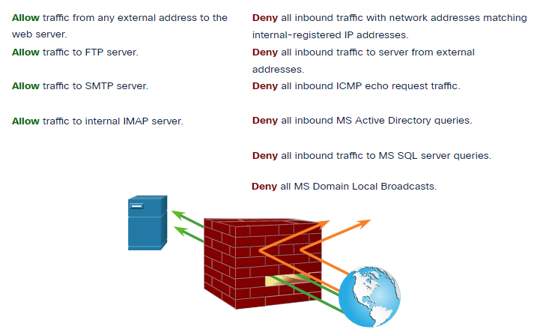

**Common Firewall Properties**

All firewalls share some common properties:

* Firewalls are resistant to network attacks.
* Firewalls are the only transit point between internal corporate networks and external networks because all traffic flows through the firewall.
* Firewalls enforce the access control policy.

**Firewall Benefits**

There are several benefits of using a firewall in a network:

* They prevent the exposure of sensitive hosts, resources, and applications to untrusted users.
* They sanitize protocol flow, which prevents the exploitation of protocol flaws.
* They block malicious data from servers and clients.
* They reduce security management complexity by off-loading most of the network access control to a few firewalls in the network.

**Firewall Limitations**

Firewalls also have some limitations:

* A misconfigured firewall can have serious consequences for the network, such as becoming a single point of failure.
* The data from many applications cannot be passed over firewalls securely.
* Users might proactively search for ways around the firewall to receive blocked material, which exposes the network to potential attack.
* Network performance can slow down.
* Unauthorized traffic can be tunneled or hidden as legitimate traffic through the firewall.

### 9.1.2. Types of Firewalls

It is important to understand the different types of firewalls and their specific capabilities so that the right firewall is used for each situation.

#### Packet Filtering (Stateless) Firewall

Packet filtering firewalls are usually part of a router firewall, which permits or denies traffic based on Layer 3 and Layer 4 information. They are stateless firewalls that use a simple policy table look-up that filters traffic based on specific criteria.

For example, SMTP servers listen to port 25 by default. An administrator can configure the packet filtering firewall to block port 25 from a specific workstation to prevent it from broadcasting an email virus.

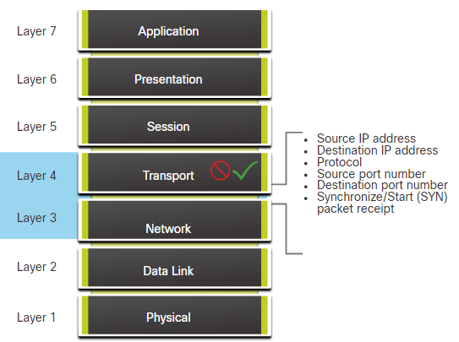

#### Stateful Firewall

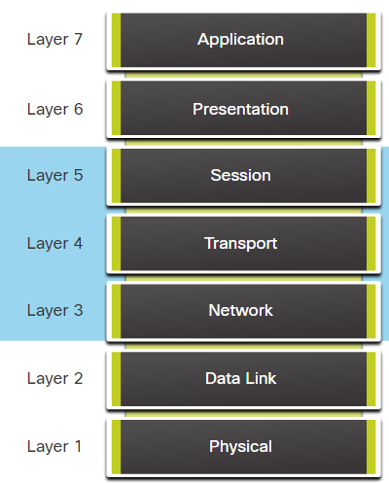Stateful firewalls are the most versatile and the most common firewall technologies in use. Stateful firewalls provide stateful packet filtering by using connection information maintained in a state table. Stateful filtering is a firewall architecture that is classified at the network layer. It also analyzes traffic at OSI Layer 4 and Layer 5.

#### Application Gateway Firewall

An application gateway firewall (proxy firewall), as shown in the figure, filters information at Layers 3, 4, 5, and 7 of the OSI reference model. Most of the firewall control and filtering is done in software. When a client needs to access a remote server, it connects to a proxy server. The proxy server connects to the remote server on behalf of the client. Therefore, the server only sees a connection from the proxy server.

#### Next Generation Firewall

Next-generation firewalls (NGFW) go beyond stateful firewalls by providing:

* Integrated intrusion prevention
* Application awareness and control to see and block risky apps
* Upgrade paths to include future information feeds
* Techniques to address evolving security threats

Other methods of implementing firewalls include:

* **Host-based (server and personal) firewall** - A PC or server with firewall software running on it.
* **Transparent firewall** - Filters IP traffic between a pair of bridged interfaces.
* **Hybrid firewall** - A combination of the various firewall types. For example, an application inspection firewall combines a stateful firewall with an application gateway firewall.

### 9.1.3. Packet Filtering Firewall Benefits and Limitations

Packet filtering firewalls are usually part of a router firewall, which permits or denies traffic based on Layer 3 and Layer 4 information. They are stateless firewalls that use a simple policy table look-up that filters traffic based on specific criteria, as shown in the figure. For example, SMTP servers listen to port 25 by default. An administrator can configure the packet filtering firewall to block port 25 from a specific workstation to prevent it from broadcasting an email virus.

There are several advantages of using a packet filtering firewall:

* Packet filters implement simple permit or deny rule sets.
* Packet filters have a low impact on network performance.
* Packet filters are easy to implement, and are supported by most routers.
* Packet filters provide an initial degree of security at the network layer.
* Packet filters perform almost all the tasks of a high-end firewall at a much lower cost.

Packet filters do not represent a complete firewall solution, but they are an important element of a firewall security policy. There are several disadvantages of using a packet filtering firewall:

* Packet filters are susceptible to IP spoofing. Threat actors can send arbitrary packets that meet ACL criteria and pass through the filter.
* Packet filters do not reliably filter fragmented packets. Because fragmented IP packets carry the TCP header in the first fragment and packet filters filter on TCP header information, all fragments after the first fragment are passed unconditionally. Decisions to use packet filters assume that the filter of the first fragment accurately enforces the policy.
* Packet filters use complex ACLs, which can be difficult to implement and maintain.
* Packet filters cannot dynamically filter certain services. For example, sessions that use dynamic port negotiations are difficult to filter without opening access to a whole range of ports.

Packet filters are stateless. They examine each packet individually rather than in the context of the state of a connection.

### 9.1.4. Stateful Firewall Benefits and Limitations

There are several benefits to using a stateful firewall in a network:

* Stateful firewalls are often used as a primary means of defense by filtering unwanted, unnecessary, or undesirable traffic.
* Stateful firewalls strengthen packet filtering by providing more stringent control over security.
* Stateful firewalls improve performance over packet filters or proxy servers.
* Stateful firewalls defend against spoofing and DoS attacks by determining whether packets belong to an existing connection or are from an unauthorized source.
* Stateful firewalls provide more log information than a packet filtering firewall.

Stateful firewalls also present some limitations:

* Stateful firewalls cannot prevent application layer attacks because they do not examine the actual contents of the HTTP connection.
* Not all protocols are stateful. For example, UDP and ICMP do not generate connection information for a state table, and, therefore, do not garner as much support for filtering.
* It is difficult to track connections that use dynamic port negotiation. Some applications open multiple connections. This requires a whole new range of ports that must be opened to allow this second connection.
* Stateful firewalls do not support user authentication.

|  |
| --- |
|  |
| **Benefits** | **Limitations** |
| Primary means of defense | No Application Layer inspection |
| Strong packet filtering | Limited tracking of stateless protocols |
| Improved performance over packet filters | Difficult to defend against dynamic port negotiation |
| Defends against spoofing and DoS attacks | No authentication support |
| Richer data log |  |

## 9.2) Firewalls in Network Design

### 9.2.1. Common Security Architectures

Firewall design is primarily about device interfaces permitting or denying traffic based on the source, the destination, and the type of traffic. Some designs are as simple as designating an outside network and inside network, which are determined by two interfaces on a firewall.

Here are three common firewall designs:

**Private and Public**

As shown in the figure, the public network (or outside network) is untrusted, and the private network (or inside network) is trusted.

Typically, a firewall with two interfaces is configured as follows:

* Traffic originating from the private network is permitted and inspected as it travels toward the public network. Inspected traffic returning from the public network and associated with traffic that originated from the private network is permitted.
* Traffic originating from the public network and traveling to the private network is generally blocked.

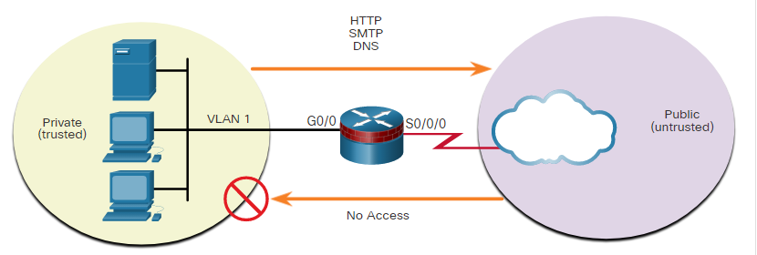

**Demilitarized Zone (DMZ)**

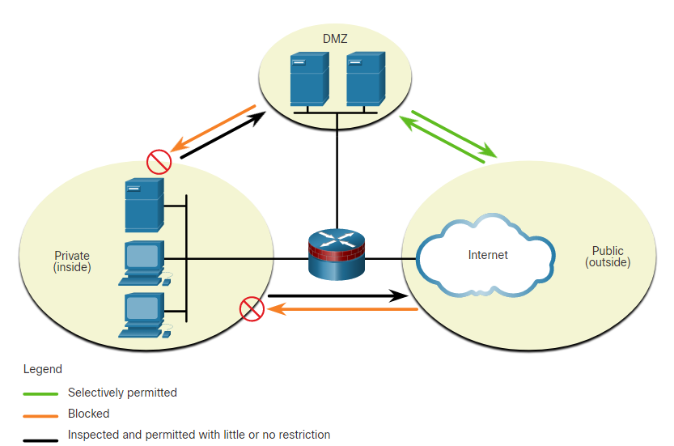A demilitarized zone (DMZ) is a firewall design where there is typically one inside interface connected to the private network, one outside interface connected to the public network, and one DMZ interface, as shown in the figure.

* Traffic originating from the private network is inspected as it travels toward the public or DMZ network. This traffic is permitted with little or no restriction. Inspected traffic returning from the DMZ or public network to the private network is permitted.
* Traffic originating from the DMZ network and traveling to the private network is usually blocked.
* Traffic originating from the DMZ network and traveling to the public network is selectively permitted based on service requirements.
* Traffic originating from the public network and traveling toward the DMZ is selectively permitted and inspected. This type of traffic is typically email, DNS, HTTP, or HTTPS traffic. Return traffic from the DMZ to the public network is dynamically permitted.
* Traffic originating from the public network and traveling to the private network is blocked.

**Zone-Based Policy Firewalls**

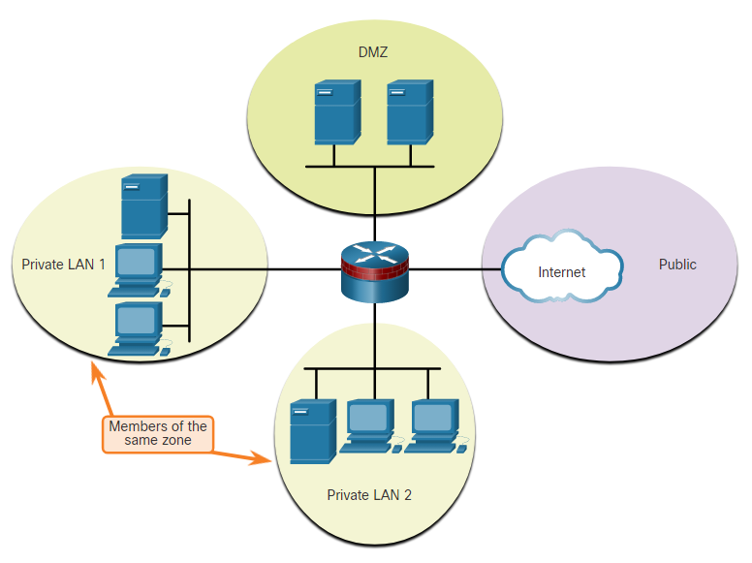Zone-based policy firewalls (ZPFs) use the concept of zones to provide additional flexibility. A zone is a group of one or more interfaces that have similar functions or features. Zones help you specify where a Cisco IOS firewall rule or policy should be applied. In the figure, security policies for LAN 1 and LAN 2 are similar and can be grouped into a zone for firewall configurations. By default, the traffic between interfaces in the same zone is not subject to any policy and passes freely. However, all zone-to-zone traffic is blocked. In order to permit traffic between zones, a policy allowing or inspecting traffic must be configured.

The only exception to this default **deny any** policy is the router self zone. The self zone is the router itself and includes all the router interface IP addresses. Policy configurations that include the self zone would apply to traffic destined to and sourced from the router. By default, there is no policy for this type of traffic. Traffic that should be considered when designing a policy for the self zone includes management plane and control plane traffic, such as SSH, SNMP, and routing protocols.

### 9.2.2. Layered Defense

A layered defense uses different types of firewalls that are combined in layers to add depth to the security of an organization. Policies can be enforced between the layers and inside the layers. These policy enforcement points determine whether traffic is forwarded or discarded. For example, traffic that comes in from the untrusted network first encounters a packet filter on the edge router. If allowed by the policy, the traffic goes to the screened firewall or bastion host system that applies more rules to the traffic and discards suspect packets. A bastion host is a hardened computer that is typically located in the DMZ. Then the traffic goes to an interior screening router. The traffic moves to the internal destination host only after successfully passing through all policy enforcement points between the outside router and the inside network. This type of DMZ setup is called a screened subnet configuration.

A layered defense approach is not all that is needed to ensure a safe internal network. A network administrator must consider many factors when building a complete in-depth defense:

* Firewalls typically do not stop intrusions that come from hosts within a network or zone.
* Firewalls do not protect against rogue access point installations.
* Firewalls do not replace backup and disaster recovery mechanisms resulting from attack or hardware failure.
* Firewalls are no substitute for informed administrators and users.

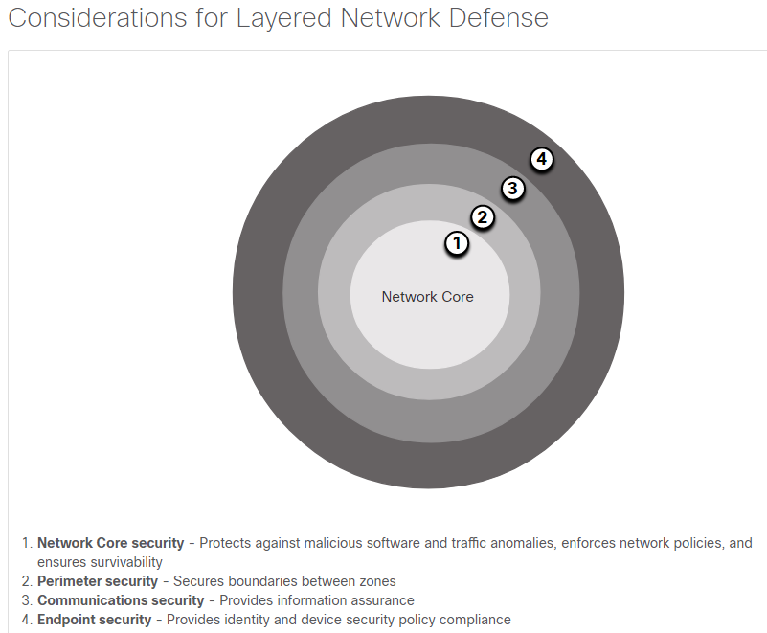

This partial list of best practices can serve as a starting point for a firewall security policy.

* Position firewalls at security boundaries. Firewalls are a critical part of network security, but it is unwise to rely exclusively on a firewall for security.
* Deny all traffic by default.
* Permit only services that are needed.
* Ensure that physical access to the firewall is controlled.
* Regularly monitor firewall logs.
* Practice change management for firewall configuration changes.
* Remember that firewalls primarily protect from technical attacks originating from the outside.

## 9.3) What Did I Learn in this Module?

**Secure Networks with Firewalls**  
There are several different types of firewalls. Packet filtering (stateless) firewalls provide Layer 3 and sometimes Layer 4 filtering. A stateful inspection firewall allows or blocks traffic based on state, port, and protocol. Application gateway firewalls (proxy firewall) filter information at Layers 3, 4, 5, and 7. Next-generation firewalls provide additional services beyond application gateways such as Integrated intrusion prevention, application awareness and control to see and block risky apps, access to future information feeds, and techniques to address evolving security threats.

**Firewalls in Network Designs**  
Common security architectures define the boundaries of traffic entering and leaving the network. When looking at a topology that has access to outside or public networks, you should be able to determine the security architecture. Some designs are as simple as designating an outside network and inside network which are determined by two interfaces on a firewall. Networks that require public access to services will often include a DMZ that the public can access, while strictly blocking access to the inside network. ZPFs use the concept of zones to provide additional flexibility. A zone is a group of one or more interfaces that have similar functions, features, and security requirements. A layered security approach uses firewalls and other security measures to provide security at different functional layers of the network.

# 10. Zone-Based Policy Firewalls

## 10.0) Introduction

### 10.0.1. Why Should I Take this Module?

Zone-based policy firewalls (ZPFs) are an evolutionary step beyond classic firewalls. While classic firewalls based security configuration on router interfaces, a ZPF allows interfaces to be assigned to zones. Security policies are defined based on the zone, and the security relationships between zones. Multiple interfaces can be made members of a zone and zone policies will be applied to those interfaces. Security requirements can be defined by the nature of the zones, not the IP networks that are communicating through a given interface.

In this module you will learn about ZPFs and learn how to implement a basic ZPF design.

### 10.0.2. What Will I Learn in this Module?

**Module Title:** Zone-Based Policy Firewalls

**Module Objective**: Implement Zone-Based Policy Firewall using CLI.

| **Topic Title** | **Topic Objective** |
| --- | --- |
| **ZPF Overview** | Explain how Zone-Based Policy Firewalls are used to help secure a network. |
| **ZPF Operation** | Explain the operation of a Zone-Based Policy Firewall. |
| **Configure a ZPF** | Configure a Zone-Based Policy Firewall with CLI. |

## 10.1) ZPF Overview

### 10.1.1. Benefits of a ZPF

There are two configuration models for Cisco IOS Firewall:

* **Classic Firewall** - The traditional configuration model in which firewall policy is applied on interfaces.
* **Zone-based Policy Firewall (ZPF)** - The configuration model in which interfaces are assigned to security zones, and firewall policy is applied to traffic moving between the zones.

If an additional interface is added to the private zone, the hosts connected to the new interface in the private zone can pass traffic to all hosts on the existing interface in the same zone. A simple three-zone network is shown in the figure.

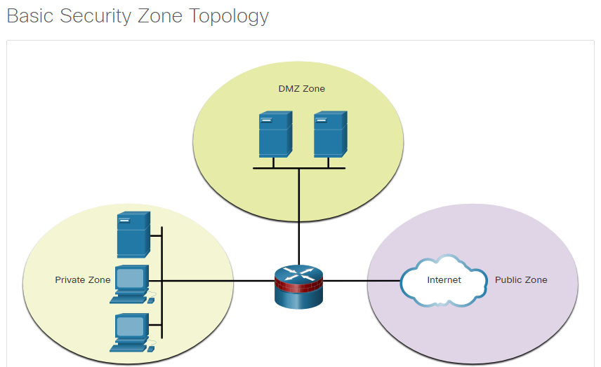

The primary motivations for network security professionals to migrate to the ZPF model are structure and ease of use. The structured approach is useful for documentation and communication. The ease of use makes network security implementations more accessible to a larger community of security professionals.

There are several benefits of a ZPF:

* It is not dependent on ACLs.
* The router security posture is to block unless explicitly allowed.
* Policies are easy to read and troubleshoot with the Cisco Common Classification Policy Language (C3PL). C3PL is a structured method to create traffic policies based on events, conditions, and actions. This provides scalability because one policy affects any given traffic, instead of needing multiple ACLs and inspection actions for different types of traffic.
* Virtual and physical interfaces can be grouped into zones.
* Policies are applied to unidirectional traffic between zones.

When deciding whether to implement IOS Classic Firewall or a ZPF, it is important to note that both configuration models can be enabled concurrently on a router. However, the models cannot be combined on a single interface. For example, an interface cannot be simultaneously configured as a security zone member and for IP inspection.

### 10.1.2. ZPF Design

Designing ZPFs involves several steps:

**Step 1**. **Determine the zones** - The administrator focuses on the separation of the network into zones. Zones establish the security borders of a network. A zone defines a boundary where traffic is subjected to policy restrictions as it crosses to another region of the network. For example, the public network would be one zone and the internal network would be another zone.

**Step 2**. **Establish policies between zones** - For each pair of "source-destination" zones (for example, from the inside network to the outside internet), define the sessions that clients in the source zones can request from servers in destination zones. These sessions are most often TCP and UDP sessions, but may also be ICMP sessions, such as ICMP echo. For traffic that is not based on the concept of sessions, the administrator must define unidirectional traffic flows from source to destination and vice versa. Policies are unidirectional and are defined based on source and destination zones, which are known as zone pairs.

**Step 3**. **Design the physical infrastructure** - After the zones have been identified, and the traffic requirements between them documented, the administrator must design the physical infrastructure. The administrator must take into account security and availability requirements when designing the physical infrastructure. This includes dictating the number of devices between most-secure and least-secure zones and determining redundant devices.

**Step 4**. **Identify subsets within zones and merge traffic requirements** - For each firewall device in the design, the administrator must identify zone subsets that are connected to its interfaces and merge the traffic requirements for those zones. For example, multiple zones might be indirectly attached to a single interface of a firewall. This would result in a device-specific interzone policy. Although an important consideration, implementing zone subsets is beyond the scope of this curriculum.

## 10.2) ZPF Operation

### 10.2.1. ZPF Actions

Policies identify actions that the ZPF will perform on network traffic. Three possible actions can be configured to process traffic by protocol, source and destination zones (zone pairs), and other criteria.

* **Inspect** - This performs Cisco IOS stateful packet inspection.
* **Drop** - This is analogous to a **deny** statement in an ACL. A **log** option is available to log the rejected packets.
* **Pass** - This is analogous to a **permit** statement in an ACL. The pass action does not track the state of connections or sessions within the traffic.

### 10.2.2. Rules for Transit Traffic

Traffic transiting through router interfaces is subject to several rules governing interface behavior. For the transit traffic example, refer to the topology shown in the figure.

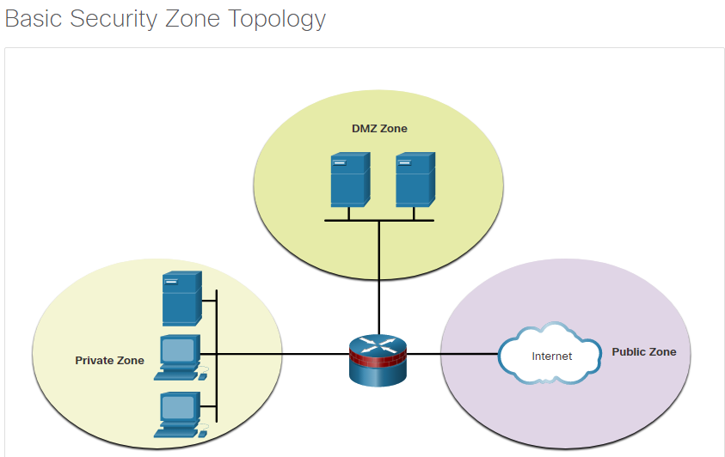

The rules depend on whether or not the ingress and egress interfaces are members of the same zone:

* If neither interface is a zone member, then the resulting action is to pass the traffic.
* If both interfaces are members of the same zone, then the resulting action is to pass the traffic.
* If one interface is a zone member, but the other is not, then the resulting action is to drop the traffic regardless of whether a zone-pair exists.
* If both interfaces belong to the same zone-pair and a policy exists, then the resulting action is inspect, allow, or drop as defined by the policy.

The table summarizes these rules.

| **Source Interface Member of Zone?** | **Destination Interface Member of Zone?** | **Zone-Pair Exists?** | **Policy Exists?** | **Result** |
| --- | --- | --- | --- | --- |
| NO | NO | N/A | N/A | PASS |
| YES | NO | N/A | N/A | DROP |
| NO | YES | N/A | N/A | DROP |
| YES (private) | YES (private) | N/A | N/A | PASS |
| YES (private) | YES (public) | NO | N/A | DROP |
| YES (private) | YES (public) | YES | NO | PASS |
| YES (private) | YES (public) | YES | YES | INSPECT |

### 10.2.3. Rules for Traffic to the Self Zone

The self zone is the router itself and includes all of the IP addresses assigned to the router interfaces. This is traffic that originates at the router or is addressed to a router interface. Specifically, the traffic is either for device management, for example SSH, or traffic forwarding control, such as routing protocol traffic. The rules for a ZPF are different for the self zone. For the self zone traffic example, refer to the topology shown in the previous figure.

The rules depend on whether the router is the source or the destination of the traffic, as shown in the table. If the router is the source or the destination, then all traffic is permitted. The only exception is if the source and destination are a zone-pair with a specific service-policy. In that case, the policy is applied to all traffic.

| **Source Interface Member of Zone?** | **Destination Interface Member of Zone?** | **Zone-Pair Exists?** | **Policy Exists?** | **Result** |
| --- | --- | --- | --- | --- |
| YES (self zone) | YES | NO | N/A | PASS |
| YES (self zone) | YES | YES | NO | PASS |
| YES (self zone) | YES | YES | YES | INSPECT |
| YES | YES (self zone) | NO | N/A | PASS |
| YES | YES (self zone) | YES | NO | PASS |
| YES | YES (self zone) | YES | YES | INSPECT |

## 10.3) Configure a ZPF

### 10.3.1. Configuration

The topology shown in the figure will be used throughout the remainder of this topic to demonstrate ZPF configuration. The sequence of steps is not required. However, some configurations must be completed in order. For instance, you must configure a class-map before you assign a class-map to a policy-map. Similarly, you cannot assign a policy-map to a zone-pair until you have configured the policy. If you try to configure a section that relies on another portion of the configuration that you have not yet configured, the router responds with an error message.

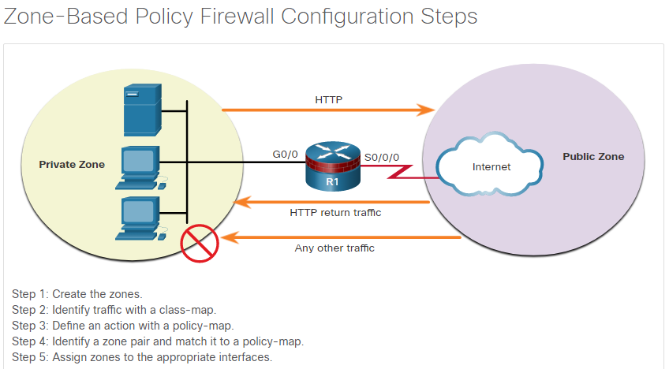

### 10.3.2. Step 1: Create the Zones

The first step, is to create the zones. However, before creating the zones answer a few questions:

* What interfaces should be included in the zones?
* What will be the name for each zone?
* What traffic is necessary between the zones and in which direction?

In the example topology, we have two interfaces, two zones, and traffic flowing in one direction. Traffic sourced from the public zone will not be allowed. Create the private and public zones for the firewall with the zone security command, as shown here.

Router(config)# **zone security** zone-name

R1(config)# **zone security PRIVATE**

R1(config-sec-zone)# **exit**

R1(config)# **zone security PUBLIC**

R1(config-sec-zone)# **exit**

### 10.3.3. Step 2: Identify Traffic

The second step is to use a class-map to identify the traffic to which a policy will be applied. A class is a way of identifying a set of packets based on its contents using “match” conditions. Typically, you define a class so that you can apply an action to the identified traffic that reflects a policy. A class is defined with class-maps.

The example below shows the syntax for the **class-map** command. There are several types of class-maps. For a ZPF configuration, use the **inspect** keyword to define a class-map. Determine how packets are evaluated when multiple match criteria exist. Packets must meet one of the match criteria (**match-any**) or all of the match criteria (**match-all**) to be considered a member of the class.

Router(config)# **class-map type inspect** [**match-any** | **match-all**] class-map-name

| **Parameter** | **Description** |
| --- | --- |
| **match-any** | Packets must meet one of the match criteria to be considered a member of the class. |
| **match-all** | Packets must meet all of the match criteria to be considered a member of the class. |
| *class-map-name* | Name of the class-map that will be used to configure the policy for the class in the policy-map. |

The example below shows the syntax for the match statements in **class-map** sub-configuration mode. Match traffic to an ACL, a specific protocol, or even another class-map.

Router(config-cmap)# **match access-group** {acl-# | acl-name }

Router(config-cmap)# **match protocol** protocol-name

Router(config-cmap)# **match class-map** class-map-name

| **Parameter** | **Description** |
| --- | --- |
| **match access-group** | Configures the match criteria for a class-map based on the specified ACL number or name. |
| **match protocol** | Configures the match criteria for a class-map based on the specified protocol. |
| **match class-map** | Uses another class-map to identify traffic. |

In the topology, HTTP traffic is being allowed to cross R1 from the PRIVATE to the PUBLIC zone. When allowing HTTP traffic, it is recommended to specifically include HTTPS and DNS protocols, as shown in the example below. Traffic can match any of the statements to become a member of the HTTP-TRAFFIC class.

R1(config)# **class-map type inspect match-any HTTP-TRAFFIC**

R1(config-cmap)# **match protocol http**

R1(config-cmap)# **match protocol https**

R1(config-cmap)# **match protocol dns**

### 10.3.4. Step 3: Define an Action

The third step is to use a policy-map to define what action should be taken for traffic that is a member of a class. The example below shows the command syntax to configure a policy-map. An action is a specific functionality. It is typically associated with a traffic class. For example, **inspect**, **drop**, and **pass** are actions.

R1(config)# **policy-map type** **inspect** policy-map-name

R1(config-pmap)# **class type inspect** class-map-name

R1(config-pmap-c)# {**inspect** | **drop** | **pass**}

| **Parameter** | **Description** |
| --- | --- |
| **inspect** | An action that offers state−based traffic control. The router maintains session information for TCP and UDP and permits return traffic. |
| **drop** | Discards unwanted traffic |
| **pass** | A stateless action that allows the router to forward traffic from one zone to another |

The example below shows an example of a policy-map configuration. The class HTTP-TRAFFIC that was configured in the previous step is associated with a new policy-map named PRIV-TO-PUB-POLICY. The third **inspect** command configures R1 to maintain state information for all traffic that is a member of the class HTTP-TRAFFIC.

R1(config)# **policy-map type inspect PRIV-TO-PUB-POLICY**

R1(config-pmap)# **class type inspect HTTP-TRAFFIC**

R1(config-pmap-c)# **inspect**

* **inspect** - This action offers state-based traffic control. For example, if traffic traveling from the PRIVATE zone to the PUBLIC zone is inspected, the router maintains connection or session information for TCP and UDP traffic. The router would then permit return traffic sent from PUBLIC zone hosts in reply to PRIVATE zone connection requests.
* **drop** - This is the default action for all traffic. Similar to the implicit **deny any** at the end of every ACL, there is an explicit **drop** applied by the IOS to the end of every policy−map. It is listed as **class class-default** in the last section of any policy-map configuration. Other class−maps within a policy−map can also be configured to drop unwanted traffic. Unlike ACLs, traffic is silently dropped, and no ICMP unreachable messages are sent to the source of the traffic.
* **pass** - This action allows the router to forward traffic from one zone to another. The pass action does not track the state of connections. Pass only allows the traffic in one direction. A corresponding policy must be applied to allow return traffic to pass in the opposite direction. The pass action is ideal for secure protocols with predictable behavior, such as IPsec. However, most application traffic is better handled in the ZPF with the **inspect** action.

### 10.3.5. Step 4: Identify a Zone-Pair and Match to a Policy

The fourth step is to identify a zone pair and associate that zone pair to a policy-map. The example below shows the command syntax. Create a zone-pair with the **zone-pair security** command. Then use the **service-policy type inspect** command to attach a policy-map and its associated action to the zone-pair.

Router(config)# **zone-pair security** zone-pair-name **source** {source-zone-name | **self**} **destination** {destination-zone-name | **self}**

Router(config-sec-zone-pair)# **service-policy type inspect** policy-map-name

| **Parameter** | **Description** |
| --- | --- |
| **source** *source-zone-name* | Specifies the name of the zone from which traffic is originating. |
| **destination** *destination-zone-name* | Specifies the name of the zone to which traffic is destined. |
| **self** | Specifies the system-defined zone. Indicates whether traffic will be going to or from the router itself. |

The example below shows an example of a zone-pair configuration. A zone-pair named PRIV-PUB is created with PRIVATE assigned as the source zone and PUBLIC assigned as the destination zone. Then the policy-map created in the previous step is associated to the zone-pair.

After the firewall policy has been configured, the administrator applies it to traffic between a pair of zones using the zone-pair security command. To apply a policy, it is assigned to a zone pair. The zone pair needs to specify the source zone, the destination zone, and the policy for handling the traffic between the source and destination zones.

R1(config)# **zone-pair security PRIV-PUB source PRIVATE destination PUBLIC**

R1(config-sec-zone-pair)# **service-policy type inspect PRIV-TO-PUB-POLICY**

### 10.3.6. Step 5: Assign Zones to Interfaces

The fifth step is to assign zones to the appropriate interfaces. Associating a zone to an interface will immediately apply the service-policy that has been associated with the zone. If no service-policy is yet configured for the zone, all transit traffic will be dropped. Use the **zone-member security** command to assign a zone to an interface, as shown in the example below.

Router(config-if)# **zone-member security** zone-name

In the following example, GigabitEthernet 0/0 is assigned the PRIVATE zone, and Serial 0/0/0 is assigned the PUBLIC zone.

R1(config)# **interface GigabitEthernet 0/0**

R1(config-if)# **zone-member security PRIVATE**

R1(config-if)# **interface Serial 0/0/0**

R1(config-if)# **zone-member security PUBLIC**

The service-policy is now active. HTTP, HTTPS, and DNS traffic sourced from the PRIVATE zone and destined for the PUBLIC zone will be inspected. Traffic sourced from the PUBLIC zone and destined for the PRIVATE zone will only be allowed if it is part of sessions originally initiated by PRIVATE zone hosts.

### 10.3.7. Verify a ZPF Configuration

Verify a ZPF configuration by viewing the running configuration. Notice that the class-map is listed first. Then the policy-map makes use of the class-map. Also, notice the highlighted **class class-default** that will drop all other traffic that is not a member of the HTTP-TRAFFIC class.

The zone configurations follow the policy-map configurations with zone naming, zone pairing, and associating a service-policy to the zone pair. Finally, the interfaces are assigned zones.

R1# **show run | begin class-map**

!

<some output omitted>

!

class-map type inspect match-any HTTP-TRAFFIC

match protocol http

match protocol https

match protocol dns

!

policy-map type inspect PRIV-TO-PUB-POLICY

class type inspect HTTP-TRAFFIC

inspect

class class-default

drop

!

zone security PRIVATE

zone security PUBLIC

zone-pair security PRIV-PUB source PRIVATE destination PUBLIC

service-policy type inspect PRIV-TO-PUB-POLICY

!

interface GigabitEthernet0/0

zone-member security PRIVATE

!

interface Serial0/0/0

zone-member security PUBLIC

!

The example below shows verification information after a test of the ZPF configuration. A PRIVATE zone host 192.168.1.3 established an HTTPS session with a web server at 10.1.1.2. Notice further down in the command output that four packets matched the **class class-default**. This verification information was generated by having host 192.168.1.3 ping the web server at 10.1.1.2.

R1# **show policy-map type inspect zone-pair sessions**

policy exists on zp PRIV-PUB

Zone-pair: PRIV-PUB

Service-policy inspect : PRIV-TO-PUB-POLICY

Class-map: HTTP-TRAFFIC (match-any)

Match: protocol http

12 packets, 384 bytes

30 second rate 0 bps

Match: protocol https

5 packets, 160 bytes

30 second rate 0 bps

Match: protocol dns

0 packets, 0 bytes

30 second rate 0 bps

Inspect

Number of Established Sessions = 1

Established Sessions

Session 2204E220 (192.168.1.3:1049)=>(10.1.1.2:443) https:tcp

SIS_OPEN/TCP_CLOSEWAIT

Created 00:00:14, Last heard 00:00:11

Bytes sent (initiator:responder) [821:1431]

Class-map: class-default (match-any)

Match: any

Drop

4 packets, 160 bytes

The example below shows four other ZPF verification commands that allow a view of specific portions of the ZPF configuration.

R1# **show class-map** **type inspect**

Class Map type inspect match-any HTTP-TRAFFIC (id 1)

Match protocol http

Match protocol https

Match protocol dns

R1# **show zone security**

zone self

Description: System Defined Zone

zone PRIVATE

Member Interfaces:

GigabitEthernet0/0

zone PUBLIC

Member Interfaces:

Serial0/0/0

R1# **show zone-pair security**

Zone-pair name PRIV-PUB

Source-Zone PRIVATE Destination-Zone PUBLIC

service-policy PRIV-TO-PUB-POLICY

R1# **show policy-map type inspect**

Policy Map type inspect PRIV-TO-PUB-POLICY

Class HTTP-TRAFFIC

Inspect

Class class-default

Drop

### 10.3.8. ZPF Configuration Considerations

When configuring a ZPF with the CLI, there are several factors to consider:

* The router never filters the traffic between interfaces in the same zone.
* An interface cannot belong to multiple zones. To create a union of security zones, specify a new zone and appropriate policy map and zone pairs.
* ZPF can coexist with Classic Firewall although they cannot be used on the same interface. Remove the **ip inspect** interface configuration command before applying the **zone-member security** command.
* Traffic can never flow between an interface assigned to a zone and an interface without a zone assignment. Applying the **zone-member** configuration command always results in a temporary interruption of service until the other zone-member is configured.
* The default inter-zone policy is to drop all traffic unless otherwise specifically allowed by the service-policy configured for the zone-pair.
* The **zone-member** command does not protect the router itself (traffic to and from the router is not affected) unless the zone- pairs are configured using the predefined self zone.

## 10.4) What Did I Learn in this Module?

**ZPF Overview**  
The IOS ZPF provides a flexible and powerful replacement for the older Classic IOS Firewall. It provides a new configuration mode in which interfaces are assigned to security zones and firewall policies are applied to traffic moving between the zones. The ZPF provides a structured and simplified method of designing and implementing network security on routers that are performing a firewall function.

**ZPF Operation**  
ZPFs use user-defined policies to act on specific traffic that is travelling from a source zone to a destination zone. Three actions can be specified:

* **Inspect** - The ZPF performs stateful packet inspection.
* **Drop** - The traffic is not permitted to travel to the destination. The rejected packets can be logged.
* **Pass** - The traffic is permitted to travel to the destination zone. This does not track the state of connections or sessions.

Default rules are applied to transit traffic based on the configuration of the ingress and egress interfaces and the existence of policies. For example, if neither ingress or egress interface is defined as member of a zone, traffic is permitted to exit the egress interface. Similarly, if both interfaces are members of the same zone, then traffic is allowed to pass. However, if one interface is a member of a zone and the other is not, traffic will be dropped. It is important to understand these and the other rules covered in the module.

A special zone exists that is known as the self zone. The self zone is the router itself. In the self zone, the router interfaces serve as either the source or destination of the traffic. Self zone traffic is either for management of the device, or for traffic forwarding control. Similar to the rules for transit traffic, rules exist for how traffic in the self zone will be handled.

**Configure a ZPF**  
There are five steps in the process of configuring a ZPF. First the zones are created. Next, one or more class maps are created to specify the traffic which should be associated with a policy. Then, policies are created that associate the class-map traffic with the pass, drop, or inspect actions. It is then necessary to create zone pairs that will be associated with policy maps. Finally interfaces are associated with zones. At this point, the ZPF policy is active.

# 11. IPS Technologies

## 11.0) Introduction

### 11.0.1. Why Should I Take this Module?

Various devices and systems combine to protect the network at multiple levels. Security threats include malware and data theft. Devices at the network edge prevent threat actor intrusions and malware from entering the network. Software systems on hosts also work to protect against malware and data theft. In this module, you will learn about intrusion detection and intrusion prevention systems that operate on network devices and network hosts.

### 11.0.2. What Will I Learn in this Module?

**Module Title:** IPS Technologies

**Module Objective**: Explain how network-based Intrusion Prevention Systems are used to help secure a network.

| **Topic Title** | **Topic Objective** |
| --- | --- |
| **IDS and IPS Characteristics** | Explain the functions and operations of IDS and IPS systems. |
| **IPS Implementations** | Explain how network-based IPS are implemented. |
| **IPS on Cisco ISRs** | Describe the IPS technologies that are available on Cisco ISR routers. |
| **Cisco Switched Port Analyzer** | Configure Cisco SPAN. |

## 11.1) IDS and IPS Characteristics

### 11.1.1. Zero-Day Attacks

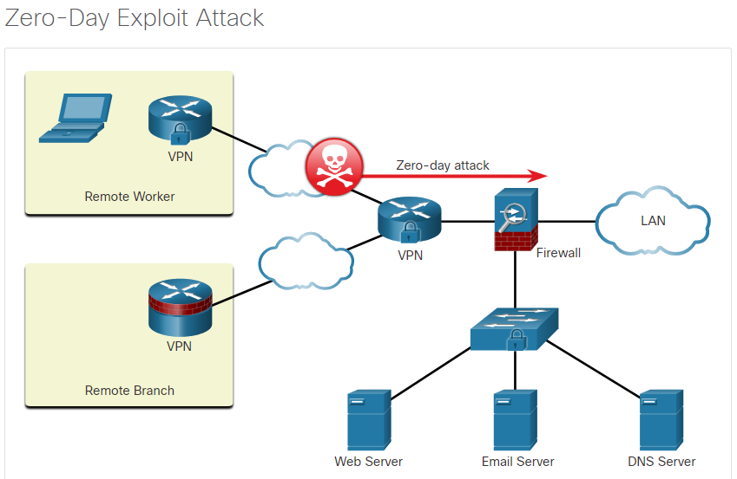Malware can spread across the world in a matter of minutes. A network must instantly recognize and mitigate malware threats. Firewalls can only do so much and cannot provide protection against all malware and zero-day attacks.

A zero-day attack, sometimes referred to as a zero-day threat, is a cyberattack that tries to exploit software vulnerabilities that are unknown or undisclosed by the software vendor, as shown in the figure. The term zero-day describes the moment when a previously unknown threat is identified.

During the time it takes the software vendor to develop and release a patch, the network is vulnerable to these exploits. Defending against these fast-moving attacks requires network security professionals to adopt a more sophisticated view of the network architecture. It is no longer possible to contain intrusions at a few points in the network.

### 11.1.2. Monitor for Attacks

One approach to prevent malware exploits is for an administrator to continuously monitor the network and analyze the log files generated by network devices. Security operations center (SOC) tools, such as security information and event management (SIEM) and security orchestration, automation, and response (SOAR) systems automate the log file gathering and analysis process. It has become an accepted fact that malware will enter the network despite the best defenses. For this reason, a multilayered approach to malware protection must be employed. Logfiles generated by devices at each layer will help to identify whether an exploit has occurred, the diagnostic features of the exploit, and the extent of the damage within the enterprise. The information gathered in logfiles will also help to inform measures taken in response to the exploit, such as containment and mitigation.

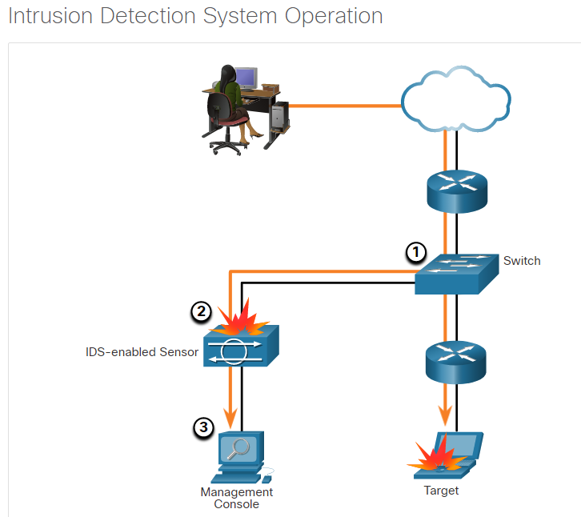Intrusion Detection Systems (IDS) were implemented to passively monitor the traffic on a network. The figure shows that an IDS-enabled device copies the traffic stream and analyzes the copied traffic rather than the actual forwarded packets.

Working offline, the IDS compares the captured traffic stream with known malicious signatures, similar to software that checks for viruses. Working offline means several things:

* The IDS works passively.
* The IDS device is physically positioned in the network so that traffic must be mirrored in order to reach it.
* Network traffic does not pass through the IDS unless it is mirrored.
* Very little latency is added to network traffic flow.

Although the traffic is monitored, logged, and perhaps reported, no action is taken on packets by the IDS. This offline IDS implementation is referred to as promiscuous mode.

The advantage of operating with a copy of the traffic is that the IDS does not negatively affect the packet flow of the forwarded traffic. The disadvantage of operating on a copy of the traffic is that the IDS cannot stop malicious single-packet attacks from reaching the target. An IDS often requires assistance from other networking devices, such as routers and firewalls, to respond to an attack.

A better solution is to use a device that can immediately detect and stop an attack. An Intrusion Prevention System (IPS) performs this function.

### 11.1.3. Intrusion Prevention and Detection Devices

A networking architecture paradigm shift is required to defend against fast-moving and evolving attacks. This must include cost-effective detection and prevention systems, such as intrusion detection systems (IDS) or the more scalable intrusion prevention systems (IPS). The network architecture integrates these solutions into the entry and exit points of the network.

When implementing IDS or IPS, it is important to be familiar with the types of systems available, host-based and network-based approaches, the placement of these systems, the role of signature categories, and possible actions that a Cisco IOS router can take when an attack is detected.

The figure shows how an IPS device handles malicious traffic.

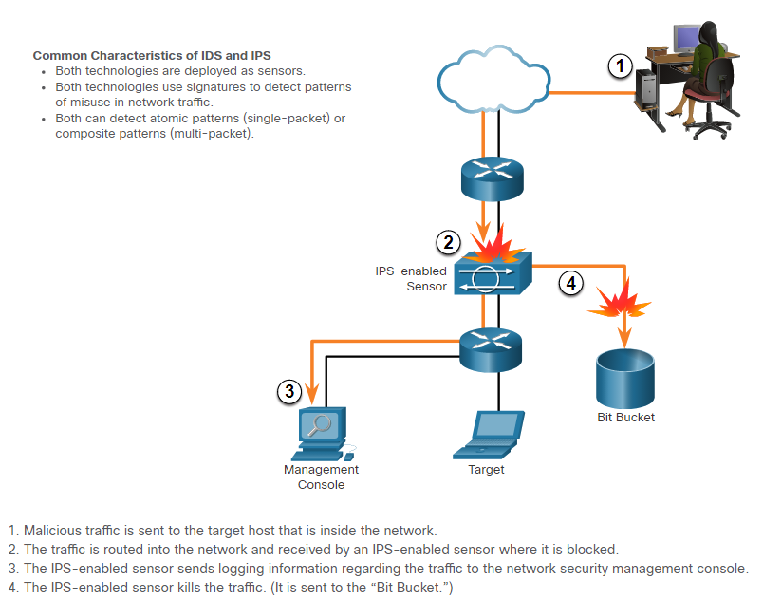

IDS and IPS technologies are both deployed as sensors. An IDS or IPS sensor can be in the form of several different devices:

* A router configured with IPS software
* A device specifically designed to provide dedicated IDS or IPS services
* A hardware module installed in an adaptive security appliance (ASA), switch, or router

IDS and IPS technologies use signatures to detect patterns in network traffic. A signature is a set of rules that an IDS or IPS uses to detect malicious activity. Signatures can be used to detect severe breaches of security, to detect common network attacks, and to gather information. IDS and IPS technologies can detect atomic signature patterns (single-packet) or composite signature patterns (multi-packet).

### 11.1.4. Advantages and Disadvantages of IDS and IPS

| **Solution** | **Advantages** | **Disadvantages** |
| --- | --- | --- |
| **IDS** | * No impact on network (latency, jitter) * No network impact if there is a sensor failure * No network impact if there is sensor overload | * Response action cannot stop trigger packets * Correct tuning required for response actions * More vulnerable to network security evasion techniques |
| **IPS** | * Stops trigger packets * Can use stream normalization techniques | * Sensor issues might affect network traffic * Sensor overloading impacts the network * Some impact on network (latency, jitter) |

**IDS Advantages**

An IDS is deployed in offline mode and therefore:

* The IDS does not impact network performance. Specifically, it does not introduce latency, jitter, or other traffic flow issues.
* The IDS does not affect network functionality if the sensor fails. It only affects the ability of the IDS to analyze the data.

**IDS Disadvantages**

Disadvantages of an IDS include:

* An IDS sensor cannot stop the packets that have triggered an alert and are less helpful in detecting email viruses and automated attacks, such as worms.
* Tuning IDS sensors to achieve expected levels of intrusion detection can be very time-consuming. Users deploying IDS sensor response actions must have a well-designed security policy and a good operational understanding of their IDS deployments.
* An IDS implementation is more vulnerable to network security evasion techniques because it is not inline.

**IPS Advantages**

Advantages of an IPS include:

* An IPS sensor can be configured to drop the trigger packets, the packets associated with a connection, or packets from a source IP address.
* Because IPS sensors are inline, they can use stream normalization. Stream normalization is a technique used to reconstruct the data stream when the attack occurs over multiple data segments.

**IPS Disadvantages**

Disadvantages of an IPS include:

* Because it is deployed inline, errors, failure, and overwhelming the IPS sensor with too much traffic can have a negative effect on network performance.
* An IPS sensor can affect network performance by introducing latency and jitter.
* An IPS sensor must be appropriately sized and implemented so that time-sensitive applications, such as VoIP, are not adversely affected.

**Deployment Considerations**

You can deploy both an IPS and an IDS. Using one of these technologies does not negate the use of the other. In fact, IDS and IPS technologies can complement each other.

For example, an IDS can be implemented to validate IPS operation because the IDS can be configured for deeper packet inspection offline. This allows the IPS to focus on fewer but more critical traffic patterns inline.

Deciding which implementation to use is based on the security goals of the organization as stated in their network security policy.

## 11.2) IPS Implementations

### 11.2.1. Types of IPS

There are two primary kinds of IPS available: host-based IPS and network-based IPS.

**Host-based IPS**

Host-based IPS (HIPS) is software installed on a host to monitor and analyze suspicious activity. A significant advantage of HIPS is that it can monitor and protect operating system and critical system processes that are specific to that host. With detailed knowledge of the operating system, HIPS can monitor abnormal activity and prevent the host from executing commands that do not match typical behavior. This suspicious or malicious behavior might include unauthorized registry updates, changes to the system directory, executing installation programs, and activities that cause buffer overflows. Network traffic can also be monitored to prevent the host from participating in a denial-of-service (DoS) attack or being part of an illicit FTP session.

HIPS can be thought of as a combination of antivirus software, antimalware software, and a firewall. An example of a HIPS is Windows Defender. It provides a range of protection measures for Windows hosts. Combined with a network-based IPS, HIPS is an effective tool in providing additional protection for the host.

A disadvantage of HIPS is that it operates only at a local level. It does not have a complete view of the network, or coordinated events that might be happening across the network. To be effective in a network, HIPS must be installed on every host and have support for every operating system. The table lists the advantages and disadvantages of HIPS.

| **Advantages** | **Disadvantages** |
| --- | --- |
| * Provides protection specific to a host operating system * Provides operating system and application level protection * Protects the host after the message is decrypted | * Operating system dependent * Must be installed on all hosts |

**Network-based IPS**

A network-based IPS can be implemented using a dedicated or non-dedicated IPS device such as a router. Network-based IPS implementations are a critical component of intrusion prevention. Host-based IDS/IPS solutions must be integrated with a network-based IPS implementation to ensure a robust security architecture.

Sensors detect malicious and unauthorized activity in real time and can take action when required. As shown in the figure, sensors are deployed at designated network points. This enables security managers to monitor network activity while it is occurring, regardless of the location of the attack target.

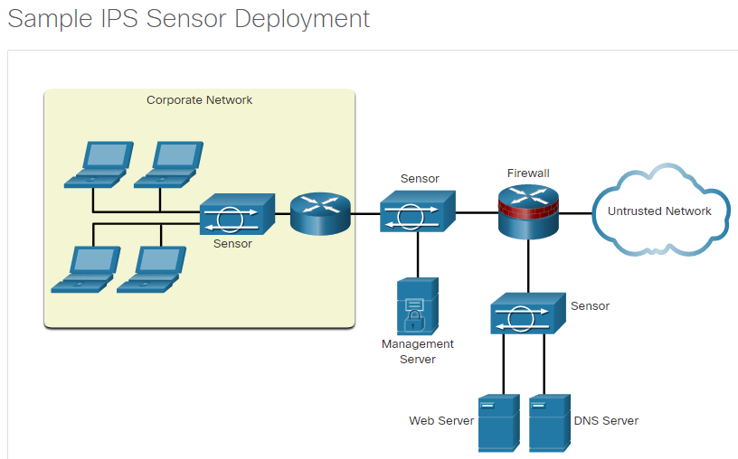

### 11.2.2. Network-Based IPS

Network-based IPS Sensors can be implemented in several ways:

* On a Cisco Firepower appliance
* On an ASA firewall device
* On an ISR router
* As a virtual Next-Generation IPS (NGIPSv) for VMware

An example of a network-based IPS is the Cisco Firepower NGIPS. It is tuned for intrusion prevention analysis. The underlying operating system of the platform is stripped of unnecessary network services, and essential services are secured. This is known as hardening.

The hardware of all network-based sensors includes three components:

* **NIC** - The network-based IPS must be able to connect to any network, such as Ethernet, Fast Ethernet, and Gigabit Ethernet.
* **Processor** - Intrusion prevention requires CPU power to perform intrusion detection analysis and pattern matching.
* **Memory** - Intrusion detection analysis is memory-intensive. Memory directly affects the ability of a network-based IPS to efficiently and accurately detect an attack.

Network-based IPS gives security managers real-time security insight into their networks regardless of growth. Additional hosts can be added to protected networks without requiring more sensors. Additional sensors are only required when their rated traffic capacity is exceeded, when their performance does not meet current needs, or when a revision in security policy or network design requires additional sensors to help enforce security boundaries. When new networks are added, additional sensors are easy to deploy.

### 11.2.3. Modes of Deployment

IDS and IPS sensors can operate in inline mode (also known as inline interface pair mode) or promiscuous mode (also known as passive mode).

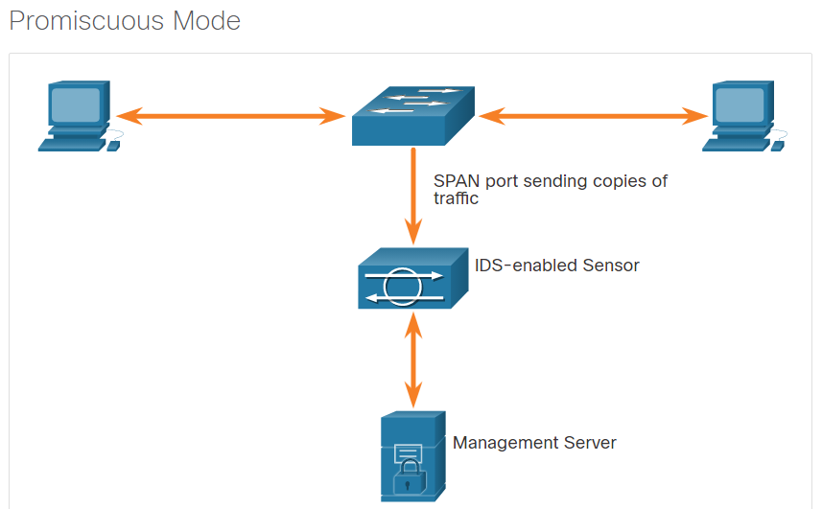As shown in the figure, packets do not flow through the sensor in promiscuous mode. The sensor analyzes a copy of the monitored traffic, not the actual forwarded packet. The advantage of operating in promiscuous mode is that the sensor does not affect the packet flow with the forwarded traffic. The disadvantage of operating in promiscuous mode is that the sensor cannot stop malicious traffic from reaching its intended target for certain types of attacks, such as atomic attacks (single-packet attacks). The response actions implemented by promiscuous sensor devices are post-event responses and often require assistance from other networking devices (for example, routers and firewalls) to respond to an attack. Such response actions can prevent some classes of attacks. However, in atomic attacks the single packet has the chance of reaching the target system before the promiscuous-based sensor can apply an ACL modification on a managed device (such as a firewall, switch, or router). In the figure, Switched Port Analyzer (SPAN) is used to mirror the traffic entering, going to, and coming from the host.

As shown in the figure below, operating in inline mode puts the IPS directly into the traffic flow and makes packet-forwarding rates slower by adding latency. Inline mode allows the sensor to stop attacks by dropping malicious traffic before it reaches the intended target, thus providing a protective service. Not only is the inline device processing information on Layers 3 and 4, but it is also analyzing the contents and payload of the packets for more sophisticated embedded attacks (Layers 3 to 7). This deeper analysis lets the system identify and stop or block attacks that would pass through a traditional firewall device. An IDS sensor could also be deployed inline. The IDS would be configured so that it only sends alerts and does not drop any packets.

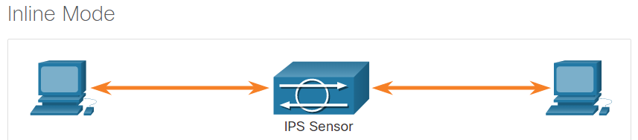

## 11.3) IPS on Cisco ISRs

### 11.3.1. IPS Components

An IPS sensor has two components:

* **IPS detection and enforcement engine** - To validate traffic, the detection engine compares incoming traffic with known attack signatures that are included in the IPS attack signature package.
* **IPS attack signatures package** - This is a list of known attack signatures that are contained in one file. The signature pack is updated frequently as new attacks are discovered. Network traffic is analyzed for matches to these signatures.

As shown in the figure, the IPS detection and enforcement engine that can be implemented depends on the router platform:

* 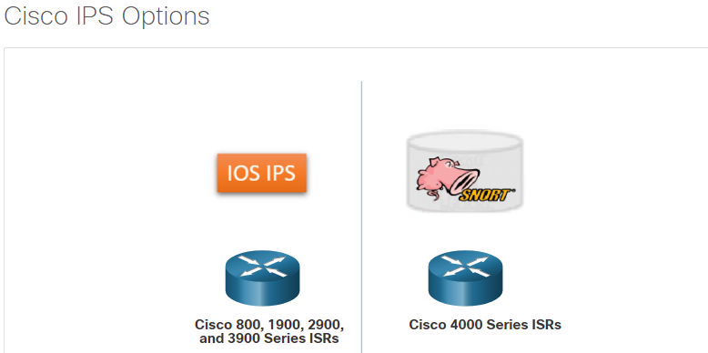**Cisco IOS Intrusion Prevention System (IPS)** - This is available on older Cisco 800, 1900, 2900, and 3900 Series ISRs. IOS IPS is no longer supported and should not be used.
* **Cisco Snort IPS -** This is available on the Cisco 4000 Series ISRs and Cisco Cloud Services Routers in the 1000v Series.

The Cisco Snort IPS delivers traditional intrusion detection and prevention by comparing network traffic to continually updated databases of known malware and threat signatures. The Cisco IOS IPS signatures are no longer updated.

### 11.3.2. Cisco IOS IPS

Enabling a router to work as an IPS is a cost-effective way to protect branch office networks. Rather than purchasing a router and a dedicated IPS device, combining the functionalities in one device not only saves money but also simplifies network designs and administration.

In the past, a Cisco ISR could be enabled as an IPS sensor that scanned packets and sessions to match any of the Cisco IOS IPS signatures. The legacy Cisco IOS IPS operated in RAM as illustrated in the figure. This means that it shared device memory with other Cisco IOS features.

When Cisco IOS IPS detected suspicious activity, it responded before network security could be compromised. It logged the event as Cisco IOS syslog messages or through Security Device Event Exchange (SDEE).

The network administrator could configure the Cisco IOS IPS to choose the appropriate response to various threats. For example, when packets in a session matched a signature, Cisco IOS IPS could be configured to respond as follows:

* Send an alarm to a syslog server or a centralized management interface
* Drop the packet
* Reset the connection
* Deny traffic from the source IP address of the threat for a specified amount of time
* Deny traffic on the connection for which the signature was seen for a specified amount of time

### 11.3.3. Snort IPS

Many of the devices that supported Cisco IOS IPS are no longer available, or no longer supported. The newer Cisco 4000 Series Integrated Services Routers (ISR) no longer support IOS IPS. Instead, they provide IPS services using the Snort IPS feature. Snort IPS complements existing network security features of the 4000 Series without the need to deploy a second appliance at branch locations.

Snort is the most widely deployed IPS solution in the world. It is an open source network IPS that performs real-time traffic analysis and generates alerts when threats are detected on IP networks. It can also perform protocol analysis, content searching or matching, and detect a variety of attacks and probes, such as buffer overflows, stealth port scans, and so on.

The Snort engine runs in a virtual service container on Cisco 4000 Series ISRs. A virtual service container is a virtual machine that runs on the ISR router operating system. Service containers are applications that can be hosted directly on Cisco IOS XE routing platforms. These apps use the Linux aspects of the IOS XE operating system to host both Linux Virtual Containers (LXC) and Kernel virtual machines (KVM). The Snort container is distributed as an Open Virtualization Appliance (OVA) file that is installed on the router.

Unlike IOS IPS, Snort IPS can use the computer power of the service container to scale security with the platform without affecting routing capabilities or other data plane functionality. The virtual service supports three resource profiles that indicate how the Snort container uses system CPU, RAM, and Flash or disk resources.

#### Snort Operations

Snort IPS signatures are delivered automatically to the ISR by Cisco Talos. There are currently more than 30,000 signatures in the Snort rule set. It also supports the ability to customize rule sets and provides centralized deployment and management capabilities for 4000 Series ISRs.

Snort can be enabled in either of the following modes:

* **IDS mode** - Snort inspects the traffic and reports alerts, but does not take any action to prevent attacks.
* **IPS mode** - In addition to intrusion detection, actions are taken to prevent attacks.

In the network intrusion detection and prevention mode, Snort performs the following actions:

* Monitors network traffic and analyzes against a defined rule set.
* Performs attack classification.
* Invokes actions against matched rules.

The Snort IPS monitors the traffic and reports events to an external log server or the IOS syslog. Enabling logging to the IOS syslog may impact performance due to the potential volume of log messages. External third-party monitoring tools that support Snort logs can be used for log collection and analysis.

#### Snort Features

The table lists the features and benefits of Snort IPS.

| **Feature** | **Benefit** |
| --- | --- |
| Signature-based intrusion detection system (IDS) and intrusion prevention system (IPS) | Snort open-source IPS, capable of performing real-time traffic analysis and packet logging on IP networks, runs on the 4000 Series ISR service container without the need to deploy an additional device at the branch. |
| Snort rule set updates | Snort rule set updates for 4000 Series ISRs are generated by Cisco Talos, a group of leading-edge network security experts who work around the clock to proactively discover, assess, and respond to the latest trends in hacking activities, intrusion attempts, malware, and vulnerabilities. |
| Snort rule set pull | The router will be able to download rule sets directly from cisco.com or snort.org to a local server, using one-time commands or periodic automated updates. |
| Snort rule set push | A centralized management tool can push the rule sets based on preconfigured policy, instead of the router directly downloading on its own. |
| Signature allowed listing | Allowed listing allows the disabling of certain signatures from the rule set. Disabled signatures can be reenabled at any time. |

#### Snort System Requirements

To run the service container infrastructure with IDS/IPS functionality, Snort IPS requires an ISR 4000 (i.e., 4300 or higher) with a minimum of 8 GB of memory (DRAM) and 8 GB of flash.

Note: The Cisco 4200 series ISR does not support the default Snort IPS implementation.

A security K9 license (SEC) is required to activate Snort IPS functionality. Customers also need to purchase a yearly subscription for the signature package distributed on cisco.com. To keep current with the latest threat protection, Snort rule sets are term-based subscriptions, available for one or three years.

There are two types of term-based subscriptions:

* **Community Rule Set** - This set offers limited coverage against threats, focusing on reactive response to security threats versus proactive research work. There is 30-day delayed access to updated signatures in the Community Rule Set, and this subscription does not entitle the customer to Cisco support.
* **Subscriber Rule Set** - This set offers the best protection against threats. It includes coverage in advance of exploits by using the research work of the Cisco Talos security experts. The Subscriber Rule Set also provides the fastest access to updated signatures in response to a security incident or the proactive discovery of a new threat. This subscription is fully supported by Cisco.

PulledPork is a rule management application that can be used to automatically download Snort rule updates. In order to use PulledPork, you must obtain an authorization code, called an oinkcode, from your snort.org account. The oinkcode is free with registration.

## 11.4) Cisco Switched Port Analyzer

### 11.4.1. Network Monitoring Methods

The day-to-day operation of a network consists of common patterns of traffic flow, bandwidth usage, and resource access. Together, these patterns identify normal network behavior. Security analysts must be intimately familiar with normal network behavior because abnormal network behavior typically indicates a problem.

To determine normal network behavior, network monitoring must be implemented. Various tools are used to help discover normal network behavior including IDS, packet analyzers, SNMP, NetFlow, and others.

Some of these tools require captured network data. There are two common methods used to capture traffic and send it to network monitoring devices:

* Network taps, sometimes known as test access points (TAPs)
* Traffic mirroring using Switch Port Analyzer (SPAN) or other port mirroring approaches

### 11.4.2. Network Taps

A network tap is typically a passive splitting device implemented inline between a device of interest and the network. A tap forwards all traffic, including physical layer errors, to an analysis device while also allowing the traffic to reach its intended destination.

The figure displays a sample topology displaying a tap installed between a network firewall and the internal router.

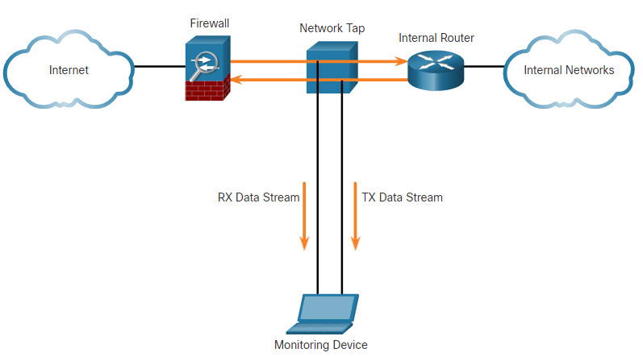

Notice how the tap simultaneously sends both the transmit (TX) data stream from the internal router and the receive (RX) data stream to the internal router on separate, dedicated channels. This ensures that all data arrives at the monitoring device in real time. Therefore, network performance is not affected or degraded by monitoring the connection.

Taps are also typically fail-safe, which means if a tap fails or loses power, traffic between the firewall and internal router is not affected.

Search the internet for information on NetScout Taps for copper UTP Ethernet, fiber Ethernet, and serial links.

### 11.4.3. Traffic Mirroring and SPAN

Network switches segment the network by design. This limits the amount of traffic that is visible to network monitoring devices. Because capturing data for network monitoring requires all traffic to be captured, special techniques must be employed to bypass the network segmentation imposed by network switches. Port mirroring is one of these techniques. Supported by many enterprise switches, port mirroring enables the switch to copy frames that are received on one or more ports to a Switch Port Analyzer (SPAN) port that is connected to an analysis device.

The table identifies and describes terms used by the SPAN feature.

| **SPAN Term** | **Description** |
| --- | --- |
| **Ingress traffic** | Traffic that enters the switch. |
| **Egress traffic** | Traffic that leaves the switch. |
| **Source (SPAN) port** | Source ports are monitored as traffic entering them is replicated (mirrored) to the destination ports. |
| **Destination (SPAN) port** | A port that mirrors source ports. Destination SPAN ports often connect to analysis devices such as a packet analyzer or an IDS. |

The figure shows a switch that interconnects two hosts and mirrors traffic to an intrusion detection device (IDS) and network management server.

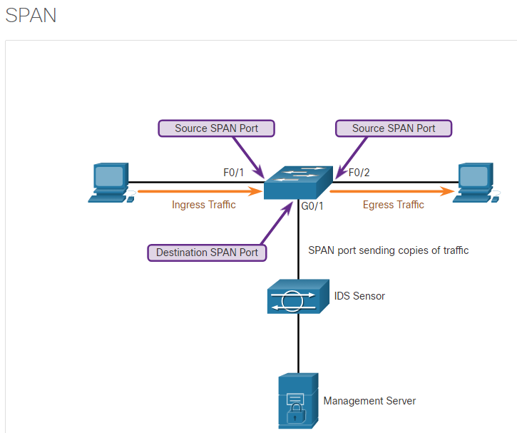The switch will forward ingress traffic on F0/1 and egress traffic on F0/2 to the destination SPAN port G0/1 that connects to an IDS.

The association between source ports and a destination port is called a SPAN session. In a single session, one or multiple ports can be monitored. On some Cisco switches, session traffic can be copied to more than one destination port. Alternatively, a source VLAN can be specified in which all ports in the source VLAN become sources of SPAN traffic. Each SPAN session can have ports or VLANs as sources, but not both.

**Note**: A variation of SPAN called Remote SPAN (RSPAN) enables a network administrator to use the flexibility of VLANs to monitor traffic on remote switches.

### 11.4.4. Configure Cisco SPAN

The SPAN feature on Cisco switches sends a copy of each frame entering the source port out the destination port and toward the packet analyzer or IDS.

A session number is used to identify a SPAN session. The examples show the monitor session command, which is used to associate a source port and a destination port with a SPAN session. A separate monitor session command is used for each session. A VLAN can be specified instead of a physical port.

Switch(config)# **monitor session** number **source** [**interface** interface | **vlan** vlan]

Switch(config)# **monitor session** number **destination** [**interface** interface | **vlan** vlan]

In the figure below, PCA is connected to F0/1 and an IDS is connected to F0/2. The objective is to capture all the traffic that is sent or received by PCA on port F0/1 and send a copy of those frames to the IDS (or a packet analyzer) on port F0/2. The SPAN session on the switch will copy all the traffic that it sends and receives on source port F0/1 to the destination port F0/2.

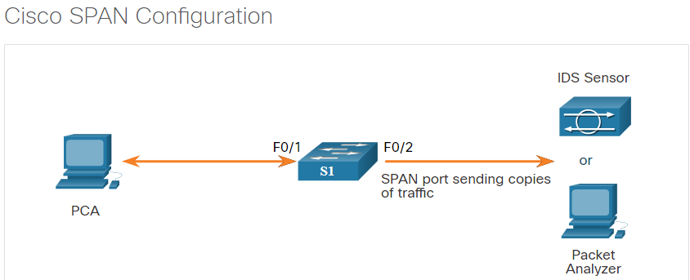

S1(config)# **monitor session 1 source interface fastethernet 0/1**

S1(config)# **monitor session 1 destination interface fastethernet 0/2**

The **show monitor** command is used to verify the SPAN session. The command displays the type of the session, the source ports for each traffic direction, and the destination port. In the example below, the session number is 1, the source port for both traffic directions is F0/1, and the destination port is F0/2. The ingress SPAN is disabled on the destination port, so only traffic that leaves the destination port is copied to that port.

S1# **show monitor**

Session 1

---------

Type : Local Session

Source Ports :

Both : Fa0/1

Destination Ports : Fa0/2

Encapsulation : Native

Ingress : Disabled

**Note**: Remote SPAN (RSPAN) can be used when the packet analyzer or IDS is on a different switch than the traffic being monitored. RSPAN extends SPAN by enabling remote monitoring of multiple switches across the network. The traffic for each RSPAN session is carried over a user-specified RSPAN VLAN that is dedicated (for that RSPAN session) in all participating switches.

## 11.4) What Did I learn in this Module?

**IDS and IPS Characteristics**  
Malware is an ever-increasing threat to network security. New network attacks occur daily. The threat landscape is constantly evolving. Monitoring network logs is one way to know that an exploit has occurred. But by then it is too late. IDS and IPS make up part of a multi-layered approach to network security. IDS work offline to detect malicious traffic through traffic mirroring. IDS can alert security personnel about a potential attack. While the IDS does nothing to stop network attacks, it has no effect on network performance. IPS devices work inline to prevent network attacks, however they can add latency and slow network performance. IDS and IPS devices can be routers equipped with IPS software, dedicated devices, or hardware modules installed in adaptive security appliances, switches or routers.

**IPS Implementations**  
Intrusion prevention systems can be host-based or network-based. HIPS are installed on network hosts. They monitor activity on the host and can prevent attacks and log suspicious activity. HIPS are like a combination of antimalware and firewall software. HIPS have mostly a local view of the network and are only an effective solution if they are used on all hosts. In addition, they should not be the only security measure taken in a network, but instead are just one layer of security.

NIPS can be implemented using a dedicated device or a router with IPS software. Network-based IPS act in real time to block malicious software and network attacks. Network-based IPS can be deployed in two modes. In promiscuous mode, they function as IDS by monitoring mirrored traffic. While they can’t stop network attacks, they can alert personnel and log information when attacks occur. An inline mode IPS processes all traffic that enters a network and checks that traffic at Layers 3 to 7. IPS can also check the contents of payloads that are carried in network traffic, such as email attachments. Because inline mode puts the IPS directly into the traffic flow it makes packet-forwarding rates slower by adding latency. Inline mode allows the sensor to stop attacks by dropping malicious traffic before it reaches the intended target.

**IPS on Cisco ISRs**  
Enabling IPS functionality on routers at the branch level is a cost-effective way to protect networks with a single device. The IPS detection and enforcement engine that ran on legacy router platforms was the Cisco IOS IPS. However, the Cisco IOS IPS is no longer supported. For the 4000 Series ISR, the Cisco Snort IPS has replaced the IOS IPS. Snort runs in a virtual container on the router hardware. The IPS function does not affect the traffic forwarding functions of the router. When running as an IPS, Snort monitors network traffic and analyzes it against a defined-rule set. Snort can classify attacks by type, and can perform actions against the traffic such as sending alerts, logging events, and acting against traffic when attack signatures are matched. Snort can be configured to automatically update its rules from an internet source such as Cisco or snort.org. Problematic signatures can be disabled, and custom rules created. Snort is intended to be run on 4300 ISR and above. It requires 8 GB of DRAM and 8 GB of Flash to run. Resource profiles can be configured to control how Snort uses ISR system resources.

**Cisco Switched Port Analyzer**  
SPAN is a technology that enables network monitoring and IDS to function in segmented networks. Network traffic is mirrored from source ports or VLANs to a destination port or VLAN that is connected to the monitoring device or IDS. Traffic from the source ports is copied and sent to the destination port. Traffic that enters the switch is called ingress traffic, and traffic exits the switch is called egress traffic. Source ports carry the traffic that is to be monitored, and destination ports are connected to the monitoring devices. The monitored traffic is copied and sent out of the destination port. The configuration of SPAN entails defining the source and destination switchports.

# 12. IPS Operation and Implementation

## 12.0) Introduction

### 12.0.1. Why Should I Take this Module?

A networking architecture paradigm shift is required to defend against fast-moving and evolving attacks. This must include cost-effective detection and prevention systems, such as intrusion detection systems (IDS) or the more scalable intrusion prevention systems (IPS). The network architecture integrates these solutions into the entry and exit points of the network.

When implementing IDS or IPS, it is important to be familiar with the types of IPS systems available, the role of signature categories, and possible actions that a Cisco IOS router can take when an attack is detected.

The first part of the module examines conventional IPS signatures and alerts. The remainder of the module discusses the Snort IPS which can run on 4000 series ISR devices.

### 12.0.2. What Will I Learn in this Module?

**Module Title:** IPS Operation and Implementation

**Module Objective**: Explain how signatures are used to detect malicious network traffic.

| **Topic Title** | **Topic Objective** |
| --- | --- |
| **IPS Signatures** | Describe IPS signatures. |
| **Cisco Snort IPS** | Explain how the Cisco Snort IPS provides network security services. |
| **Configure Snort IPS** | Explain how to configure Snort IPS on a Cisco ISR G2. |

## 12.1) IPS Signatures

### 12.1.1. IPS Signature Attributes

The network must be able to identify incoming malicious traffic in order to stop it. Fortunately, malicious traffic displays distinct characteristics or “signatures”.

Conceptually similar to the **virus.dat** file used by virus scanners, a signature is a set of rules that an IDS and an IPS use to detect typical intrusion activity. Signatures uniquely identify specific viruses, worms, protocol anomalies, and malicious traffic (e.g., a DoS attacks).

A malicious packet flow has a specific type of activity and signature. IPS sensors must be tuned to look for matching signatures or abnormal traffic patterns. As sensors scan network packets, they use signatures to detect known attacks and respond with predefined actions. An IDS or IPS sensor examines the data flow using many different signatures. A sensor takes action when it matches a signature with a data flow, such as logging the event or sending an alarm to the IDS or IPS management software.

Signatures also have three distinctive attributes:

* **Type** - Atomic or Composite
* **Trigger** - Also called the alarm
* **Action** - What the IPS will do

### 12.1.2. Types of Signatures

Some threats can be identified in one packet while other threats may require many packets and their state information (i.e., IP addresses, port numbers, and more) to identify a threat.

There are two types of signatures:

* **Atomic Signature -** This is the simplest type of signature because a single packet, activity, or event identifies an attack. The IPS does not need to maintain state information and traffic analysis can usually be performed very quickly and efficiently.
* **Composite Signature -** Also called a stateful signature because the IPS requires several pieces of data to match an attack signature. The IPS must also maintain state information, which is referred to as the event horizon. The length of an event horizon varies from one signature to the next.

### 12.1.3. IPS Signature Alarms

The heart of any IPS signature is the signature alarm, which is often referred to as the signature trigger. The signature alarm (i.e., trigger) for an IPS sensor could be anything that can reliably signal an intrusion or security policy violation. A network-based IPS might trigger a signature action if it detects a packet with a payload containing a specific string that is going to a specific TCP port, for example.

The IPS signature alarm is analogous to the alarm in a home security system. The triggering mechanism for a burglar alarm could be a motion detector. When the burgler alarm is enabled, the movement of an individual entering a room is detected. This triggers the alarm.

These triggering mechanisms can be applied to atomic and composite signatures. The triggering mechanisms can be simple or complex. Every IPS incorporates signatures that use one or more of these basic triggering mechanisms to trigger signature actions.

There are four general IPS signature trigger categories as listed in the table.

| **Detection Type** | **Advantages** |
| --- | --- |
| **Pattern-Based Detection** | * Also known as signature-based detection. * Simplest triggering mechanism as it searches for a specific and pre-defined atomic or composite pattern. * A IPS sensor compares the network traffic to a database of known attacks, and triggers an alarm or prevents communication if a match is found. |
| **Anomaly-Based Detection** | * Also known as profile-based detection. * Involves first defining a profile of what is considered normal network or host activity. * This normal profile is usually defined by monitoring traffic and establishing a baseline. * Once defined, any activity beyond a specified threshold in the normal profile will generate a signature trigger and action. |
| **Policy-Based Detection** | * Also known as behavior-based detection. * Although similar to pattern-based detection, an administrator manually defines behaviors that are suspicious based on historical analysis. * The use of behaviors enables a single signature to cover an entire class of activities without having to specify each individual situation. |
| **Honey Pot-Based Detection** | * Honey pot-based detection uses a server as a decoy server to attract attacks. * The purpose of a decoy server is to lure attacks away from production devices. * Allows administrators time to analyze incoming attacks and malicious traffic patterns to tune their sensor signatures. |

### 12.1.4. IPS Signature Actions

When a signature detects the activity for which it is configured, the signature triggers one or more actions.

Depending on the IPS sensor, various actions can be enabled. The table lists some actions that an IPS sensor may provide.

**Note:** The available actions depend on the signature type and the platform.

| **Alert Category** | **Specific Action** | **Description** |
| --- | --- | --- |
| Generate an alert | Produce alert | The IPS sends events as alerts. |
| Produce verbose alert | The IPS sends a detailed event alert. |
| Log the activity | Log attacker packets | Logs packets from the attacker IP address and sends an alert. |
| Log pair packets | Logs packets from the victim and attacker IP addresses and sends an alert. |
| Log victim packets | Logs packets from the victim IP address and sends an alert. |
| Deny the activity | Deny packet inline | Terminates the packet. |
| Deny connection inline | Terminates the current packet and future packets on this TCP flow. |
| Deny attacker inline | Terminates the current packet and future packets from this attacker address for a specified period of time. |
| Reset the TCP connection | Reset TCP connection | Sends TCP resets to hijack and terminate the TCP flow. |
| Block future activity | Request block connection | Sends a request to a blocking device to block this connection. |
| Request block host | Sends a request to a blocking device to block this attacker host. |
| Request SNMP trap | Sends a request to the notification application component of the sensor to perform SNMP notification. |

### 12.1.5. Evaluating Alerts

Triggering mechanisms can generate alarms that are false positives or false negatives. These alarms must be addressed when implementing an IPS sensor. True positives and true negatives are desirable and indicate the IPS is functioning properly. False positives and false negatives are undesirable and must be investigated.

The table summarizes the following four types of alarms:

| **Alarm Type** | **Network Activity** | **IPS Activity** | **Outcome** |
| --- | --- | --- | --- |
| **True positive** | Attack traffic | Alarm generated | Ideal setting |
| **True negative** | Normal user traffic | No alarm generated | Ideal setting |
| **False positive** | Normal user traffic | Alarm generated | Tune alarm |
| **False negative** | Attack traffic | No alarm generated | Tune alarm |

Alerts can be classified as follows:

* **True positive** - (Desirable) This is used when the IPS generates an alarm because it detected known attack traffic. The alert has been verified to be an actual security incident and also indicates that the IPS rule worked correctly.
* **True negative** - (Desirable) This is used when the system is performing as expected. No alerts are issued because the traffic that is passing through the system is clear of threats.
* **False positive** - (Undesirable) This is used when an IPS generates an alarm after processing normal user traffic that should not have triggered an alarm. The IPS must be tuned to change these alarm types to true negatives. The alert does not indicate an actual security incident. Benign activity that results in a false positive is sometimes referred to as a benign trigger. False positives are costly because they must be investigated.
* **False negative** - (Dangerous) This is used when an IPS fails to generate an alarm and known attacks are not being detected. This means that exploits are not being detected by the security systems that are in place. These incidents could go undetected for a long time, and ongoing data loss and damage could result. The goal is for these alarm types to generate true positive alarms.

## 12.2) Cisco Snort IPS

### 12.2.1. IPS Service Options

Intrusion prevention services were available on the first-generation Integrated Services Routers (ISR G1) using the Cisco IOS IPS. Cisco IOS IPS monitored and prevented intrusions by comparing traffic against signatures of known threats and blocking the traffic when a threat was detected.

**Note**: Support for Cisco IOS IPS discontinued in 2018. Therefore, IOS IPS is no longer recommended on branch routers.

Organizations now have three options available to provide intrusion prevention services.

* **Cisco Firepower Next-Generation IPS (NGIPS)** - These are dedicated in-line threat prevention appliances that provide industry leading effectiveness against both known and unknown threats.
* **Cisco Snort IPS** - This is an IPS service that can be enabled on a second generation ISR (ISR G2) (i.e., ISR 4000s). Note that Cisco 4000 ISRs no longer support Cisco IOS IPS.
* **External Snort IPS Server** - This is similar to the Cisco Snort IPS solution but requires a promiscuous port (i.e., a SPAN switch port) and an external Snort IDS/IPS.

All three IPS services use Snort and receive rule updates from Cisco Talos.

### 12.2.2. NGIPS

NGIPSs are dedicated IPS appliances. They are built on Snort's core open technology and use vulnerability-focused IPS rules and embedded IP-, URL-, and DNS-based security intelligence provided by Cisco Talos.

NGIPS features include the following:

* IPS rules that identify and block attack traffic targeted at network vulnerabilities.
* Tightly integrated defense against advanced malware by incorporating advanced analysis of network and endpoint activity.
* Sandboxing technology that uses hundreds of behavioral indicators to identify zero-day and evasive attacks.
* Also includes Application Visibility and Control (AVC), Cisco Advanced Malware Protection (AMP) for Networks, and URL Filtering.

**Note**: Further discussion of NGIPS appliances is out of scope for this course.

### 12.2.3. Snort IPS

Snort is an open source network IPS that performs real-time traffic analysis and generates alerts when threats are detected on IP networks. It can also perform protocol analysis, content searching or matching, and detect a variety of attacks and probes (e.g., buffer overflows, stealth port scans, and more). Snort was inducted into the InfoWorld Open Source Hall of Fame as one greatest pieces of open source software ever.

The Snort engine can now run as a virtual container service on Cisco 4000 ISRs and Cisco Cloud Services Router 1000v Series. It is ideal for smaller organizations looking for a cost-effective routing and threat defense solution. For instance, an ISR G2 can provide advanced routing capabilities and integrated threat defense security using Snort IPS.

Snort IPS can be implemented with other security features integrated into the 4000 Series ISRs, such as VPN, zone-based Cisco IOS firewalls, and Cisco Cloud Web Security. This enables the ISR to provide comprehensive threat protection in a small footprint. This is crucial for small branch locations that need to address security for the local internet connection. Snort IPS integrated in an ISR is a cost-effective alternative for branch office locations because a separate firewall device is not required.

Snort IPS on the 4000 Series ISR provides the following functionalities:

* **IDS and IPS mode** - Configure threat detection or prevention mode. In prevention mode, attack traffic will be dropped.
* **Three signature levels** - Snort provides three levels of signature protection: connectivity (least secure), balanced (middle option), and security (most secure). The security level is the most secure as it enables the highest number of signatures to be verified.
* **An allowed list** - This provides the ability to turn off certain signatures and helps to avoid false positives such as legitimate traffic triggering an IPS action. Up to 1000 entries can be supported in the allowed list.
* **Snort health monitoring** - Cisco IOS Software keeps track of the health of the Snort engine that is running in the service container.
* **Fail open and close** - In the event of IPS engine failure, the router can be configured to block the traffic flow or to bypass IPS checking until the Snort engine recovers.
* **Signature update** - Automatic and manual updates are supported. Snort IPS can download the signature package directly from cisco.com or a local resource location over HTTP and HTTPS.
* **Event logging** - IPS logs can be sent to an independent log collector or included along with the router syslog stream. Sending IPS logs separately helps if the security event management tool is different from the regular syslog server.

### 12.2.4. Snort Components and Rules

Snort IPS for 4000 Series ISRs consists of two components:

* **Snort engine** - This is the IPS detection and enforcement engine that is included in the Security (SEC) license for 4000 Series ISRs.
* **Snort rule software subscriptions for signature updates** - Snort rule sets to keep current with the latest threat protection are term-based subscriptions, available for one or three years.

To address the rapidly evolving threat landscape, it is important to ensure that signatures are as up-to-date as possible.

There are two types of term-based subscriptions:

* **Community Rule Set** - Available for free, this subscription offers limited coverage against threats. The community rule set focuses on reactive response to security threats versus proactive research work. There is also a 30-day delayed access to updated signatures meaning that newest rule will be a minimum of 30 days old. In addition, there is no Cisco customer support available.
* **Subscriber Rule Set** - Available for a fee, this service provides the best protection against threats. It includes coverage of advance exploits by using the research work of the Cisco Talos security experts. The Subscriber Rule Set also provides the fastest access to updated signatures in response to a security incident or the proactive discovery of a new threat. This subscription is fully supported by Cisco.

**Note**: Contact Cisco Support to obtain the subscriber rule set license.

### 12.2.5. ISR Container Applications

Routers were initially packet processing devices. However, over the years, they have evolved to perform many computing functions. Routers have acquired so much processing power that server applications can now be hosted inside the router using virtual machines called service containers.

Applications such as Snort IPS can be uploaded and hosted on these routers. Service containers are supported on most IOS XE platforms. IOS XE is based on the Linux architecture and supports virtual machine hosting.

The Snort engine runs as a Linux Service Container application on the ISR 4000. This provides it with dedicated computing resources that run independently of the data plane CPU load. It also makes it easier for the Snort engine to be regularly updated.

Specifically, the Snort engine on the 4000 Series ISR runs as a container application. The 4000 Series ISR uses a multi-core CPU, and the Cisco IOS-XE has the ability to allocate these cores for control-plane or data-plane functions. Computing resources unused by control plane functions can be used for running other services. A Linux container infrastructure hosts these applications. Applications running in this container infrastructure can have a tighter integration with Cisco IOS Software.

### 12.2.6. Snort IPS Rule Alarms

In Snort IPS, signatures are configured using “rules”. These rules serve as the signature alarms by comparing incoming traffic to the Snort rules. Traffic matching a rule header generates an action.

A rule header is conceptually similar to an access control list (ACL) statement. It is a one line statement that identifies malicious traffic.

The basic rule header command syntax is:

[*action*] [*protocol*] [*sourceIP*] [*sourceport*] -> [*destIP*] [*destport*] ([*Rule options*])

**Note:** The Rule options contain additional rule information.

For example, the following sample header generates an alert whenever a TCP connection for the hosts/ports identified in the rule header variables are going to the identified destination hosts/ports variables:

**alert tcp $EXTERNAL_NET $HTTP_PORTS -> $HOME_NET any**

Refer to the figure for a detailed explanation of this example.

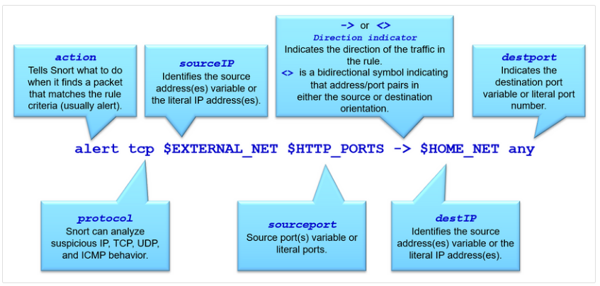

### 12.2.7. Snort IPS Rule Actions

Snort can be enabled in IDS mode or in IPS mode.

Snort IDS mode can perform the following three actions:

* **Alert** - Generate an alert using the selected alert method.
* **Log** - Log the packet.
* **Pass** - Ignore the packet.

Snort IPS mode can perform all the IDS actions plus the following:

* **Drop** - Block and log the packet.
* **Reject** - Block the packet, log it, and then send a TCP reset if the protocol is TCP or an ICMP port unreachable message if the protocol is UDP.
* **Sdrop** - Block the packet but do not log it.

### 12.2.8. Snort IPS Header Rule Options

A Snort rule header also contains rule options (fields) to provide additional information for the rule. Options are separated by semicolons (;) and the rule option keywords are separated from their arguments using colons (:).

The figure displays sample rule options for the **alert tcp $EXTERNAL_NET $HTTP_PORTS -> $HOME_NET any** rule header.

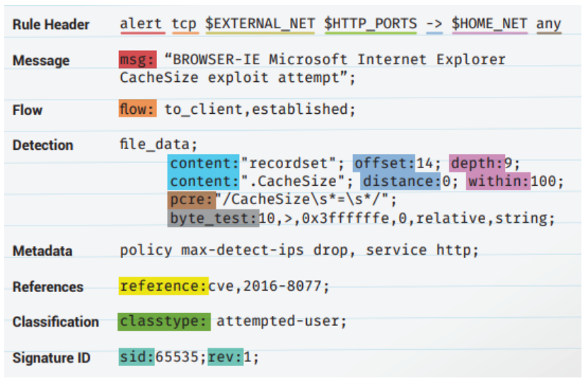

The table describes the common general rule and the detection rule options in the sample rule header.

**Note**: These are just a few of the different types of rule options. For more examples, search the internet for "snort rule options"

| **Rule Option** | **Specific Action** |
| --- | --- |
| **msg:** | This is a simple text string that provides a meaningful message to output when the rule matches. |
| **flow:** | Specifies the direction of network traffic. |
| **content:** | A detection rule option that allows the rule creator to set rules that search for specific content in the packet payload and trigger response based on that data. This option data can contain mixed text and binary data |
| **distance: / offset:** | Detection rule keywords that allow the rule creator to specify where to start searching relative to the beginning of the payload or the beginning of a content match. |
| **within: / depth:** | Detection rule keywords that allow the rule creator to specify how far forward to search relative to the end of a previous content match and, once that content match is found, how far to search for it. |
| **pcre** | A detection rule keyword that allows rules to be written using “perl compatible regular expressions” which allows for more complex matches. |
| **byte_test** | A detection rule keyword that allows a rule to test a number of bytes against a specific value in binary. |
| **metadata:** | Allows a rule creator to embed additional information about the rule. |
| **reference:** | Allows rules to include references to external sources of information. |
| **classtype:** | Identifies the potential effect of what a successful attack would be. |
| **sid / rev** | The signature ID (**sid**) is a unique identifier for each rule making them easy to identify. It should be used with the **rev** (revision) keyword to indicate the current version of the rule. |

### 12.2.9. Snort IPS Operations

Packets arriving on Snort enabled interfaces are inspected as follows:

1. Cisco IOS Software forwards the packets to be inspected to the Snort IPS engine using an internal virtual port group (VPG) interface.
2. Snort IPS inspects the traffic and takes necessary action.
3. Snort drops the packets associated with bad flows (IPS mode). Good flow packets are returned back to the router for further processing.

Packet exchange between the container applications and the IOS data plane is done using VPG interfaces. These routed interfaces are connected through the router back plane. The corresponding interface on the container side will appear as virtual Ethernet ports.

Snort IPS requires two VPG interfaces:

* **Management interface** - This is the interface that is used to source logs to the log collector and for retrieving signature updates from Cisco.com. For this reason, this interface requires a routable IP address.
* **Data interface** - This is the interface that is used to send user traffic between the Snort virtual container service and the router forwarding plane.

In the figure, VPG0 is used for Snort management traffic while VPG1 is used for user traffic to be inspected. User traffic to be inspected is forwarded to the Snort engine using VPG1 as shown. Traffic is then inspected and either rejected (dropped) or forwarded back to the router as shown.

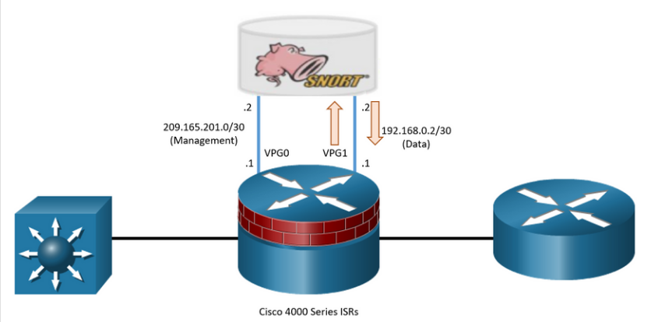

## 12.3) Configure Snort IPS

#### Snort IPS Configuration Steps

To deploy Snort IPS on supported devices, perform the following steps:

**Step 1**. Download the Snort OVA file.  
**Step 2**. Install the OVA file.  
**Step 3**. Configure Virtual Port Group interfaces.  
**Step 4**. Activate the virtual services.  
**Step 5**. Configure Snort specifics.  
**Step 6**. Enable IPS globally or on desired interfaces.  
**Step 7**. Verify Snort IPS.

**Note:** The Snort IPS functionality is available only in security K9-licensed IOS XE version. The security license tis required to enable the service. This feature is available in Cisco IOS XE Release 3.16.1S, 3.17S, and later releases.

#### Step 1. Download the Snort OVA File

An Open Virtualization Archive (OVA) is a file that contains a compressed, installable version of a virtual machine. The Snort service OVA file is not bundled with the Cisco IOS XE Release images installed on the router. However, if the OVA file is be preinstalled in the flash of the router, it is recommended that the latest OVA file be downloaded from Cisco.com.

For example, in the figure, the user is downloading the OVA file for an ISR 4321 router using IOS Fuji-16.9.6.

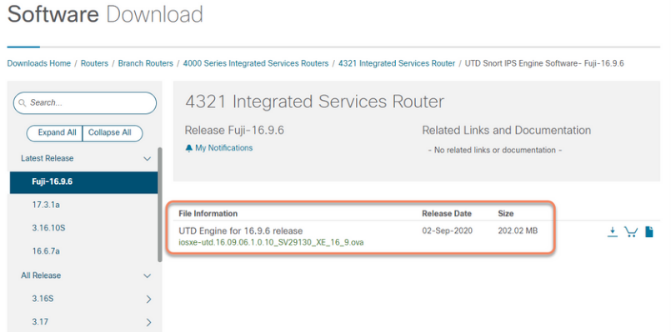

**Note**: CCO access is required to download files from Cisco.com.

#### Step 2. Install the Snort OVA File

The OVA file must be downloaded and saved in a file location available to the ISR router (e.g., Flash).

To install the OVA file, use the **virtual-service install name** *virtual-service-name* **package** *file-url* **media** *file-system* privilege EXEC command. The length of the *name* is 20 characters and the complete path to the OVA file must be specified.

An example configuration is shown below.

R1# **virtual-service install name MYIPS package flash:iosxe-utd.16.09.06.1.0.10_SV29130_XE_16_9.ova**

Installing package 'bootflash:/iosxe-utd.16.09.06.1.0.10_SV29130_XE_16_9.ova' for virtual-service 'MYIPS'. Once the install has finished, the VM may be activated. Use 'show virtual-service list' for progress.

R1#

*Oct 5 08:07:45.953: %VMAN-5-PACKAGE_SIGNING_LEVEL_ON_INSTALL: R0/0: vman: Package 'iosxe-utd.16.09.06.1.0.10_SV29130_XE_16_9.ova' for service container 'MYIPS' is 'Cisco signed', signing level cached on original install is 'Cisco signed'

During the OVA file installation, the security license is checked and an error is reported if the license is not present. Therefore, the Cisco IOS XE image must be enabled with the security license. In the output, you can see that the OVA is Cisco signed.

Use the **show virtual-service list** command to display the status of the installation of all applications installed on the virtual service container.

#### Step 3. Configure Virtual Port Group Interfaces

Two VirtualPortGroup (VPG) interfaces must then be configured along with their guest IP addresses.

In our example, the VPG interfaces will be configured as follows:

* **VGP0 -** This is for management traffic to exchange information with IPS servers. The guest IP address needs to be routable to connect to the signature update server and external log server. It is also used to log traffic to log collectors.
* **VPG1 -** This is for user traffic marked for inspections. This should not be routable and therefore use a non-routable private IP address.

**Note**: Be sure to provide proper NAT and routing to enable the management VPG to reach the log server as well as cisco.com to retrieve signature update files.

The following is a sample configuration of VPG0 and VPG1.

R1# **configure terminal**

R1(config)# **interface VirtualPortGroup0**

R1(config-if)# **description Management interface**

R1(config-if)# **ip address 209.165.201.1 255.255.255.252**

R1(config-if)# **exit**

R1(config)#

*Oct 5 08:13:10.970: %LINEPROTO-5-UPDOWN: Line protocol on Interface VirtualPortGroup0, changed state to up

R1(config)# **interface VirtualPortGroup1**

R1(config-if)# **description Data interface**

R1(config-if)# **ip address 192.168.0.1 255.255.255.252**

R1(config-if)# **exit**

R1(config)#

*Oct 5 08:13:12.921: %LINEPROTO-5-UPDOWN: Line protocol on Interface VirtualPortGroup1, changed state to up

#### Step 4. Activate Virtual Services

The next step is to configure guest IPs on the same subnet for the container side and activate the virtual service as shown in the output.

R1(config)# **virtual-service MYIPS**

R1(config-virt-serv)# **vnic gateway VirtualPortGroup0**

R1(config-virt-serv-vnic)# **guest ip address 209.165.201.2**

R1(config-virt-serv-vnic)# **exit**

R1(config-virt-serv)# **vnic gateway VirtualPortGroup1**

R1(config-virt-serv-vnic)# **guest ip address 192.168.0.2**

R1(config-virt-serv-vnic)# **exit**

R1(config-virt-serv)# **activate**

The **virtual-service** *virtual-service-name* command configures the logical name, **MYIPS** in the example, that is used to identify the virtual container service.

The **vnic gateway VirtualPortGroup** *interface-number* command creates a virtual network interface card (vNIC) gateway interface for the virtual container service. It also maps the vNIC gateway interface to the virtual port group, and enters the virtual-service vNIC configuration mode.

The **guest ip address** *ip-address* command configures a guest vNIC address for the vNIC gateway interface.

Finally, the **activate** command activates the application installed in a virtual container service.

#### Step 5. Configure Snort Specifics

Next is to configure how Snort is to be deployed (i.e. IPS or IDS mode), where the Snort logs should be sent, the policy and profile to configure for Snort, and more.

Refer to the sample command output.

R1(config)# **utd engine standard**

R1(config-utd-eng-std)# **logging host 10.10.10.254**

R1(config-utd-eng-std)# **logging syslog**

R1(config-utd-eng-std)#

R1(config-utd-eng-std)# **threat-inspection**

R1(config-utd-engstd-insp)# **threat protection**

R1(config-utd-engstd-insp)# **policy balanced**

R1(config-utd-engstd-insp)#

R1(config-utd-engstd-insp)# **signature update occur-at daily 0 0**

R1(config-utd-engstd-insp)# **signature update server cisco username Bob password class**

R1(config-utd-engstd-insp)# **logging level warning**

R1(config-utd-engstd-insp)#

R1(config-utd-engstd-insp)# **exit**

R1(config-utd-eng-std)# **exit**

The **utd engine standard** command configures the UTD standard engine and enters UTD standard engine configuration mode.

The **logging host** and **logging syslog** commands enable the logging of emergency messages to a server.

The **threat-inspection** command configures threat inspection for the Snort engine. From here you can specify which mode Snort will be in:

* **threat protection -** Snort will be in IPS mode.
* **threat detection -** Snort will be in IDS mode.

The **policy** command specifies three security policies used by Snort and provided by Cisco Talos, as shown in the following help facility example.

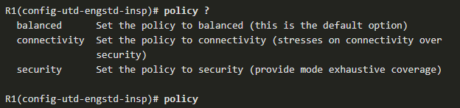

The three policy settings in order from least protection to most protection are:

* **connectivity** - This provides the least protection as it prioritizes connectivity over security. Approximately 1,000 rules are pre-loaded using this policy.
* **balanced** - This is the default policy. It is recommended for initial deployments. This policy attempts to balance security needs and performance characteristics of the network. Approximately 8,000 rules are pre-loaded using this policy.
* **security** - This provides the most protection. It is designed for organizations that are exceptionally concerned about security. Customers deploy this policy in protected networks, that have a lower bandwidth requirements, but much higher security requirements. Approximately 12,000 rules are pre-loaded using this policy.

**Note:** IPS system performance is negatively affected as more rules are enabled.

The **signature update** command configures the signature update interval parameters. In our sample output, Snort will update its signatures every night at midnight.

The **signature update server** command configures the signature update server parameters. You must specify the signature update parameters with the server details. If you use Cisco.com for signature updates, you must provide the username and password. If you use local server for signature updates, based on the server settings you can provide the username and password. In our sample output, Snort updates its signature file from cisco.com using the username Bob and password class.

Finally the **logging level** command specifies the types of syslog messages that will be generated.

#### Step 6. Enable IPS Globally or on Desired Interfaces

Based on the organizational requirements, Snort can be enabled globally (i.e., on all the interfaces) or on selected interfaces.

The example in the output enables UTD globally on all interfaces and defines what to do if the Snort engine fails.

R1(config)# **utd**

R1(config-utd)# **all-interfaces**

R1(config-utd)#

R1(config-utd)# **engine standard**

R1(config-engine-std)# **fail close**

R1(config-engine-std)# **exit**

R1(config-utd)# **exit**

The **all-interfaces** option configures unified threat defense (UTD) on all Layer 3 interfaces of the device.

The **engine standard** command configures the Snort-based UTD engine and enters standard engine configuration mode. From this mode, we can specify how Snort will behave if there is a UTD engine failure.

Specifically, Snort can be configured to:

* **fail-open** (default) - When there is a UTD engine failure, this option allows all of the IPS/IDS traffic through without being inspected.
* **fail-close** - If enabled, this option drops all the IPS/IDS traffic when there is an UTD engine failure. Therefore, no traffic will be allowed to leave.

Alternatively, Snort could be enabled only on select interfaces as shown.

**Note**: An error message will be displayed if the global configuration was first configured.

R1(config)# **interface G0/0/0**

R1(config-if)# **utd enable**

R1(config-if)# **exit**

R1(config)# **interface G0/0/1**

R1(config-if)# **utd enable**

R1(config-if)# **exit**

You can also enable the UTD allowed list feature. This enables you to identify IPS signature IDs to be suppressed (not used).

For example, when an IPS is incorrectly identifying normal user traffic as a threat (i.e., a false positive), we can add those signatures to an allowed list. The IPS will not use signatures in the allowlist.

To do so, enter UTD allowed list configuration mode and identify signature IDs to be excluded from inspection. After the allowed list signature ID is configured, Snort will allow the flow to pass through the device without any alerts and drops.

For example, assume that the IPS has incorrectly identified user traffic from **Branch1** as malicious and assigned it **id 21555**. This signature can be added to an allowed list, as shown.

R1(config)# **utd threat-inspection whitelist**

R1(config-utd-whitelist)# **signature id 21555 comment traffic from Branch 1**

#### Step 7. Verify Snort IPS

After Snort IPS is implemented, it is necessary to verify the configuration to ensure correct operation.

There are several **show** commands that can be used to verify the Snort IPS configuration and operation.

* **show virtual-service list** - The command displays an overview of resources that are utilized by the applications.
* **show virtual-service detail** - The command displays a list of resources that are committed to a specified application, including attached devices.
* **show utd engine standard config** - The command displays the UTD configuration.
* **show utd engine standard status** - The command displays the status of the UTD engine.
* **show platform hardware qfp active feature utd stats** - The command checks the data plane. It verifies increments for encap, decap, redirect, and reinject and displays a health of "Green".

## 12.4) What Did I Learn in this Module?

**IPS Signatures**  
IPS signatures have three attributes: type, trigger, and action. The signature type can be atomic or composite. The signature alarms can use pattern-based detection, anomaly-based detection, policy-based detection, or honey pot-based detection. The IPS signature actions include generate an alert, log the activity, deny the activity, reset the TCP connection, and block future activity. Triggering mechanisms can generate results such as true positive, true positive, false negatives, and false negatives.

**Cisco Snort IPS**  
Intrusion protection is provided in modern Cisco networks using either dedicated NGIPS Firepower enabled devices, Snort IPS on ISR 4000 routers, or using an external Snort IPS server. Snort IPS on ISR device can provide both IDS or IPS services. It has predefined security levels (i.e., connectivity, balanced, and security). It can refer to a allowed list, provide feedback on the health of the Snort engine, offer fail-open and fail-close failover, and automated signature updates and logging. Snort IPS consists of a Snort engine and Snort rule set. There are community rules available for free and subscriber rules available for a fee. Snort IPS runs in a Linux service container VM supported by ISR 4000 routers. Snort IPS uses rules consisting of rule headers and rule options to identify malicious traffic.

**Configure Snort IPS**  
To configure Snort IPS on an ISR 4000 device, you must download the latest OVA file, install it on the router, configure VPG interfaces, activate the virtual services, configure Snort IPS specifics, and enable UTD. After Snort is configured and activated, show commands allow verification of its operation.

# 13. Endpoint Security

## 13.0) Introduction

### 13.0.1. Why Should I Take this Module?

Endpoints are susceptible to data theft. The network has evolved to include traditional endpoints and new, lightweight, portable, consumerized endpoints such as smartphones, tablets, wearables, and others. These new endpoints have blurred the network border because access to network resources can be initiated by users from many locations using various connectivity methods at any time. What methods are used to protect endpoints? Keep reading to learn about protecting endpoints!

### 13.0.2. What Will I Learn in this Module?

**Module Title:** Endpoint Security

**Module Objective**: Explain endpoint vulnerabilities and protection methods.

| **Topic Title** | **Topic Objective** |
| --- | --- |
| **Endpoint Security Overview** | Describe endpoint security and the enabling technologies. |
| **802.1X Authentication** | Explain the functions of 802.1x components. |

## 13.1) Endpoint Security Overview

### 13.1.1. LAN Elements Security

News media commonly cover external network attacks on enterprise networks. These are some examples of such attacks:

* DoS attacks on an organization’s network to degrade or even halt public access to it
* Breach of an organization’s Web server to deface their web presence
* Breach of an organization’s data servers and hosts to steal confidential information

Various network security devices are required to protect the network perimeter from outside access. As shown in the figure, these devices could include a hardened ISR that is providing VPN services, an ASA firewall appliance, an IPS, and a AAA server.

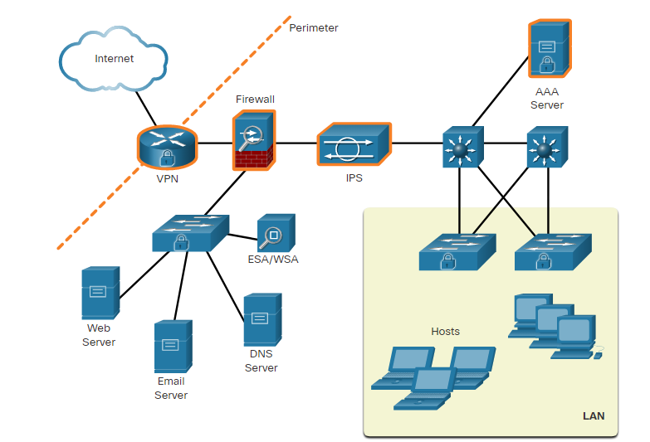Many attacks can, and do, originate from inside the network. Therefore, securing an internal LAN is just as important as securing the outside network perimeter. Without a secure LAN, users within an organization are still susceptible to network threats and outages that can directly affect an organization’s productivity and profit margin. After an internal host is infiltrated, it can become a starting point for an attacker to gain access to critical system devices, such as servers and the sensitive information they contain.

Specifically, there are two internal LAN elements to secure:

* **Endpoints** - Hosts commonly consist of laptops, desktops, servers, and IP phones which are susceptible to malware-related attacks. Endpoints also include video cameras, point-of-sale devices, and devices on the Internet of Things.
* **Network infrastructure** - LAN infrastructure devices interconnect endpoints and typically include switches, wireless devices, and IP telephony devices. Most of these devices are susceptible to LAN-related attacks including MAC address table overflow attacks, spoofing attacks, DHCP related attacks, LAN storm attacks, STP manipulation attacks, and VLAN attacks.

This module focuses on securing endpoints.

### 13.1.2. Traditional Endpoint Security

Historically, employee endpoints were company-issued computers which resided within a clearly defined LAN perimeter. These hosts were protected by firewalls and IPS devices which worked well with hosts that were connected to the LAN and behind the firewall.

The endpoints also used traditional host-based security measures:

* **Antivirus/Antimalware Software** - This is software installed on a host to detect and mitigate viruses and malware. Companies that provide anti-virus software include Norton, TotalAV, McAfee, MalwareBytes and many others.
* **Host-based IPS** - This is software that is installed on the local host to monitor and report on the system configuration and application activity, provide log analysis, event correlation, integrity checking, policy enforcement, rootkit detection, and alerting. Examples include Snort IPS, OSSEC, and Malware Defender, among others.
* **Host-based firewall** - This is software that is installed on a host that restricts incoming and outgoing connections to those initiated by that host only. Some firewall software can also prevent a host from becoming infected and stop infected hosts from spreading malware to other hosts. Included in some operating systems such as Windows, or produced by companies such as NetDefender, Zonealarm, Comodo Firewall, and many others.

### 13.1.3. The Borderless Network

The network has evolved to include traditional endpoints and new, lightweight, portable, consumerized endpoints such as smartphones, tablets, wearables, and others. The new bring-your-own-device (BYOD) needs of workers require a different way of approaching endpoint security. These new endpoints have blurred the network border because access to network resources can be initiated by users from many locations using various connectivity methods at any time.

There are some problems with the traditional method of securing endpoints. In many networks, the network-based devices are disparate and typically do not share information among themselves. Additionally, new endpoint devices are not good candidates for the traditional host-based endpoint security solutions because of the variety of devices and the variety of operating systems available on those devices.

The challenge is allowing these heterogeneous devices to connect to enterprise resources securely.

### 13.1.4. Security for Endpoints in the Borderless Network

Larger organizations now require protection before, during, and after an attack. IT administrators must be able to answer the following questions:

* Where did the attack come from?
* What was the exploit method and point of entry?
* What systems were affected?
* What did the exploit do?
* How do we recover from the exploit?
* How can we mitigate the vulnerability and root cause?

Organizations must also protect their endpoints from new threats and provide the protection measures that are outlined in the table below.

| **Measure** | **Purpose** |
| --- | --- |
| **antimalware software** | Protect endpoints from malware. |
| **spam filtering** | Prevent spam emails from reaching endpoints. |
| **blocklisting** | Prevent endpoints from connecting to websites with bad reputations by immediately blocking connections based on the latest reputation intelligence. |
| **data loss prevention (DLP)** | Prevent sensitive information from being lost or stolen. |

### 13.1.5. Network-Based Malware Protection

New security architectures for the borderless network address security challenges by having endpoints use network scanning elements. These devices provide many more layers of scanning than a single endpoint possibly could. Network-based malware prevention devices are also capable of sharing information among themselves to make better informed decisions.

Protecting endpoints in a borderless network can be accomplished using network-based, as well as host-based techniques, as shown in the figure.

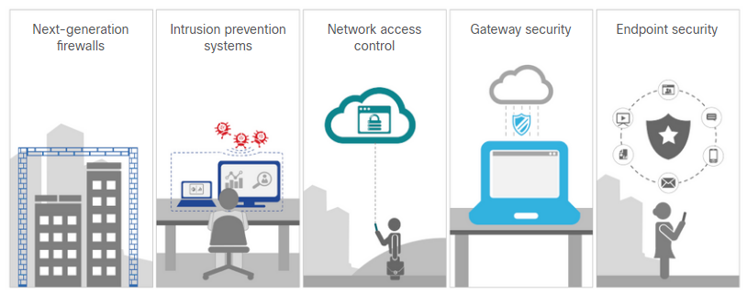

The following are examples of devices and techniques that implement host protections at the network level.

* **Advanced Malware Protection (AMP)** – This provides endpoint protection from viruses and malware.
* **Email Security Appliance (ESA)** – This provides filtering of SPAM and potentially malicious emails before they reach the endpoint. An example is the Cisco ESA.
* **Web Security Appliance (WSA)** – This provides filtering and blocking of websites to prevent hosts from reaching dangerous locations on the web. The Cisco WSA provides control over how users access the internet and can enforce acceptable use policies, control access to specific sites and services, and scan for malware.
* **Network Admission Control (NAC)** – This permits only authorized and compliant systems to connect to the network.

These technologies work in concert with each other to give more protection than host-based suites can provide, as shown in the figure.

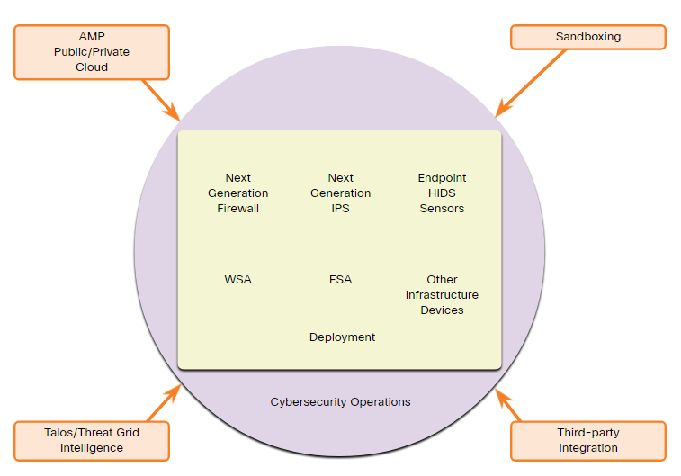

### 13.1.6. Hardware and Software Encryption of Local Data

Endpoints are also susceptible to data theft. For instance, if a corporate laptop is lost or stolen, a thief could scour the hard drive for sensitive information, contact information, personal information, and more.

The solution is to locally encrypt the disk drive with a strong encryption algorithm such as 256-bit AES encryption. The encryption protects the confidential data from unauthorized access. The encrypted disk volumes can only be mounted for normal read/write access with the authorized password.

Operating systems such as MAC OSX natively provide encryption options. The Microsoft Windows 10 operating system also provides encryption natively. Individual files, folders, and drives can be configured to encrypt data. In Windows, BitLocker provides drive encryption, as shown in the figure. Files can also be encrypted, but because applications can create unencrypted back up files, the entire folder that the file is stored in should be encrypted.

### 13.1.7. Network Access Control

The purpose of network access control (NAC) is to allow only authorized and compliant systems, whether managed or unmanaged, to access the network. It unifies endpoint security technologies with user or device authentication and network security policy enforcement. A NAC system can deny network access to noncompliant devices, place them in a quarantined area, or give them only restricted access to computing resources, thus keeping insecure nodes from infecting the network.

NAC systems can have the following capabilities:

* **Profiling and visibility** - This recognizes and profiles users and their devices before malicious code can cause damage.
* **Guest network access** - This manages guests through a customizable, self-service portal that includes guest registration, guest authentication, guest sponsoring, and a guest management portal.
* **Security posture checking** - This evaluates security-policy compliance by user type, device type, and operating system.
* **Incident response** - This mitigates network threats by enforcing security policies that block, isolate, and repair noncompliant machines without administrator attention.

NAC systems should extend NAC to all network access methods, including access through LANs, remote-access gateways, and wireless access points.

The Cisco Identity Services Engine (ISE) combines AAA and network device profiling into a single system.

### 13.1.8. NAC Functions

The goal of NAC systems is to ensure that only hosts that are authenticated and have had their security posture examined and approved are permitted onto the network. For example, company laptops used offsite for a period of time might not have received current security updates or could have become infected from other systems. Those systems cannot connect to the network until they are examined, updated, and approved.

Network access devices can function as the enforcement layer, as shown in the figure. They force the clients to query a RADIUS server for authentication and authorization. The RADIUS server can query other devices, such as an antivirus server, and reply to the network enforcers.

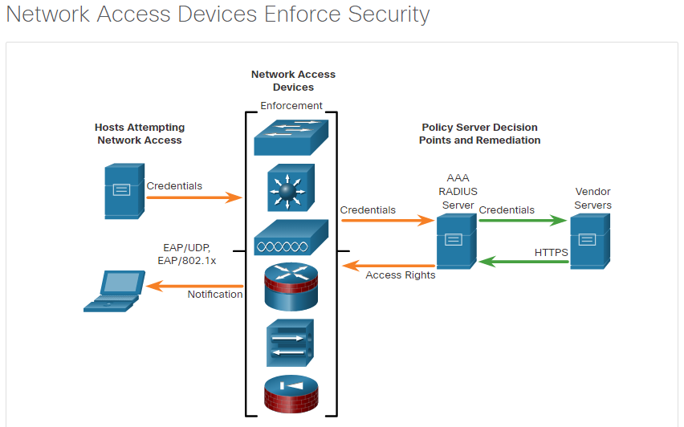

## 13.2) 802.1X Authentication

### 13.2.1. Security Using 802.1X Port-Based Authentication

The IEEE 802.1X standard defines a port-based access control and authentication protocol that restricts unauthorized workstations from connecting to a LAN through publicly accessible switch ports. The authentication server authenticates each workstation that is connected to a switch port before making available any services offered by the switch or the LAN.

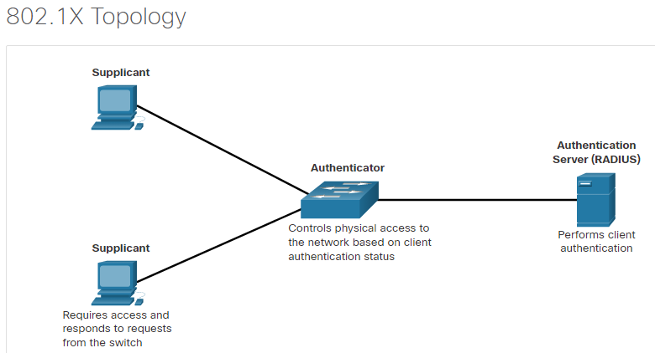The figure shows that with 802.1X port-based authentication, the devices in the network have specific roles.

The 802.1x roles include:

* **Supplicant (Client)** - The device (workstation) that requests access to LAN and switch services and then responds to requests from the switch. The workstation must be running 802.1X-compliant client software. (The port that the client is attached to is the supplicant [client] in the IEEE 802.1X specification.)
* **Authenticator (Switch)** - This device controls physical access to the network based on the authentication status of the client. The switch acts as an intermediary (proxy) between the client (supplicant) and the authentication server, requesting identifying information from the client, verifying that information with the authentication server, and relaying a response to the client. The switch uses a RADIUS software agent, which is responsible for encapsulating and de-encapsulating the EAP (Extensible Authentication Protocol) frames and interacting with the authentication server.
* **Authentication server** - This server performs the actual authentication of the client. The authentication server validates the identity of the client and notifies the switch whether the client is authorized to access the LAN and switch services. Because the switch acts as the proxy, the authentication service is transparent to the client. The RADIUS security system with EAP extensions is the only supported authentication server.

Until the workstation is authenticated, 802.1X access control enables only Extensible Authentication Protocol over LAN (EAPOL), Cisco Discovery Protocol (CDP), and Spanning Tree Protocol (STP) traffic through the port to which the workstation is connected. After authentication succeeds, normal traffic can pass through the port.

The switch port state determines whether the client is granted access to the network. When configured for 802.1X port-based authentication, the port starts in the unauthorized state. While in this state, the port disallows all ingress and egress traffic except for 802.1X protocol, STP, and CDP packets. When a client is successfully authenticated, the port transitions to the authorized state, allowing all traffic for the client to flow normally. If the switch requests the client identity (authenticator initiation) and the client does not support 802.1X, the port remains in the unauthorized state, and the client is not granted access to the network.

In contrast, when an 802.1X-enabled client connects to a port and the client initiates the authentication process (supplicant initiation) by sending the EAPOL-start frame to a switch that is not running the 802.1X protocol, no response is received, and the client begins sending frames as if the port is in the authorized state.

The figure shows the complete message exchange between the supplicant, authenticator, and the authentication server. The encapsulation occurs as follows:

* **Between the supplicant and the authenticator** - EAP data is encapsulated in EAPOL frames.
* **Between the authenticator and the authentication server** - EAP data is encapsulated using RADIUS.

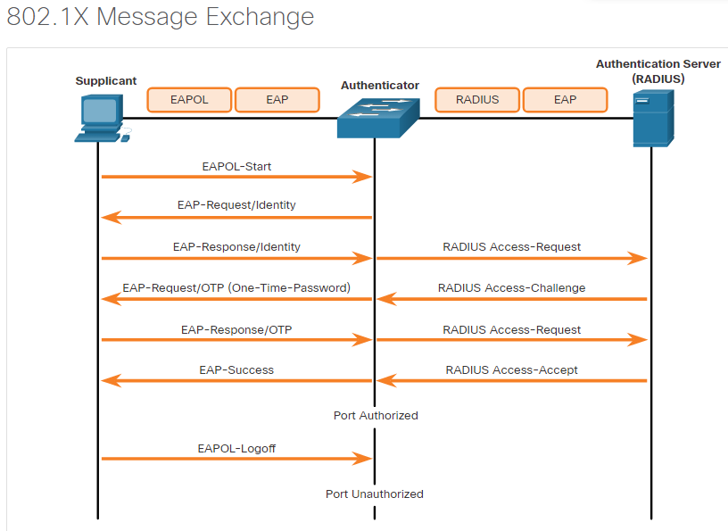

If the client is successfully authenticated (the switch receives an “accept” frame from the authentication server), the port state changes to authorized, and all frames from the authenticated client are enabled through the port.

If the authentication fails, the port remains in the unauthorized state, but authentication can be retried. If the authentication server cannot be reached, the switch can retransmit the request. If no response is received from the server after the specified number of attempts, authentication fails, and network access is not granted.

When a client logs out, it sends an EAPOL-logout message, causing the switch port to transition to the unauthorized state.

### 13.2.2. Control the 802.1X Authorization State

It may be necessary to configure a switch port to override the 802.1X authentication process. To do this, use the **authentication port-control** interface configuration command to control the port authorization state. The parameters for this command are shown below. The individual port on the authenticator switch is configured with this command, in this case, port F0/1 of S1. By default, a port is in the **force-authorized** state meaning it can send and receive traffic without 802.1x authentication.

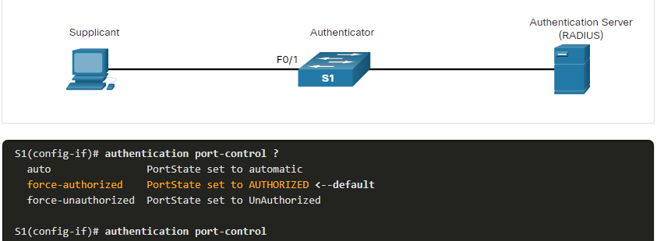

| **Parameter** | **Description** |
| --- | --- |
| **auto** | Enables 802.1X port-based authentication and causes the port to begin in the unauthorized state. During this time only EAPOL, STP, and CDP frames are the only type of frames that can be sent or received through the port until the client device has been authenticated. |
| **force-authorized** | The port sends and receives normal traffic without 802.1x-based authentication of the client. This is the default setting. |
| **force-unauthorized** | Causes the port to remain in the unauthorized state, ignoring all attempts by the client to authenticate. The switch cannot provide authentication services to the client through the port. |

The **auto** keyword must be entered to enable 802.1X authentication. Therefore, to enable 802.1X on the port, use the **authentication** **port-control auto** interface configuration command.

If the client is successfully authenticated (receives an Accept frame from the authentication server), the port state changes to authorized, and all frames from the authenticated client are allowed through the port. If the authentication fails, the port remains in the unauthorized state, but authentication can be retried. If the authentication server cannot be reached, the switch can resend the request. If no response is received from the server after the specified number of attempts, authentication fails, and network access is not granted.

When a client logs off, it sends an EAPOL-logoff message, causing the switch port to change to the unauthorized state.

If the link state of a port changes from up to down, or if an EAPOL-logoff frame is received, the port returns to the unauthorized state.

### 13.2.3. 802.1X Configuration

This scenario is implemented the same topology as above. A PC is attached to F0/1 on the switch and the device is will be authenticated via 802.1X with a RADIUS server. Unlike in previous AAA scenarios in which administrators were authenticated to the router configuration lines, in this scenario, an endpoint is authenticated before access is granted to the network.

Configuring 802.1X requires a few basic steps:

**Step 1**. Enable AAA using the **aaa new-model** command.  
**Step 2**. Designate the RADIUS server and configure its address and ports.  
**Step 3**. Create an 802.1X port-based authentication method list using the **aaa authentication dot1x** command.  
**Step 4**. Globally enable 802.1X port-based authentication using the **dot1x system-auth-control** command.  
**Step 5**. Enable port-based authentication on the interface using the **authentication port-control auto** command.  
**Step 6**. Enable 802.1X authentication on the interface using the **dot1x pae** command. The **authenticator** options sets the Port Access Entity (PAE) type so the interface acts only as an authenticator and will not respond to any messages meant for a supplicant.

An example configuration is shown below.

S1(config)# **aaa new-model**

S1(config)# **radius server NETSEC**

S1(config-radius-server)# **address ipv4 10.1.1.50 auth-port 1812 acct-port 1813**

S1(config-radius-server)# **key RADIUS-Pa55w0rd**

S1(config-radius-server)# **exit**

S1(config)#

S1(config)# **aaa authentication dot1x default group radius**

S1(config)# **dot1x system-auth-control**

S1(config)#

S1(config)# **interface F0/1**

S1(config-if)# **description Access Port**

S1(config-if)# **switchport mode access**

S1(config-if)# **authentication port-control auto**

S1(config-if)# **dot1x pae authenticator**

## 13.3) What Did I Learn in this Module?

**Introducing Endpoint Security**  
Traditionally endpoints included PCs, servers, and printers. However, in today’s network, endpoints also include phones, tablets, laptops, Internet of Things devices, network video cameras and many other things. Endpoint security used to depend on host-based security measures such as antimalware software, host-based IPS, and host-based firewall software. Many devices and technologies enhance host-based endpoint protections. Some of them are email security appliances, web security appliances, NAC, and the Cisco Identity Services Engine. Another way that endpoints can be protected from data loss is through the use of encryption of local data at the file, folder, or drive level. Software such as BitLocker is included with Microsoft Windows 10 for this purpose.

Network Access Control is a system that can check whether endpoints that attempt to the network comply with network security policies. It handles user authentication and can take action against devices that violate security policies by having out date security software. It can even take action to bring devices up to compliance standard before allowing access. NAC can also provide easy to manage methods of providing network access to guest computers require connectivity to the network. Cisco ISE combines AAA and NAC and into a single system.

**802.1X Authentication**  
802.1X provides a means by which authenticator network access switch can act as an intermediary between a client and an authentication server. The switch forwards authentication information from the client to the server. If authentication is successful, the client will be allowed to access the network through the connected switch port. If authorization fails, the switch will not permit the client endpoint to connect to the network. The system uses the EAP and EAPOL to carry authentication traffic between the switch and the authenticator switch. The switch uses EAP and RADIUS to communicate with the authentication server. The 802.1X authentication process can be control by configuring the authenticator port with the **authentication port-control** command. The port can be set carryout the authentication process, provide authorized access, or to be in unauthorized state. In this state no device will be able to connect to the network.

802.1X port-based authentication is configured by first globally activating AAA and by specifying the RADIUS server name, address, and ports. After that the authenticator interface is configured with 802.1X parameters.

# 14. Layer 2 Security Considerations

## 14.0) Introduction

### 14.0.1. Why Should I Take this Module?

Security is only as strong as the weakest link. Layer 2 provides access to users of the network, and also makes up an essential part of the network infrastructure. Layer 2 devices provide redundancy by offering multiple high-speed paths to connect large segments of the network. By providing access to all internal network users, it can also provide access to threat actors who may attempt to bring down the network infrastructure. Therefore, in your rule as a network security administrator, you must be diligent with mitigating threats to your Layer 2 infrastructure. Continue reading to learn about the many potential threats to Layer 2 and the various means available to alleviate these threats. Layer 2 is the weakest link!

### 14.0.2. What Will I Learn in this Module?

**Module Title:** Layer 2 Security Considerations

**Module Objective**: Implement security measures to mitigate Layer 2 attacks.

| **Topic Title** | **Topic Objective** |
| --- | --- |
| **Layer 2 Security Threats** | Describe Layer 2 vulnerabilities. |
| **MAC Table Attacks** | Describe MAC address spoofing attacks. |
| **Mitigate MAC Table Attacks** | Configure port security. |
| **Mitigate VLAN Attacks** | Explain how to mitigate VLAN attacks. |
| **Mitigate DHCP Attacks** | Use the correct commands to implement DHCP Snooping for attack mitigation.. |
| **Mitigate ARP Attacks** | Use the correct commands to mitigate ARP attacks. |
| **Mitigate Address Spoofing Attacks** | Use the correct commands to mitigate address spoofing attacks. |
| **Spanning Tree Protocol** | Explain the operation of Spanning Tree Protocol. |
| **Mitigate STP Attacks** | Configure security measures to mitigate STP attacks. |

## 14.1) Layer 2 Security Threats

### 14.1.1. Describe Layer 2 Vulnerabilities

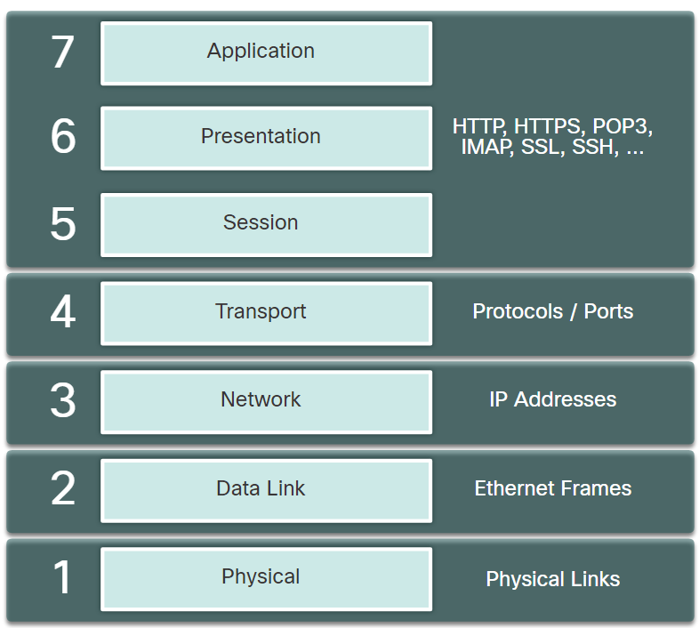The OSI reference model is divided into seven layers which work independently of each other. As shown in the figure, each layer performs a specific function and has core elements that can be exploited.

Network administrators routinely implement security solutions to protect the elements in Layer 3 up through Layer 7 using VPNs, firewalls, and IPS devices. However, as shown in the figure below, if Layer 2 is compromised, then all layers above it are also affected. For example, if an employee or visitor with access to the internal network could capture Layer 2 frames, then all of the security implemented on the layers above would be useless. The employee could also wreak havoc on the Layer 2 LAN networking infrastructure.

### 14.1.2. Switch Attack Categories

Security is only as strong as the weakest link in the system, and Layer 2 is considered to be that weakest link. This is because traditionally LANs were under the administrative control of a single organization. We inherently trusted all persons and devices connected to our LAN. Today, with BYOD and more sophisticated attacks, our LANs have become more vulnerable to penetration. Therefore, in addition to protecting Layer 3 to Layer 7, network security professionals must also mitigate attacks to the Layer 2 LAN infrastructure.

The first step in mitigating attacks on the Layer 2 infrastructure is to understand the underlying operation of Layer 2 and the threats posed by the Layer 2 infrastructure.

Attacks against the Layer 2 LAN infrastructure are highlighted in the table.

**Note**: The focus of this module is on common Layer 2 attacks.

| **Type** | **Description** |
| --- | --- |
| MAC Table Attacks | Includes MAC table overflow (also called MAC Address Flooding) Attacks. |
| VLAN Attacks | Includes VLAN hopping and VLAN double-tagging attacks. It also includes attacks between devices on a common VLAN. |
| DHCP Attacks | Includes DHCP starvation and DHCP spoofing attacks. |
| ARP Attacks | Includes ARP spoofing and ARP poisoning attacks. |
| Address Spoofing Attacks | Includes MAC Address and IP address spoofing attacks. |
| STP Attacks | Includes Spanning Tree Protocol manipulation attacks. |

The figure below provides an overview of Cisco solutions that help mitigate Layer 2 attacks.

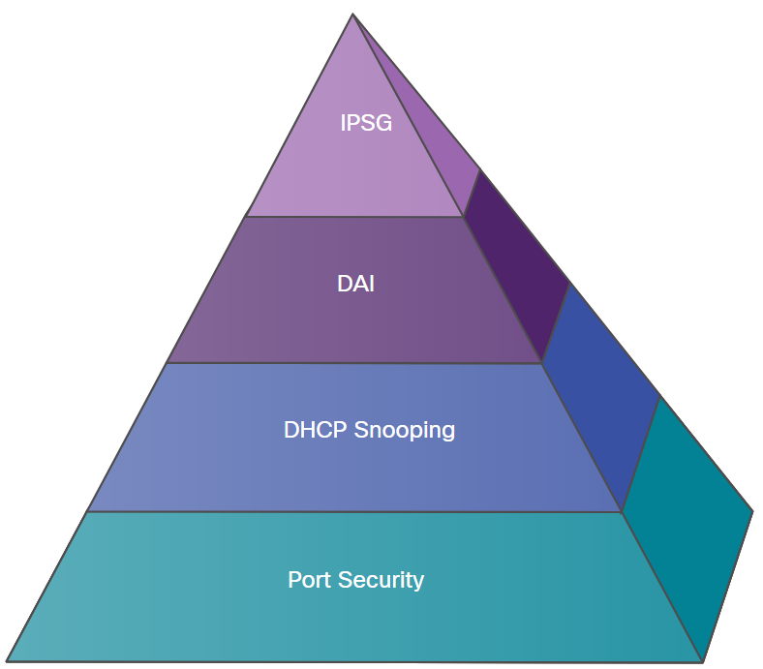

| **Topic Title** | **Topic Objective** |
| --- | --- |
| Port Security | Port security prevents many types of attacks including MAC table overflow attacks and DHCP starvation attacks. |
| DHCP Snooping | DHCP Snooping prevents DHCP starvation and DHCP spoofing attacks by rogue DHCP servers. |
| Dynamic ARP Inspection (DAI) | DAI prevents ARP spoofing and ARP poisoning attacks. |
| IP Source Guard (IPSG) | IP Source Guard prevents MAC and IP address spoofing attacks. |

These Layer 2 solutions will not be effective if the management protocols are not secured. An example would be if attackers can easily telnet into a switch. Syslog, SNMP, TFTP, telnet, FTP and most other common network management protocols are insecure. Therefore, the following strategies are recommended:

* Always use secure variants of these protocols such as SSH, SCP, and SSL.
* Consider using out-of-band (OOB) management.
* Use a dedicated management VLAN where nothing but management traffic resides.
* Use ACLs to filter unwanted access.

## 14.2) MAC Table Attacks

### 14.2.1. Switch Fundamentals

A switch uses MAC addresses to forward (or discard) frames to other devices on a network. If a switch just forwarded every frame it received out all ports, your network would be so congested that it would probably come to a complete halt.

A Layer 2 Ethernet switch uses Layer 2 MAC addresses to make forwarding decisions. It is completely unaware of the data (protocol) being carried in the data portion of the frame, such as an IPv4 packet, an ARP message, or an IPv6 ND packet. The switch makes its forwarding decisions based solely on the Layer 2 Ethernet MAC addresses.

An Ethernet switch examines its MAC address table to make a forwarding decision for each frame, unlike legacy Ethernet hubs that repeat bits out all ports except the incoming port. In the figure, the four-port switch was just powered on. The table shows the MAC Address Table which has not yet learned the MAC addresses for the four attached PCs.

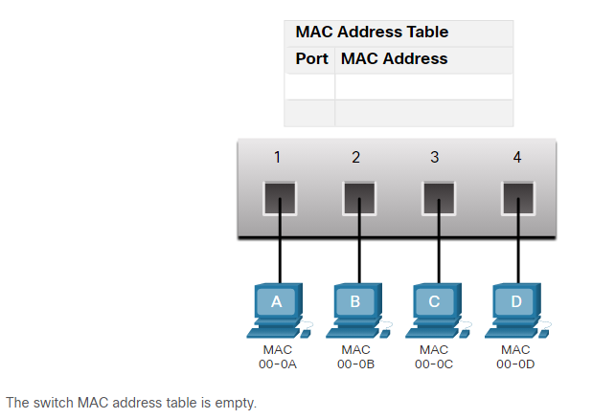**Note**: MAC addresses are shortened throughout this topic for demonstration purposes.

**Note**: The MAC address table is sometimes referred to as a content addressable memory (CAM) table. While the term CAM table is fairly common, for the purposes of this course, we will refer to it as a MAC address table.

### 14.2.2. Switch Learning and Forwarding

The switch dynamically builds the MAC address table by examining the source MAC address of the frames that are received on a port. The switch forwards frames by searching for a match between the destination MAC address in the frame and an entry in the MAC address table.

**Learn - Examine the Source MAC Address:**

Every frame that enters a switch is checked for new information to learn. It does this by examining the source MAC address of the frame and the port number where the frame entered the switch. If the source MAC address does not exist, it is added to the table along with the incoming port number. If the source MAC address does exist, the switch updates the refresh timer for that entry in the table. By default, most Ethernet switches keep an entry in the table for 5 minutes.

In the figure for example, PC-A is sending an Ethernet frame to PC-D. The table shows the switch adds the MAC address for PC-A to the MAC Address Table.

Note: If the source MAC address does exist in the table but on a different port, the switch treats this as a new entry. The entry is replaced using the same MAC address but with the more current port number.

**Forward - Find the Destination MAC Address:**

If the destination MAC address is a unicast address, the switch will look for a match between the destination MAC address of the frame and an entry in its MAC address table. If the destination MAC address is in the table, it will forward the frame out the specified port. If the destination MAC address is not in the table, the switch will forward the frame out all ports except the incoming port. This is called an unknown unicast.

As shown in the figure, the switch does not have the destination MAC address in its table for PC-D, so it sends the frame out all ports except port 1.

Note: If the destination MAC address is a broadcast or a multicast, the frame is also flooded out all ports except the incoming port.

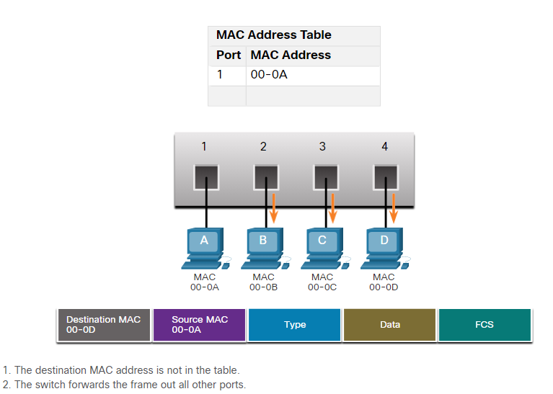

### 14.2.3. MAC Address Table Flooding

All MAC tables have a fixed size and consequently, a switch can run out of resources in which to store MAC addresses. MAC address flooding attacks take advantage of this limitation by bombarding the switch with fake source MAC addresses until the switch MAC address table is full.

When this occurs, the switch treats the frame as an unknown unicast and begins to flood all incoming traffic out all ports on the same VLAN without referencing the MAC table. This condition now allows a threat actor to capture all of the frames sent from one host to another on the local LAN or local VLAN.

**Note**: Traffic is flooded only within the local LAN or VLAN. The threat actor can only capture traffic within the local LAN or VLAN to which the threat actor is connected.

The figure shows how a threat actor can easily use the network attack tool **macof** to overflow a MAC address table.

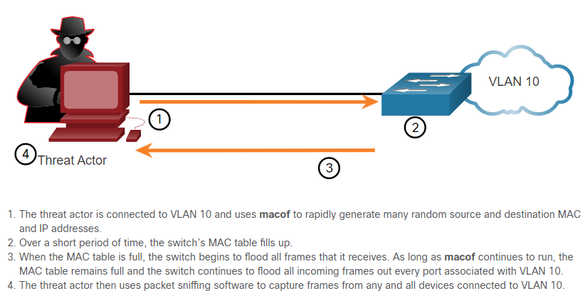

If the threat actor stops **macof** from running or is discovered and stopped, the switch eventually ages out the older MAC address entries from the table and begins to act like a switch again.

### 14.2.4. MAC Address Table Attack Mitigation

What makes tools such as **macof** so dangerous is that an attacker can create a MAC table overflow attack very quickly. For instance, a Catalyst 6500 switch can store 132,000 MAC addresses in its MAC address table. A tool such as **macof** can flood a switch with up to 8,000 bogus frames per second; creating a MAC address table overflow attack in a matter of a few seconds. The example shows a sample output of the **macof** command on a Linux host.

# **macof -i eth1**

36:a1:48:63:81:70 15:26:8d:4d:28:f8 0.0.0.0.26413 > 0.0.0.0.49492: S 1094191437:1094191437(0) win 512

16:e8:8:0:4d:9c da:4d:bc:7c:ef:be 0.0.0.0.61376 > 0.0.0.0.47523: S 446486755:446486755(0) win 512

18:2a:de:56:38:71 33:af:9b:5:a6:97 0.0.0.0.20086 > 0.0.0.0.6728: S 105051945:105051945(0) win 512

e7:5c:97:42:ec:1 83:73:1a:32:20:93 0.0.0.0.45282 > 0.0.0.0.24898: S 1838062028:1838062028(0) win 512

62:69:d3:1c:79:ef 80:13:35:4:cb:d0 0.0.0.0.11587 > 0.0.0.0.7723: S 1792413296:1792413296(0) win 512

c5:a:b7:3e:3c:7a 3a:ee:c0:23:4a:fe 0.0.0.0.19784 > 0.0.0.0.57433: S 1018924173:1018924173(0) win 512

88:43:ee:51:c7:68 b4:8d:ec:3e:14:bb 0.0.0.0.283 > 0.0.0.0.11466: S 727776406:727776406(0) win 512

b8:7a:7a:2d:2c:ae c2:fa:2d:7d:e7:bf 0.0.0.0.32650 > 0.0.0.0.11324: S 605528173:605528173(0) win 512

e0:d8:1e:74:1:e 57:98:b6:5a:fa:de 0.0.0.0.36346 > 0.0.0.0.55700: S 2128143986:2128143986(0) win 512

Another reason why these attack tools are dangerous is because they not only affect the local switch, they can also affect other connected Layer 2 switches. When the MAC address table of a switch is full, it starts flooding out all ports including those connected to other Layer 2 switches.

To mitigate MAC address table overflow attacks, network administrators must implement port security. Port security will only allow a specified number of source MAC addresses to be learned on the port. Port security is further discussed later in this module.

## 14.3) Mitigate MAC Table Attacks

### 14.3.1. Secure Unused Ports

Layer 2 devices are considered to be the weakest link in a company’s security infrastructure. Layer 2 attacks are some of the easiest for hackers to deploy but these threats can also be mitigated with some common Layer 2 solutions.

All switch ports (interfaces) should be secured before the switch is deployed for production use. How a port is secured depends on its function.

A simple method that many administrators use to help secure the network from unauthorized access is to disable all unused ports on a switch. For example, if a Catalyst 2960 switch has 24 ports and there are three Fast Ethernet connections in use, it is good practice to disable the 21 unused ports. Navigate to each unused port and issue the Cisco IOS **shutdown** command. If a port must be reactivated at a later time, it can be enabled with the **no shutdown** command.

To configure a range of ports, use the **interface range** command.

Switch(config)# **interface range** type module/first-number - last-number

### 14.3.2. Mitigate MAC Address Table Attacks

The simplest and most effective method to prevent MAC address table overflow attacks is to enable port security.

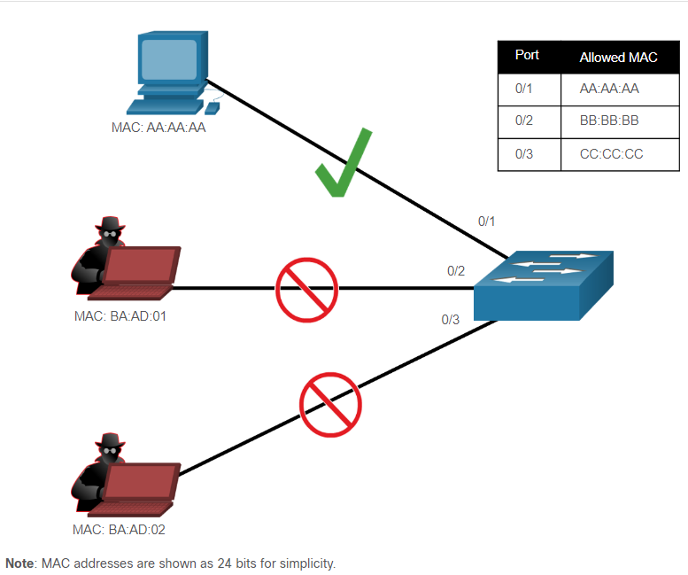Port security limits the number of valid MAC addresses allowed on a port. It allows an administrator to manually configure MAC addresses for a port or to permit the switch to dynamically learn a limited number of MAC addresses. When a port that is configured with port security receives a frame, the source MAC address of the frame is compared to the list of secure source MAC addresses that were manually configured or dynamically learned on the port.

By limiting the number of permitted MAC addresses on a port to one, port security can be used to control unauthorized access to the network, as shown in the figure.

### 14.3.3. Enable Port Security

Notice in the example, the **switchport port-security** command was rejected. This is because port security can only be configured on manually configured access ports or manually configured trunk ports. By default, Layer 2 switch ports are set to dynamic auto (trunking on). Therefore, in the example, the port is configured with the **switchport mode access** interface configuration command.

**Note**: Trunk port security is beyond the scope of this course.

S1(config)# **interface f0/1**

S1(config-if)# **switchport port-security**

Command rejected: FastEthernet0/1 is a dynamic port.

S1(config-if)# **switchport mode access**

S1(config-if)# **switchport port-security**

S1(config-if)# **end**

Use the **show port-security interface** command to display the current port security settings for FastEthernet 0/1, as shown in the example below. Notice that port security is enabled, and the port status is Secure-down, which means there are no devices attached and no violation has occurred. Also, the violation mode is Shutdown, and the maximum number of MAC addresses allowed is 1. If a device is connected to the port, the switch port status would display Secure-up and the switch will automatically add the device’s MAC address as a secure MAC. In this example, no device is connected to the port.

S1# **show port-security interface f0/1**

Port Security : Enabled

Port Status : Secure-down

Violation Mode : Shutdown

Aging Time : 0 mins

Aging Type : Absolute

SecureStatic Address Aging : Disabled

Maximum MAC Addresses : 1

Total MAC Addresses : 0

Configured MAC Addresses : 0

Sticky MAC Addresses : 0

Last Source Address:Vlan : 0000.0000.0000:0

Security Violation Count : 0

**Note**: If an active port is configured with the **switchport port-security** command and more than one device is connected to that port, the port will transition to the error-disabled state. This condition is discussed later in this topic.

After port security is enabled, other port security specifics can be configured, as shown in the example.

S1(config-if)# **switchport port-security ?**

aging Port-security aging commands

mac-address Secure mac address

maximum Max secure addresses

violation Security violation mode

S1(config-if)# **switchport port-security**

### 14.3.4. Limit and Learn MAC Addresses

To set the maximum number of MAC addresses allowed on a port, use the following command:

Switch(config-if)# **switchport port-security maximum** value

The default port security value is 1. The maximum number of secure MAC addresses that can be configured depends on the switch and the IOS.

The switch can be configured to learn about MAC addresses on a secure port in one of three ways:

**1. Manually Configured**

The administrator manually configures a static MAC address(es) by using the following command for each secure MAC address on the port:

Switch(config-if)# **switchport port-security mac-address** mac-address

**2. Dynamically Learned**

When the **switchport port-security** command is entered, the current source MAC for the device connected to the port is automatically secured but is not added to the startup configuration. If the switch is rebooted, the port will have to re-learn the device’s MAC address.

**3. Dynamically Learned - Sticky**

The administrator can enable the switch to dynamically learn the MAC address and “stick” them to the running configuration by using the following command:

Switch(config-if)# **switchport port-security mac-address sticky**

Saving the running configuration will commit the dynamically learned MAC address to NVRAM.

The following example demonstrates a complete port security configuration for FastEthernet 0/1 with a host connected to port Fa0/1. The administrator specifies a maximum of 2 MAC addresses, manually configures one secure MAC address, and then configures the port to dynamically learn additional secure MAC addresses up to the 2 secure MAC address maximum. Use the **show port-security interface** and the **show port-security address** command to verify the configuration.

*Mar 1 00:12:38.179: %LINK-3-UPDOWN: Interface FastEthernet0/1, changed state to up

*Mar 1 00:12:39.194: %LINEPROTO-5-UPDOWN: Line protocol on Interface FastEthernet0/1, changed state to up

S1#**conf t**

Enter configuration commands, one per line. End with CNTL/Z.

S1(config)#

S1(config)# **interface fa0/1**

S1(config-if)# **switchport mode access**

S1(config-if)# **switchport port-security**

S1(config-if)# **switchport port-security maximum 2**

S1(config-if)# **switchport port-security mac-address aaaa.bbbb.1234**

S1(config-if)# **switchport port-security mac-address sticky**

S1(config-if)# **end**

S1# **show port-security interface fa0/1**

Port Security : Enabled

Port Status : Secure-up

Violation Mode : Shutdown

Aging Time : 0 mins

Aging Type : Absolute

SecureStatic Address Aging : Disabled

Maximum MAC Addresses : 2

Total MAC Addresses : 2

Configured MAC Addresses : 1

Sticky MAC Addresses : 1

Last Source Address:Vlan : a41f.7272.676a:1

Security Violation Count : 0

S1# **show port-security address**

Secure Mac Address Table

-----------------------------------------------------------------------------

Vlan Mac Address Type Ports Remaining Age

(mins)

---- ----------- ---- ----- -------------

1 a41f.7272.676a SecureSticky Fa0/1 -

1 aaaa.bbbb.1234 SecureConfigured Fa0/1 -

-----------------------------------------------------------------------------

Total Addresses in System (excluding one mac per port) : 1

Max Addresses limit in System (excluding one mac per port) : 8192

The output of the **show port-security interface** command verifies that port security is enabled, there is a host connected to the port (i.e., Secure-up), a total of 2 MAC addresses will be allowed, and S1 has learned one MAC address statically and one MAC address dynamically (i.e., sticky).

The output of the **show port-security address** command lists the two learned MAC addresses.

### 14.3.5. Port Security Aging

Port security aging can be used to set the aging time for static and dynamic secure addresses on a port. Two types of aging are supported per port:

* **Absolute** - The secure addresses on the port are deleted after the specified aging time.
* **Inactivity** - The secure addresses on the port are deleted only if they are inactive for the specified aging time.

Use aging to remove secure MAC addresses on a secure port without manually deleting the existing secure MAC addresses. Aging time limits can also be increased to ensure past secure MAC addresses remain, even while new MAC addresses are added. Aging of statically configured secure addresses can be enabled or disabled on a per-port basis.

Use the **switchport port-security aging** command to enable or disable static aging for the secure port, or to set the aging time or type.

Switch(config-if)# **switchport port-security aging** { **static** | **time** time | **type** {**absolute** | **inactivity**}}

| **Parameter** | **Description** |
| --- | --- |
| **static** | Enable aging for statically configured secure addresses on this port. |
| **time** *time* | Specify the aging time for this port. The range is 0 to 1440 minutes. If the time is 0, aging is disabled for this port. |
| **type absolute** | Set the absolute aging time. All the secure addresses on this port age out exactly after the time (in minutes) specified and are removed from the secure address list. |
| **type inactivity** | Set the inactivity aging type. The secure addresses on this port age out only if there is no data traffic from the secure source address for the specified time period. |

**Note**: MAC addresses are shown as 24 bits for simplicity.

The example shows an administrator configuring the aging type to 10 minutes of inactivity and then using the **show port-security interface** command to verify the configuration.

S1(config)# **interface fa0/1**

S1(config-if)# **switchport port-security aging time 10**

S1(config-if)# **switchport port-security aging type inactivity**

S1(config-if)# **end**

S1# **show port-security interface fa0/1**

Port Security : Enabled

Port Status : Secure-up

Violation Mode : Shutdown

Aging Time : 10 mins

Aging Type : Inactivity

SecureStatic Address Aging : Disabled

Maximum MAC Addresses : 2

Total MAC Addresses : 2

Configured MAC Addresses : 1

Sticky MAC Addresses : 1

Last Source Address:Vlan : a41f.7272.676a:1

Security Violation Count : 0

### 14.3.6. Port Security Violation Modes

If the MAC address of a device that is attached to the port differs from the list of secure addresses, then a port violation occurs. By default, the port enters the error-disabled state.

To set the port security violation mode, use the following command:

Switch(config-if)# **switchport port-security violation** { **protect** | **restrict** | **shutdown**}

The following table describes the different switch modes.

| **Mode** | **Description** |
| --- | --- |
| **shutdown**  (default) | The port transitions to the error-disabled state immediately, turns off the port LED, and sends a syslog message. It increments the violation counter. When a secure port is in the error-disabled state, an administrator must re-enable it by entering the **shutdown** and **no shutdown** commands. |
| **restrict** | The port drops packets with unknown source addresses until you remove a sufficient number of secure MAC addresses to drop below the maximum value or increase the maximum value. This mode causes the Security Violation counter to increment and generates a syslog message. |
| **protect** | This is the least secure of the security violation modes. The port drops packets with unknown MAC source addresses until you remove a sufficient number of secure MAC addresses to drop below the maximum value or increase the maximum value. No syslog message is sent. |

The following table shows how a switch reacts based on the configured violation mode.

| **Violation Mode** | **Discards Offending Traffic** | **Sends Syslog Message** | **Increase Violation Counter** | **Shuts Down Port** |
| --- | --- | --- | --- | --- |
| Protect | Yes | No | No | No |
| Restrict | Yes | Yes | Yes | No |
| Shutdown | Yes | Yes | Yes | Yes |

The following example shows an administrator changing the security violation to “restrict”. The output of the **show port-security interface** command confirms that the change has been made.

S1(config)# **interface f0/1**

S1(config-if)# **switchport port-security violation restrict**

S1(config-if)# **end**

S1#

S1# **show port-security interface f0/1**

Port Security : Enabled

Port Status : Secure-up

Violation Mode : Restrict

Aging Time : 10 mins

Aging Type : Inactivity

SecureStatic Address Aging : Disabled

Maximum MAC Addresses : 2

Total MAC Addresses : 2

Configured MAC Addresses : 1

Sticky MAC Addresses : 1

Last Source Address:Vlan : a41f.7272.676a:1

Security Violation Count : 0

### 14.3.7. Ports in error-disabled State

What happens when the port security violation is shutdown and a port violation occurs? The port is physically shutdown and placed in the error-disabled state, and no traffic is sent or received on that port.

In the example, the port security violation is changed back to the default shutdown setting. Then the host with MAC address a41f.7272.676a is disconnected and a new host is plugged into Fa0/1.

Notice that a series of port security related messages are generated on the console.

S1(config)# **int fa0/1**

S1(config-if)# **switchport port-security violation shutdown**

S1(config-if)# **end**

S1#

*Mar 1 00:24:15.599: %LINEPROTO-5-UPDOWN: Line protocol on Interface FastEthernet0/1, changed state to down

*Mar 1 00:24:16.606: %LINK-3-UPDOWN: Interface FastEthernet0/1, changed state to down

*Mar 1 00:24:19.114: %LINK-3-UPDOWN: Interface FastEthernet0/1, changed state to up

*Mar 1 00:24:20.121: %LINEPROTO-5-UPDOWN: Line protocol on Interface FastEthernet0/1, changed state to up

S1#

*Mar 1 00:24:32.829: %PM-4-ERR_DISABLE: psecure-violation error detected on Fa0/1, putting Fa0/1 in err-disable state

*Mar 1 00:24:32.838: %PORT_SECURITY-2-PSECURE_VIOLATION: Security violation occurred, caused by MAC address a41f.7273.018c on port FastEthernet0/1.

*Mar 1 00:24:33.836: %LINEPROTO-5-UPDOWN: Line protocol on Interface FastEthernet0/1, changed state to down

*Mar 1 00:24:34.843: %LINK-3-UPDOWN: Interface FastEthernet0/1, changed state to down

**Note**: The port protocol and link status are changed to down and the port LED is turned off.

In the example, the **show interface** command identifies the port status as **err-disabled**. The output of the **show port-security** interface command now shows the port status as Secure-shutdown instead of Secure-up. The Security Violation counter increments by 1.

S1# **show interface fa0/1 | include down**

FastEthernet0/18 is down, line protocol is down (err-disabled)

(output omitted)

S1# **show port-security interface fa0/1**

Port Security : Enabled

Port Status : Secure-shutdown

Violation Mode : Shutdown

Aging Time : 10 mins

Aging Type : Inactivity

SecureStatic Address Aging : Disabled

Maximum MAC Addresses : 2

Total MAC Addresses : 2

Configured MAC Addresses : 1

Sticky MAC Addresses : 1

Last Source Address:Vlan : a41f.7273.018c:1

Security Violation Count : 1

The administrator should determine what caused the security violation If an unauthorized device is connected to a secure port, the security threat is eliminated before re-enabling the port.

In the next example, the first host is reconnected to Fa0/1. To re-enable the port, first use the **shutdown** command, then, use the **no shutdown** command to make the port operational, as shown in the example.

S1(config)# **interface fa0/1**

S1(config-if)# **shutdown**

S1(config-if)#

*Mar 1 00:39:54.981: %LINK-5-CHANGED: Interface FastEthernet0/1, changed state to administratively down

S1(config-if)# **no shutdown**

S1(config-if)#

*Mar 1 00:40:04.275: %LINK-3-UPDOWN: Interface FastEthernet0/1, changed state to up

*Mar 1 00:40:05.282: %LINEPROTO-5-UPDOWN: Line protocol on Interface FastEthernet0/1, changed state to up

### 14.3.8. Verify Port Security

After configuring port security on a switch, check each interface to verify that the port security is set correctly, and check to ensure that the static MAC addresses have been configured correctly.

**Port Security for All Interfaces**

To display port security settings for the switch, use the **show port-security** command. The example indicates that only one port is configured with the switchport port-security command.

S1# **show port-security**

Secure Port MaxSecureAddr CurrentAddr SecurityViolation Security Action

(Count) (Count) (Count)

---------------------------------------------------------------------------

Fa0/1 2 2 0 Shutdown

---------------------------------------------------------------------------

Total Addresses in System (excluding one mac per port) : 1

Max Addresses limit in System (excluding one mac per port) : 8192

**Port Security for a Specific Interface**

Use the **show port-security interface** command to view details for a specific interface, as shown previously and in this example.

S1# **show port-security interface fastethernet 0/1**

Port Security : Enabled

Port Status : Secure-up

Violation Mode : Shutdown

Aging Time : 10 mins

Aging Type : Inactivity

SecureStatic Address Aging : Disabled

Maximum MAC Addresses : 2

Total MAC Addresses : 2

Configured MAC Addresses : 1

Sticky MAC Addresses : 1

Last Source Address:Vlan : a41f.7273.018c:1

Security Violation Count : 0

**Verify Learned MAC Addresses**

To verify that MAC addresses are “sticking” to the configuration, use the **show run** command as shown in the example for FastEthernet 0/19.

S1# **show run interface fa0/1**

Building configuration...

Current configuration : 365 bytes

!

interface FastEthernet0/1

switchport mode access

switchport port-security maximum 2

switchport port-security mac-address sticky

switchport port-security mac-address sticky a41f.7272.676a

switchport port-security mac-address aaaa.bbbb.1234

switchport port-security aging time 10

switchport port-security aging type inactivity

switchport port-security

end

**Verify Secure MAC Addresses**

To display all secure MAC addresses that are manually configured or dynamically learned on all switch interfaces, use the **show port-security address** command as shown in the example.

S1# **show port-security address**

Secure Mac Address Table

-----------------------------------------------------------------------------

Vlan Mac Address Type Ports Remaining Age

(mins)

---- ----------- ---- ----- -------------

1 a41f.7272.676a SecureSticky Fa0/1 -

1 aaaa.bbbb.1234 SecureConfigured Fa0/1 -

-----------------------------------------------------------------------------

Total Addresses in System (excluding one mac per port) : 1

Max Addresses limit in System (excluding one mac per port) : 8192

### 14.3.9. SNMP MAC Address Notification

Network managers need a way of monitoring who is using the network and what their location is. For example, if port Fa0/1 is secure on a switch, an SNMP trap is generated when a MAC address entry for that port disappears from the MAC table.

The MAC address notification feature sends SNMP traps to the network management station (NMS) whenever a new MAC address is added to, or an old address is deleted from, the forwarding tables. MAC address notifications are generated only for dynamic and secure MAC addresses.

MAC address notification allows the network administrator to monitor MAC addresses that are learned, as well as MAC addresses that age out and are removed from the switch. For example, in the figure, the laptop with MAC C has disconnected from the network. The switch will eventually timeout port Fa0/3 and send an SNMP trap notification to the NMS Server.

Use the **mac address-table notification** global configuration command to enable the MAC address notification feature on a switch.

